Phylogenetic Rate Shifts in Chewing Time During the Evolution of Homo

Chris Organ¹, Charles L. Nunn², Zarin Machanda², Richard Wrangham²

¹ Department of Organismic and Evolutionary Biology, Harvard University, 26 Oxford Street, Cambridge, MA 02138.
² Department of Human Evolutionary Biology, Peabody Museum, 11 Divinity Avenue
Harvard University, Cambridge MA 02138

Classification: Biological Sciences (Evolution)
Abstract
Unique among animals, humans eat a diet rich in cooked and non-thermally processed food. The ancestors of modern humans who invented food processing (including cooking) gained critical advantages in survival and fitness through increased caloric intake. However, the time and manner in which food processing became biologically significant is uncertain. Here, we assess the inferred evolutionary consequences of food processing in the human lineage by applying a Bayesian phylogenetic outlier test to the first comparative analysis of feeding time in humans and non-human primates. We find that modern humans spend an order of magnitude less time feeding than predicted by phylogeny and body mass (4.7% vs. a predicted 48% of daily activity). This result suggests that a substantial evolutionary rate change in feeding time occurred along the human branch after the human-chimpanzee split. Along this same branch, Homo erectus shows a marked reduction in molar size that is followed by a gradual, though erratic decline in H. sapiens. We show that reduction in molar size in early Homo (H. habilis and H. rudolfensis) is explicable by phylogeny and body size alone. By contrast, the change in molar size to H. erectus, H. neanderthalensis, and H. sapiens cannot be explained by the rate of craniodental and body size evolution. Together, our results indicate that the behaviorally-driven adaptations of food processing (reduced feeding time and molar size) originated after the evolution of Homo, but before or concurrent with the evolution of H. erectus, around 1.9 million years ago.

\body
Changes in behavior can place an animal under a new suite of selective forces that open new evolutionary pathways. Such adaptations have played a crucial role during the history of animal life. Recent evidence suggests that extant humans are biologically adapted for eating cooked and processed food (the Cooking Hypothesis) – an adaptation that was behaviorally-driven by controlled use of fire . Food processing would have provided higher caloric intake in the ancestors of modern humans, which likely bestowed significant advantages on reproductive success and survival . Malnutrition resulting from a committed raw food diet strongly suggests that eating cooked and processed food is necessary for long term survival on wild foods in H. sapiens . This hypothesis explains the small teeth, jaws, and guts of modern humans and the universal importance that cooking has played in cultures throughout recorded history .
Quantitative, phylogenetically-based tests of this hypothesis are lacking, as is direct evidence on whether cooking began in the pre-H. sapiens lineage in Africa . Furthermore, considerable disagreement exists concerning the evolutionary relationships of species within our lineage . This phylogenetic uncertainty limits our ability to discern the evolutionary history of many aspects of human behavioral evolution, including obligate food processing. For example, the time a primate spends feeding as a percentage of its daily activity can be an important constraint on other behaviors , and is expected to be related to metabolic requirements, body size, molar size and how they socialize with conspecifics and interact with their environment. Yet, the relationship between the amount of time humans spend feeding compared to the time spent by other primates has never been studied.
Feeding time is an important behavioral trait dependent on the metabolic needs of the organism as well as ingestion time, chewing time, and bolus formation. The occlusal surface area with which food is chewed also plays an important role in food processing and has long been used to infer shifts in feeding behavior in extinct hominins . The reduction of molar size during hominin evolution is thought to be associated with the advent of advanced food processing because cooking softens food and soft food puts less biomechanical demand on feeding teeth . Softer foods also adhere more quickly while being chewed and are therefore swallowed after fewer chewing cycles .
Here, we investigate the amount of time spent feeding by humans in comparison to other primates, and we use a phylogenetic analysis to distinguish hominoid species according to whether or not changes in molar size are explicable by the overall rate of cranio-dental evolution. This allows us to test the hypothesis that a major shift in selection pressure involving food processing can be identified in the human past. We thus use new comparative and phylogenetic methods to test an explicit phylogenetic prediction of the cooking hypothesis, namely that a significant phylogenetic rate change occurred in molar size, and hence inferentially in feeding time, along the human lineage.

Results
We regressed feeding time on body mass for wild populations of non-human primates in a statistical model that accounted for the phylogenetic relationships among the primates using a Bayesian posterior distribution of trees . We found that time spent feeding increases with body mass in non-human primates (mean slope (β) = 0.24, σ = 0.06), with 19% of the variation in feeding time in non-human primates explained by variation in body mass (Figure 1A and B). Although the variance explained is relatively low, the model can still be used to predict feeding time in humans, with the lower R² producing a wider posterior probability distribution and thus making it harder to detect an outlier (i.e., a conservative test).
The posterior distribution of the regression models was then used to predict the time spent feeding in modern humans by adding H. sapiens to the distribution of trees and supplying an estimate of human body mass as a predictor variable. The posterior predictive distribution (Figure 1C) of time spent feeding shows that, based on the regression models and phylogenetic position, modern humans should spend roughly 48% of the day feeding. The actual value of 4.7% falls well outside the 99% credible interval (21% to 76%) and outside the entire posterior distribution (min = 13%), indicating that compared to non-human primates, modern humans are clear evolutionary outliers for the amount of time spent feeding.
To better pinpoint when this shift in feeding time occurred, we applied phylogenetic prediction to infer feeding time in extinct hominins by studying the biological significance of shifts in molar size based on a phylogenetic outlier test. Although evolutionary changes in tooth size have been well-studied in the fossil record , new advances in Bayesian phylogenetic methods have yet to be applied to compare empirical patterns to those predicted by evolutionary modeling. More specifically, the rate of molar size evolution - in relation to the rate of other characters across hominins - is unknown. This distinction is important because if the overall rate of cranio-dental evolution across primates can account for changes in molar size for specific hominins, then molar size evolved in pace with other cranio-dental characters. Consistent with this view, we find that for non-human haplorrhines (tarsiers, monkeys and apes) time spent feeding is related to log₁₀ molar size (n=51, 95% credible interval for the slope of 0.04 to 0.5, mean r²=0.12, mean phylogenetic signal, λ=0.68).
To analyze feeding time and molar size in extinct hominins we included 14 extinct hominins into our dataset using standard craniodental data and inferred phylogenetic trees with branch lengths in units of character change and branch lengths in time (Figure 2A and B). We found highly resolved trees that generally match the most parsimonious tree for the same data , but with stronger support for some groups. For the dated tree using molecular and morphological data we find that the group Homo, which includes our most recent relatives, dates to 2.9 Mya. This is slightly older than estimates based on the fossil record at roughly 2.3 Mya , though the 95% credible interval on our estimate is 2.1-3.9 Mya. Given that first and last fossil occurrences are rare observations (the Signor–Lipps effect ), our results predict that older Homo fossils may be discovered given a sufficiently adequate fossil record. We combined molecular and morphological data to create a phylogeny that included living primates and the extinct hominins. This distribution of trees showed high levels of support among extant primates, but Ardipithecus groups with Pan in 62% of the trees (68% in the time trees) and the analysis provides slightly lower support near Homo, likely due to large amounts of missing data.
We investigated molar size and feeding time evolution over both the combined dataset (including the dated trees) and trees in which we grafted the posterior morphology trees for the fossil taxa, from Pan to Homo, onto the molecular and time trees of extant non-human primates. Analyses yielded similar results regardless of the trees that were used. In each case our comparative analyses were integrated over 1,000 trees, thereby accounting for phylogenetic uncertainty , although sensitivity analyses showed that the phylogenetic ambiguities, as well as the grouping of Ardipithecus with Pan, do not affect our results or conclusions.
We used estimated body mass (based on postcrania and orbit data), the posterior distributions of the regression coefficients and the distribution of trees to perform a phylogenetic outlier test for extinct hominins. We found that the association between molar size and body mass covaries strongly with the phylogenetic relatedness of different primate species (mean λ=0.9). Molar size increases with body mass in non-Homo primates (mean slope, β = 0.62, σ = 0.04), with 77% of the variation in molar size explained by variation in body mass (Figure 3A and B). Using the posterior distributions of the regression coefficients, estimated body mass for fossil taxa, and the distribution of trees we performed a phylogenetic outlier test of molar size for members of the genus Homo. The posterior predictive distributions (Figure 3C-G) show that H. erectus, H. neanderthalensis, and H. sapiens have substantially smaller molars than predicted for a typical primate (actual molar size falls outside the 99% credible intervals for all three species). To represent the higher rate of evolution along these lineages, the branches in the clade containing H. erectus, H. neanderthalensis, and H. sapiens would need to be 50 times longer under a random walk (Brownian motion) model of evolutionary change. Thus, it is highly unlikely that the large changes in molar size would have occurred simply through the time available for evolution to occur.
To predict feeding time for H. erectus and H. neanderthalensis we used the posterior regression models of feeding time and body mass, but included feeding time data for H. sapiens. The posterior predictive distributions of feeding time in extinct hominins are then a function of correlated evolution between feeding time and body mass in non-human primates, the estimated body mass of the extinct hominin, phylogenetic relatedness to H. sapiens, and the feeding time value for H. sapiens. The posterior predictive distributions of feeding time suggest that H. erectus and H. neanderthalensis spent 6.1% and 7% of their active day feeding (σ = 1.4 and 1.8, respectively), which is similar to modern humans (μ = 4.7%, σ = 2). The evolutionary decrease in feeding time is unlikely to have been caused solely by shifts to a carnivorous diet, because no tropical or sub-tropical people are known to subsist on a diet of more than 50% meat , but also because tool use associated with butchery originated by 2.6 Mya , and recent evidence suggests that tool-assisted carnivory in hominins may date to over 3.39 Mya with the evolution of Australopithecus .

Discussion
In this paper we have taken advantage of new methods to reevaluate existing hypotheses and promote the generation of new hypotheses. As in many recent phylogenetically-based studies, our analysis has made a critical distinction between observable differences (typological) and the evolution of those differences (transformational), with the latter type of question explicitly addressed with phylogenetic comparative methods . This type of comparative phylogenetic analysis allows quantitative testing of hypotheses about the evolution of traits, including brain size in hominins , body size in animals , and differences in promiscuity in birds . These studies have provided new evolutionary insights by analyzing traits for which observable variation had long been known.
Concerning the work presented here, the question is whether the overall rate of cranio-dental evolution across primates can explain the decrease in relative tooth size in hominins under a random walk (Brownian motion) model of character change. Our approach moves this question into a broader comparative framework and connects feeding time (a behavior) with the evolution of other anatomical characters. If we had found that evolutionary change in molar size of Homo was predicted from evolutionary rates across primates, we would have concluded that the transformation of tooth size in hominins was not associated with a specific new behavior. With our approach, however, we made the opposite finding: human feeding time and molar size are truly exceptional compared to other primates, and their oddity began around the start of the Pleistocene.
The evolution of morphology and physiology in animals can be driven by the prior evolution of functionally correlated behaviors. For example, changes in diet for members of Homo relative to other hominins have been inferred from changes in molar size and structure in the fossil record , with dramatic drops in relative molar size occurring with the evolution of Homo erectus . The evolutionary shift in dietary habits (including reduced feeding time) likely causally preceded these morphological adaptations because cooking or non-thermally processing food decreases its toughness, which reduces the need for high bite forces and changes feeding patterns . The exact biomechanical processes that link jaw and tooth morphology to cooked and processed food are unknown. Experimental work on craniofacial biomechanics has further shown that soft food, of the kind resulting from food processing, contributes to changes in facial size and shape during ontogeny of mammals . This suggests that there is a link between eating soft (cooked) food and evolutionary changes throughout the human face, including smaller teeth and jaws, despite increases in body size .
Changes in body size have important ramifications for feeding because large animals generally have greater caloric requirements. Large-bodied animals can accommodate this need by ingesting larger food boluses and a greater number of food items at a time, and feeding more often throughout the day. Our results show that the amount of the day spent feeding scales with body size in primates, probably to compensate, in part, for the per-chew food-processing rate, which declines with increased body size . The phylogenetic expectation is that human feeding time should be similar to the feeding time of great apes such as chimpanzees. The dramatic difference in feeding time between chimpanzees and humans contrasts sharply with our close phylogenetic distance and indicates that feeding time was substantially reduced on the lineage to modern humans.
Larger animals typically consume even more food each day than might be expected because large bodied animals generally eat lower-quality food . Humans are able to spend less time feeding because they typically consume higher quality food than chimpanzees, and they render more calories available from food by cooking and non-thermally processing . Cooking and non-thermally processing foods also reduces food particle size and increases starch gelatinization, which results in earlier bolus formation and swallowing . These facts suggest that a dramatic increase in caloric intake from cooking and non-thermally processing food played an important role in shaping our evolutionary history.
Previous research has shown that some of the cross-species variation in feeding time is also explained by changes in the number and types of food items consumed . For example, our result that humans are evolutionary outliers for the small amount of time spent feeding could be explained by the inclusion of large amounts of meat in the human diet , except that feeding time was measured for modern humans whose diets were dominated by plant material. Furthermore, human tooth morphology is clearly not adapted for obligatory carnivory , and only extreme high-latitude populations are able to survive solely on animal foods . The best explanation for our result is that a shift in consumption (from raw unprocessed foods to soft cooked and non-thermally processed foods) originated somewhere along the line to modern Homo sapiens after the human-chimpanzee split.
Early H. erectus (ergaster) lived in southern and eastern Africa from 1.9–1.5 Mya . Based on reconstructions indicating that it had small molars and a small gut volume, H. erectus has been hypothesized to have cooked its food . Our findings support this view by showing that by the time H. erectus evolved, the molars in our lineage were so small that changes in body mass cannot account for the change in molar size. Hence, they spent substantiality less of their day engaging in feeding activities. Facultative food processing, including cooking, therefore likely originated prior to the appearance of H. erectus, perhaps even in H. habilis or H. rudolfensis. Although distinct morphological correlates of feeding time are difficult to distinguish in these species, inference of feeding time based on body size and phylogenetic position suggests that H. habilis is within the human range (μ = 7.2%, σ = 2.3), whereas H. rudolfensis (μ = 9.5%, σ = 3.3) borders the human range. Outside of the genus Homo, we have no a priori reason to expect species to have had feeding times like modern humans. Our model predicts that Paranthropus spent an average of 43% (σ = 11.4) of its day feeding, which is similar to the time chimpanzees spend feeding (37%). Nevertheless, our phylogenetic analyses reveal that behavioral, physiological, and other non-fossilizing adaptations related to feeding and now necessary for long-term survival of modern humans evolved by the time of H. erectus 1.9 mya before our lineage left Africa.

Materials and Methods
We generated posterior distributions of phylogenetic trees (in units of character change and time) for extinct hominins based on 109 morphological characters from Strait and Grine to assess how the Hominini tree compares with previous parsimony based inferences. Next we inferred trees for comparative analysis that included Loris and 12 species of lemurs (Strepsirrhini), 28 species of New World monkeys (Platyrrhini), and 33 species of Old World monkeys, gibbons, and apes (Catarrhini). The genetic data were obtained from the 10kTrees (version 1) website (http://10ktrees.fas.harvard.edu/) and from the EMBL Nucleotide Sequence Database for H. neanderthalensis. We used MrBayes v3.1.2 to infer phylogenetic relationships separately for the morphological dataset and for the molecular dataset. In both cases, four MCMC replicates were run for 20,000,000 generations, each with 8 chains and a sampling frequency of 2,000. The average standard deviation of split frequencies between the MrBayes runs was less than 0.01, which indicates that the runs converged. We double-checked that the runs had reached a stationary phase by examining a time-series plot for the log-likelihoods in Tracer .
We extracted body mass (mean of male and female) and the percentage of the active day spent feeding from the literature (see Table S1), being careful to distinguish feeding time from non-feeding components of feeding, such as searching for food. For these data adult mean values (both sexes) are reported. Feeding data for humans were obtained from the literature (see Table S2). Feeding time data were logit transformed - a standard practice for percentile data .
For the molar data, the occlusal surface area of the second lower molar was estimated by multiplying the buccolingual breadth by the mesiodistal length. Molar data were averaged for adult males and females. When available in the literature, we used an average of the trigonid (mesial portion of the molar) and the talonid (distal portion of the molar) buccolingual breadth. If no data were available from the lower second molar (mandibular), upper second molar (maxillary) measurements were used instead. Note that the dataset used to build the phylogeny contains characters derived from molar size (but not molar occlusal area), which is an acceptable procedure given that branch lengths are assumed to reflect rates of evolution in the character of interest.
We used this posterior distribution of trees and the program BayesTraits to analyze time spent feeding (percentage of daily activity) relative to body mass, and molar size relative to body mass. We generated posterior distributions of phylogenetic generalized least square (PGLS) regression models that account for the non-independence among the characters created by common evolutionary descent . Because trees are sampled in proportion to their posterior probability this approach accounts for phylogenetic uncertainty surrounding the evolutionary relationships of extinct hominins . The scaling parameter λ (phylogenetic signal) was sampled during the MCMC regression analysis, which produced posterior distributions of regression models (slopes, intercepts, and λ). We ran the analysis for 2,000,000 iterations sampling every 200 iterations with a burnin of 200,000. The rate deviation setting was adjusted so that acceptance values ranged between 0.2 and 0.4.
Based on the Bayesian phylogenetically-informed prediction method developed in Organ et al. , we developed a phylogenetic outlier test. This test produces a posterior distribution of predictions for the dependent variable in a new taxon given: (a) its value for the independent variable x, (b) the posterior distribution of regression models derived from the initial analysis, and (c) the phylogenetic tree. Predictive distributions that deviate strongly from the known value (i.e., outliers) provide evidence that the species has undergone a substantial amount of evolutionary change that cannot be accounted for by the length of its phylogenetic position, branch lengths, and evolutionary change in the independent variable. The implication is that the trait has adaptive value for the species in ways not shared by its close relatives. This may be used to test hypotheses about evolutionary singularities, and we call it a phylogenetic outlier test.
Because log-log regressions estimate the geometric mean as opposed to the arithmetic mean, we performed a correction when anti-logging the predictions by adding half the mean square error (MSE = SSE/(n-p-1)) to the prediction before the back transformation . For more details about the methods and data used in this report, see the supporting information

Acknowledgements
We thank the Departments of Human Evolutionary Biology and Organismic and Evolutionary Biology and the Museum of Comparative Zoology at Harvard University for providing support that enabled this research. We also appreciate help from M. Plavcan for access to his morphological dataset; C. Arnold and L. Matthews for compiling the genetic dataset and providing advice on its analysis; and C. Venditti and M. Fujita for discussions about phylogenetic inference. Discussions, advice, and comments from D. Strait, R. Carmody, D. Lieberman, J. J. Wiens, D. Pilbeam, C. Ross, C. Stetler, N. Kroupa, S. Hadley, N. Hobbs helped improve this manuscript.

Correspondence and requests for materials should be addressed to: Chris Organ, corgan@oeb.harvard.edu.

References
Figure 1: The relationship between feeding time (percent of the time spent feeding per active hours of the day) and body mass in non-human primates. a, Phylogenetic generalized least square regression (average of the Bayesian posterior distribution) relating feeding time to body mass. Feeding time was logit transformed to range from negative infinity when feeding time = 0 to positive infinity when feeding time = 100. b, The posterior distribution of the slope parameter for the regression model compared with the null hypothesis (slope = 0). c, The posterior predictive distribution of feeding time in Homo sapiens compared with the actual value (phylogenetic outlier test) indicate that humans have evolved to spend significantly less time feeding than would be predicted by the model and the phylogeny (i.e., the observed values fall outside the 99% credible intervals).

Figure 2: Phylogenetic trees for great apes and extinct hominins along the human lineage. a, This tree is inferred using morphological characters in a Bayesian framework and has branch lengths relative to the amount of evolutionary change in the characters. b, A time calibrated tree shows the same general relationships. Labels at nodes are posterior probability support (the fraction of times the node appeared in the posterior distribution of trees) for both panels.

Figure 3: The relationship between molar size and body mass. a, The phylogenetic generalized least square regression (average of the Bayesian posterior distribution) relates the area of the second lower molar (mesio-distal length multiplied by bucco-lingual breadth), a proxy for chewing surface area, with body mass. b, The posterior distribution of the slope parameter for the regression model compared with the null hypothesis (slope = 0). c-g, The posterior predictive distributions of molar size in Homo compared with actual values – a phylogenetic outlier test. The actual molar size values fall outside the 99% credible intervals for H. sapiens, H. neanderthalensis, and H. erectus.

Figure 1
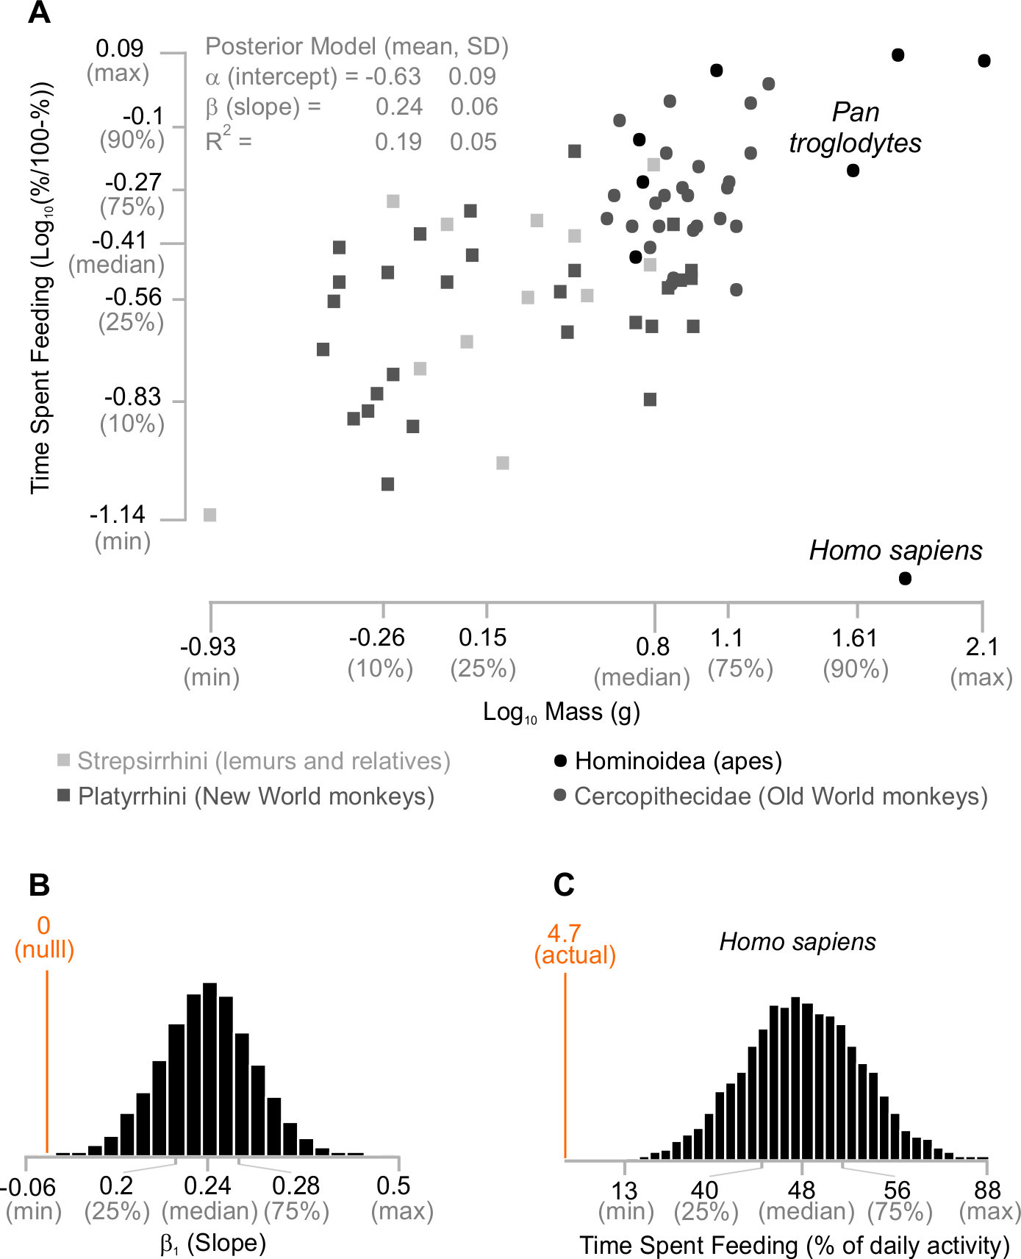

Figure 2
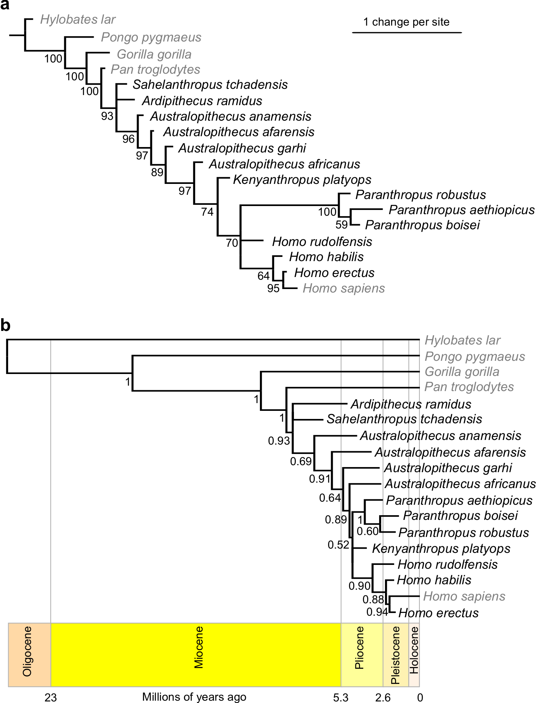

Figure 3


