Silver-Mediated Trifluoromethoxylation of Aryl Stannanes and Arylboronic Acids
Chenghong Huang, Theresa Liang, Shinji Harada, Eunsung Lee, and Tobias Ritter*
Department of Chemistry and Chemical Biology, Harvard University, 12 Oxford Street, Cambridge, Massachusetts 02138, United States
ritter@chemistry.harvard.edu

ABSTRACT: A silver-mediated cross-coupling of trifluoromethoxide with aryl stannanes and arylboronic acids to give aryl trifluoromethyl ethers is reported. This is the first report of a transition-metal-mediated C_{aryl}–OCF₃ bond formation.
Fluorine incorporation often improves the properties of pharmaceuticals, agrochemicals, and materials.¹ Previous research has resulted in the development of several trifluoromethylation² and fluorination3 reactions via transition-metal-mediated and catalyzed cross-coupling reactions. Despite the utility of trifluoromethoxy arenes in pharmaceuticals and agrochemicals, in part due to their high stability towards metabolism,⁴ transition-metal-mediated cross-coupling reactions for trifluoromethoxylation (C_{aryl}–OCF₃) are currently unavailable. Difficulties in C–OCF₃ bond formation can be attributed to the reversible decomposition of trifluoromethoxide anion in solution above room temperature to afford carbonic difluoride (b.p.: –84 ºC) and fluoride,⁵ as well as β-fluoride elimination⁶ from transition metal–trifluoromethoxide complexes. Earlier this year Buchwald reported a Pd-catalyzed C_{aryl}–SCF₃ cross coupling reaction.7 Thus far, the analogous reaction to make aryl trifluoromethyl ethers has not been developed via Pd-catalyzed cross-coupling, possibly due to the commonly employed reaction conditions involving basic media at elevated temperature typically used for challenging C–X bond forming reactions;3n such conditions may lead to decomposition of trifluoromethoxide anion before C–O bond formation. Herein we report a silver-mediated cross-coupling reaction of trifluoromethoxide 1 with aryl stannanes and arylboronic acids to give aryl trifluoromethyl ethers (Ar–OCF₃) (Scheme 1). The reported trifluoromethoxylation reaction provides access to several novel aryl trifluoromethyl ethers under conditions tolerant of a variety of functional groups.
Aryl trifluoromethyl ethers are conventionally made from phenols via fluoroformate or chlorothionoformate intermediates, followed by nucleophilic fluorination with antimony trifluoride, hydrofluoric acid, or sulfur tetrafluoride at 100 °C to 160 °C.⁸ Only structurally simple phenol derivatives can tolerate such reaction conditions. Togni and coworkers have reported the successful trifluoromethylation of primary and secondary alcohols with electrophilic hypervalent iodine reagents.⁹ Similar attempts to trifluoromethylate 2,4,6-trimethylphenol afforded products primarily resulting from carbon trifluoromethylation and up to 15% yield of the desired aryl trifluoromethoxy ether.¹⁰ Umemoto and coworkers have reported trifluoromethylation of phenols using O-(trifluoromethyl)-dibenzofuranium salts under photo-irradiation at −100 °C.¹¹ And Kolomeitsev has reported the synthesis of phenyl and naphthyl trifluoromethyl ether via addition of trifluoromethoxide to in situ generated benzyne and α-naphthyne, respectively.^{5a}
Here we report a new strategy for the synthesis of aryl trifluoromethyl ethers: trifluoromethoxylation of aryl nucleophiles by C_{aryl}–O bond formation. Treatment of aryl stannanes with trifluoromethoxide 1, F-TEDA-PF₆ (4), and silver(I) hexafluorophosphate (AgPF₆) in a THF/acetone mixture at −30 °C afforded the desired aryl trifluoromethyl ethers in 59–88% yield (Table 1). Reagent 1 was prepared in situ from trifluoromethyl trifluoromethanesulfonate, a non-fuming, hydrolytically stable liquid that is commercially available and synthesized from triflic acid in one step (see Supporting Information) and tris(dimethylamino)sulfonium difluorotrimethylsilicate (TASF). The trifluoromethoxylation reaction tolerates functional groups like alcohols, halogens, esters, ethers, alkenes, and ketones and can be applied to electron-rich, electron-poor, and ortho-substituted arenes. Trifluoromethoxylation can also be accomplished from arylboronic acids (Table 2). While in general arylboronic acids are preferred reagents over aryltin reagents, a two-step, one-pot procedure is required for the presented trifluoromethoxylation of arylboronic acids. Treatment of arylboronic acids with sodium hydroxide in methanol followed by AgPF₆ gave the corresponding aryl silver complexes, which afforded aryl trifluoromethyl ethers upon addition of 1 and 4 in a THF/acetone solvent mixture. Currently, aryl nucleophiles (both arylboronic acids and aryl stannanes) containing basic nitrogen functional groups such as pyridine afford trifluoromethyl ethers in substantially lower yield. For example, trifluoromethoxylation of 6-(tributylstannyl)quinoline gives 6-(trifluoromethoxy)quinoline in 16% yield.
Scheme 1. Trifluoromethoxylation.
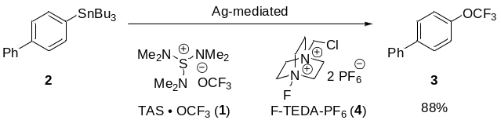
Both trifluoromethoxide salt and solvent have a significant impact on the yield of trifluoromethoxylation. Deviation from the reaction conditions described in Table 1 leads to byproducts, which result from fluorodestannylation, hydroxydestannylation, protodestannylation, and biaryl formation via homocoupling in up to 50% combined yield. Byproduct formation was minimized by reaction optimization (see Supporting Information), but remains challenging for some substrates. For example, trifluoromethoxylation of morphine derivative 25, the substrate that affords the lowest yield among the examples shown in Table 1, gave 24% of the corresponding fluorodestannylated and 10% the corresponding protodestannylated product, respectively. Byproducts could be separated in all cases by column chromatography.

Table 1. Trifluoromethoxylation of Aryl Stannanes
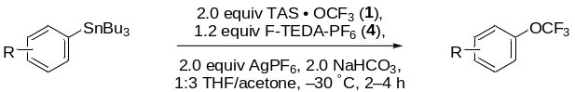
substrate | product | yield [%]
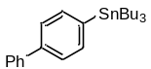  2 | 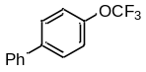  3 | 88
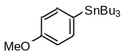  5 | 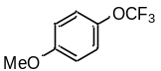  6 | 87
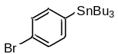  7 | 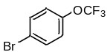  8 | 84
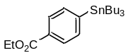  9 | 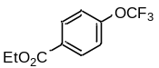  10 | 79
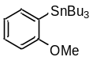  11 | 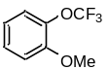  12 | 77
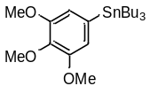  13 | 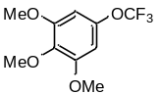  14 | 75
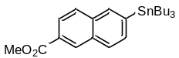  15 | 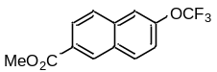  16 | 75
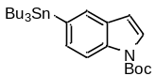  17 | 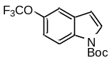  18 | 72
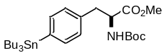  19 | 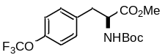  20 | 75
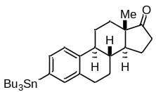  21 | 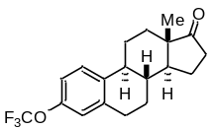  22 | 72
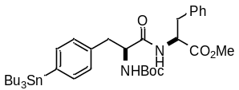  23 | 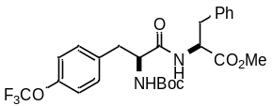  24 |  | 67
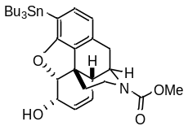  25 | 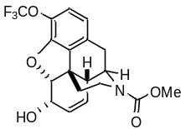26 | 59
Table 2. Trifluoromethoxylation of Arylboronic Acids.
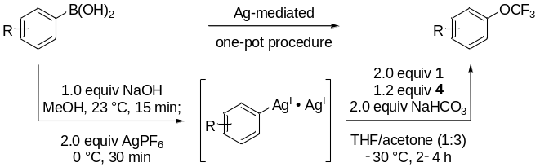
substrate | product | yield (%)
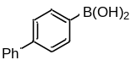  27 | 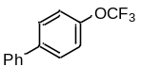  2 | 72
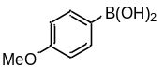  28 | 6 | 63
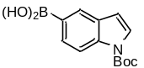  29 | 18 | 76
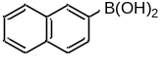  30 | 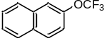  31 | 64
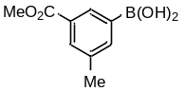  32 | 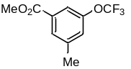  33 | 65
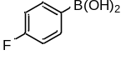  34 | 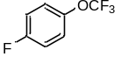  35 | 67ª
a) Yield was determined by ¹⁹F NMR with 3-nitrofluorobenzene as internal standard.
The ability to form carbon–heteroatom bonds at a lower temperature than usually employed for challenging C–heteroatom cross coupling reactions^{3n,7} was key to the development of trifluoromethoxylation because irreversible fluoride dissociation from trifluoromethoxide could be prevented. The ability to effect challenging carbon–heteroatom bond transformations from silver complexes may be a consequence of synergistic metal–metal interactions that can lower activation barriers, as identified for bimetallic catalysis.¹² We hypothesize that trifluoromethoxylation proceeds from discrete high-valent silver complexes, formed via oxidation of aryl silver complexes with F-TEDA-PF₆ (4), followed by fluoride to trifluoromethoxide ligand exchange. The use of two equivalents of AgPF₆ gave the highest observed yields of trifluoromethoxylation, which could suggest a dinuclear silver complex as a key intermediate in C–OCF₃ bond formation. Bimetallic silver redox behavior has previously been proposed for the Ag-mediated fluorination of aryl stannanes.^{3j,o,r} In the fluorination reaction, catalysis could be achieved but required heating to 65 °C. A similar approach to achieve silver catalysis for trifluoromethoxylation was not successful, presumably due to the thermal instability of trifluoromethoxide.
In conclusion, a Ag-mediated trifluoromethoxylation of functionalized aryl stannanes and arylboronic acids is reported. The inability to efficiently trifluoromethoxylate arenes with basic functional groups such as amines and pyridines is currently a limitation of the reaction. In addition, the necessity for toxic arylstannanes and the two-step procedure from arylboronic acids currently limit the practicality of the presented trifluoromethoxylation reaction. Currently, however, no other method is available to trifluoromethoxylate aryl nucleophiles via cross coupling. We have addressed the fundamental challenges associated with C_{aryl}–OCF₃ bond formation via silver redox chemistry. Future efforts in the field should be directed at the development of more practical reactions with broader functional group tolerance.
ACKNOWLEDGMENT: We thank Pingping Tang (Harvard), Jean Reynaud (Harvard), and Ian Mangion (Merck) for helpful discussions as well as NSF (CHE-0952753), the Massachusetts Life Science Center, and Merck for funding. TR is a Sloan fellow, a Lilly Grantee, an Amgen Young Investigator, and an AstraZeneca Awardee.
Supporting Information paragraph Detailed experimental procedures and spectroscopic characterization for all new compounds. This material is available free of charge via the Internet at http://pubs.acs.org.
REFERENCES:
- (a) Yamazaki, T.; Taguchi, T; Ojima, I. In Fluorine in Medicinal Chemistry and Chemical Biology; Ojima, I., Ed.; Wiley-Blackwell: United Kingdom, 2009. (b) Jeschke, P. ChemBioChem 2004, 5, 570–589. (c) Babudri, F.; Farinola, G. M.; Naso, F.; Ragni, R. Chem. Commun. 2007, 1003–1022. (d) Müller, K.; Faeh, C.; Diederich, F. Science 2007, 317, 1881–1886. (e) Purser, S.; Moore, P. R.; Swallow, S.; Gouverneur, V. Chem. Soc. Rev. 2008, 37, 320–330. (f) Furuya, T.; Kamlet, A. S.; Ritter, T. Nature 2011, 473, 470–477.
- (a) Kobayashi, Y.; Kumadaki, I. Tetrahedron Lett. 1969, 10, 4095–4096. (b) McLoughlin, V. C. R.; Thrower, J. Tetrahedron 1969, 25, 5921–5940. (c) Matsui, K.; Tobita, E.; Ando, M.; Kondo, K. Chem. Lett. 1981, 10, 1719–1720. (d) Kitazume, T.; Ishikawa, N. Chem. Lett. 1982, 11, 137–140. (e) Wiemers, D. M.; Burton, D. J. J. Am. Chem. Soc. 1986, 108, 832–834. (f) Cottet, F.; Schlosser, M. Eur. J. Org. Chem. 2002, 327–330. (g) Schlosser, M. Angew. Chem. Int. Ed. 2006, 45, 5432–5446. (h) Grushin, V. V.; Marshall, W. J. J. Am. Chem. Soc. 2006, 128, 4632–4641. (i) Grushin, V. V.; Marshall, W. J. J. Am. Chem. Soc. 2006, 128, 12644–12645. (j) Dubinina, G. G.; Ogikubo, J.; Vicic, D. A. Organometallics 2008, 27, 6233–6235. (k) Dubinina, G. G.; Furutachi, H.; Vicic, D. A. J. Am. Chem. Soc. 2008, 130, 8600–8601. (l) Oishi, M.; Kondo, H; Amii, H. Chem. Commun. 2009, 1909–1911. (m) Chu, L.; Qing, F.-L. Org. Lett. 2010, 12, 5060–5063. (n) Ball, N. D.; Kampf, J. W.; Sanford, M. S. J. Am. Chem. Soc. 2010, 132, 2878–2879. (o) Wang, X.; Truesdale, L.; Yu, J.-Q. J. Am. Chem. Soc. 2010, 132, 3648–3649. (p) Ye, Y.; Ball, N. D.; Kampf, J. W.; Sanford, M. S. J. Am. Chem. Soc. 2010, 132, 14682–14687. (q) Cho, E. J.; Senecal, T. D.; Kinzel, T.; Zhang, Y.; Watson, D. A.; Buchwald, S. L. Science 2010, 328, 1679–1681. (r) Lundgren, R. J.; Stradiotto, M. Angew. Chem. Int. Ed. 2010, 49, 9322–9324. (s) Chu, L.; Qing, F.-L. Org. Lett. 2010, 12, 5060–5063. (t) Knauber, T.; Arikan, F.; Röschenthaler, G.-V.; Gooßen, L. J. Chem. Eur. J. 2011, 17, 2689–2697. (u) Zhang, C-P.; Wang, Z.-L.; Chen, Q-Y.; Zhang, C.-T.; Gu, Y.-C.; Xiao, J.-C. Angew. Chem. Int. Ed. 2011, 50, 1896–1900. (v) Senecal, T. D.; Parsons, A. T.; Buchwald, S. L. J. Org. Chem. 2011, 76, 1174–1176. (w) Morimoto, H.; Tsubogo, T.; Litvinas, N. D.; Hartwig, J. F. Angew. Chem. Int. Ed. 2011, 50, 3793–3798. (x) Ball, N. D.; Gary, J. B.; Ye, Y.; Sanford, M. S. J. Am. Chem. Soc. 2011, 133, 7577–7584.
- (a) Tius, M. A.; Kawakami, J. K. Synth. Commun. 1992, 22, 1461–1471. (b) Tius, M. A.; Kawakami, J. K. Synlett 1993, 207. (c) Tius, M. A.; Kawakami, J. K. Tetrahedron 1995, 51, 3997–4010. (d) Subramanian, M. A.; Manzer, L. E. Science 2002, 297, 1665. (e) Hull, K. L.; Anani, W. Q.; Sanford, M. S. J. Am. Chem. Soc. 2006, 128, 7134–7135. (f) Akana, J. A.; Bhattacharyya, K. X.; Müller, P.; Sadighi, J. P. J. Am. Chem. Soc. 2007, 129, 7736–7737. (g) Kaspi, A. W.; Yahav-Levi, A.; Goldberg, I.; Vigalok, A. Inorg. Chem. 2008, 47, 5–7. (h) Furuya, T.; Kaiser, H. M.; Ritter, T. Angew. Chem. Int. Ed. 2008, 47, 5993–5996. (i) Furuya, T.; Ritter, T. J. Am. Chem. Soc. 2008, 130, 10060–10061. (j) Furuya, T.; Strom, A. E.; Ritter, T. J. Am. Chem. Soc. 2009, 131, 1662–1663. (k) Ball, N. D.; Sanford, M. S. J. Am. Chem. Soc. 2009, 131, 3796–3797. (l) Wang, X.; Mei, T. S.; Yu, J.-Q. J. Am. Chem. Soc. 2009, 131, 7520–7521. (m) Wu, T.; Yin, G.; Liu, G. J. Am. Chem. Soc. 2009, 131, 16354–16355. (n) Watson, D. A.; Su, M.; Teverovskiy, G.; Zhang, Y.; García-Fortanet, J.; Kinzel, T.; Buchwald, S. L. Science 2009, 325, 1661–1664. (o) Furuya, T.; Ritter, T. Org. Lett. 2009, 11, 2860–2863. (p) Gorske, B. C.; Mbofana, C. T.; Miller, S. J. Org. Lett. 2009, 11, 4318–4321. (q) Furuya, T.; Benitez, D.; Tkatchouk, E.; Strom, A. E.; Tang, P.; Goddard, W. A., III; Ritter, T. J. Am. Chem. Soc. 2010, 132, 3793–3807. (r) Tang, P.; Furuya, T.; Ritter, T. J. Am. Chem. Soc. 2010, 132, 12150–12154.
- (a) Jeschke, P.; Bastonb, E.; Leroux, F. R. Mini-Rev. Med. Chem. 2007, 7, 1027–1034. (b) Leroux, F. R.; Manteau, B.; Vors, J.-P; Pazenok, S. Beilstein J. Org. Chem. 2008, 4, No. 13.
- (a) Kolomeitsev, A. A.; Vorobyev, M.; Gillandt, H. Tetrahedron Lett. 2008, 49, 449–454. (b) Martin, J. C.; Taylor, S. L. J. Org. Chem. 1987, 52, 4147–4156.
- (a) Fout, A. R.; Scott, J.; Miller, D. L.; Bailey, B. C.; Pink, M.; Mindiola, D. J. Organometallics 2009, 28, 331–347. (b) Kraft, B. M.; Lachicotte, R. J.; Jones, W. D. Organometallics 2002, 21, 727–731.
- Teverovskiy, G.; Surry, D. S., Buchwald, S. L. Angew. Chem., Int. Ed. 2011, DOI:10.1002/ange.201102543.
- (a) Sheppard, W. A. J. Org. Chem. 1964, 29, 1–11. (b) Feiring, A. E. J. Org. Chem. 1979, 44, 2907–2010. (c) Kuroboshi, M.; Suzuki, K.; Hiyama, T. Tetrahedron Lett. 1992, 33, 4173–4176. (d) Salomé, J.; Mauger, C.; Brunet, S.; Schanen, V. J. Fluorine Chem. 2004, 125, 1947–1958. (e) Leroux, F.; Jeschke, P.; Schlosser, M. Chem. Rev. 2005, 105, 827–856.
- Koller, R.; Stanek, K.; Stolz, D.; Aardoom, R.; Niedermann, K.; Togni, A. Angew. Chem. Int. Ed. 2009, 48, 4332–4336.
- Stanek, K.; Koller, R.; Togni, A. J. Org. Chem. 2008, 73, 7678–7685.
- Umemoto, T.; Adachi, K.; Ishihara, S. J. Org. Chem. 2007, 72, 6905–6917.
- (a) Powers, D. C.; Ritter, T. Nature Chem. 2009, 1, 302–309. (b) Powers, D. C.; Geibel, M. A. L.; Klein, J. E. M. N.; Ritter, T. J. Am. Chem. Soc. 2009, 131, 17050–17051. (c) Powers, D. C.; Xiao, D. Y.; Geibel, M. A. L.; Ritter, T. J. Am. Chem. Soc. 2010, 132, 14530–14536. (d) Powers, D. C.; Ritter, T. Top. Organomet. Chem. 2011, 35, 129–156.

TOC:


