A Fork's Impact: The Reach of Mission-Driven Fine Dining
Lia Mondavi
Harvard College Senior Thesis
March 2019

Table of Contents

Introduction 03
Section 1: Dish Analysis 07
Section 2: Mathematical Model Introduction 17
Section 3: Discussion of Data Sourcing 22
Section 4: Set-up for Adapting the SIR Model 24
Section 5: Proposal for Modelling Spread of Ideas About Food
System Sustainability Promoted by Fine Dining 27
Section 6: Application of SIR Model for Food System Sustainability 30
Section 7: Conclusions 37
Appendix 38
Acknowledgements 58

This past summer, I learned of a completely new vegetable: the Honeynut Squash. This squash was bred by Michael Mazourek, a seed breeder at Cornell. He started with two different squash varieties, breeding them together and then selecting from their seeds, continuing to select for certain desirable characteristics each generation. Mazourek shared the new squash with Dan Barber, chef and co-owner of Blue Hill at Stone Barns in New York, who then helped to introduce the Honeynut Squash to more people by discussing it at the G9 Chef’s Summit in 2013. In exposing this new squash to the chefs at this conference, Barber prompted a rise in the demand and popularity of the Honeynut Squash, starting at the level of restaurants run by the chefs attending the summit but eventually reaching down to more everyday sources of food. Last September, I found the Honeynut Squash available at a Whole Foods store and at a farmers’ market in Cambridge, MA. This timeline is remarkable, with less than ten years for this squash to travel from being a mere idea in 2009 to a unique vegetable available at a grocery store in a metropolitan area in 2018.
I heard about this squash last summer while working as an intern at Blue Hill at Stone Barns, a mission-driven fine dining restaurant in Westchester County outside New York City. While there, I observed the incredible attention given to each dish served and the greater meaning behind the dish. It quickly became clear to me that those at Blue Hill were trying to influence the food system and our food culture through this restaurant as well as through the different touchpoints they and the restaurant have with the public in general, those in the restaurant industry, and those in agriculture. Over the course of the summer, I saw countless examples where this approach appeared to be working. However, I was in an epicenter with others who believed in this mission and understood our food system and its flaws extremely well. I therefore grew to wonder if this apparent success could be tracked or confirmed. I also wanted to learn more about other restaurants in the fine dining realm that were working to similarly impact the food system and food culture in the United States.
While Blue Hill at Stone Barns is a leader in both fine dining and food system sustainability efforts in the United States, there are other fine dining restaurants with sustainability efforts. To focus on the top restaurants in the United States, I used the Michelin guide selecting for three Michelin starred restaurants as well as restaurants appearing on the World’s 50 Best Restaurants list. This narrowed the list of restaurants to twenty restaurants across the United States, with the main focal points being the extended San Francisco Bay Area including Napa and Sonoma Valleys and the New York City and Hudson Valley areas.
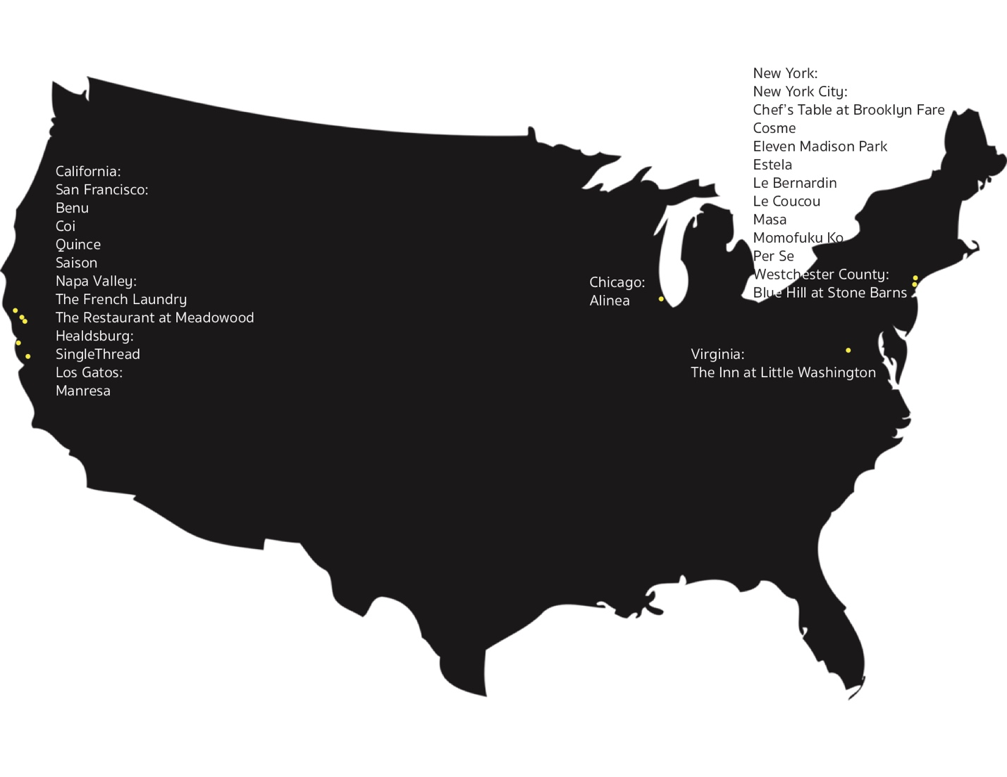
Figure 1: Map of Fine Dining Restaurants in the United States
SingleThread in Healdsburg, California also stood out as a restaurant pursuing a sustainable approach to fine dining. Their menu is based on the seasonably available produce from their farm located near the restaurant in Sonoma county. The concept of SingleThread’s restaurant is tightly tied to their farm, with the farm growing and supplying unique produce for the restaurant, which is Japanese influenced California cuisine. Some produce, especially traditional Japanese produce, is not readily available in California. By having a farm, SingleThread is able to grow their own specialty produce and provide diners with a unique experience and a taste of unexpected fruits, vegetables, and herbs. This exposure to new types of foods is important to expanding a diner’s view of food.
These two restaurants represent two approaches to showcasing sustainability through fine dining on opposite coasts and in differing communities. Blue Hill at Stone Barns’ proximity to Manhattan and SingleThread’s proximity to San Francisco (and to the Napa Valley) afford each restaurant a constant stream of affluent consumers willing to pay hundreds of dollars for a multi-course, multi-hour dining and educational experience. These two restaurants form the foundation of my exploration of fine dining restaurants arguing for changes in our food system towards a more sustainable food culture and agriculture supply system.

Section 1: Dish Analysis
As an initial inquiry into discovering the greater messages behind the dishes served at Blue Hill at Stone Barns, as well as dishes served at other similar caliber restaurants such as SingleThread, I diagrammed a selection of these dishes and worked with these diagrams to read the dishes, extrapolate content from the dishes, and connect the dish back to the restaurants’ overall message concerning sustainability and the global food system. The first dish I focused on for analyzing Blue Hill’s menu was the Habanada Pepper and Badger Flame Beet dish.
Figure 2: Habanada Pepper and Badger Flame Beet Diagram (See Appendix 4)
This dish features two vegetables bred by Row 7 Seed Company in partnership with Michael Mazourek and Irwin Goldman respectively. The Habanada Pepper was bred from the habanero pepper to remove the spiciness or heat. Michael Mazourek was successful in achieving this, leading to the habanero-looking and tasting Habanada Pepper with no heat. Similarly, the Badger Flame Beet was bred by Irwin Goldman to be a beet with less of the characteristic earthiness of beets as well as more sweetness. This beet was designed to be more approachable and to appeal to the broader audience than the traditional, rather polarizing, beet varieties. The marriage of these two vegetables on this dish not only highlights their complementary flavors but also emphasizes the abilities of seed breeding and selection for flavor.
My analysis of this dish drew on the regionality of the presentation. Each vegetable had its own territory on the plate. This had implications for the notion of seasonality and what is available at a given time in a given region. Additionally, two vegetables occupying an entire plate for a singular course references our need to greatly reduce meat consumption from our diets by substituting hearty vegetable alternatives, such as beets. Blue Hill, through this dish, argues that, with better tasting vegetables specifically bred for flavor, transitioning to a vegetable-focused, lower meat diet will be more attainable and desirable. Flavor is a strong motivator for what we choose to grow and eat as a society.
Another essential dish at Blue Hill at Stone Barn is “The Fence.” This dish arrives at the table first and is alone. The clean table with no utensils or plates focuses diners to this singular dish with an atypical presentation – fresh vegetables from the farm are placed on nails stuck into a wooden block. The diagram below demonstrates the presentation of “The Fence” with fresh early summer vegetables, such as French breakfast radishes, little gem lettuce, and baby bok choy.
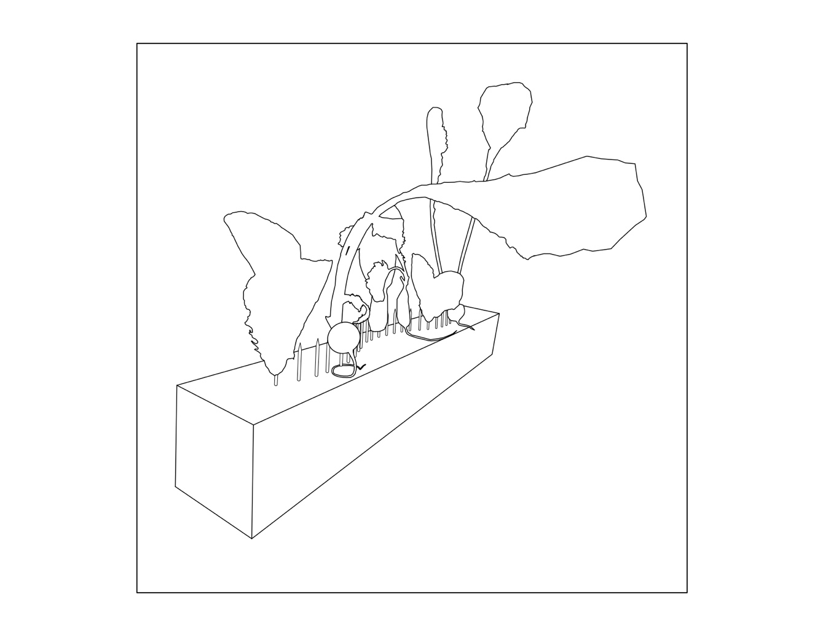Figure 3: “The Fence” Diagram (See Appendix 5)
This dish is extremely minimal and is therefore intended to shock as the first dish of a high-end, expensive restaurant by breaking the standard expectations of fine dining. Rather than caviar, truffles, gold leaf flakes, or other ostentatious foods often seen, and expected, in high-end dining, this dish reverts to the simple and basic in a way that subverts the system beautifully. The singular vegetables presented with little seasoning, perhaps some salt and a spray of lemon juice, to a diner’s fresh palate emphasize the true flavor of vegetables. This dish is used to set the stage for the remainder of the meal, arguing for the flavor of vegetables and their ability to stand alone as the star of a dish. A shift in vegetables to be more central in our dining habits, replacing meat as the primary portion on our plates, could lead to a food system that is less taxing on the environment.
While this dish is designed to show the potential of vegetables because of their incredible flavor, texture, and overall quality when grown correctly, harvested at peak flavor, and served fresh, it also emphasizes the shortcomings of our current food system. In any Whole Foods store in New York City in the middle of winter, there are “fresh” strawberries available (for those who can afford them). Yet, in the middle of summer when strawberries can be locally sourced in many areas of the United States, there are food deserts where such produce is never available. This element in our food system of who is getting what produce and when does not align with the actual seasonality of a particular region. The global nature of our food system has altered our consumer nature to expect strawberries in winter and brussel sprouts in summer. Therefore, to satisfy this, sourcing of produce spreads to a larger, and ultimately global, scale. This dish argues that a region’s seasonal and local produce should be highlighted and focused upon.
Additionally, this dish contains some implicit connections with availability and affordability of food in our country. The title – “The Fence” – inherently calls to mind a divider. Rather than calling to mind a quaint, wooden slat fence dividing the grazing cows in one field from the rows of vegetables in another, this could just as easily call to mind the wall between those who can afford to dine at Blue Hill at Stone Barns, with a $258 price tag for food alone, and those who rely on under $5 meals from McDonald’s. This “fence” in our society divides individuals into classes, purely based on what they eat. For those relying on McDonald’s, changing food habits to eat more sustainably is potentially impossible financially, and may also not be possible because of lack of availability of foods. Food deserts exist across the United States, leading to limited choices and availability of foods for those living in these areas or those unable to reach a grocery store. The arguments made in this dish for changing our food system are not possible in these areas, because the fresh vegetables are not available, and in many other areas, the vegetables are not affordable. Additionally, vegetable dishes are often more time consuming to prepare than meat dishes and are definitely more time consuming and more expensive than fast food, which provides a high number of calories for little time and money. These issues surrounding availability and access are key to changing aspects of our food system to be more sustainable.
The next dish – the fried Grimaud Hybrid Pekin duck feet dish at Blue Hill at Stone Barns – is connected to arguments about waste in our food system. The particular ducks whose feet are featured in this dish were raised at Stone Barns and slaughtered at seven to eight weeks of age. In the United States, traditionally undesirable parts, such as the feet, are thrown out in large slaughterhouses, leading to waste. While not all of this is salvageable, some of it could be used in alternative ways. Serving fried duck feet as a dish at Blue Hill shows the potential of this waste that is a current byproduct of our food system, and specifically our slaughterhouse system.
Figure 4: Fried Duck Feet Diagram (See Appendix 6)
The diagram above shows the presentation of the duck feel on a nest of hay. This not only emphasizes the lowly status associated with feet, especially animal feet, and the infrequency of seeing them served in American high-end dining, but also calls to mind the agricultural background of all of our food, with the use of hay in the nest. As consumers, Americans are often very removed from the agricultural aspects of our food system, arriving at a grocery store to purchase processed foods or going to a restaurant or fast food chain to select a prepared meal. Most Americans do not grow their own vegetables or slaughter their own chickens. While this is essential for the nature and function of our modern world, there are downsides to having generations raised with no proximity to where our food is actually grown and raised. Educating about this will help consumers make more conscious and informed decisions about their food. This is needed to effect change in our food system. Consumers’ decisions help to set what food is grown, raised, and made. Raising the general consumer’s awareness of his or her options and choices will help provide such consumers with the opportunity to make informed decisions that could ultimately help set our food system on a more sustainable path. While this is not the only change that needs to occur, it is definitely an element of the issue that needs to be addressed.
In addition to Blue Hill at Stone Barns, I also looked at SingleThread in Healdsburg, California to explore and evaluate their efforts to educate their diners and followers about the food system. SingleThread, similarly to Blue Hill at Stone Barns, has its own farm where they source many of their ingredients for the restaurant. In analyzing their dishes, I also focused on dishes whose presentation was deliberate and from which I read arguments about our food system. One of these dishes was the potato soufflé served in an egg shell with caviar. I will focus on this dish, but another of their dishes, the fresh nectarine with honeysuckle blossoms, appears in the appendix.
There was an immediately obvious reference to a nest with this dish, created by the moss “nest” base and egg shell “egg” in the nest. This called attention to origin and sourcing of foods. As discussed above, we as consumers are becoming less informed about the source of our foods. In making a nest as the presentation, the diner is invited to think about the origins of their food, whether they realize this or not when enjoying the potato soufflé finished with a dollop of caviar.
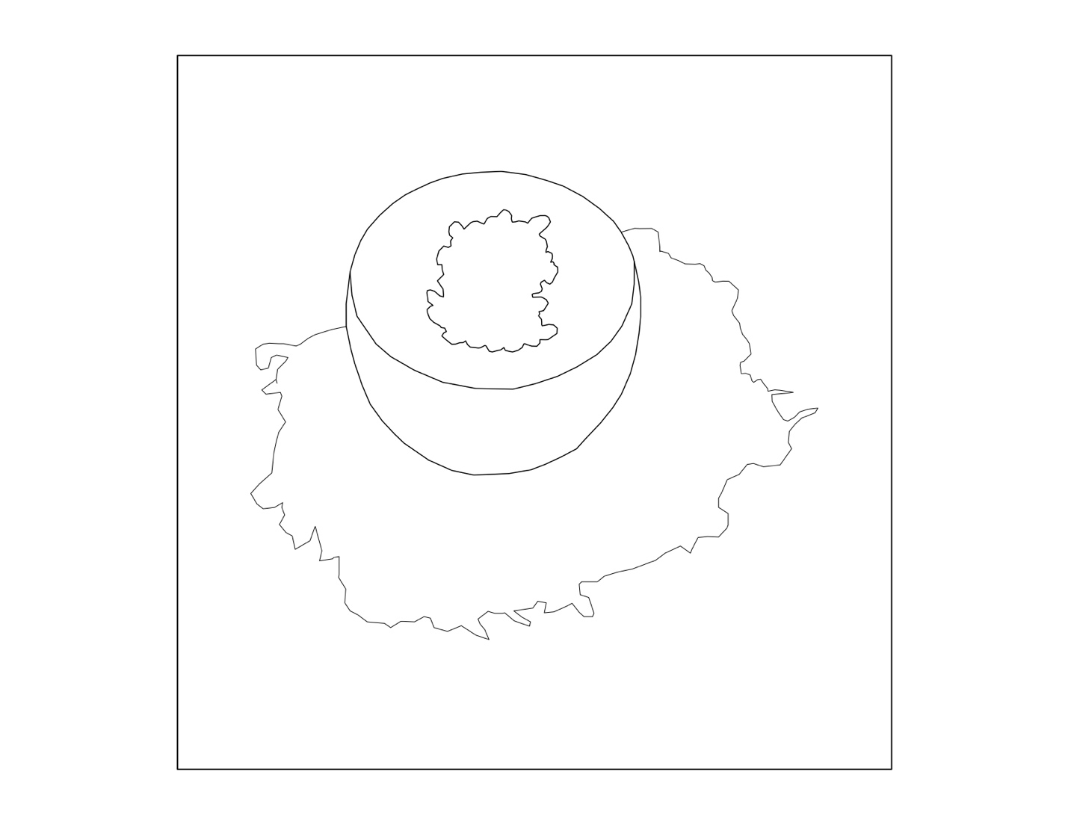Figure 5: Potato Soufflé with Caviar Diagram (See Appendix 7)
This dish had more of the generally accepted elements of fine dining. First, the soufflé, as traditionally French, fits with the idea that French dining is elevated dining. Additionally, the soufflé is a somewhat particular preparation that requires excellent technique, timing, and execution to be served at a restaurant. The fact that this level of perfection is expected at restaurants of the caliber of SingleThread reinforces the fact that this dish plays into the stereotype. Then the caviar element as the finishing for the soufflé was another elevated dining aspect. Caviar is often associated with fine dining because of its high price and difficulty in procuring. However, these were all served in a fairly generic looking brown egg shell, which is commonly found across grocery stores in America. Yes, this egg was likely from free range, pasture raised, certified happy chickens who live a blessed life under the California sun. Yet, chicken eggs are something everyone can recognize and relate to, making their presence on this dish a nod to the common. Additionally, the soufflé was a potato soufflé. Potatoes represent one of the most generic and common foods, present in every fast food chain in the country in the form of French Fries and in many households as mashed potatoes or baked potatoes. This extremely common food serving as the base for the soufflé contrasts with the elevated nature of the dish as a soufflé served with caviar in such a fine dining establishment.
The juxtaposition of soufflé and caviar with eggs and potatoes calls attention to what our food culture chooses to serve on a silver platter and what it deems as food for the masses. While these lines do exist due to historical factors and corresponding costs and availability, this dish points out that we should care more about why we eat what we do and prompts us to have more agency in this decision. Realizing the historical factors, both within the United States as well as globally, that have led to our current food culture and agricultural system is key to defining and addressing these issues embedded in such systems.

Section 2: Mathematical Model Introduction
In approaching this project, I was interested in taking both a qualitative review of these restaurants’ approach to making an argument through food and a quantitative analysis of the success of these efforts. In looking through potential approaches to the latter process, the SIR (Susceptible-Infected-Recovered) epidemiology model, which analyzes the spread of a disease in a population, stood out as a model that can be and has been adapted to tracking the spread of ideas. This model has been adapted to include differing variables and assumptions based on various populations and natures of diseases. Additionally, this model has been adapted to analyze the spread of ideas. My goal was to use this application of the SIR model to evaluate the effectiveness of fine dining restaurants in spreading the idea that our food system needs to change to be more sustainable, and correspondingly that our eating habits as a society must be challenged and modified. However, due to issues of accessing data, I had to reevaluate this goal. Rather than apply the model to a set of data, I will be proposing a theoretical approach to this problem using an adapted SIR model then showing this application in a limited data set with informed but general assumptions.
The basic setup of the SIR model is to approach a certain population and determine how fast a particular disease will spread based on an infection rate, recovery rate, initial number of people infected, and size of the population. More complicated models add in incubation period, details about the population, and various other factors. For the purpose of converting this model to the spread of an idea, the initial basics are appropriate to start.
The series of equations for the SIR model are:
Susceptible individuals: $S=S\left(t\right)$
Infected individuals: $I=I(t)$
Recovered individuals: $R=R(t)$
Number of individuals in the population: $N=S\left(t\right)+I\left(t\right)+R(t)$
Infection rate: $b$
Recovery rate: $k$
Susceptible equation: $\frac{ds}{dt}=-b*S\left(t\right)*I(t)$
Infected equation: $\frac{di}{dt}=b*S\left(t\right)*I\left(t\right)-k*I(t)$
Recovered equation: $\frac{dr}{dt}=k*I(t)$
The following figure demonstrates the standard SIR model with infection rate of 0.001 individuals infected per time unit and recovery rate of 0.1 individuals recovered per time unit and a starting population of 1000 people with one person infected. As demonstrated by the graph, for this population, at some point a large portion of the population is infected then recovers. For this particular example, there is no possibility of re-infection.
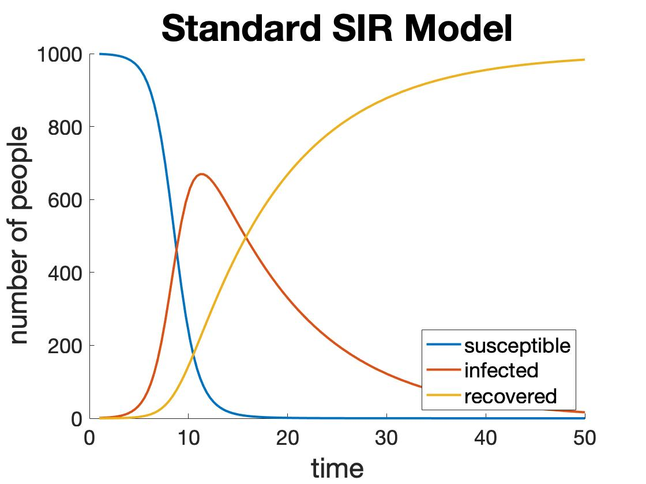
Figure 6: Graphical Representation of SIR Model
From this standard SIR model, several aspects have to be adapted to fit idea spreading. The key first change is that the SIR model is based on the spread of a disease, an inherently negative event. For the idea-spreading model, in this case, the goal is for the idea to spread, assuming the idea sparks a potentially positive event. Therefore, while the “infection rate” still signifies the spread, the interpretation of what this implies is reversed. Additionally, where the spread and recovery of a disease is fairly clear, the adoption of an idea and any abandonment of that same idea is not as clear or well defined as the spread of a disease. And often an idea is adopted because of repeated exposure to a concept and resultant gradual change over time, whereas diseases spread in a much more predictable and scientific way. Also, individuals generally make a conscious choice in adapting an idea. This distinction becomes murky when an idea is prevalent enough to cause it to be the default in a society. However, in my example, the ideas being analyzed are not prevalent enough for this to be an issue. Therefore, individuals do have to make an active and conscious choice to adopt an idea. Because of the details outlined above, this model will have to make assumptions about the population, the way an idea spreads, and what the adoption of an idea means, or what signals the adoption of an idea.
There are examples of others who have adapted the tracking of disease spreading to idea spreading. Bettencourt et al. in the 2016 paper “The Power of a Good Idea: Quantitative Modeling of the Spread of Ideas from Epidemiological Models” used an adaptation of the SIR (and more detailed versions of the SIR model) to model how an idea – or any “concept that can be transmitted from person to person” – spreads in a population by using the example of the spread of Feynman diagrams. While this specific example is unrelated to my work, the general application of the SIR model to the spread of an idea is parallel. In another example, Filip-Crawford and Neuberg in the 2016 paper “Homosexuality and Pro-Gay Ideology as Pathogens? Implications of a Disease-Spread Lay Model for Understanding Anti-Gay Behaviors” also approached mathematically modelling the spread of an idea or, in this case, a sentiment using the SIR model. These examples will provide a foundation for approaching my area of analysis.

Section 3: Discussion of Data Sourcing
As I mentioned previously, I had to modify my ideals for this project due to lack of access to data. Ideally, I wanted to have the demographic information of diners at high-end restaurants. However, due to the nature of these restaurants as well as the nature of the restaurant industry as a whole, this information was not accessible. This is an interesting point because I have realized that this lack of information is a result of fine dining restaurants choreographing the entire experience of an evening for their diners. The diner, who is there to enjoy a meal with friends or family, does not wish to be identified. These individuals, who tend to be in the higher socioeconomic brackets, want to share their experiences on their own terms, not be included in a restaurant’s statistic or data collection. Therefore, fine dining restaurants oblige, maintaining this selected anonymity, and any data they may have from reservations, payment, or other exchanges with diners is a tightly coveted secret.
This aspect of restaurant withholding, or not collecting, data is compounded by the fact that restaurants of this level are few and far between. By my selection criteria described above, there are twenty restaurants in the United States of this caliber. While this is merely one way of narrowing down restaurants from the many more fine dining restaurants in the United States, this does capture the competition these restaurants face among each other. I believe that restaurants feel their clients are a large part of what makes them successful, rightly so. Guarding the information of who these individuals are, or at least statistics on generally who they are, becomes paramount. Due to these issues surrounding accessing data in the fine dining restaurant industry, I was unable to approach my topic by an analysis of the data. Therefore, I will use limited information from onsite observation about the quantity of diners Blue Hill serves to extrapolate using assumptions to then apply the adapted SIR model. Because of the limited nature of my data, the conclusions drawn from modelling the spread of an idea from this restaurant will not be absolute but will confirm the ability of this model to track idea spreading. Given a more complete data set, this model would be more useful for drawing conclusions.

Section 4: Set-up for Adapting the SIR Model
To adapt the SIR model to an idea spread model, I will first define the equivalences between various aspects of these two models. The below tables lay out the equivalences between actions, actors, and features of these two models.
Actions | SIR Model | Idea Spread Model
Identification of spread | Hospitals and clinics; screening and testing | Monitoring behavior change; sharing idea and discussion
Prevention of spread | Physiological methods; prevention is ideal for healthcare workers and individuals | Maintain status quo; for negative ideas, is the goal; for positive ideas, is not desired
Encouragement of spread | Not desired; no medical intervention; active infecting of individuals or groups of individuals | Repetition, especially from different sources; encouraging interest; for positive ideas, is the goal; for negatives ideas, is not desired
Treatment | Medical intervention; time | Time; lack of follow-up or repetition; being isolated; again, goal varies depends on the idea
Figure 7: Adapting Actions from SIR Model to Idea Spread Model
Actors | SIR Model | Idea Spread Model
General public | Everyone | Everyone, specifically those with ability to change their dining habits and choices
Professionals | Physicians, healthcare providers | Restaurant industry, specifically those involved in food system sustainability
Policy makers | Government health organizations | Government environmental and food organizations
Treatment sources | Pharmaceutical companies; other health companies | Food industry companies and groups promoting food culture harmful to the environment
Figure 8: Adapting Actors from SIR Model to Idea Spread Model
Features | SIR Model | Idea Spread Model
Source | Pathogen | Idea; argument for change in our food system design
Transmission | Physiological disease spreading methods | Contact between people with and without idea; media exposure; dining experience
Susceptibility | State of immune system | Open-minded people; people thinking about environment
Effect of infection | Sick; show symptoms | Change of view towards food/food culture/food system; change of purchasing decisions
Prevalence | Number of cases | Number of people thinking about or arguing for changes in food system
Incidence | New cases per time unit | Rate of the number of people thinking about food system sustainability
Figure 9: Adapting Features of the SIR Model to the Idea Spread Model
The above tables outline the basic changes made to the SIR model and its interpretations for the idea spreading approach. For the specific model I am proposing, the spread of the idea – a view towards the change in our food system to be more sustainable – is the goal, flipping many of the interpretations of actions and features of the SIR model. With this in mind, the equations involved in the SIR model will not be altered, but the conclusions drawn from the model will reflect this difference.

Section 5: Proposal for Modelling Spread of Ideas About Food System Sustainability Promoted by Fine Dining
The same set of equations applies for this adapted SIR model, with $S$ still indicating the susceptible individuals but $I$ indicating the impacted individuals, or those who had adopted the idea and changed their behavior to reflect this, and $R$ indicating the individuals who have reverted to their previous way of thinking about food. Then the two rates become the spread rate of the idea and the reverting rate of individuals returning to their original view. The series of equations for the adapted SIR model are:
Susceptible individuals: $S=S\left(t\right)$
Impacted individuals: $I=I(t)$
Reverted individuals: $R=R(t)$
Number of individuals in the population: $N=S\left(t\right)+I\left(t\right)+R(t)$
Spread rate: $p$
Reverting rate: $v$
Number of people added to impacted group each night at restaurant: $n$
Susceptible equation: $\frac{ds}{dt}=-p*S\left(t\right)*I(t)$
Impacted equation: $\frac{di}{dt}=p*S\left(t\right)*I\left(t\right)-v*I\left(t\right)+n$
Reverted equation: $\frac{dr}{dt}=v*I(t)$
The relations of these equations remain the same because the spread of an idea tracks with the spread of a disease, merely with different interpretations of the elements of this model. To apply this model to the spread of ideas about food system sustainability by fine dining restaurants, I will define the different groups within this model. First, the susceptible group consists of those who have dined at high-end restaurants. To have accurate numbers about this group, the information and statistics on diners at these restaurants would have to be known. The impact group would start as those who work at fine dining restaurants being considered by this model, and then ideally grow as the ideas spread in the susceptible group. Finally, the reverted group consists of those who have abandoned the ideas about food system sustainability and reverted to their old dining behaviors.
To determine the spread rate $p$ and reverting rate $v$, information about the behavior of individuals in these groups would have to be tracked, as well as how they spread the ideas to others. The spread rate $p$ will be determined by the changes in behavior of those who have dined at high-end restaurants to be more sustainability conscious about their food choices and of others who have been impacted by these individuals to trace the spread through the population. This information is hard to track so would have to be self-reported by those who have dined at such restaurants as a follow-up study. Gathering data on the groups then impacted by these individuals would prove to be more difficult. Perhaps isolating the study to one area and surveying everyone in the population of that area to serve as a proxy for the greater population would be a way around this difficulty. Similarly, the reverting rate $v$ would be the rate of those in the impacted group reverting back their old habits. This could be sparked by a variety of factors, including economic hardship, inconvenience, or other personal or community factors. Again, this information would have to be found using self-reporting by diners from a follow-up at standard time intervals following when the diner had first been exposed to the idea at the restaurant or by looking at a subgroup of the population.
This information and model would provide a clear picture of how effective fine dining restaurants are at impacting how diners think about food and our food system following dining at these restaurants. Conclusions could be drawn about the impact of mission-driven fine dining and its role in the environmental movement promoting changes in the United States and global food system. In addition, this idea spreading model takes into account those impacted by the original people influenced by fine dining restaurants’ message and tracks their effect on those in their community as the idea is hopefully spreading. Again, this would be hard to determine, but would lead to a greater spread of such ideas beyond just those with access to fine dining, which is ultimately the goal and hope for restaurants such as Blue Hill at Stone Barns. The relatively small group of people who have the opportunity to dine at the United States’ top restaurants will not have widespread impact by modifying their own behavior but could have a greater impact by spreading the need for changes in our food system further in their communities and in our country.

Section 6: Application of SIR Model for Food System Sustainability
In applying the new SIR model, the initial susceptible population consists of those dining at fine dining restaurants who are working to educate about issues in the food system and sustainability. To determine this, first I defined the restaurants working towards this goal. This group will be made up of a selection of restaurants from the twenty restaurants mentioned in Figure 1 with the criteria outlined in the introduction. For the purpose of determining whether these restaurants are actively adding to the conversation about food system sustainability, I used a ranking system of one though four to evaluate the messages about their restaurants portrayed on their websites, with one being no mention of any sustainability focused approach, two being a minimal and initial discussion of sustainability, such as a focus on seasonality, three being a greater focus on sustainability, such as having a local farm or local farm partnerships and a daily changing menu, and four being a mission-driven restaurant focused around seasonal ingredients and sustainability.
From the list of twenty restaurants, Alinea, Eleven Madison Park, Estela, Le Bernardin, and Le Coucou all ranked at a one as there was no mention about sustainability or seasonality on their websites. Then Benu, Coi, Saison, Chef’s Table at Brooklyn Fare, Cosme, Masa, and Momofuku Ko all ranked at a two, having some mention of seasonality and a changing menu. Third, Quince, The French Laundry, Manresa, and Per Se ranked at a three, with either having a personal farm or having close partnerships with farmers and focusing on the sustainability and seasonality of their restaurants and menus. Finally, The Restaurant at Meadowood, SingleThread, and Blue Hill at Stone Barns ranked at a four, with a more sustainability focused, mission driven dining approach. While these rankings are not perfect and actually experiencing dining at these restaurants would give a much more complete idea of their approach to sustainability, the websites provide an economical, practical
proxy for sorting the restaurants and forming susceptible and impacted populations.
The susceptible group is those who have dined at restaurants ranked with levels two through four because they have theoretically been exposed to the educational aspect of these restaurants. As level one restaurants are not contributing to the spread of ideas about sustainability in the food system, these restaurants will no longer be considered. While numbers of diners are not available for these restaurants, they do tend to be on the smaller size and have less seatings per night because the meal length is longer. Therefore, from my observations at Blue Hill at Stone Barns, assuming 75 covers a night for 365 days a year will suffice. This leads to a susceptible group of approximately 383,250 individuals, with 82,125 diners at level four restaurants per year, 109,500 diners at level three restaurants per year, and 191,625 diners at level two restaurants per year.
Given a greater and indirectly susceptible population of around 383,250 people, the impacted population becomes the group of people who are advocating for the idea. In this case, this group is fine dining restaurant industry workers who are advocating for changes in our food system. To limit the spread of ideas to just those coming from these restaurants, the impacted group will be initially limited to just those working at these restaurants. While there are many more people working in the food industry, as well as the environmental and other industries, who are arguing for changes in the United States and global food system, for this specific example, this definition of the impacted populations helps to identify the contribution of fine dining to this greater discussion. This group will be made up of individuals associated with the fourteen restaurants determined above as contributing, or potentially contributing, to the environmental conversation about the food system.
While the size of these restaurants and the number of employees varies, we will assume that the average number of employees is around 45 with a third, or around 15, interacting directly with diners throughout their meal. These numbers come from my observations at Blue Hill at Stone Barns, which is on the larger size of fine dining restaurants, and the fact that high-end dining has more employees per guest on average due to the increased care given to the diners’ experiences. Given this, there are 135 employees and 45 with direct influence over diners at level four restaurants, 180 employees and 60 with direct influence over diners at level three restaurants, and 315 employees and 105 with direct influence over diners at level two restaurants.
Determining the spread rate is more difficult. In following informed estimates for these rates and iterating off these estimates, an initial spread rate $p=0.33$ is reasonable for level four restaurants, $p=0.1$ for level three restaurants, and $p=0.01$ for level two restaurants based on assumptions about how these restaurants educate diners. With actual data, these estimates would be much more accurate. This means that 27,101 people in the level four susceptible group adopt the idea, 10,950 people in the level three susceptible group adopt the idea, and 1,916 people in the level two group adopt the idea, for a total of 39,967 people added to the impacted group, for a total of 40,497 people (including all of the employees of the restaurants) in the impacted group, spreading ideas originating from these restaurants in their communities. These numbers are for a year, so around 110 people being added per night.
In determining the greater susceptible population, potentially in contact with the 40,497 impacted individuals above, assume a population of 327 million in the United States and 77.4% of that population over the age of 18, there are 253 million people in our population that could be susceptible to ideas about food system sustainability. Those under 18 years of age are eliminated because they tend to be under parental supervision and while they can be impacted by the idea, their agency to change their dining and purchasing habits to reflect this is limited by their parents. Additionally, 12.3% are living in poverty and are therefore unlikely to have the means to change their dining habits to reflect the adoption of ideas about sustainable food systems. The assumptions made about age and socioeconomic status are not meant to be claims about the ability of people of these groups to adopt new ideas. However, individuals in these groups are limited in their abilities to change their actions to reflect such a changed viewpoint and would therefore would not be marked as being in the impacted group. Specifically, for the fine dining application covered here, it is unlikely these individuals will dine at high-end, high cost restaurants. Issues surrounding access in fine dining is covered in Section 1 in greater detail.
For determining the values of $p$ and $v$, I used the method of iterating off an informed initial guess. This arrived at $p=1/1000000000$ and $v=1/00000$, for a low adoption rate among the general public because of low contact between those who have dined at these restaurants and those who have not. The reverting rate is a bit higher because those who have adopted these ideas indirectly, which is the majority of people in the impacted group after the idea has started to spread in the general population, are likely to have a higher rate of abandoning these ideas than those whose adoption of the idea occurred because they dined at a restaurant espousing these ideas. Plugging this information into the adapted SIR model leads to the following figure.
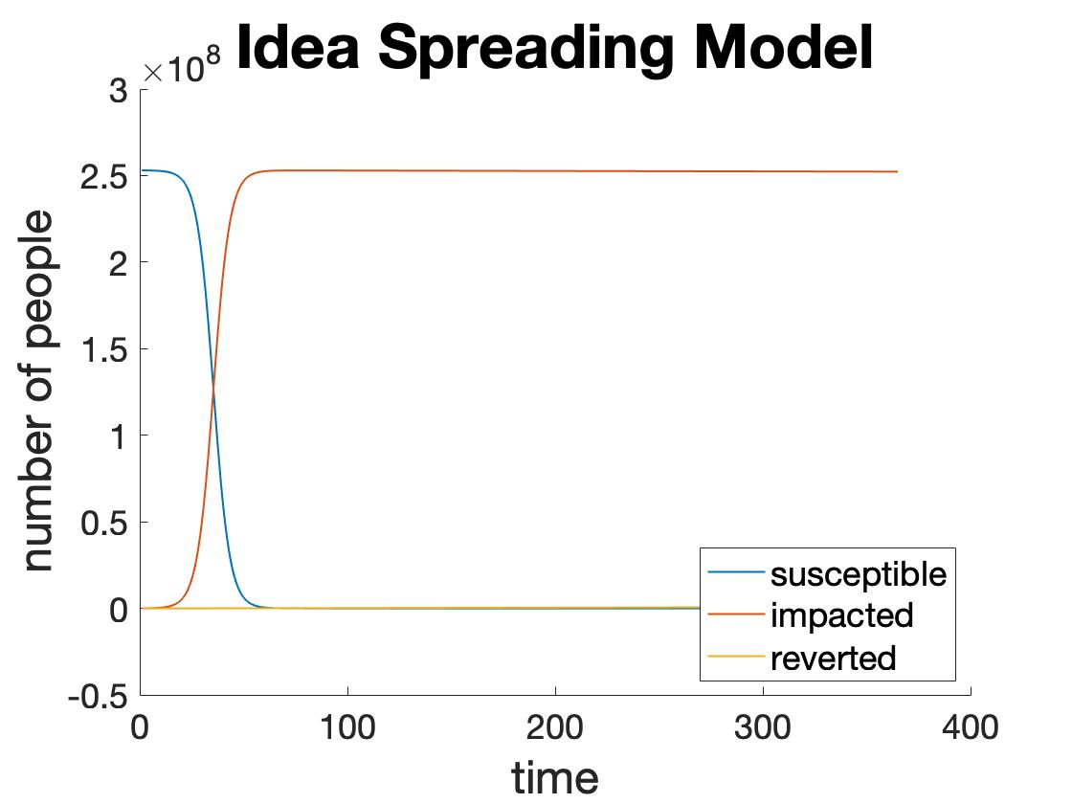
Figure 10: Graphical Representation of Adapted SIR Model to Idea Spread
This figure shows the spread of an idea starting with the employees at fine dining restaurants and the group of diners at these restaurants over a year. With the limited, heavily assumed set of data, there is an indicated spread of ideas within the population. While this application is highly inaccurate due to these assumptions, it does show that it is possible to track this idea spread with an adapted SIR model. This takes into account the number of diners added to the impacted group each night. However, since this group is relatively small, at around 110 people per day, compared to the entire population, the effect is minimal compared to the spread in society. This suggests that the real impact of such restaurants is indirect, with diners spreading ideas to others who are not able to dine at these restaurants. More accurate data would be needed to draw further, more definitive conclusions about idea spreading from fine dining restaurants.

Section 7: Conclusions
There are many restaurants and individuals in the food industry working towards a more sustainable food system. Here, I evaluated those in the high-end of fine dining and the impact they have on individuals they interact with as well as those indirectly impacted. The design of the meal and overall experience of these restaurants is a critical component of relaying ideas to diners over the course of a meal. This aspect of fine dining was covered in the first main section, focusing on design of individual dishes and their message to diners. The greater spread of the overall message about food system sustainability that these restaurants are working to promote can then be mapped using an adapted SIR model. While robustly modelling this requires more accurate sources of data about the populations interacting with these restaurants, it is possible to use this model for this issue. Further study and access to data would be needed to achieve this.
Ultimately, the work of these restaurants will join the efforts of others in the environmental and food system sustainability spheres to actually change American food culture and our food system. Decreases in meat consumption, more seasonal produce selection at grocery stores, and sourcing of local ingredients will all be factors indicating that these efforts have been successful. However, this will take time, as there is so much working against these efforts at present. Years of history and cultural adoption of certain types of foods inform what Americans, and people around the world, eat. Changing this behavior is not easy but must be accomplished to steer our food system towards a more sustainable path.

Appendix

1: Thesis Manifesto: Food System Sustainability Through the Lens of Fine Dining
With my thesis, I am hoping to analyze an aspect of fine dining. Specifically, I want to focus on how fine dining restaurants through the narrative established over the course of a meal and through their presence on social media and broader platforms demonstrate to diners and others the importance of sustainability, seasonality, and locality to the future of our food system. I then want to create some visual representation that adds to this conversation about the importance of sustainability.
The greater problem involved with my project is the effectiveness of fine dining restaurants in impacting the broader narrative around sustainability and the future of our food system, using both their direct interactions with diners and their more indirect connections with the broader public. In this context, sustainability is the twofold. First, there is what restaurants are doing specifically to cut down on waste, source locally and seasonally, and focus on ingredients that have less of an environmental impact to grow, harvest, and process. Then there is what these institutions are doing to add to the narrative surrounding sustainability and the need to make changes to our current food system to ensure its longevity and effectiveness for future generations.
My audience for this would primarily be those who run or work at high-end dining establishments and secondarily be those who follow the food and dining industry. Therefore, my hope would be that my thesis would aid fine dining restaurants in effectively relaying their story around sustainability to be able to leave diners and followers with more information and a greater curiosity about sustainability and the future of the food system.
I compiled data from various sources to present some numerical indicator of sustainability and related aspects read from the four dishes I diagrammed. I hope the design interpretation for this presentation focusing on regionality, sourcing, seasonality, and/or other factors succeeds in highlighting the goal of these restaurants, specifically the need for a shift in our food system’s practices.

2: Project “Menu”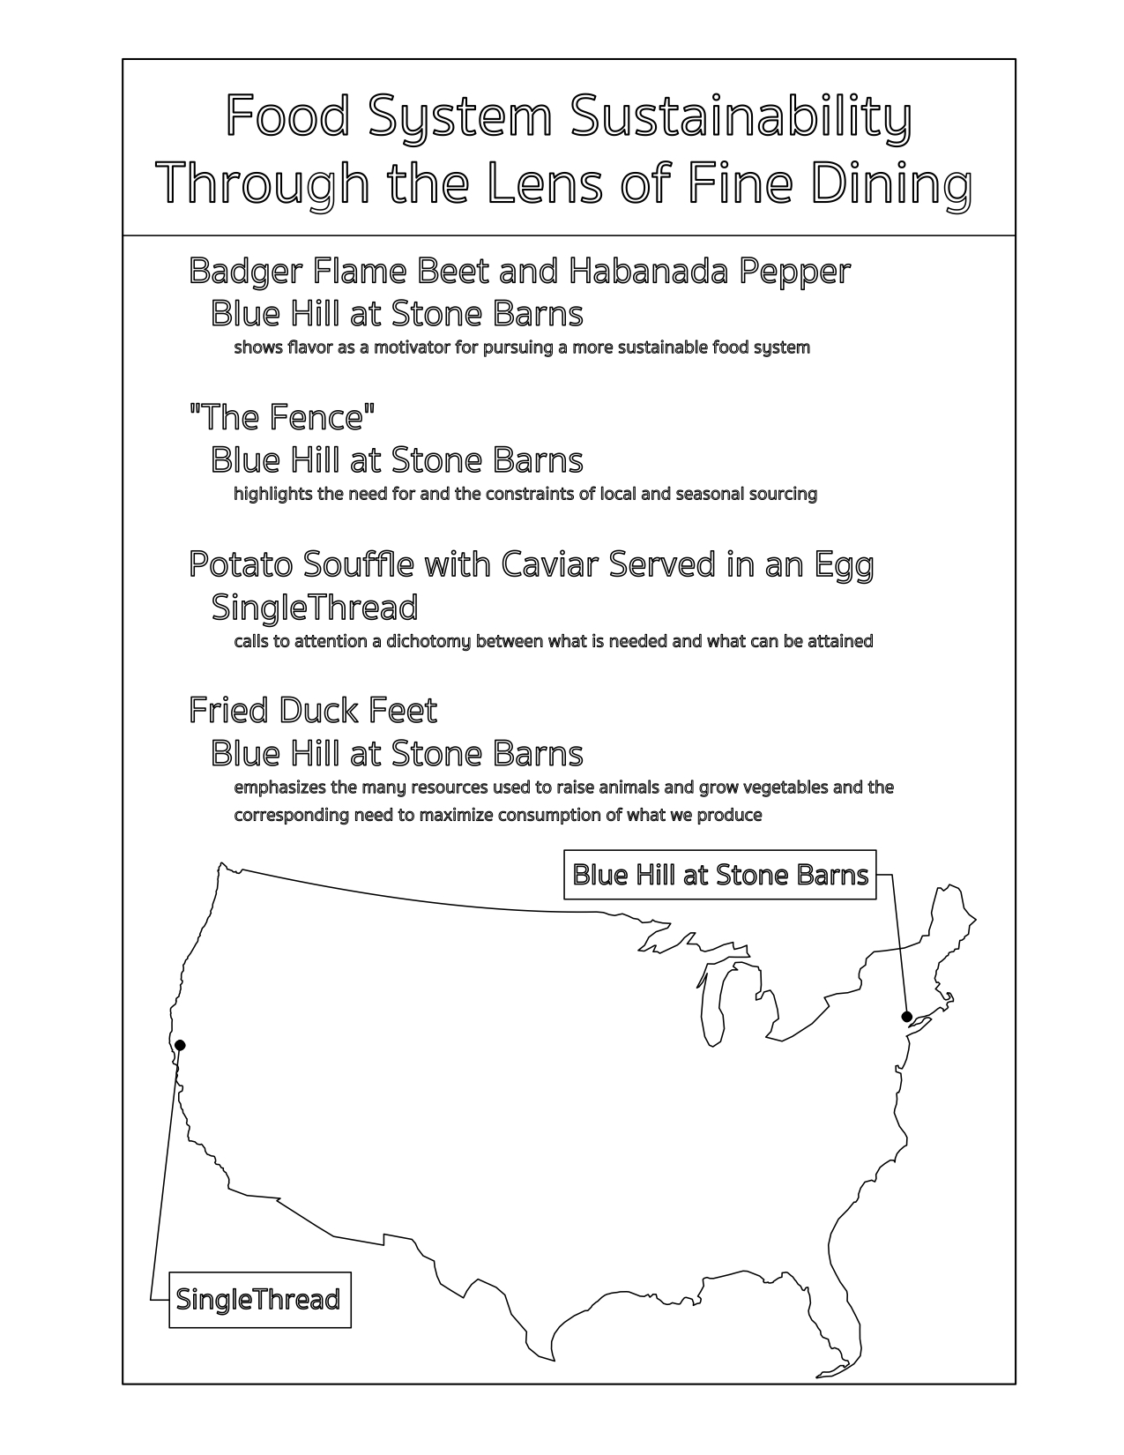

3: Printed Display of Diagrams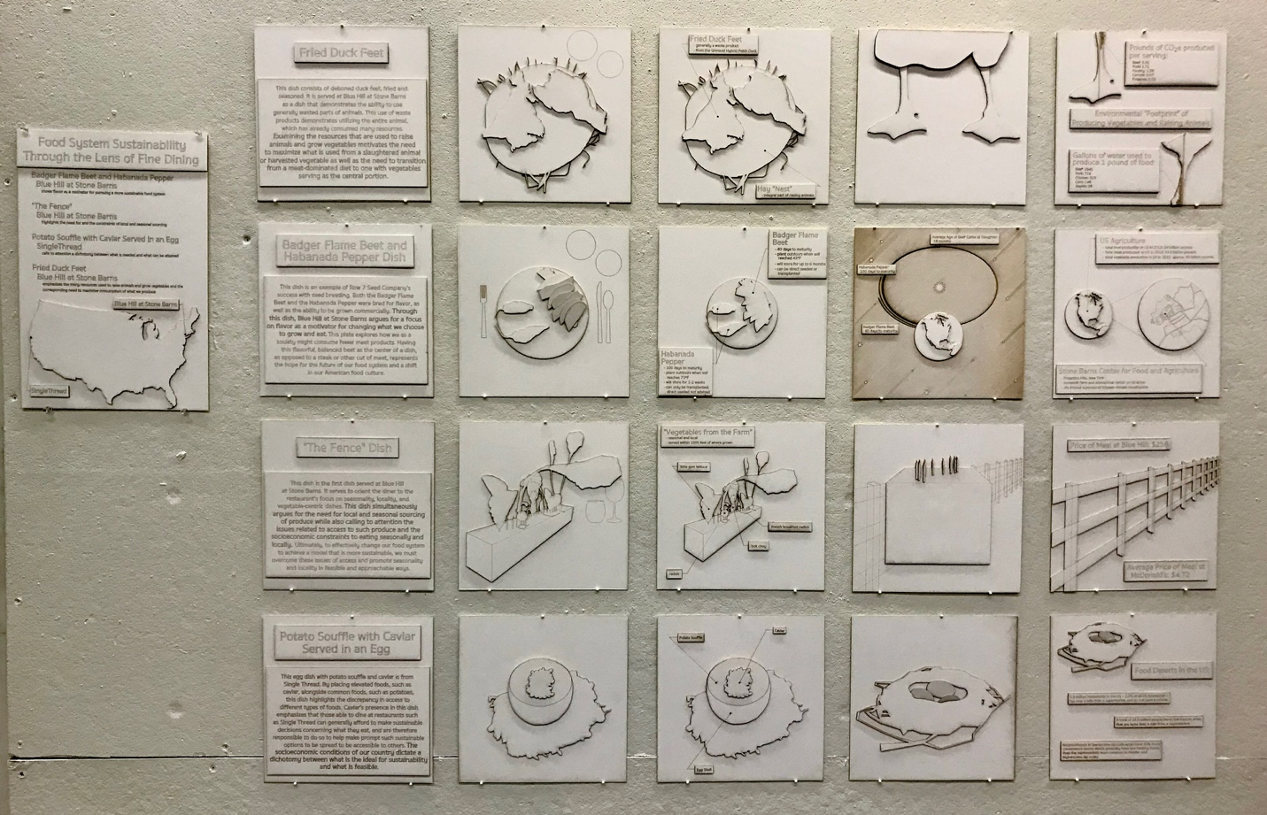

4.A: Habanada Pepper and Badger Flame Beet Dish Summary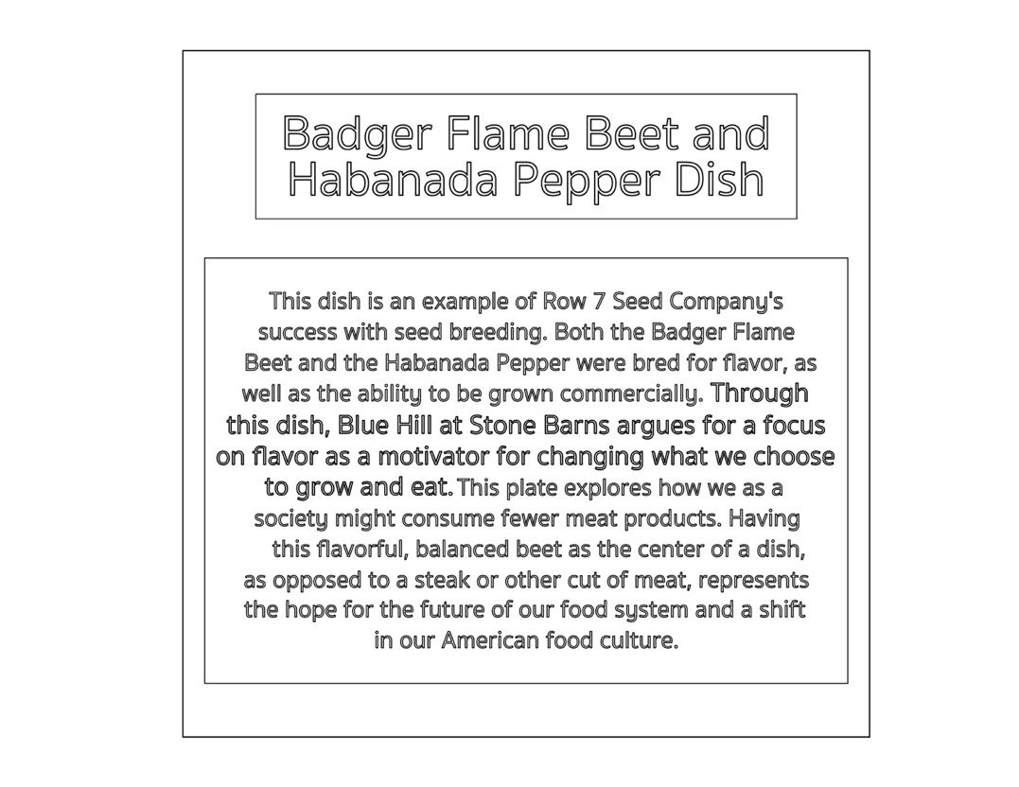
4.B: Habanada Pepper and Badger Flame Beet Dish; Blue Hill at Stone Barns
4.C: Habanada Pepper and Badger Flame Beet Dish Analysis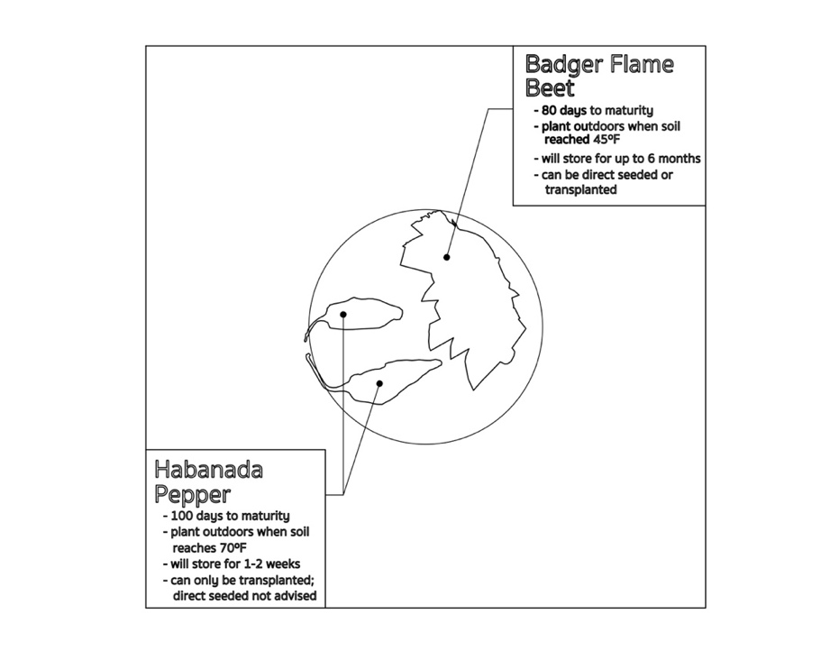
4.D: Habanada Pepper and Badger Flame Beet Dish Extrapolation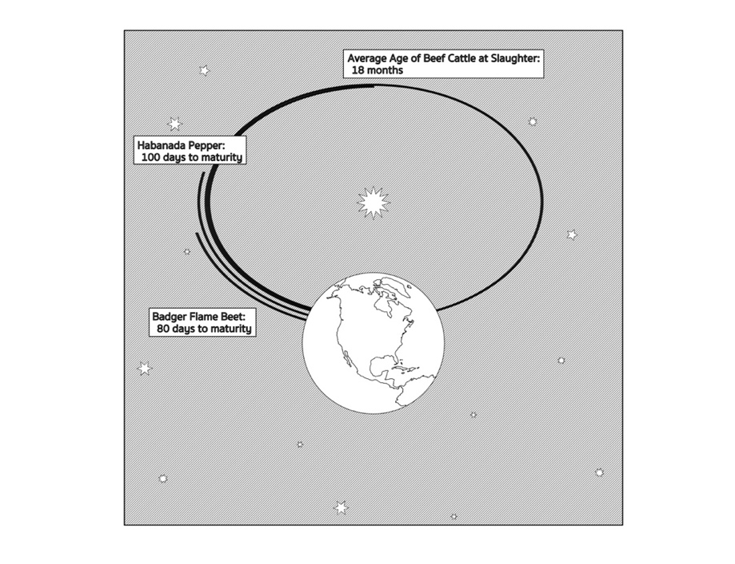
In translating the dish to tie into the greater argument about food system sustainability, the regions on the original plate grew to represent the regionality of our food system and the differences in growing and producing different foods. The representation in 4.D shows visually the time required to grow or raise the Habanada Pepper and Badger Flame Beet as well as the average age of cattle at slaughter. This juxtaposition, while comparing vegetables with meat, follows the difference in environmental impact between these different food options.
4.E: Food System Connection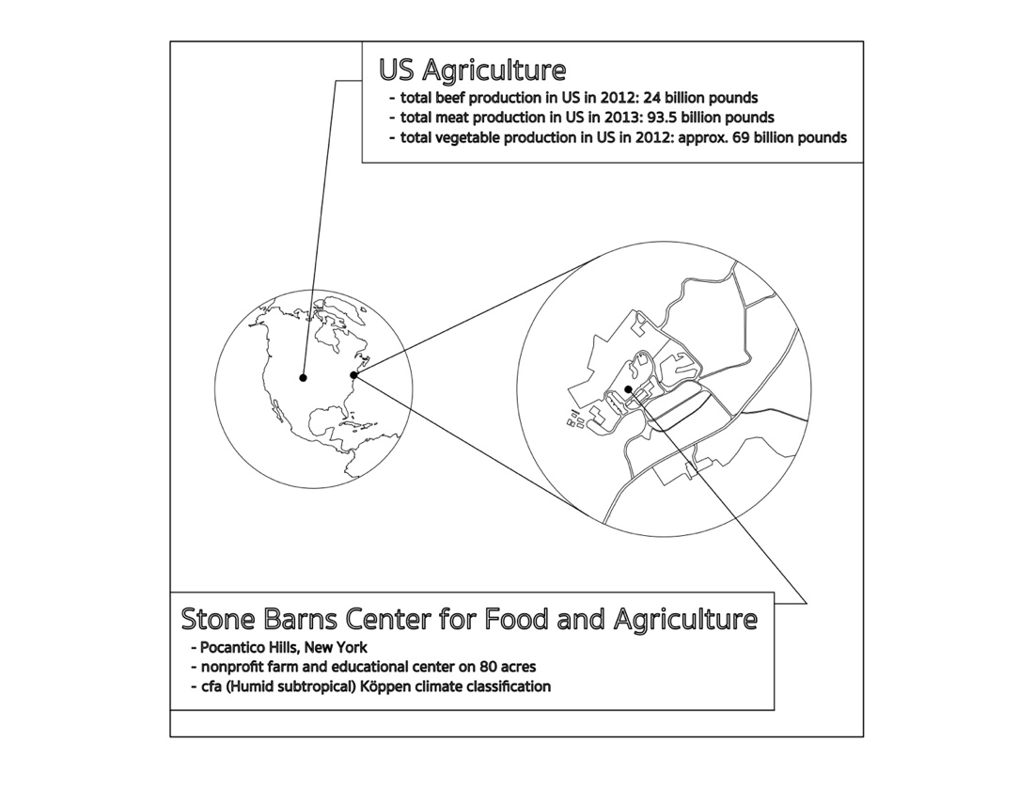

5.A: “The Fence” Dish Summary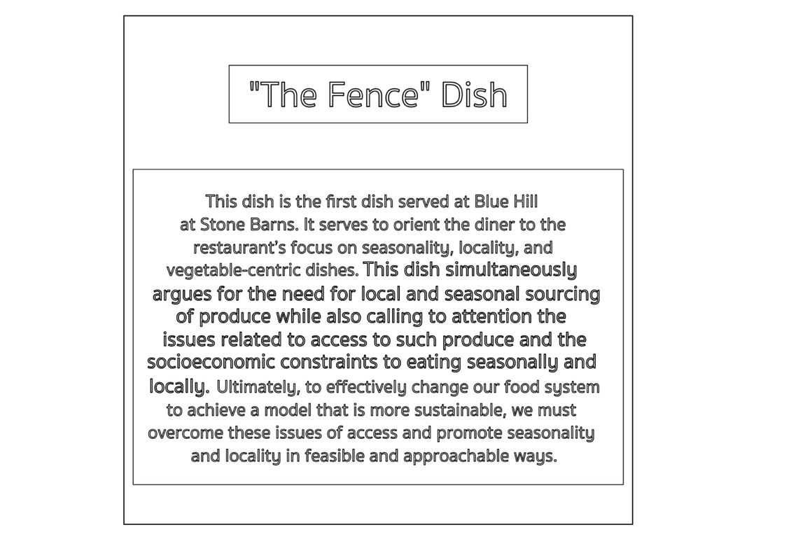
5.B: “The Fence” Dish; Blue Hill at Stone Barns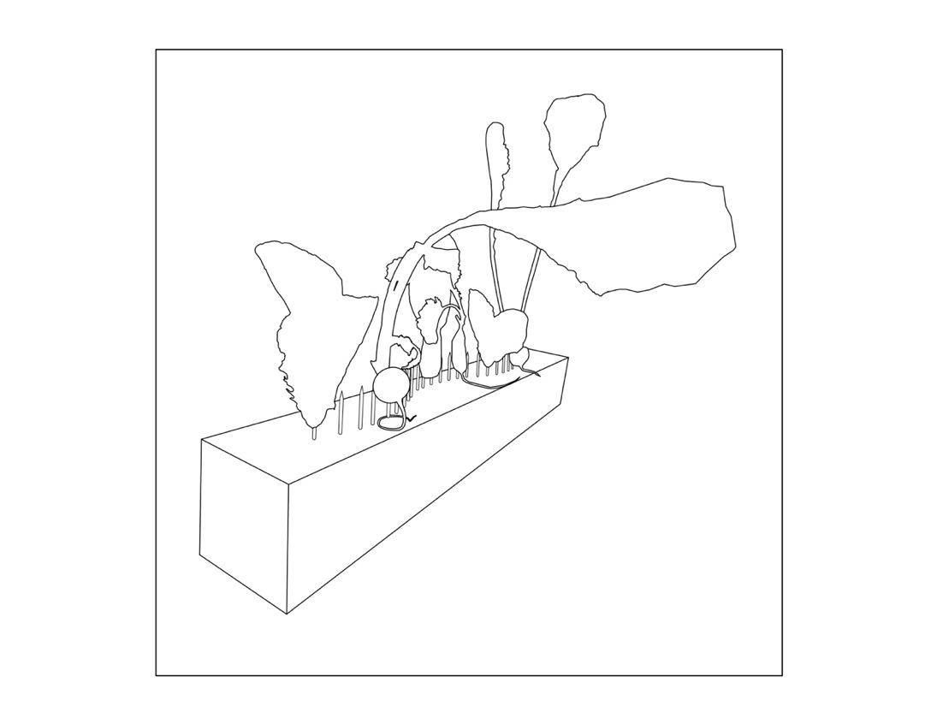
5.C: “The Fence” Dish Analysis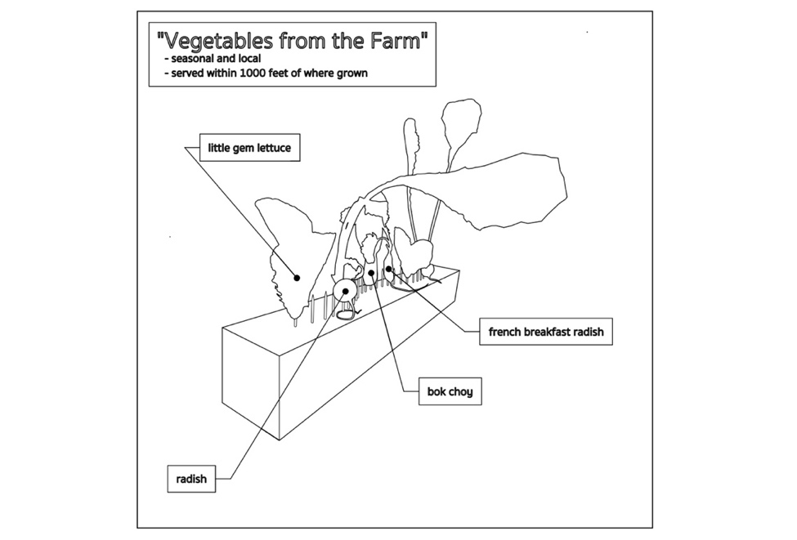
5.D: “The Fence” Dish Extrapolation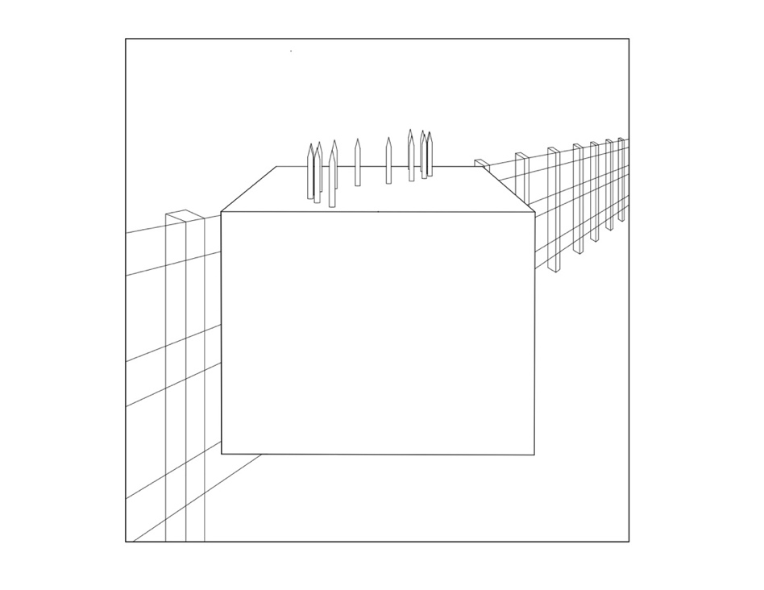
This dish, being named “The Fence,” calls to mind a fence. In superimposing the block of wood with nails used in serving the dish with an actual fence, this connection is highlighted. The physical fence association is both negative and positive. On one hand, the fence calls to mind a divider that separates groups of people in harmful ways or does not allow certain types of people to access certain foods. On the other hand, there is an idyllic view of small farms in America with nice wooden fences dividing the farm animals from the vegetable patch. While this does not describe the large American farms, it does create a positive view due to our history and views about rural America.
5.E: Food System Connection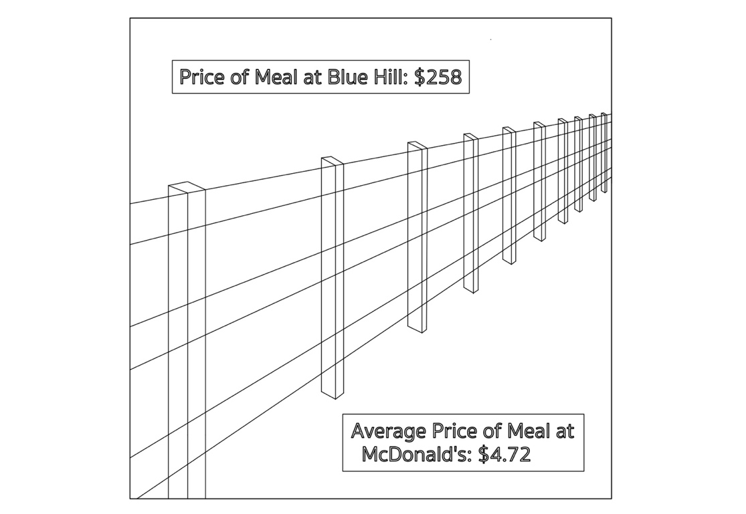

6.A: Fried Duck Feet Dish Summary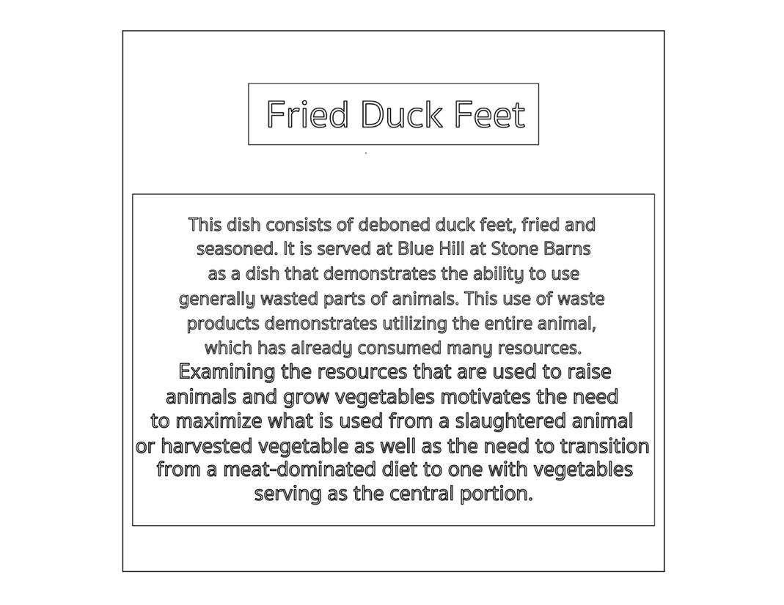
6.B: Fried Duck Feet Dish; Blue Hill at Stone Barns
6.C: Fried Duck Feet Dish Analysis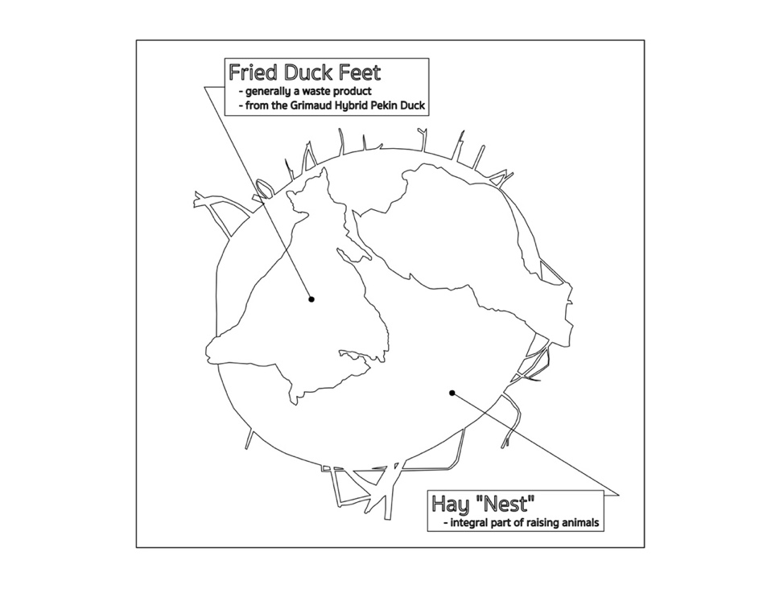
6.D: Fried Duck Feet Dish Extrapolation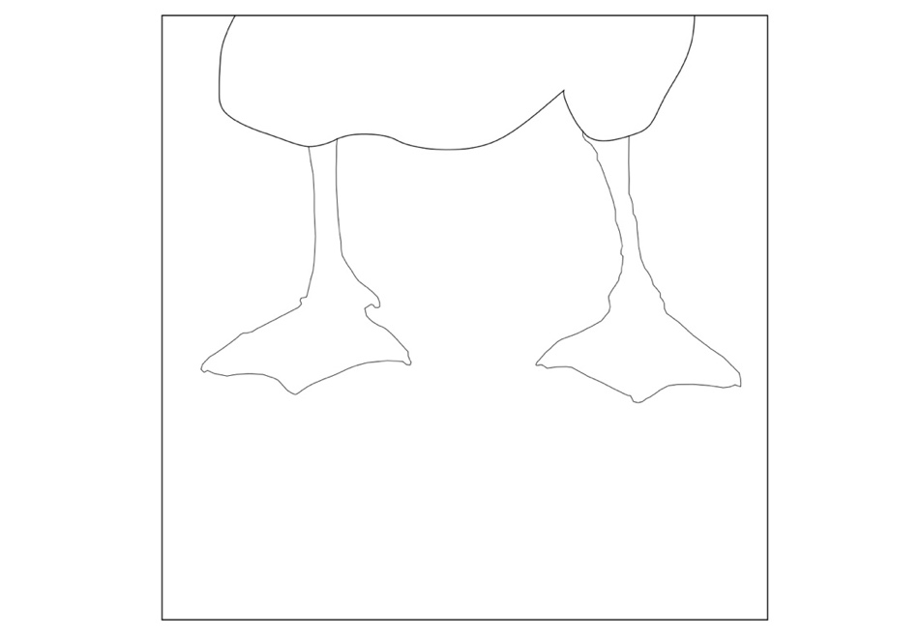
The extrapolation of this dish drew on the duck feet, as a traditionally wasted part of duck, being served as the main element of this dish and the connection with a footprint. This dish’s commentary on our need to minimize waste in the food industry and switch away from heavy meat diets to vegetable and fruit focused diets parallels the environmental footprint of these different foods, with vegetables and fruits having a lower environmental footprint and meats having a higher environmental footprint.
6.E: Food System Connection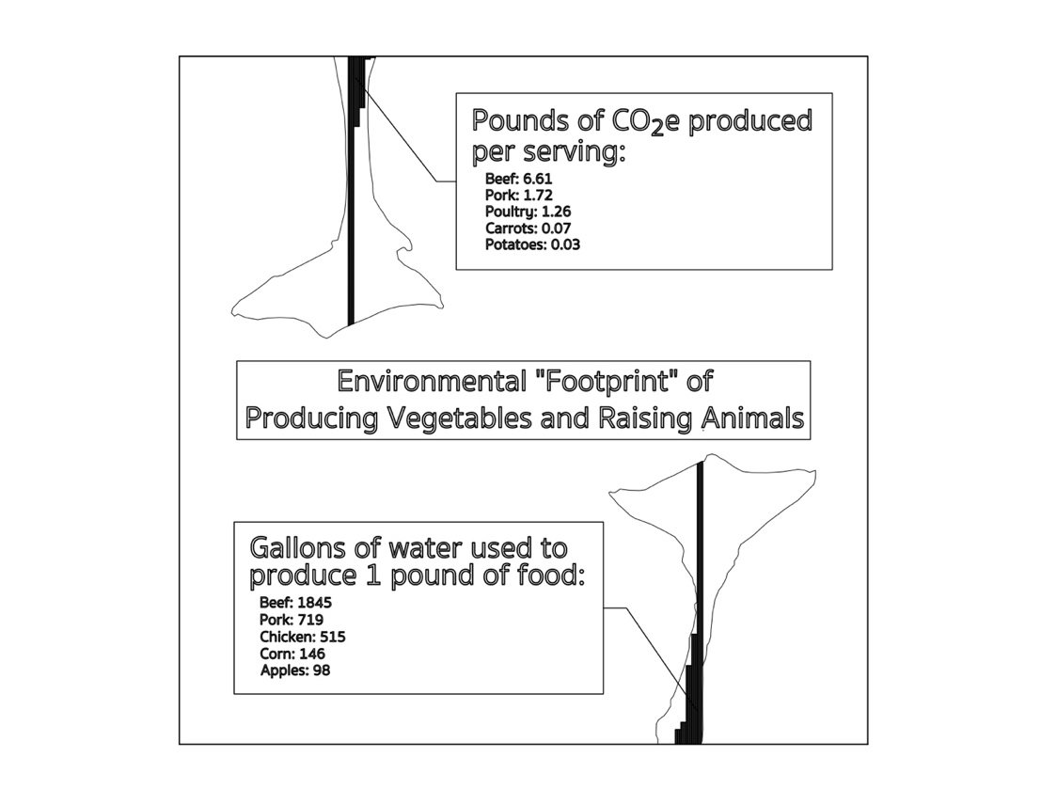

7.A: Potato Soufflé with Caviar Served in an Egg Dish Summary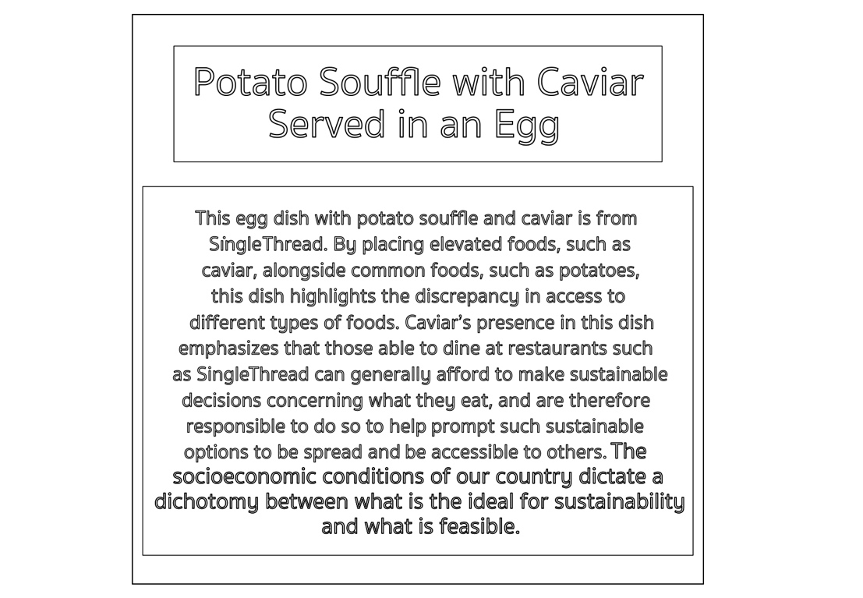
7.B: Potato Soufflé with Caviar Served in an Egg Dish; SingleThread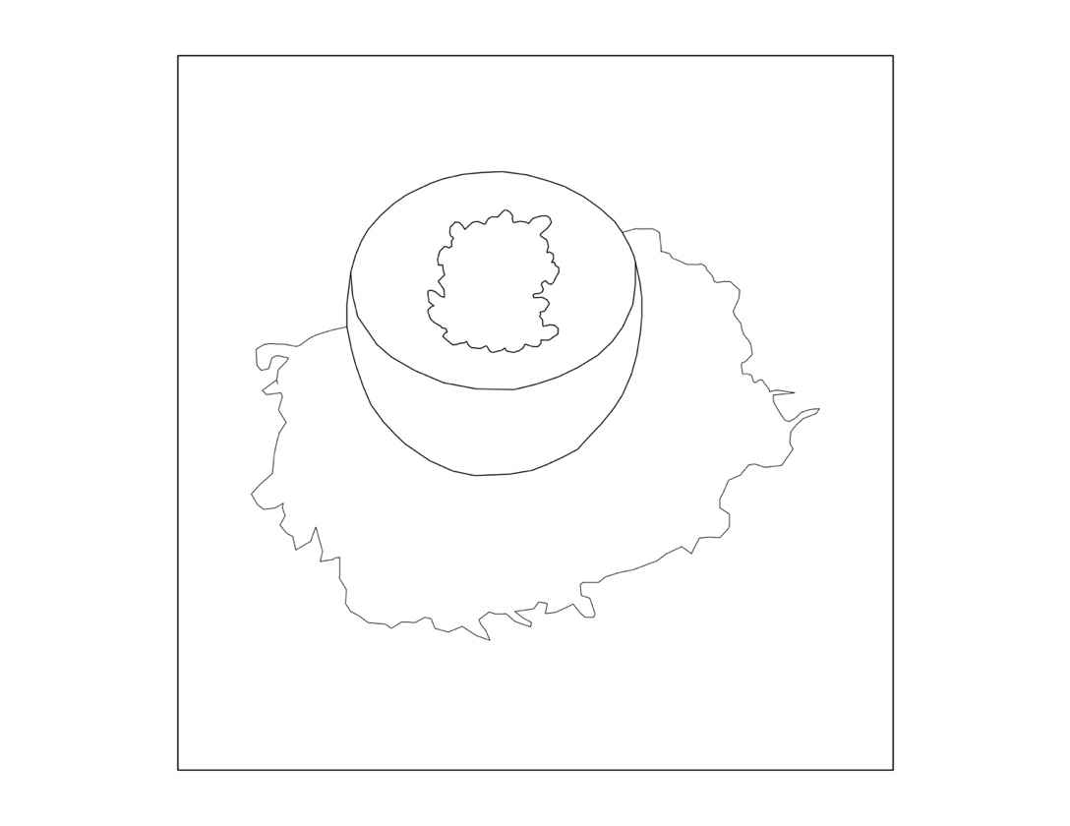
7.C: Potato Soufflé with Caviar Served in an Egg Dish Analysis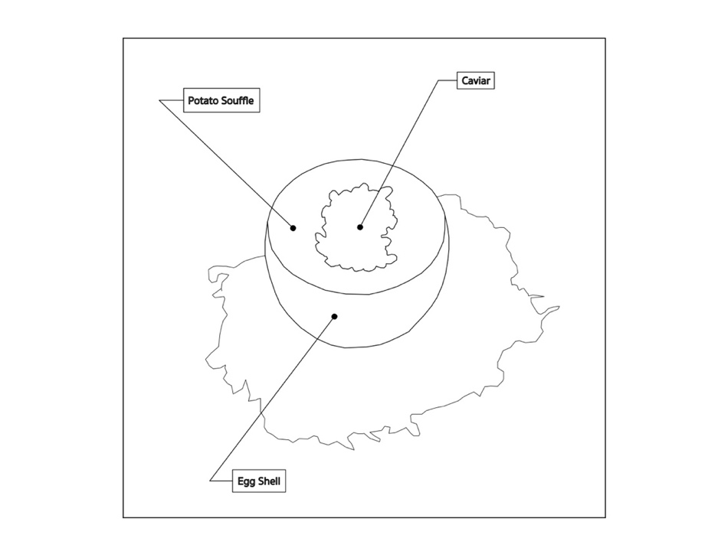
7.D: Potato Soufflé with Caviar Served in an Egg Dish Extrapolation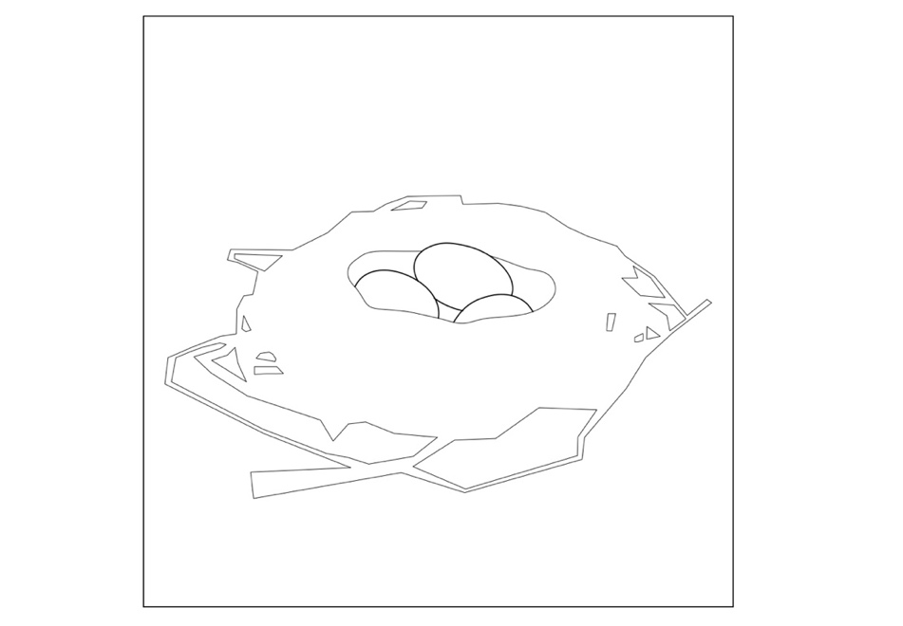
I used the reference to a nest in this dish to call to mind the homey and comforting nature of nests. There is an implicit reference to providing for young and being nurturing. However, once again, within the United States, and around the world, there are many people living in situations with lack of sufficient food and nutrients. Some of these individuals live in food desserts and do not have access to fresh produce or do not have transportation to reach fresh produce. This contrasts directly with the visual of a nest and the reference to providing for oneself and one’s family.
7.E: Food System Connection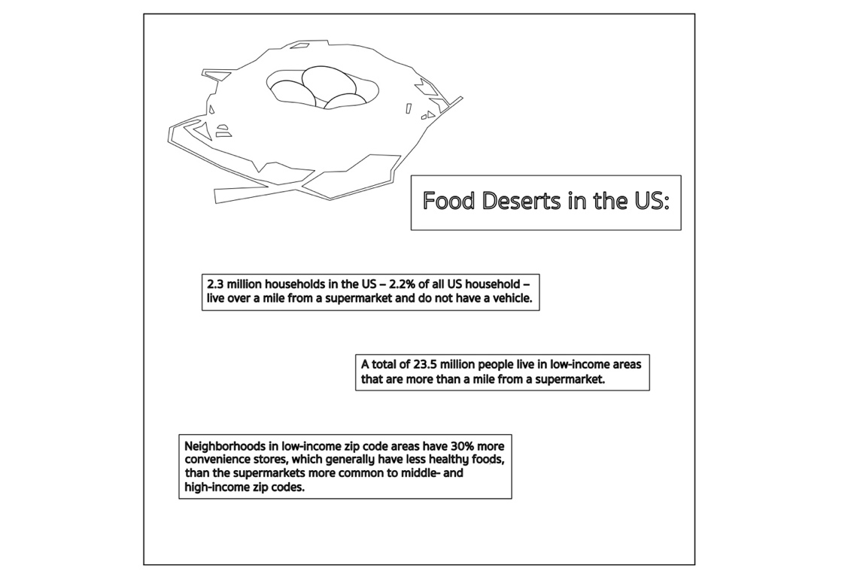

8: Fresh Nectarine Dish; SingleThread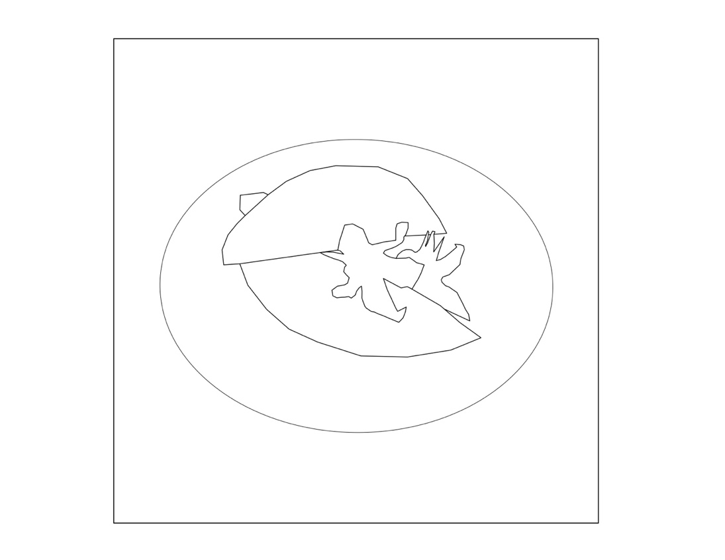

9: MATLAB Code Used for SIR Model
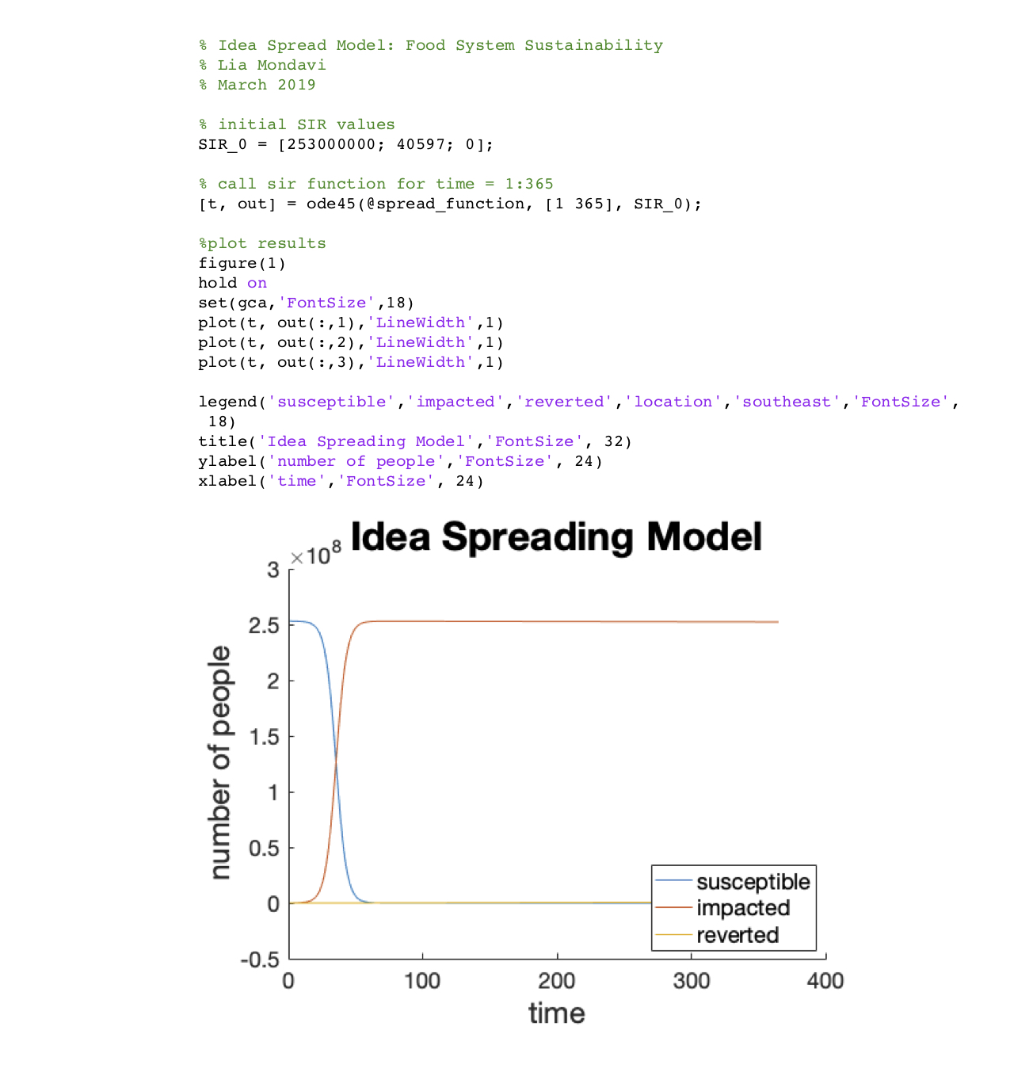



Acknowledgements
I would first like to thank my thesis advisor Megan Panzano at the Graduate School of Design at Harvard University, who continually offered guidance and helped me develop a project that was authentic to my interests. Additionally, I would like to thank Lisa Haber-Thomson at the Graduate School of Design for providing key insights at the start of this project. I would also like to thank Margo Levine in the Applied Mathematics Department at the Harvard John A. Paulson School of Engineering and Applied Sciences for encouraging me to focus on a topic that was interesting and true to myself and for being a reference for the mathematical aspects of my thesis.
I also must express gratitude to those at Blue Hill at Stone Barns, especially Irene Hamburger and Dan Barber, for an incredible summer internship. Without the insights gained from that experience, I would have struggled to approach this topic.
Finally, I must acknowledge the role of family and friends in endlessly encouraging me throughout my time working on this project and throughout my years of study. Writing this thesis would not have been possible without the support of my parents, Peter Mondavi and Katie Williams, and my brother, Lucio Mondavi. Additionally, my parents and brother were and are a large part of the reason I am so interested in food, the food system, and dining establishments. Thank you for sparking this curiosity in me. Finally, I must thank my dear friends who kept me sane and happy during this process.

Alyse Whitney, “Honeynut Is a Tiny Squash with a Big History,” Bon Appetit, accessed February 9, 2019, https://www.bonappetit.com/story/honeynut-squash-history.
Whitney.
“3 Stars Michelin – the Michelin Guide,” Michelin Guide, n.d., accessed March 10, 2019; “The Worlds 50 Best Restaurants,” The World’s 50 Best Restaurants, n.d., accessed March 10, 2019.
“3 Stars Michelin – the Michelin Guide”; “The Worlds 50 Best Restaurants.”
“SingleThread Farms » Restaurant,” n.d., accessed March 10, 2019.
Hillary Dixler Canavan, “Single Thread Is the Biggest Opening of 2016,” Eater, November 30, 2015.
“Row 7 Seed Company,” Row 7 Seed Company, n.d., accessed February 16, 2019.
“Habanada Pepper,” Row 7 Seed Company, n.d., accessed February 16, 2019.
“Badger Flame Beet,” Row 7 Seed Company, n.d., accessed February 16, 2019.
Dan Barber, The Third Plate: Field Notes on the Future of Food (New York, NY: Penguin Books, 2015).
Ashley Lutz, “Cost to Eat at Every Major Fast Food Chain,” Business Insider, September 4, 2015; “Dine at Blue Hill Stone Barns | Blue Hill Farm,” n.d., accessed March 9, 2019.
Michele Ver Ploeg et al., “Access to Affordable and Nutritious Food: Measuring and Understanding Food Deserts and Their Consequences,” June 2009, 38.
“Stone Barns Center,” Stone Barns Center, n.d., accessed March 13, 2019; “Dine at Blue Hill Stone Barns | Blue Hill Farm.”
“SingleThread Farms » Restaurant”; “SingleThread Farms » Farm,” n.d., accessed March 12, 2019.
Benjamin R. Chisholm et al., “A Competing Infection Model for the Spread of Different Viewpoints of a Divisive Idea,” The Journal of Mathematical Sociology 0, no. 0 (December 30, 2018): 1–17; Gabrielle Filip-Crawford and Steven L. Neuberg, “Homosexuality and Pro-Gay Ideology as Pathogens? Implications of a Disease-Spread Lay Model for Understanding Anti-Gay Behaviors,” Personality and Social Psychology Review 20, no. 4 (November 2016): 332–64; Ching-Shan Chou and Avner Friedman, Introduction to Mathematical Biology: Modelikng, Analysis, and Simulations (New York, NY: Springer Science+Business Media, 2016); Luís M. A. Bettencourt et al., “The Power of a Good Idea: Quantitative Modeling of the Spread of Ideas from Epidemiological Models,” Physica A: Statistical Mechanics and Its Applications 364 (May 15, 2006): 513–36; “The SIR Model for Spread of Disease - The Differential Equation Model,” Mathematical Association of America, n.d., accessed March 11, 2019.
Chou and Friedman, Introduction to Mathematical Biology: Modelikng, Analysis, and Simulations; Henri Schurz and Kursad Tosun, “Stochastic Asymptotic Stability of SIR Model with Variable Diffusion Rates,” Journal of Dynamics and Differential Equations 27, no. 1 (March 2015): 69–82.
Filip-Crawford and Neuberg, “Homosexuality and Pro-Gay Ideology as Pathogens?”; Bettencourt et al., “The Power of a Good Idea.”
“The SIR Model for Spread of Disease - The Differential Equation Model.”
Chou and Friedman, Introduction to Mathematical Biology: Modelikng, Analysis, and Simulations.
W. O. Kermack and A. G. McKendrick, “A Contribution to the Mathematical Theory of Epidemics,” Proceedings of the Royal Society A: Mathematical, Physical and Engineering Sciences 115, no. 772 (August 1, 1927): 700–721.
Bettencourt et al., “The Power of a Good Idea,” 3.
Bettencourt et al., “The Power of a Good Idea.”
Filip-Crawford and Neuberg, “Homosexuality and Pro-Gay Ideology as Pathogens?”
Filip-Crawford and Neuberg.
Filip-Crawford and Neuberg.
Filip-Crawford and Neuberg.
“Alinea,” Alinea, n.d., accessed March 24, 2019; “Welcome to Eleven Madison Park,” Eleven Madison Park, n.d., accessed March 24, 2019; “Estela,” Estela l New York Restaurant, n.d., accessed March 24, 2019; “Le Bernardin by Eric Ripert | About,” Le Bernardin by Eric Ripert, n.d., accessed March 24, 2019; “About – Le Coucou,” Le Coucou, n.d., accessed March 24, 2019.
“Benu Menu,” Benu, n.d., accessed March 24, 2019; “Coi Restaurant Menu,” Coi Restaurant, n.d., accessed March 24, 2019; “Saison Information,” Saison, n.d., accessed March 24, 2019; “Chef’s Table at Brooklyn Fare: About,” Chef’s Table at Brooklyn Fare, n.d., accessed March 24, 2019; “Cosme: About,” Cosme, n.d., accessed March 24, 2019; “Masa Is Shibui,” Masa, n.d., accessed March 24, 2019; “About Ko,” Momofuku Ko, n.d., accessed March 24, 2019.
“Quince: Our Farm,” Quince Restaurant, n.d., accessed March 24, 2019; “Farmers & Foragers | Thomas Keller Restaurant Group,” The French Laundry, n.d., accessed March 24, 2019; “Our Menu,” Manresa: David Kinch, n.d., accessed March 24, 2019; “Farmers & Foragers | Thomas Keller Restaurant Group,” Per Se, n.d., accessed March 24, 2019.
“Farm,” The Restaurant at Meadowood, n.d., accessed March 24, 2019; “SingleThread Farms » Farm”; “Dine at Blue Hill Stone Barns | Blue Hill Farm.”
“The SIR Model for Spread of Disease - Relating Model Parameters to Data,” Mathematical Association of America, n.d., accessed March 11, 2019.
“U.S. Census Bureau QuickFacts: United States,” United States Census Bureau, n.d., accessed March 24, 2019.
“U.S. Census Bureau QuickFacts.”
“The SIR Model for Spread of Disease - Relating Model Parameters to Data.”
“Dine at Blue Hill Stone Barns | Blue Hill Farm”; “SingleThread Farms » Restaurant.”
“Row 7 Seed Company”; “Dine at Blue Hill Stone Barns | Blue Hill Farm.”
“Dine at Blue Hill Stone Barns | Blue Hill Farm.”
“Row 7 Seed Company,” 7; “Dine at Blue Hill Stone Barns | Blue Hill Farm.”
“Row 7 Seed Company,” 7; “Age of Animals Slaughtered,” Aussie Abattoirs, n.d., accessed March 13, 2019.
“Stone Barns Center”; “The United States Meat Industry at a Glance,” North American Meat Institute, 2017; “Census of Agriculture,” United States Department of Agriculture National Agricultural Statistics Service, 2018.
“Dine at Blue Hill Stone Barns | Blue Hill Farm.”
“Dine at Blue Hill Stone Barns | Blue Hill Farm.”
“Stone Barns Center”; “Dine at Blue Hill Stone Barns | Blue Hill Farm.”
“Dine at Blue Hill Stone Barns | Blue Hill Farm.”
“Dine at Blue Hill Stone Barns | Blue Hill Farm”; Lutz, “Cost to Eat at Every Major Fast Food Chain.”
“Dine at Blue Hill Stone Barns | Blue Hill Farm”; “Stone Barns Center.”
“Dine at Blue Hill Stone Barns | Blue Hill Farm.”
“Dine at Blue Hill Stone Barns | Blue Hill Farm.”
“The Water We Eat,” The Water We Eat, n.d., accessed March 13, 2019; “Food’s Big Water Footprint,” Water Footprint Calculator, July 1, 2017; “Carbon Footprint Factsheet,” Center for Sustainable Systems, University of Michigan, 2018.
“SingleThread Farms » Restaurant”; “SingleThread Farms » Farm.”
“SingleThread Farms » Restaurant.”
“SingleThread Farms » Restaurant.”
Ploeg et al., “Access to Affordable and Nutritious Food: Measuring and Understanding Food Deserts and Their Consequences”; “Food Desert Statistics” (Teaching Tolerance, n.d.), accessed March 10, 2019.
“SingleThread Farms » Restaurant.”

