The Impact of African-American Musicianship on South Korean Popular Music: Adoption, Appropriation, Hybridization, Integration, or Other?

Hyniea (Niea) Gardner

A Thesis in the Field of Anthropology and Archaeology
for the Degree of Master of Liberal Arts in Extension Studies

Harvard University
May 2019

© May 2019 Hyniea (Niea) Gardner

Abstract
In 2016 the Korea Creative Content Agency (KOCCA) reported that the Korean music industry saw an overseas revenue of ₩5.3 trillion ($4.7 billion) in concert tickets, streaming music, compact discs (CDs), and related services and merchandise such as fan meetings and purchases of music artist apparel and accessories (Kim 2017 and Erudite Risk Business Intelligence 2017). Korean popular music (K-Pop) is a billion-dollar industry. Known for its energetic beats, synchronized choreography, and a sound that can be an amalgamation of electronica, blues, hip-hop, rock, and R&B all mixed together to create something that fans argue is “uniquely K-Pop.” However, further examination reveals that producers and songwriters – both Korean and the American and European specialists contracted by agencies – tend to base the foundation of the K-Pop sound in hip-hop and R&B, which has strong ties to African-American musical traditions.
This thesis explores the degree in which African-American music has influenced South Korean popular music; specifically, Korean R&B and hip-hop. It studies South Korean artists and their adoption, appropriation, and/or “genre incorporation” of traditionally and/or nominally identified aspects of colloquially termed and grouped “Black music” into their own musical styles. The term Black music is inclusive of sounds attributed to African-American artists as well as artists from across the African Diaspora.
As art forms, music, especially hip-hop and R&B are “‘vehicle[s] for global youth affiliation and tool[s] for reworking local identity all over the world’; and, as universally recognized popular genre[s], also draw our attention to local specificities” (Um 2013: 52). When South Korean artists incorporate musical genres with roots and traditional or universal recognition as being part of another culture’s art form, questions of the Korean artist’s authenticity within the genre may arise, as well as if these artists give proper attribution. This thesis investigates the sources of inspiration of Korean music practitioners, defined as (but not limited to) artists, writers, choreographers, producers, etc. as well as the awareness of the general public (i.e. Korean community) of the cultural roots and implications of Korean hip-hop and R&B. It explores whether the Korean music industry is building collective communities in hip-hop and R&B cultures or if these genres are primarily being commodified for financial gain.
The overall conclusion of this research is that both of the above are true: segments of the Korean music industry are building collective communities within hip-hop and R&B, while the bulk of the industry appropriates Black hip-hop and R&B culture for profit. Some artists, producers, fans, etc. do their due diligence in learning about the history of these music forms within the U.S. and aim to create music that is a fusion of Korean and African-American sounds that is respectful of Black culture while also highlighting the “Koreanness” of these genres. Such efforts exemplify the idea of cultural hybridization, understood to have “a cultural focus and emphasize cultural interplay where ‘traces of other cultures exist in every culture’ [and the idea of culture is linked to] ‘the mobilization of group identities’ allowing for a wide range of identity conceptions” (Hare and Baker 2017: 2-3).
Conversely, a vast majority continue to remain heavily dependent on what I have termed Black constructs of genres – how African-American artists have cultivated and exemplified hip-hop and R&B – which impacts the claims of originality, integration, and creation of a “local, traditional [music] culture” (Jin 2016: 130) made by Korean artists. By relying on these constructs, the effectiveness of showing the “Koreanness” of the hip-hop and R&B performed is diluted and incidents of appropriation – willful or accidental – and the exemplification of racial stereotypes of the Black community and Black culture continue. There are several avenues noted in this research that the Korean music industry can take to divorce itself of this over-dependence and to have greater agency over the style, sound, and development of its music that is culturally appreciative, respectful, and truly – “uniquely K-Pop.”

Dedication
This thesis is for all of the music lovers. Poet Maya Angelou once said “music was my refuge. I could crawl into the space between the notes and curl my back to loneliness.” Music plays many roles in our lives and has been both a solace and sanctuary for me, personally. The opportunity to explore varieties of music that I have loved since a child and the questions, conflicts, and intersectionality with a culture and medium that I have learned to love as an adult was an academic panacea; like a balm to my soul. I was inspired to examine different, yet similar styles of genres that I enjoy. Perhaps, after reading this, you may be inspired too.
This thesis is dedicated to all of the music lovers.

Acknowledgements
To Philippe Miguel, for starting me on my K-Pop journey: Your affection and enthusiasm for all things K-Pop was irresistible. Thank you for opening the door to a new culture of music (television and film) for me to explore and to fall in love with. It all started with you sending me a video link of a performance by BoA and saying that I needed to watch her because: “She’s my all-time favorite artist. She’s my Beyoncé.” I appreciate you and I love you dearly baby brother.
To my nieces Monica, CiAiris, and Dahlia, and to my nephew Max, whose birth dates provided the numbers used to randomly select artist discographies to analyze: It was serendipitous that your birth months and days numerically worked out to number two (2) through nine (9), smile. Auntie/Tía loves you all!
To my good friend and fellow hip-hop and R&B aficionado Kamanaokakuhihewa Seymour: Your input was invaluable. Thank you for lending your time and your ear towards identifying songs within genres that we both love.
To my thesis research advisor Dr. Donald Ostrowski: Thank you for your continuous encouragement in refining my topic. It took a few iterations and ideas, but your inquiries and clarifications prodded me in the right direction.
To my thesis director Dr. Katy Leonard: Your support and encouragement throughout this writing has been inestimable. You trusted me and my “vision” for this entire process and that means the world to me.
Finally, to everyone who supported me in various stages of this thesis, who shared my enthusiasm, and asked interested questions: You are too numerous to name, but I fed
off of all of your fascinated energy and support. You gave me that extra push when I had researcher’s frustration and/or writer’s block. Thank you.

Table of Contents
Dedication vi
Acknowledgements vii
Table of Contents ix
List of Tables xi
List of Figures xii
Chapter I Introduction 1
Chapter II A Brief History: The Origins of Korean Popular Music 9
Chapter III The Impact of Hallyu on Korean Popular Music 13
Chapter IV South Korea Is Introduced to Hip-Hop and R&B 16
Chapter V Hip-Hop and R&B in Korean Popular Music: Offset of Globalization and Cultural Hybridization? 26
Chapter VI Understanding of Hip-Hop and R&B by the Korean Community 32
Chapter VII Commercial and Consumer Power of Korean Popular Music 43
Chapter VIII Performance Review, Part I: Album Review (Random Sampling) 49
Album Review 57
Chapter IX Performance Review, Part II: Selected Singles and Artist Interviews (Random Sampling) 80
Selected Singles: Music Videos 83
Artist Interviews 95
Review Limitations 109
Performance Review Conclusions 112
Chapter X Solo Singer “Bright Spots”: BoA and Rain 117
Kwon Boa 119
Rain 123
Chapter XI Performance Group “Bright Spots”: BIGBANG and 2NE1 131
BIGBANG 132
2NE1 138
Chapter XII Defining, Applying, and Observing Authenticity in Korean Music 146
Defining “Authenticity” as it relates to Korean Hip-Hop and R&B 147
Applying Authenticity to Korean Hip-Hop and R&B 153
Observing Authenticity in Korean Hip-Hop and R&B 157
Chapter XIII Looking Ahead: R&B and Hip-Hop’s Future Representation in the Mainstream Media 166
Reality Television and the Further Economics of K-Pop 170
Underground Artists’ Movement into the Mainstream 174
The Narrative Competition Shows Create Around Hip-Hop and R&B 181
The Public Faces of Hip-Hop and R&B 190
Chapter XIV Conclusion 196
Appendix 1. Table Information 206
Appendix 2. Figure Information 207
References 212

List of Tables
Table I. Black Producers/Production and Songwriting Teams that have worked with Korean Artists 27
Table II. Korean Artists Considered for Discography Review 51
Table III. Album Discography 53
Table IV. Example of Korean Artist Song Sampling 70
Table V. Selected Single Discography 81
Table VI. 2017 Revenue and Net Profit of Highest Reporting Entertainment Agencies .171

List of Figures
Figure 1. Korean singers of trot, soul music, and rock 11
Figure 2. Seo Taiji and Boys 18
Figure 3. Gummy, Sechskies, SOLID, and Soul Star 22
Figure 4. K-Pop videos with Asian cultural elements 29
Figure 5. Hip-hop inspired fashion in Seoul 36
Figure 6. Cultural appropriation in situ 40
Figure 7. Song track comparison of English use by all artists 59
Figure 8. Individual comparisons of English use by artist, per album 59
Figure 9. Use of English profanity within all albums by artist. 60
Figure 10. Big Mama vocal embellishments & gestures 66
Figure 11. By Korean artist, the number of songs that include samples 72
Figure 12. Number of identified samples within songs 72
Figure 13. Method Man’s cameo in CL’s video for “Lifted” 75
Figure 14. Album covers for Soul Free (2003) and The Wind, The Sea, The Rain (2007) by Brown Eyed Soul 76
Figure 15. Spying theme of video “Troublemaker”. 84
Figure 16. “Swag” collage (clockwise): MFBTY, Jay Park, and Jessi 87
Figure 17. Video choreography and hairstyles (clockwise): MFBTY, Se7en, BLACKPINK, and EXO 89
Figure 18. Imitation swagger by BLACKPINK and EXO 94
Figure 19. Lee Hi performance in video “My Star”. 102
Figure 20. Brown Eyed Soul in pose similar to many American R&B vocal groups 105
Figure 21. Big Mama’s appearance from 2003-2010 107
Figure 22. The ten (10) artists 114
Figure 23. BoA collage 121
Figure 24. BoA, only female judge on K-Pop Star with YG (in hat) and JYP Entertainment CEOs 123
Figure 25. Promotional posters for films Speed Racer and Ninja Assassin. 126
Figure 26. Rain performing. 129
Figure 27. BIGBANG group photos. 133
Figure 28. 2NE1 collage. 140
Figure 29. Nike “Run It” video stills and participants 156
Figure 30. Keith Ape, Crush, and Dean 178
Figure 31. KATIE 183
Figure 32. Show logos for SMTM and “K-Pop Star”. 186
Figure 33. Contestant on “Unpretty Rapstar” 188
Figure 34. Performers with artistic, appropriative, and offensive interpretations of Black culture 193

Chapter I
Introduction

“Music is the greatest communication in the world. Even if people don’t understand the language you’re singing in, they still know good music when they hear it” – Lou Rawls

Music is a universal form of communication. It is an art. It is a way that cultures and communities use to express themselves − their views, their history, their narrative − to the broader public. Music is reflective of life. It is happy, sad, whimsical, fun, and reminiscent. Personally, music plays a strong role in my life. It is always in the background when I am working or studying. It is a form of relaxation, to de-stress, and has contributed to several “soundtracks” for different periods and memories. Specifically, there are certain artists and groups for whom I can immediately recall what I was doing as their song played, whose lyrics resonated through artistic appreciation, or because I felt that what they sang or spoke about had a direct connection to my life at that time.
As expressed by singer Lou Rawls, the music one listens to does not always have to be in a language that one understands. Before strengthening my grasp of Spanish, I loved listening to songs by La India, Carlos Vives, and Celia Cruz. Though I still cannot speak or understand Hindi, I have several Bollywood music stations on my streaming services. My interest in Korean popular music (also called K-Pop) began in 2003 after being introduced to it by my younger brother. He did so by forwarding videos by his (all-time) favorite artist BoA. He was impressed by her singing and dancing ability. He described her style as a mix of Korean Pop and American rhythm and blues (R&B). Until this introduction, I had never considered that R&B made inroads into the Asian music scene. Since then, off and on, K-Pop has also contributed to the “soundtrack of my life”. For example, I listened to my BoA and BIGBANG music stations while writing this thesis.
Something that I continually noticed while listening to these artists and watching their videos were the close similarities in musical style (e.g. vocalization, riffs, beats), dance, and fashion to several African-American artists or Black artists part of the African Diaspora within the R&B and hip-hop genres. In the mid to late 2000s there seemed to be a “surge” of younger South Korean artists and groups, such as Wonder Girls, EXO, 2NE1, and Beast, within the K-Pop realm whose styles were heavily influenced by R&B and hip-hop. Every “girl band” and “boy band” had their in-house rapper(s) and background dancers able to breakdance. I acknowledge that with the growing globalization and global interactions between countries and individuals, music (like everything else) has also adapted. Genres and styles cross borders. Certain musical stylings influence others. However, I still wondered if these artists that were “inspired” by American R&B and hip-hop truly understood these musical forms, or if they were simply mimicking them for popularity and sales.
This thesis explores the degree in which African-American music has influenced South Korean music; specifically, the genres of R&B and hip-hop. The early 1990s and 2000s saw the rise of the “Korean wave,” called Hallyu, when South Korean industry − television, food, music, and fashion − seemed to inundate the rest of the world. A noted aspect of the “wave” was the inclusion of characteristics known to other cultures, described as a “local appropriation of globalized styles.” This thesis focuses on the intersection of South Korean R&B and hip-hop, and African-American and/or African Diaspora originated music. Specifically, it explores South Korean artists and their adoption, appropriation, and/or “genre incorporation” of traditionally and/or nominally identified aspects of colloquially termed and grouped “Black music” into their own musical styles.
Artists who are considered “leaders” in the K-Pop industry, such as BIGBANG, and artists who are representative of the “next generation” of performers such as BLACKPINK, are well known for having a combination of R&B styled singers and rappers in their group. Their music often has a mix of “robotic hip-hop beats or danceable electronic rhythm and typical ‘twisted’ singing vocals with some add-ons of rapping.” Such observations lead to the heart of this thesis. The influence of African-American artistry has been recognized in scholarly work, but often more as an aside or footnote. An in-depth into the how – how Black musical traditions play an influence, how such traditions migrated, and how they are integrated by South Korean artists – does not yet seem to be fully answered. In researching this cross-fertilization, I consider if there is a need to revisit and revise understandings of “appropriation,” “authenticity,” and “integration” as they relate to music, specifically K-Pop musical traditions. Additionally, I wonder: in borrowing from Black artistry, do the artists themselves give proper attribution?
As an art form, music, especially hip-hop is “a ‘vehicle for global youth affiliation and a tool for reworking local identity all over the world’; and, as a universally recognized popular genre, also draws our attention to local specificities.” As such, when South Korean artists incorporate a musical genre that has roots and a traditional (or universal) recognition as being part of another culture’s art form, questions of the artist’s authenticity and/or “right” to participate within this genre may arise. Though Korean artists emulate these musical stylings many may see their music as a caricature, as the sound, moves, and lyrics do not sound natural or acceptable. Acceptance is often tied to authenticity, and it may be felt that Korean artists are not connecting to the soul of the music or that they are simply performing by rote – mimicking how others may have sung a song – without making an effort to make the song or genre their own. Several scholars have noted:

[the] commodification of soul reduces blackness to a commodity that could be bought and sold – and this is important – without the social and cultural markers that have defined Blackness. This commodification opens up the performance of soul to anyone but also makes it possible to level charges of inauthenticity at performances by non-Black performers.

In this thesis, I assert that questioning authenticity should first start at how the word is defined. Several definitions have been proffered in relation to music. For instance, “[e]thnomusicologist Bruno Nettl... proposes a commonplace criterion of authenticity, one that ‘is rooted in the idea that each culture has a primordial musical style of its own…An authentic song is thought to be one truly belonging to the people who sing it, one that really reflects their spirit and personality.’” If this narrow definition is accepted, then many K-Pop artists would be considered inauthentic “because they are not Black, nor do they share the Black cultural and historical context of the music.” If such a definition is too exclusionary and disregards extenuating or additional considerations for how “authentic” a musical sound is, then further research (as is conducted in this thesis) is needed on the definition, any culturally relative understandings of the definition, and how South Korean artists view and describe themselves within a traditionally recognized Black genre.
The subsequent chapters of this thesis aim to answer the following research questions: 1) How can this musical integration be defined? 2) Is the presence of African-American musical stylings in Korean music an example of adoption, appropriation, integration, or something else? 3) How are the terms “adoption,” “hybridization,” “integration,” etc. defined and understood within a musical context? 4) What is a good working definition and understanding of cultural appropriation as it relates to a “global” phenomenon such as music? 5) Within South Korea, are there particular African-American artists with global appeal (e.g. Run DMC, Diana Ross) who influenced this acculturation? and 6) What is the viewpoint of South Korean artists and music listeners about the influence of African-American music; is it acknowledged or ignored?
Chapters begin with a broad background and understanding of the South Korean music industry and how Black music was introduced to South Korea. They subsequently narrow to focus on Korean R&B and hip-hop by delving into the perspective of South Korean artists. The chapters explore if, when, and how artists have worked with African-American artists or producers. They look at instances of samples or direct copies of the work of American artists’ work and any accreditation that occurred. A top-level view of how South Korean R&B and hip-hop artists are received by the public (local and abroad) occurs. Chapters look to the words of artists themselves and what existing research reveals about what is the influence. Throughout each chapter are discussions around the idea of authenticity and how to understand the intersections of Korean and Black culture within these musical genres.
I hypothesized that, although some South Korean artists rightly give credit to African-American music as a portion of where their artistry originates, most are unaware or do not understand from whom they have “borrowed” their musical profile. To answer the research questions and confirm the accuracy of my hypothesis, the background and history of Korean music, with a narrow focus on hip-hop and R&B, was explored. The history of Hallyu was researched as well as broad (non African-American-specific) American influences in Korean culture. Attention was paid to the periods during and after World War II, to gain a better understanding as to where the exposure to Black music first occurred for Koreans and how (and why) similar stylings began showing in their musical forms.
A mixed methods approach was taken to this research – looking at both qualitative and quantitative data – and making use of existing literature and research. The music produced by South Korean artists from 2003 to 2018 was the primary focus of study. This data included: research papers, academic journal articles, newspapers and online news articles, and books. Existing interviews of journalists, scholars, and practitioners, including artists, choreographers, dancers, producers, etc. were scrutinized. The interviews were analyzed on how these individuals speak about their work, their experiences with artists in K-Pop, and where they receive their inspiration and/or influence. An analysis was conducted of a random sampling of artist discographies from the “Big 3” entertainment agencies – JYP Entertainment, YG Entertainment, and SM Entertainment – in South Korea. I conducted a comparative analysis of a random sampling of Korean artists to the works of Black artists. This analysis compared vocalization techniques, dance styles, lyrics, and music videos. The analysis looked for areas of commonality within performance styles that were either similar or direct copies. Content analyses were performed of South Korean reality television and competition shows as influencers on how these genres (R&B and hip-hop) are exposed to and consumed by the general public. A general review of how the broader media and how R&B and hip-hop are discussed by online citizens (called netizens) in blogs, online communities, discussion boards, platforms such as YouTube, etc. was also carried out.
Finally, throughout the thesis, I interchange descriptions of members of the Black community and artists in the United States or African Diaspora by referring to them as African-American or Black. Similarly, South Korea is sometimes referred to as Korea.
Explorations around how the “K-Pop phenomenon” started and its cultural and economic influences have been explored by other scholars. The influence of Black music has been acknowledged. Studies have also been conducted on the intersectionality of musical composition as it relates to identity (national and ethnic) and history in relation to the globalized context of the origins of Korean popular music. However, a more focused lens specifically on the Black influence of South Korean music and how that has or has not been acknowledged by practitioners – South Korean artists, producers, choreographers, etc. – has little literature.
This thesis hopes to fill in some of those gaps, to assuage my own personal questions around this topic, and to contribute to broader conversations around the globalization of musical genres.

Chapter II
A Brief History: The Origins of Korean Popular Music

“To live is to be musical, starting with the blood dancing in your veins. Everything living has a rhythm. Do you feel your music?” ― Michael Jackson

Understanding the national and international affluence and esteem of Korean popular music requires looking broadly at the history and evolution of music within South Korea. As this thesis focuses on authenticity in musicianship, then how the craft developed is important to consider. Many scholars acknowledge that colonization heavily impacted the trajectory and growth of local music, making it a “combination of naturally grown and transplanted culture...a hybridization of musical traditions and styles from minyo [folk music] and chapka [traditional music].” Traditional Korean music such as kugak [national – folk and court music], pansori [solo singer and drummer/opera], and kasa [poetry-based] was impacted by Western influences following the end of South Korea’s occupation by Japan and the end of World War II.
American musical influences took a stronghold in South Korea via the many military bases and “camps” set up in small towns. In 1953, at the end of the Korean War, there were approximately 325,000 U.S. soldiers on the bases and over 150 “camp towns” in the country. Due to their close proximity to the bases, these towns were “hotbeds for mass dissemination of American pop culture” and provided one of the earliest introductions to African-American music. The music then filtered out of the small towns and into larger cities such as Seoul in the late 1960s as soul music – the most familiar to Koreans at that time – found its way onto top music charts and onto colleges and universities where Korean students considered themselves “liberal and idealistic” and open to new sounds.
This openness led to a rise in creativity and the development of what Korean artists considered hybrid or integrated forms of music. Koreans adapted what they called soul-psyche music from American (white and Black) soul music; a mix of “the essential funky beats, electric sounds, and sensually rough vocal styles that make up soul [but also] the rumblings of rock ’n’ roll…and psychedelic rock.”

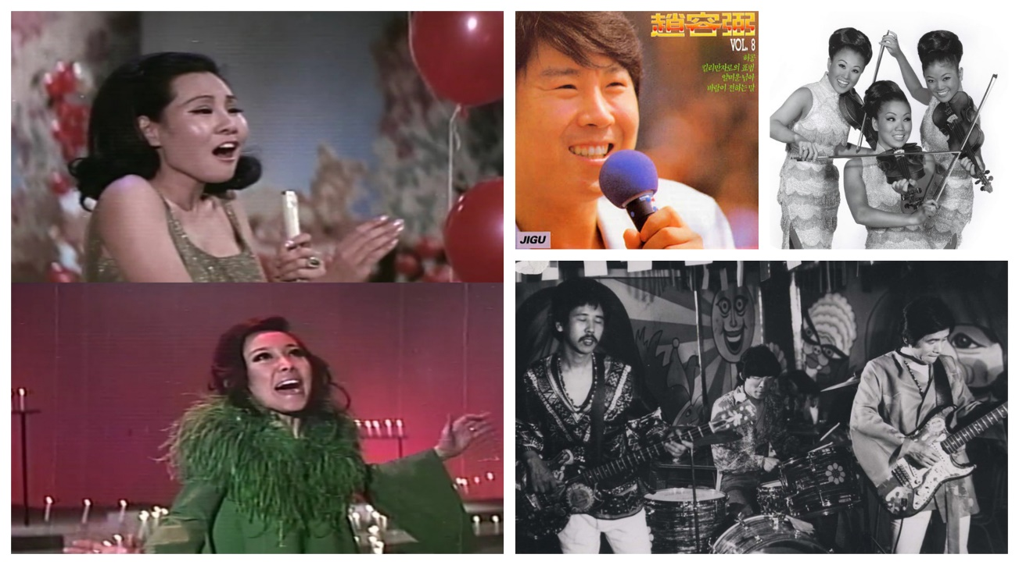
Figure 1. Korean singers of trot, soul music, and rock. Sources noted in Appendix 2.

The shift from soul-psyche to other “popular music” and how it was understood in South Korea can be attributed to its young people. This next generation was called the sinsedae, those born in the 1970s and who grew up amid Korea’s own growth politically, economically, and socially. Similar to the use of “Generation X” in the United States to describe a certain generational segment, “sinsedae in a narrow sense refers to those born during the early and mid-1970s who grew up in urban areas watching American TV shows, listening to American popular music, eating American fast food, and consuming American fashion.” This group had a different experience than their elders in terms of political upheaval or economic hardship. “The sinsedae came of age at a time of democratization when, after three decades of military control...Koreans were determined to make the most of new-found freedoms.” The 1980s were a turbulent time within Korean society. With an assassination of the country’s previous president in 1979, a military coup of the remaining government led to extended dictatorial rule and severe regulations and restrictions on the entertainment industry. As such, the sinsedae “wanted to embrace the world outside and to challenge the internal, controlled, cultural economy...The sinsedae was familiar with [and happily embraced] American popular culture” as an alternative to the restraints occurring at home.

Chapter III
The Impact of Hallyu on Korean Popular Music

“My music is the spiritual expression of what I am — my faith, my knowledge, my being…When you begin to see the possibilities of music, you desire to do something really good for people, to help humanity free itself from its hang-ups…I want to speak to their souls” – John Coltrane

With the first, true democratic elections happening in 1987, the 1990s were a prime period for change. Hallyu, or Korean Wave, refers to a period in the late 1990s that started a popularity surge of South Korean culture internationally. With the unexpected overseas popularity of certain Korean dramas and music artists, the country decided to create a cultural brand that included “Korean language, food, clothing, paper, house, and music [that] would then be commercialized, globalized and used every day…as a tool for globalizing national culture and the arts.” There are several ways to describe Hallyu. The simplest is “the popularity of South Korean popular culture [abroad] and in other Asian countries.”
There are several explanations for why Hallyu was a such a far-reaching phenomenon. Most scholars agree that two key considerations around this success can be attributed to South Korea’s proximity to its neighbors within Asia and the high-income the country was able to regenerate following the 1997 International Monetary Fund financial crisis. South Korea steadily stays ranked within the top 10th to 12th largest economy worldwide and the 3rd to 5th largest economy within Asia. To rebuild international confidence in their economy and to curry the interest of investors, South Korea took advantage of the universal enamor the world had with their entertainment and invested in the industry to rebrand its global image. The “market share of domestic popular music increased from approximately 71% in 1996 to 80% in 2004, to 81% in 2010 and [finally, a whopping] 95.5% in 2011.” In 2012, the government contributed over 25% of the venture capital funds invested within Korea, with one-third of that amount specifically earmarked for the entertainment industry.
The region fell in love with Korean television, film, and music with a more European and American contemporary, popular style. As this occurred, within local nightclubs, neighborhoods, and smaller venues, another “wave” was rising. This “wave” was an “underground Black music scene” that highlighted hip-hop, rap, and R&B as “self-sustainable cultural expressive forms” to give an avenue for sinsedae youth to illustrate how they felt about what was happening in the country during this time. More broadly, the genres being explored would also add a bit of “flavor” and “something new” to the Korean music industry as a whole.

Chapter IV
South Korea Is Introduced to Hip-Hop and R&B

“Hip-Hop when it started it was supposed to be this new thing that had no boundaries and was so different to everyday music. Now it seems like I was starting to get caught up in the mode of what made hip-hop come about. As long as the music has the true-to-the-heart soul it can be hip-hop. As long it has soul to it, hip-hop can live on” – Tupac Shakur

The next generation of music listeners, already used to Western influences in their music, were ready for something new and different. Youth in the 1980s and 1990s full heartedly accepted the globalized direction in which the country was moving. They “embraced consumerism and Western popular culture including Anglo-American pop, while rebelling against established social and cultural rules.” For those reasons, popular music was greatly influenced by additional genres heavily saturated by African-American performers. This included jazz, rap, gospel, R&B, and hip-hop.
As previously noted, African-American music was introduced to South Korea during the country’s occupation by Japan (1910-1945) with jazz (chasu) and continued through the 1950s with the presence of U.S. soldiers. This fascination continued with soul music in the 1960s and 1970s when “Black music as a musical genre exploded in the Korean domestic music scene.” The sinsedae ushered in the next iteration of Black music along with the swell of Hallyu and globalization. The incorporation of African-American musical stylings into the entertainment industry was part of a larger pattern of Korean youth “adaptati[ng] and imitati[ng] emerging global culture in their own popular culture, filtered through foreign, and especially American, media.”
In a 2003 interview with hip-hop duo Jinusean, artist Jinu commented “the Korean market sort of follows what’s hip. Hip-hop is the thing, so everyone does hip-hop, and it’s what people want to listen to. Everyone wants to do that.” Rap and hip-hop especially resonated with Korean youth, because their origins are about going against the grain. During a time where restrictive government regulations and high academic achievement expectations provided internal and external pressures and stressors, hip-hop was an outlet. It was a novel form of “rebelling against established social and cultural rules.” Hip-hop culture has a raw and forthright energy that can appeal to its consumers. At a macro level, within the mainstream music industry, hip-hop and R&B genres are the first two in which others categorize Black music, with jazz and gospel following thereafter.
It should be noted that hip-hop and rap differ on their focus; rap is specific to the spoken word or lyrics from artists. Whereas hip-hop is a combination of lyricism, dance (e.g. break dancing), street arts (e.g. graffiti), DJ-ing, and the many combinations in which the above are integrated together. A common definition of hip-hop is that it “refers to the music, arts, media, and cultural movement and community developed by Black and Latino youth in the mid-1970s on the East Coast of the United States.” Within Korea, the definition of the art of hip-hop and how it was understood shifted from the early 1990s to today. Early 1990s hip-hop group Seo Taiji and Boys are credited with the mainstream introduction of hip-hop to the market, however the group was more strongly associated with the form of “rap-dance” instead of hip-hop.

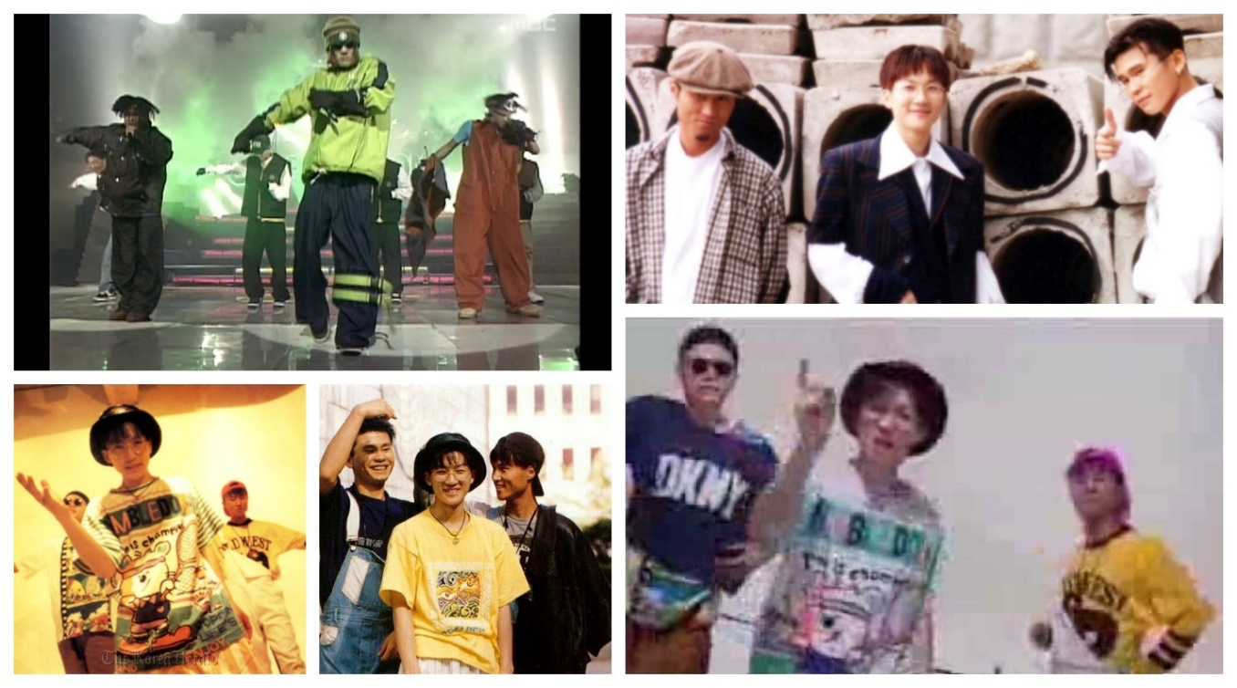
Figure 2. Seo Taiji and Boys. Sources noted in Appendix.2.

Rap-dance was not considered “real hip-hop” because of the heavy reliance on dance-oriented beats and melodies instead of a concentrated focus on verbal lyricism. Yet, due to their attempts to recreate the “musical techniques, attitudes, and fashion of original American hip-hop, they established the musical foundation for upcoming Korean hip-hop.” Seo Taiji and Boys “performed elaborate hip-hop dance choreographies in then-unconventional fashion by wearing baggy pants, sunglasses, and baseball caps. The group presented a provocative novelty within Korea’s conservative media and thus earned rapid success among the young generation.” Their adaptation is not what many scholars consider an authentic interpretation of the genre as performed in the U.S.
Instead, Seo Taiji and Boys represent for many scholars, the first example of how hip-hop can be culturally adapted to represent the regional tastes and experiences of its listeners. It was observed that “while rap [was] usually associated with confrontation in America, Seo Taiji’s use of [this genre] ranged from confrontation to supplication. He was not interested in maintaining full musical authenticity by embracing the totality of the ideology behind the idioms, but he took rap as [a kind] of language that could be used to articulate what he wanted to express.” Such observations allude to the broad appeal of hip-hop as giving voice to community issues and identities from a regional perspective, while also creating a locally unique style that “draws on local and national culture and art forms” to further ground the genre within a particular region.
Rhythm and Blues, or R&B, which has strong roots in soul music, has not had as meteoric a rise as hip-hop, though it has held a constant presence within the Korean music industry. Intertwined with the soul-psyche sound throughout the 1960s, R&B dominated Korean airwaves, until an abrupt “blackout” in the 1970s. Once again, the government stymied musical growth with the passage of Presidential Emergency Decree No. 1 in 1974 which “outlawed all public remarks and statements opposing the Yushin Constitution.” Speaking truth to current circumstance and calling out injustice, human rights abuses, or the government’s inability to protect or to look out for certain segments of its population are cornerstones of R&B; just as surely as singing about romantic interests and fun days with friends. Emergency Decree No. 1 was supported by Decree No. 2 which allowed the government to jail anyone who spoke out against the government. Individuals could be taken into custody, without the use of an arrest warrant, and given a sentence of up to fifteen (15) years. Many saw these decrees as “‘prevent[ing] any criticism of the government,’ misus[ing] the judicial power, and overrul[ing] the freedom of expression and political rights of citizens.” They were also seen as further confirmation that the “government’s true intentions [was to] eradicate soul and funk altogether because of their sociocultural impacts and attractiveness to the younger generations.” With such restrictions in place many soul-psyche and funk artists faded into the background of mainstream radio play and the musical gap was filled by trot music. Trot, also called teuroteu or teurotteu, is considered the earliest form of Korean pop music and is based on a two-beat rhythm (called ppongjjak) similarly heard in ballroom foxtrot music (hence the shortened name).
In the late 1980s, there was a brief resurgence of African-American musical sounds with the popularity of a “funk rock fusion” group named Sarang kwa P’yŏnghwa, whose music also included hints of “jazz-fusion.” However this band did not rise to the national prominence of earlier artists who incorporated Black sounds. Throughout the rest of the 1980s Korea experienced an absence of Black infused sounds within the music industry. Though artists such as Michael Jackson and Prince were dominating American charts, their music was not making its way into Korea. It would not be until the surge of hip-hop that R&B would regain its footing within the entertainment industry. Artists such as Gummy, Sechskies, SOLID, Soul Star, and Brown Eyed Soul helped to inject an R&B sound into the Korean music scene in the 1990s and early 2000s.

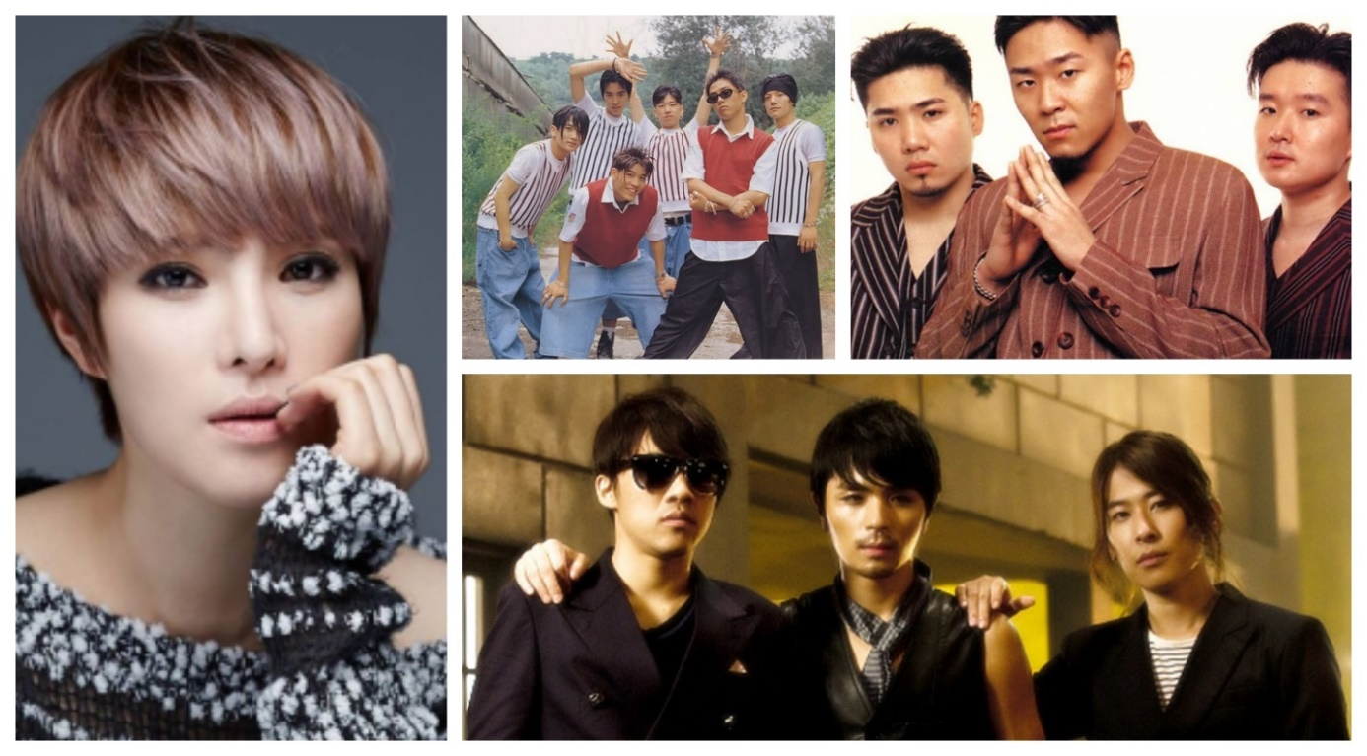
Figure 3. Gummy, Sechskies, SOLID, and Soul Star. Sources noted in Appendix 2.

In 2017 African-American artist Gallant filmed a short documentary in South Korea while en route to a local rock festival. He shared his own introduction to K-Pop and interviewed local artists, deejays, and music shop owners. Gallant learned of Korean R&B through international artist BoA. He first heard her Japanese album and upon learning that she was Korean, listened to her Korean albums and the albums of other Korean artists. Within the documentary, those that Gallant spoke with acknowledge how the history of Korean music was impacted by access to music within stringent government regulation. In the 1970s Korean folk music was mixed with the soul and funk sounds that artists could access, such as Jimi Hendrix and Carole King. Several of the interviewees continually referred to Korean R&B as a “new paradigm of music” that was creating a “cross-section of culture and music” and giving Korean artists the opportunity to “mix new ideas to existing ones.” The conjecture is that Korean audiences enjoy Korean R&B because of the genre’s “engaging and rhythmic sound of its live performances.” The documentary concluded with Gallant noting the incongruity of R&B music’s ability to embed itself within the Korean music industry compared to its turbulent beginnings in the United States:

Soul music was born from an anti-establishment angst. [It is] fascinating [to him] how that type of music which was under so much pressure in America and was born out of defiance to the government and defiance to a music industry that was heavily segregated, [and] had a hard time finding its way onto American airwaves, made its way overseas to Korean recording studios.

In both cases, for R&B and hip-hop, the roots of the music are found within strong emotions – anger, love, frustration – and using these genres as an outlet to express these emotions and thoughts about society, culture, and progress (or the lack thereof) within an artists’ community. At their core, R&B and hip-hop give an artistic illustration of everything beautiful, ugly, true, and unjust about the Black experience in the United States. The ability for Korean artists to draw parallels to their own experience, or to accurately invoke such emotion within their own songs without it seeming like mimicry is questionable. However, if one considers the supposed adaptability of these genres, then perhaps the concern is moot. Instead, perhaps the focus should be on the ability of Korean artists to accurately reflect the Korean experience in South Korea while using R&B and hip-hop as an outlet.

In making the case for ‘the locality, temporality and “universality” of hip-hop’ in the way that rap has been indigenized outside America, [academic Tony Mitchell argues that] in most countries where rap has taken root, hip-hop scenes have rapidly developed from an adoption to an adaptation of U.S. musical forms and idioms. This has involved an increasing syncretism and incorporation of local linguistic and musical features.

However, such adaptations still lead to broader questions around authenticity, origination, and the impacts of globalization on how genres such as hip-hop and R&B are integrated and commodified within certain markets. Within Korea, hip-hop was an exported cultural commodity that initially gained popularity because it was trendy. Early rap-dance groups such as Seo Taiji and Boys, and Deux, and solo artists such as Hyŏn Chin-yŏng helped to popularize the genre with their catchy beats and creative lyrics about real world issues. They emphasized the ability for hip-hop to be “a lingua franca that binds young people all around the world, all while giving them the chance to alter it with their own national flavor.” It is this hybridized version, which seemed to take root in the Korean Popular (K-Pop) music scene that developed during Hallyu that gained initial national attention. A shift towards hip-hop and R&B more closely associated with African-American performers seemed to occur as globalization and technology connected people internationally and Korean music practitioners saw “what was” in their country and “what could be,” as exhibited by Black performers.

Chapter V
Hip-Hop and R&B in Korean Popular Music: Offset of Globalization and Cultural Hybridization?

“How you act, walk, look, and talk is all part of Hip-Hop culture. And the music is colorless. Hip-Hop music is made from Black, brown, yellow, red, and white” – Afrika Bambaataa

As a whole, Korean popular music (K-Pop) is recognized as a merger of sounds from the region itself, Western Europe, and the United States. Hip-hop and R&B in Korea are a further challenge to define as they are obviously grounded in African-American genres such as jazz, soul, gospel, and (of course) hip-hop, and R&B. The broader question then becomes are hip-hop and R&B an adoption, appropriation, or hybridization of musical styles? Or something else?
A first step to answering these questions lies in how one defines Korean Black music, Korean hip-hop, and/or Korean R&B. In answer to these questions, one response asserted:

“What is Korean about Korean pop? Nothing – in the melody, the singing style, instrumentation or harmonies. It is all just a rehash of American pop with a little J-pop glam thrown in.” [This] view can be interpreted as suggesting that there is no unique Koreanness or Asianness in Korean pop music [artists, such as] Rain. In short, there exists a serious difficulty in commodifying Asian pop in the American market, which is not only a global market at the abstract level but also a specific geo-cultural market at the concrete level, which cannot be solved by presenting aesthetic difference.

Korean music is a “late bloomer” in terms of creativity because artists were stifled and restricted due to either colonization or strong censorship from the government. For this reason, the development of K-Pop, Korean hip-hop, and Korean R&B genres are heavily based on the ability of artists, writers, and producers to mix and cross-pollinate cultural elements from at home and abroad. Such cross-pollination is strongly supported with the retention of European and American, especially African-American, producers and songwriters known for creating the “sounds” that defined American hip-hop and R&B from the late 1980s to present, such as “New Jack Swing” associated with artist and producer Teddy Riley.

Table I. Black Producers/Production and Songwriting Teams that have worked with Korean Artists. Sources noted in Appendix 1.
Producer/Songwriter Name | Korean artist/group
Claude Kelly | Girls Generation
G.O.O.D Music (Kanye West’s record label) | Epik High, Lee Hi, and Oh Hyuk
Kevin Randolph | NCT 127
Nick Cannon | Wonder Girls
Patrick “J Que” Smith | EXO
Polow da Don | Girls Generation
Rodnae “Chikk” Bell | EXO, Taeyeon, and SHINee
Rodney “Darkchild” Jenkins | Se7en
Teddy Riley | Girls Generation and Jay Park
The Stereotypes (Jonathan Yip, Ray Romulus, Jeremy Reeves, and Ray Charles McCullough II) | BoA, Super Junior, Taemin, and Girls Generation
The Underdogs (Harvey Mason Jr. and Damon Thomas) | SHINee, NC127, BoA, EXO, Girls’ Generation, and TVXQ
Warren G. | RM (of BTS)
Will.i.am (Black Eyed Peas) | 2NE1 and Psy

Some scholars argue that “global hip-hop has emerged from the ‘collision and collusion between two powerful globally pervasive forces; transnational media and capital and African-American popular culture that remains steeped in Africanist expressive modes.’” As such, any definition that attempts to sub-categorize hip-hop and R&B genres is meaningless. Instead, the presumption is that the focus should be on recognizing the “global” nature of these genres and studying how it was incorporated by K-Pop within the music industry. Hallyu created a role for Korea within the global entertainment industry as a bridge between Western and East Asian entertainment. K-Pop highlights the ability for an industry (e.g. music) to modify content to regional tastes and then globally redistribute that content.

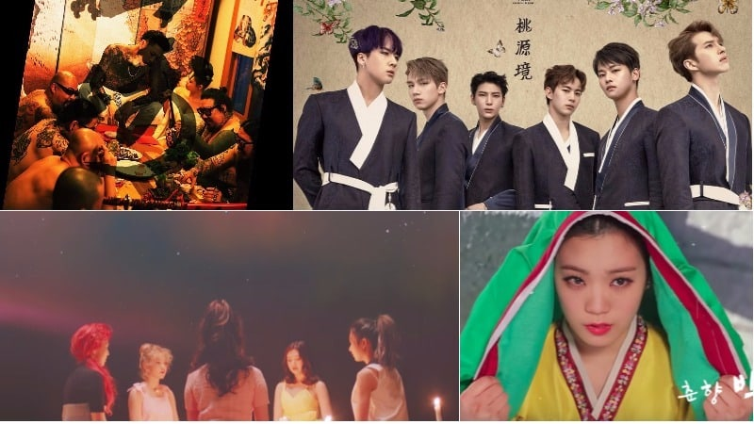
Figure 4. K-Pop videos with Asian cultural elements. Source noted in Appendix 2.

In this way, K-Pop exemplifies the idea of cultural hybridization, understood to have “a cultural focus and emphasize cultural interplay where ‘traces of other cultures exist in every culture.’” Within cultural hybridization, “a culture is not linked to ethnicity but rather ‘the mobilization of group identities’ allowing for a wide range of identity conceptions. [Such a theoretical understanding] helps theorize the move of hip-hop [and R&B] culture around the world and into countries like Korea.” More broadly, the idea of hybridization or cultural hybridization focuses on the intersections of local and global norms, processes, traditions, customs etc. and where the local and global norms overlap, connect, and conflict – similar to a Venn diagram.
A key understanding in this discourse is that “hybridity should not be understood as predicated on the negation, or the contradiction, of identity, but is always mixed, relational and inventive as a function of its inevitable and systemic condition.” Within this theory, the understanding of Korean hip-hop and R&B as forms of cultural hybridization then imply that these are new constructs within existing genres whose merits should not be predicated on where the genre originated, but instead in how the new genre has created “new forms and invent[ed] new connections with each other.”
Within Korea, the hybrid elements seem to be R&B-based melodies with intermittent breaks and hip-hop beats, and additions with traditional Korean kayo melodies and chords. From this, Korean listeners hear “songs combining robotic hip-hop beats or danceable electronic rhythm and typical ‘twisted’ singing vocals with some add-ons of rapping.” But one may still question if this new construct is still original or authentic. Within hip-hop and R&B

[their] cultural codes, such as making something from nothing, being authentic, leaving one’s mark on the world, having aspirations, having self-confidence, being relevant and, most of all, being cool are drawn upon [in Korea] to sell brands and have been used to ‘[rewrite] the rules of the new economy.’

More broadly, African-American culture and its perception, reception, and integration within other cultures and communities has had a historically discordant relationship. This relationship has vacillated between times when the outside public has either “praised [their] artistic lineages to claims of [African-Americana] having no history at all.” As such, additional exploration occurs in the next chapter on if this sometimes-acrimonious relationship between African-American cultural practitioners and the rest of the world is understood by the Korean community. It also investigates if the Korean community considers how Black artists view and perceive hip-hop and R&B performed in Korea, since such performances can infer how a group or culture understands the genres in which they are performing.

Chapter VI
Understanding of Hip-Hop and R&B by the Korean Community

“Music does a lot of things for a lot of people. It’s transporting for sure. it can take you right back, years back, to the very moment certain things happened in your life. It’s uplifting, it’s encouraging, it’s strengthening” – Aretha Franklin

The “Korean community” is a descriptive phrase to define both the listeners and audience members for whom music is made, and the practitioners who create the music. The audience ranges from those who turn the music on the radio, watch the videos on television or online, purchase content, to who discusses it and writes about it in the online community. The practitioners include, but are not limited to, the artists themselves, choreographers, songwriters, producers, and dancers – everyone is who part of the music-making process. These distinct groups indirectly and directly influence the paths of hip-hop and R&B in Korea. The audience are indirect influencers, as their reactions to certain songs and/or artists provide some input to what the so-called “Big 3” entertainment agencies – JYP, YG, and SM Entertainment – smaller labels, and independent labels will release. To explore how the Korean community understands hip-hop and R&B, it is important to consider how these genres are defined. For many they are classified in relation to their “Black roots and social location.”

[Hip-hop & R&B are] Afro-diasporic cultural form[s] which attempt to negotiate the experiences of marginalization, brutally truncated opportunity and oppression within the cultural imperatives of African American and Caribbean history, identity, and community. It is the tension between the cultural fractures produced by postindustrial oppression and the binding ties of Black cultural expressivity that sets the critical frame for the development of hip-hop [and R&B].

However, if the audience has no background or understanding of the abovementioned history and/or the “art” of hip-hop and R&B, then their reactions may be disingenuous. One may question if listeners truly appreciate the music when they do not understand it – why lyrics are as such, the narrative shared, the musical arrangement chosen, etc. If an audience does not understand what they are hearing and where something originated from, then they are losing out on an integral component of the listening experience. Though such understanding varies for demographics of certain listeners even within the United States, such lack of understanding or misunderstanding of the genre is even more egregious and critical when the sounds are being shared with a culturally and contextually-separated audience. Within hip-hop and R&B, the listener’s appreciation for and understanding of the history of these two genres play especially important roles in how they are understood and exemplified in the public sphere.
For the practitioners, such understanding is even more critical. The place that their music comes from is the root of their art. It grows and adapts with them. Artist Yo-Yo Ma is quoted as saying, “as you begin to realize that every different type of music, everybody’s individual music, has its own rhythm, life, language, and heritage, you realize how life changes, and you learn how to be more open and adaptive to what is around us.” For Korean artists within hip-hop and R&B, the mixed heritage of their music can be both a blessing and a burden. It can put Korean artists on a slippery slope between integration and appropriation. By heavily relying on Black culture and Black sounds in their performance, artists often find themselves at a crossroads in also being able to highlight what about their style and performance makes Korean hip-hop and Korean R&B truly “Korean.” The continual search for “Koreanness” while using outside styles dampens the cries of “originality” and “innovation” from artists who push back on global criticism of their style. “In the effort to show that something like hip-hop [or R&B] in [Korea] ‘really is [Korean]’ in some sense, [artists] risk underplaying the mutual construction of the global and the local.” However, this reliance can be seen in some ways as an acknowledgement of the roots of the genres. Such understanding returns to the continual search for answers to the authenticity of Korean hip-hop and R&B performers and if their sound is a meaningful contribution to the art or mimicry to make money.
Music is a universal pastime. It acts as a source of entertainment, focus, and stress relief among several other functions. In this context, research on the musical genres that the Korean community listens to (and why) may give insights into the changing perspectives, priorities, and lifestyles within the country. Moreover, in considering the broader narrative that hip-hop and R&B fall within and the stories they tell through their music, “the significance of [listening to these genres of music as a] free time activit[y] is often related deeply to real world concerns.”
The advent of technology, especially social media has greatly helped the affluence of hip-hop and R&B in South Korea. In the early 1990s, online communities were ground zero for discussion and discovery of hip-hop and R&B artists. Early virtual communities such as Rhythmer and HipHopPlaya helped in “connecting the fans to the musicians and business in the Black music scene.” A review of the discussion boards and topics for online communities such as Quora and Reddit revealed that several fans of these genres became so through accident (e.g. hearing a song somewhere), a referral from someone they knew, or hearing a duet with an artist they already liked. They continue to be fans because songs and albums are released with lyrics they find relatable. Listeners also appreciate the lyricism, or word play, of certain artists as well as their flow. Several listeners shared that the transition from more mainstream K-Pop to Korean R&B occurred as they grew older and their musical tastes and preferences changed. One fan noted that “the reasons why rap stands out is maybe because the artists are able convey more information or express them much more creatively by rapping their lyrics than singing them. It’s part oration, music, and poetry. What’s not to love?”

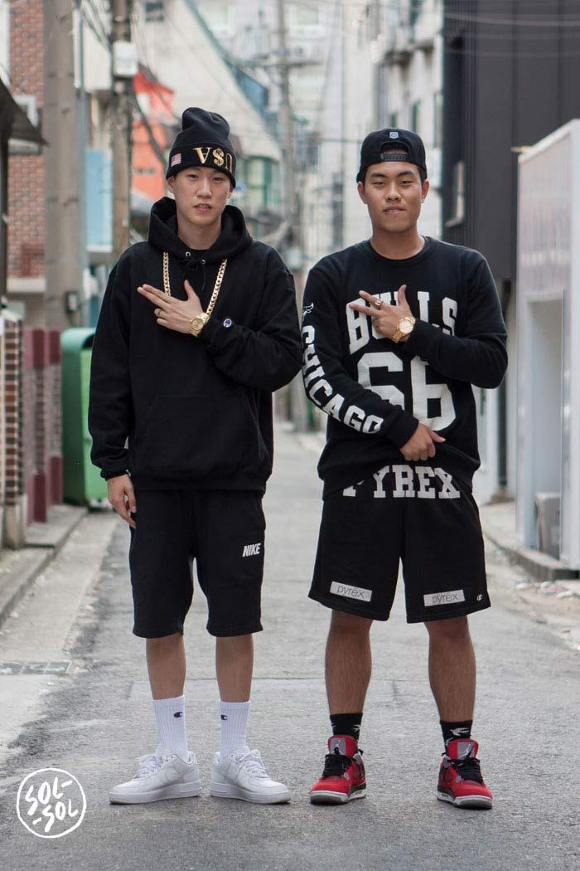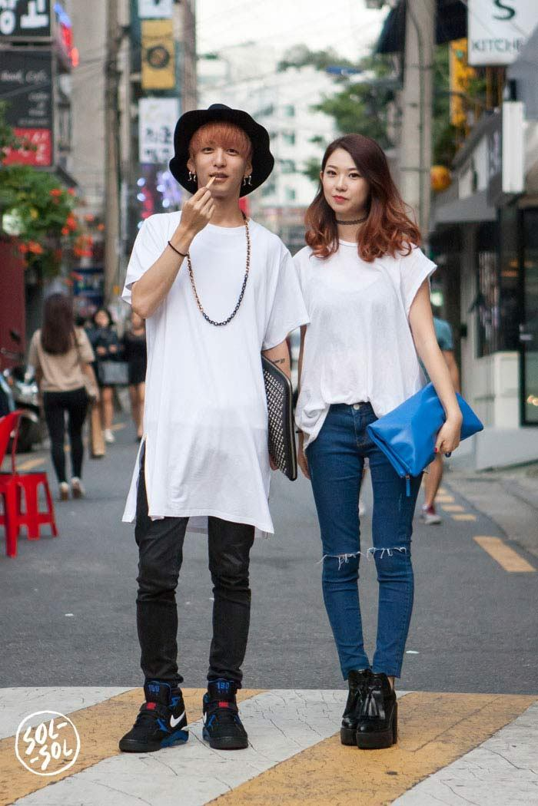
Figure 5. Hip-hop inspired fashion in Seoul. Source noted in Appendix 2.

The choice of these musical stylings is important to note, because several interviews and observations by other researchers on this topic suggest that Koreans have not always been aware of what they’re listening to or fully understood hip-hop or R&B culture. Instead, they simply wore what seemed like “hip-hop fashion” because it was cool, without understanding it; hence commodifying and appropriating this aspect of hip-hop culture. Further, researchers noted that Asian youth – in Korea, Japan, and China – where hip-hop has gained strong followings have “little, if any, firsthand experience with African-American struggles or artistic commitments, that is, the root forces that animate hip-hop in the United States.” In the same online communities mentioned above, several fans acknowledged that a translation of a Korean artist’s songs often revealed that they were discussing something more mundane or less offensive than the ferocity of the lyrics implied. For Korean R&B songs, the lyrics were about topics familiar to American audiences – first love, unrequited love, life in general, etc.
Finally, the unique role that women and girls play as audience members within hip-hop and R&B should be noted. “It is young women especially who are generally viewed as the driving force in any new fad, including ones in popular music.” They make up the majority of the listeners, buyers, and commenters/sharers on social media. A brief survey of listeners, specifically of Korean girl groups alone, shows that women range between 41%-63% of the fanbase. In this way, they are trend drivers and trendsetters whose influence should not be dismissed.
The Korean music industry has a reputation for having an intensive training regimen for up and coming stars. Members are recruited at a young age, usually while in their early teens, and spend several years honing their craft in singing and dancing. They also work to increase comfort level in public settings relating to performances and interviews, and in creating their public personalities. Some have called such training grueling, controlling, and exploitative. The artists are taught how to perform their craft well, but it seems that they are not taught the history or meaning behind the genres in which they engage. This educational gap at the artist level seems to flow outward to the audience as well, which impacts the ability of the global community to take Korean rappers and R&B singers seriously. The reasons for this gap vary. Some note that it is as simple as Koreans having a “poor knowledge of U.S. grassroots hip-hop [because they have no foundational] understanding of Black culture.”

Although sympathetic to Korean homogeneous history, in line with literature, [American rapper] Toy critiques local hip-hop’s lack of in-depth cultural knowledge. She says Korean rappers believe, “If I use English or I say the N word, if I imitate this aspect of Black music, or Black culture, people are going to like me more.” However, people ‘lose respect’ for this ‘pure ignorance’ she says, adding “I wish more people would educate themselves about the culture that they are trying to imitate.” Korean journalist Kang expands on this point highlighting Korean rappers “copy Black rappers and Black style” because “Black rappers are cool.” This suggests that Koreans adopt Black culture to follow current trends.

Others contend that it is not a lack of historical understanding, but cultural divergence that gives Korean hip-hop and R&B a different sound. Artists in Korea are credited with acknowledging that hip-hop and R&B are “Black music” and such acknowledgement is one way in which artists “pay homage to the subculture’s U.S. grassroots.” As such, Korean artists will often make references to the “founders” of hip-hop such as Grandmaster Flash, DJ Kool Herc, and Afrika Bambaataa. They will also reference “icons” within the genre, such as Tupac, Nas, the Notorious B.I.G., and Rakim. “The mention of hip-hop icons has a dual purpose: to provide knowledge about the genre’s past, particularly to rappers who have been neglected in current times, and to demonstrate some sort of connection with the artists named.”
However, these forms of tribute can be double-edged swords as detractors can note that the performances lend themselves to imitation and making references to Black culture to legitimize their participation in the genre. For many Korean groups it is part of the process or “formula” to create a concept or theme when promoting their albums. Nevertheless, artists find themselves on a slippery slope when their chosen concept focuses on facets nominally attributed to another culture. From small details such as cornrows and backwards baseball caps to more noticeable “accents” such as wearing a specific brand (e.g. Adidas made famous by Run DMC) and having graffiti in music videos, to blatant instances of artists wearing baggy jeans, bandanas, copious gold jewelry and jeweled dental grills (fake teeth), and riding in hydraulic lowriders (synonymous with late 1990s and early 2000s American rap). Within the Korean music industry “most of the stereotypical images that [K-pop] portrays comes from American media. It’s not something they experience from their actual lives, they’re just imitating what they see. Without understanding a culture and its meanings, we get caught in an endless cycle of appropriation.”

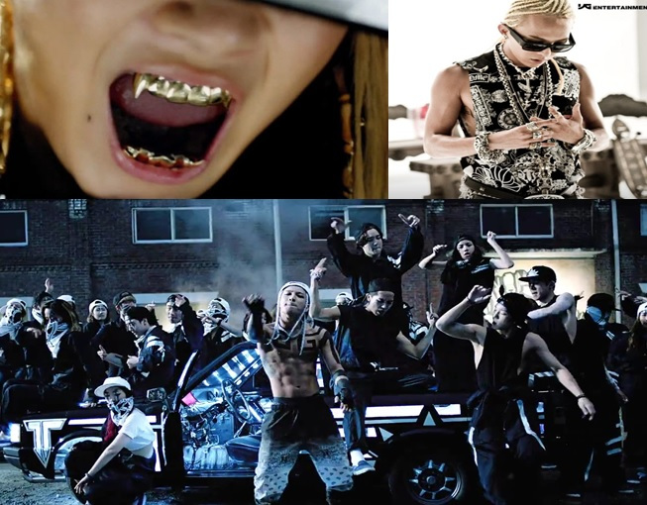
Figure 6. Cultural appropriation in situ. Source noted in Appendix 2.

A 2002 magazine article reporting on the interest of reggae in Japan noted concerns around the authenticity and legitimacy of the performers. The author wrote “any Black music fan knows about the ‘Elvis effect’…Black folk make music, and whites remake it and make big bucks…Where is the line between cross-cultural influence and cross-cultural theft?” This statement underlines the concern that the Black community – listeners and practitioners – of hip-hop and R&B have when the forms are acculturated across borders. This hesitancy and apprehension is well-documented as being part and parcel for the Black community. Time and again, they have seen their music, fashion, art, etc. appropriated “without acknowledgment or recompense.”
Adding a monetary value to this art – whether given to those who inspired it or to those who perform it – opens another avenue towards exploring the legitimacy and authenticity of Korean hip-hop and R&B. Is this music made due to genuine interest or the high possibility for monetary gain? According to anthropologist Arjun Appadurai’s description of “transnational cultural flows,” the answer is irrelevant. The monetary value is a natural component of cultural exchange that falls within the financescapes, with the art being a commodity that is able to be traded and exchanged between Black and Korean cultures. By their form, hip-hop and R&B are part of a global diaspora that “shares characteristics of ethnic constructions of diaspora.” The hip-hop and R&B global communities can be “described as translocal because they so often represent complex, cultural, artistic, and political dialogues between local innovations of diverse hip-hop [and R&B] art forms; transcultural interactions between local hip-hop [and R&B] scenes in cities and nations outside of the United States; and exchanges between local scenes and U.S.-based hip-hop [and R&B] media.”
As such, any financial gains that artists receive from this exchange are a natural consequence of engaging in what has proven to be a highly attractive and appealing form to broad audiences. The lack of reciprocity again returns to Appadurai’s flow idea in that he believes that “flows are ‘non-isomorphic’ (i.e., flows of one do not necessarily entail flows of others, as for example in the way [Korea] accepts foreign ideas more readily than [the country accepts] foreigners themselves).” Performers make the music they know people will want to buy and to listen to. As previously noted, in Korea, it is especially important that artists have a strong album or musical repertoire from which they can create a solid live performance. “In many ways, fans epitomize both the rewards and distortions of consumer culture.”

Chapter VII
Commercial and Consumer Power of Korean Popular Music

“When you sit down to write something, there should be no guidelines. The main idea is not supposed to be, “How many different ways can we sell it?” That’s so far away from the true spirit of what music is” – Prince

While the Korean community at large has an impact on the path and growth of hip-hop and R&B as art forms, as consumers, Koreans influence the mainstream areas of interest and reception of the genres. The media, using venues such as traditional print, radio and television, and going online, is a “‘cultural disseminator that helps organize and interpret subcultural experience.’ It is ‘essential to the creation, classification, and distribution of cultural knowledge.’” The media is reporter, commentator, and social discourse facilitator of what is happening within a community. Rapper Chuck D of Public Enemy once compared hip-hop to the media in asserting that it is a source of communication and information to the Black community. He described hip-hop music as being “dispatchers of information…[it is] almost like headline news. Rap music is the invisible TV station that Black America never had.” In this way, how hip-hop and R&B music reflect social and cultural narratives is similar to how the media reflects and amplifies what is happening in the world.
Music that gets people to dance will be popular at various venues and events. Music that people cannot help but sing along to will be frequently requested and played. Music that sells receives attention. R&B and hip-hop check all of those boxes for Korean artists. The early 1990s saw the founding of the “Big 3” entertainment agencies in South Korea; SM Entertainment (1995), YG Entertainment (1996), and JYP Entertainment (1997). Between these agencies, their artists account for the bulk of Korean celebrities or “idols” in the music industry. They continually trade places in charts in terms of market capitalization – who has the highest exports, record sales, and artists with number one hits or long-term placement on music charts. For example, in 2013, their market capitalization ranged in order of their founding years. SM was first with ₩780 billion, YG had ₩515 billion, and JYP had ₩120 billion.
In 2018, this upward trend continued. Amidst a year of overall market uncertainty within South Korea, entertainment agencies still showed fiscal growth and development. On the same day that the South Korea Stock Market’s Korea Composite Stock Price Index (KOSPI) showed losses in foreign investment and major news agencies saw drops in stock, the “Big 3” had their stocks rise. By the numbers:

JYP led, with their stock price rising 8.21%, while YG advanced 7.05% and SM rose 6.3%. Respectively, they closed on Aug. 16 at 25,700 KRW (just under $23 USD), 37,100 KRW (around $33 USD) and 43,800 KRW (around $39 USD). The rising share prices followed each of the labels releasing their second-quarter performance reports earlier last week. Both JYP and SM saw major gains as the former posted sales of 31.6 billion KRW ($28.2 million USD), a 10.6% increase on-year, and the latter reported 124.4 billion KRW ($111.1 million USD) in sales, 83.8% higher in comparison to last year. JYP recorded a 9.1 billion KRW ($8.1 million USD) operating profit, 30.9% higher than last year, and SM a 10 billion KRW ($8.9 million USD) one, up 626.2% on-year.

This trajectory is, of course, also attributed to music fans and aficionados. How fans respond and react within global, cross-cultural markets is an important way to understand the shifts in popular music trends. Korean hip-hop and R&B are not just enjoyed within South Korea. As part of Hallyu, these genres are part of mass exports to East and Southeast Asia (e.g. Japan, China, and Thailand), North and Central America (e.g. Mexico and Canada), and parts of Europe. Consumer interest heavily influences capitalism and – as in the case of Hallyu – provides opportunities for a market or industry to reinvent itself or how its identities (national and local) are understood internally and externally. Anthropologist Daniel Miller asserts that the consumption of creativity, such as the arts, music, and performance is an effort to ease a general uneasiness around the lack of control within people’s daily lives. Miller believes that authenticity is an integral component of the consumption experience; people will more greatly appreciate a creative entity if the presenter is able to show that it originated with them.
For fans of Korean hip-hop and R&B, this implies that on a scale of enjoyment value, the more original artists are within the genre, the more fans will appreciate it and want to consume more of it.
On a scale of monetary value, the entertainment industry, specifically the music market’s value increased to $195 million in 2011 from $145.8 million in 2008. As a commodity, K-Pop is the most exported product for the country, providing revenue between $83.2 million in 2010 to $275 million in 2013 to a high of $310 million in 2014. “In 2002, Korea was the second-largest music market in Asia, with a domestic turnover of $300 million.”
The Korean government has also taken notice. In 2013, the Korean government invested ₩305.7 million in the Korean Ministry of Culture, specifically to support the advancement of popular culture. To compare, the budget in 1994 for the cultural industry was only ₩54 million. “The government budget demonstrates the changing nature of the government’s cultural policy. Since the budget is a representation in monetary terms of governmental activity” this shift highlights both the internal recognition the government made towards the capabilities of the Korean music industry and externally signaled their willingness to capitalize on such an asset. Such financial investment also signaled a shift to the government’s approach in terms of censorship and oversight over material being exported from the country. This is especially notable as it has allowed artists to be more risqué with their lyrical content, choreography, and videography. In other words, more provocative aspects of Black culture have found their way into Korean hip-hop and R&B. Though the artists have a degree of autonomy as they are developing their concept or theme, true responsibility and control over the artists “sound” and “look” lies with their entertainment agency.
As an industry, K-Pop is “tightly scripted” due to the immense training and continual oversight that artists receive from their managers, handlers, and agency. This recognition adds a consideration to who should be accountable when instances of cultural appropriation occur. It also creates a consideration around who should be responsible for ensuring authenticity and accurate cultural hybridization of musical genres. As their own public face, Korean artists are often the immediate perpetrators of perceived appropriation, but the above is a reminder that they are not the ones “producing their songs, styling their outfits, and coming up with their choreography. They’re just the final products, products made by an entire agency.”
This viewpoint gives space to the possibility that artists – rightly or wrongly – are not always able to be held accountable for their decisions and actions. Following this line of thought, then also lends itself to the conclusion, that most Korean artists truly have little to no understanding of U.S. hip-hop and R&B history or culture. This then begs the question: “Does this not prove that [R&B and] hip-hop in [Korea are] driven by entertainment companies, media outlets, and fashion industries eager to hype the latest cool fad?”

Chapter VIII
Performance Review, Part I: Album Review (Random Sampling)

“The whole thing of being in music is not to control it but to be swept away by it. If you’re swept away by it, you can’t wait to do it again and the same magical moments always come” – Bobby Hutcherson

To identify, compare, and determine similarities in vocalization techniques, dance styles, song lyrics, and music video composition of Korean, African-American, and Black artists across the African Diaspora within the hip-hop and R&B genres, I conducted an analysis of a random sampling of discographies by mainstream Korean artists. Specific to musical compositions, instances of music sampling – when the melody, lyrics, or other part of one artist’s song is used in another artist’s song – were carefully researched and listened for. The accompanying music videos of certain songs were also observed to look at the choreography and dance styles, themes, visual aesthetics (e.g. background, location), and fashion within the videos. The analysis looked for areas of commonality within performance styles that were either similar or direct copies of Black artists.
Selection was determined by curating a list of eight (8) artists from each of the Korean music industries’ “groups”: male solo, female solo, male group, female group, and co-ed or mixed gender groups. Mixed gender or co-ed groups are a rarity as they do not seem to fare as well in terms of commercial success. Through an online search and discovery of an article that listed nine mixed gender groups, eight co-ed groups were selected directly from this list. The remaining artists selected were based on those active within my research timeframe (2003-2018), that are currently popular within the Korean music industry or have had longevity in popularity, have received a fair amount of “buzz” or high-profile media attention within the past three (3) years which speaks to either longevity or new potential, were considered innovators within their genres (R&B or hip-hop), and are personal favorites. A total of forty (40) artists were part of the initial list based on the following groups:

Table II. Korean Artists Considered for Discography Review
Artist Category | Artist Name
Male Solo | 1. Jay Park 5. Crush  2. Dean 6. Zion  3. Se7en 7. Samuel Seo  4. Zico 8. Jooyung
Female Solo | 1. Taeyeon 5. Hoody  2. Lee Hyori 6. Lee Hi  3. Boni 7. IU  4. Suran 8. Jessi
Male Group | 1. Got7 5. Soul Star  2. BTS 6. g.o.d.  3. EXO 7. Brown Eyed Soul  4. SOLID 8. SHINee
Female Group | 1. BLACKPINK 5. Secret  2. Wonder Girls 6. Big Mama  3. Girls Generation 7. Red Velvet  4. Brown Eyed Girls 8. Miss A
Mixed Gender (Co-ed) Group | 1. MFBTY 5. Urban Zakapa  2. Triple H 6. Clazziquai  3. K.A.R.D 7. Co-ed School  4. Akdong Musician 8. Trouble Maker

Using the birth dates and months for my nieces and nephew as the selection numbers, the forty (40) Korean artists were input into a computerized random selection tool. From oldest to youngest, Monica was born on March 8th, Max on February 9th, CiAiris on July 6th, and Dahlia on April 5th. Based on these dates, the artists selected were those numbered two (2) through nine (9) in the lists generated by the tool. To have balance between the number of solo and group discographies analyzed, if there were more than three selections of one group in the generated list (e.g. three or more mixed gender groups in places #2-9), then another selection was processed. Ten (10) selections occurred to have ten (10) final discographies chosen for review, with artists from each group highlighting both genres of hip-hop and R&B. The multiple selections occurred to remove duplicity (e.g. having two female rappers in top count), lessen oversaturation (one selection had five male groups), and to ensure representation of all five groups (one selection had no male soloists). The tenth selection of only female soloists occurred midway through the review process. Singer IU was initially selected as a female soloist. However, it was noticed halfway into listening to her debut album that much of the musical style was K-Pop. A quick review of the other selected discographies and of available album reviews of IU noted that although R&B is listed as a genre in which she performs, many of her albums fall within K-Pop and dance. As such, another selection occurred for a new R&B singer. An outlying observation from this incident creates questions around how R&B is defined and understood in Korea, and to possibly examine how R&B is spoken of in later artist and producer interviews.
The discography reviews were grounded in factors and criteria noted in previous research conducted to gain familiarity and knowledge within this subject. Based on this research, content was appraised regarding the use of English verses, the influence of Western and European music on compositions, paying homage to well-known soul/R&B singers, the progenitors of hip-hop, or local Korean hip-hop “legends”, and lyrical substance. The application Shazam was used to try to identify sampled songs that were not noted in the collection of sampled music on the website WhoSampled. Based on random selection, the discographies of Jay Park and Se7en as male soloists, Lee Hi and Jessi as female soloists, EXO and Brown Eyed Soul as male groups, Big Mama and BLACKPINK as female groups, and MFBTY and Trouble Maker as mixed gender groups were analyzed. The length of artists’ careers and work with a major label impacted the discographies available for review. Mixtapes and “underground” albums or singles that did not receive mainstream radio play were not considered. Conversely, if the artist released less than three videos for songs across all albums reviewed, then a third music video with a high viewer count was considered. Where available three (3) albums of each artist were chosen; their debut, their highest selling (has asterisk), and their most recent. If their highest selling album overlapped with one of the others (e.g. best-selling album was also debut album), then an album produced mid-career was chosen. All albums were listened to using one of three streaming services – Spotify, Deezer, or YouTube. A total of twenty-five albums (25) were reviewed.

Table III. Album Discography
a. The first album listed is the artists’ debut album.
b. An asterisk indicates that this is the highest-selling album (to date) of the artist’s career.
Artist (debut year): dominant genre | Album (release year): # of tracks
Jay Park (2008): Hip-Hop | 1. New Breed* (2012): 15  2. Evolution (2014): 17  3. Everything You Wanted (2016): 19
Se7en (2003): R&B | 1. Just Listen* (2003): 14  2. Must Listen (2004): 15  3. Sevolution (2006): 14
Lee Hi (2012): R&B | 1. First Love* (2013): 11  2. Seoulite (2016): 12
Jessi (2005): Hip-Hop | 1. Get Up* (2005): 8  2. Un2verse (2017): 5
EXO (2012): Mix | 1. XOXO (2013): 13  2. The War* (July 2017): 9  3. Universe (December 2017): 8
Brown Eyed Soul (2003): R&B | 1. Soul Free* (2003): 17  2. The Wind, The Sea, The Rain (2007): 19  3. Soul Cooke (2015): 17
Big Mama (2003): R&B | 1. Like the Bible (2003): 12  2. It’s Unique* (2005): 14  3. 5 (2010): 15
BLACKPINK (2016): Mix | 1. BlackPink (2017): 6  a. a compilation album “re-release” of three separate mini-albums - Square One, Square Two, As If It’s Your Last  2. Square Up* (2018): 4
MFBTY (2013): Hip-Hop | 1. The Cure (2013): 9  2. Wondaland* (2015): 17
Trouble Maker (2011): Mix | 1. Troublemaker* (2011): 4  2. Chemistry (2013): 5

This review included a mixed methods approach that provided both quantitative and qualitative data relevant to the following research questions: 1) Is the presence of African-American musical stylings in Korean music an example of adoption, appropriation, integration, or something else? 2) Within South Korea, are there particular African-American artists with global appeal (e.g. Run DMC, Diana Ross) who influenced this acculturation? and 3) What is the viewpoint of South Korean practitioners (artists, producers, choreographers) and music listeners (fans, professional reviewers) about the influence of African-American music; is it acknowledged or ignored? The process to answer these questions was dependent on my own personal knowledge and general interest in music, particularly Black music, as a fan and music aficionado.
The album review was a multi-tiered approach. The songs on each album were listened to multiple times and tracked for the use of English words, the use of English profanity or crude words, musical samples from African-American or Black Diaspora artists, and stated references or “call outs” to African-American or Black Diaspora artists. The sampling process was not a definitive identification or discovery of international copyright infringement by the Korean artists, though the samples were ascertained with a high probability of accuracy. It is possible, and likely probable, that the rights to these songs were properly licensed. Such identifications were based on my own knowledge of Black music and grounded in the sense that lyrics or music heard sounded familiar, and the use of various applications and online music databases to try to search and confirm musical content. The potential familiarity led to the search of songs on the website WhoSampled to see if it was listed as well as playing the song on the application Shazam. I repeatedly listened to songs while going through my mental rolodex of song knowledge to identify either the artist or song that I was reminded of. Once a potential sample was selected, I would listen to the song independently, then overlay the two songs – play them simultaneously – in either instrumental or full-song form and listen for similarities. This process was repeated for each possible sample to narrow and eliminate possibilities. After several rounds listening to tracks alone, I shared a list of twenty-two (22) songs that I could not independently identify with Kamanaokakuhihewa (Kamana) Seymour, a friend and colleague at the University of Hawai’i at Mānoa. Like me, Kamana does not have a professional music background, but has a general love of music. Together, we went through the list by listening, searching, and talking through potential songs and artists that we heard. We also continued the song overlay process to confirm similarities. Aside from potential instances of sampling, notations were also made regarding the general musicality of the songs. For R&B songs, my ears were attuned to the background beats and tempo, the use of instruments such as pianos, drums, symbols, snares, and bass guitars, and the harmony or melody created. Well-known R&B tropes also include the use of “finger snaps” or choral arrangements in the background. With R&B vocalization techniques, I listened for the use of male falsettos, acapella arrangements, scat singing, and vocal embellishments, or runs. For hip-hop songs, my ears were attuned to the presence of beat boxing, heavy basslines, scratching, breaks in music, repeated and/or remixed portions of other songs, and syncopated drums. Well-known hip-hop tropes include numeric countdowns and the use of “hype men” who will repeat certain lyrics that the artist originally says (or spits) or who will engage the listener in call-and-response. With hip-hop vocalization techniques, I mainly listened to their voice and if it sounded as if they were using a rhyming style or tone that is unique to a particular artist.
Translations of songs were found to review lyrical content. Lyrical content within hip-hop is a key element that infers artist skill and authenticity. With hip-hop having the ability to share personal narrative or to raise social consciousness, the themes present in the Korean songs are of import to see if they compare or mimic “themes such as ‘police brutality, racial profiling, gang violence, and political apathy’ [that] are common in American hip-hop.” Select album reviews written by fans, music magazines, and others with an interest or involvement in the Korean entertainment industry were read to gauge how the songs and the artist’s body of work was understood and received by the Korean community.

Album Review

In K-Pop Now! The Korean Music Revolution Mark James Russell wrote that “perhaps one of the most defining parts of K-Pop is simply the language. Korean is a snappy, popping language, full of densely packed, tight syllables. In many ways, it is already halfway to hip-hop.” And yet, though Korean is the dominant language used in much of hip-hop and R&B songs, the album review revealed that artists are still heavily reliant on English; English vernacular and crude language to express certain emotions in a song. In listening to twenty-five (25) albums, ranging between four (4) to nineteen (19) tracks per album; two-hundred forty-six (246) songs out of two-hundred ninety-nine (299) songs included English lyrics. These results seem to follow a trend of increased English usage in K-Pop and its related genres. “Among the top fifty K-Pop songs in 2012, thirty-five (70 percent) used English in their lyrics, up from twenty-eight (56 percent) in December 2010, although some of them are just meaningless exclamations.” For both artists (hip-hop and R&B), as common in the trend, English was primarily used as part of the chorus, hook or a singular verse for songs. For example, the chorus for “Special” by Lee Hi is sung completely in English:

You are, you are, you a-are
you are, you are, you a-are
so special to me.
You are, you are, you a-are
you are, you are, you a-are
so special to me.

Similarly, MFBTY uses English for the hook in “Bang Diggy Bang Bang”, interspersed with Korean, repeating the phrases “Here come the bass that 808; 방뛰기방 방 [Bang Diggy Bang Bang] all day; All right okay; 방뛰기방 다 함께 [Bang Diggy all together]”. A study that “linguistically analyzed one hundred popular Korean songs released by thirty-six musicians between 2006 and 2012 [conducted by] Joowon Suh (2012) claims that English exclamations or interjections, such as yes;yeah;no;hey;yo;oh;uh;bang;shoot;like;okay;hello;one;two;three;listen;why; and stop are some of the most frequently used English words in recent K-pop songs.” Often, in the selected discography for this review, English was used as an additive or to emphasize certain emotions in a song. With several songs for all artists, the only English present was the use of the words “yeah,” “baby,” “oh,” “girl,” and the like.

Figure 7. Song track comparison of English use by all artists.

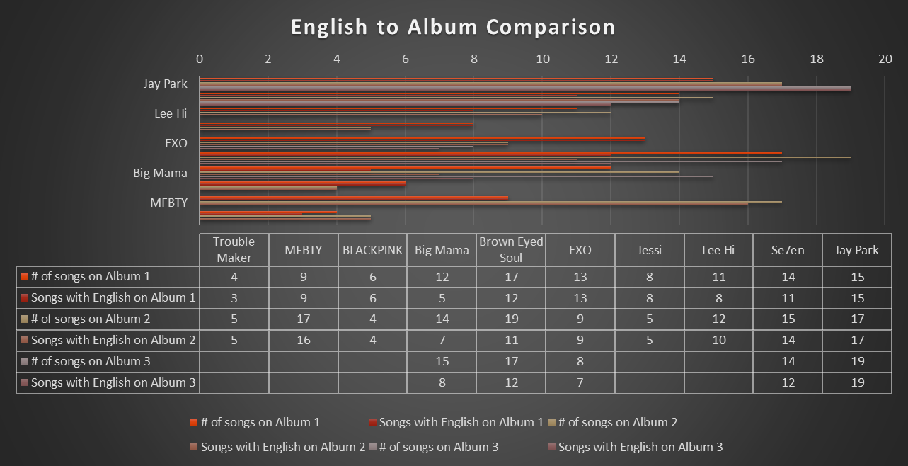

Figure 8. Individual comparisons of English use by artist, per album.

Alternatively, within hip-hop, English was also used to convey authenticity and one’s “right” to record in this genre.

Figure 9. Use of English profanity within all albums by artist.

For example, In the songs “New Breed Intro” and “Who the Fu*k Is You?”, aggressive and hard-hitting beats are the backdrop for Jay Park doggedly declaring that he is serious about his craft and has earned his spot within the colloquially termed hip-hop game:

“New Breed” verse 1: Y’all motherfu*ers don’t know me at all, I’ll make that good music leave the other sh*t up to ya’ll.

“New Breed” verse 2: I’m hip-hop just for the record and I got respect for people who put that real sh*t in their music and they go and use it to share with the world they influence. I speak the language of truth, and yes I am so fluent, And I am sick with rhymes like I always got a flu bit*h.

“Who the Fu*k Is You?”: WTF, I’m not trying to do hiphop, This isn’t acting or a concept, whatever I do, it’s hiphop.

Due to the preferred “clean” nature of the Korean music industry, curse words and profanity are used sparingly. These versions are often only heard on the album and a profanity-free version is given radio play. Among the three (3) hip-hop artist’s discographies, profanity was used in twenty-four (24) of their songs (see Figure 9). Unsurprisingly, English profanity was also present in one (1) R&B song, “FXXK Wit Us” by Lee Hi, which featured guest rapper Dok2, as Dok2 is known to create profanity-laced verses. Cursing was also heard in two (2) of BLACKPINKS songs; the semi-hard-hitting R&B/pop break-up song “See U Later” and an ode to youth and living life, titled “Forever Young.” Finally, colloquial English language use was ripe across all artists. The words “swagger,” “bling,” “playa,” “booty,” “bboys,” and “thots,” among others, that one would expect to find in the American urban dictionary were included in songs. Similarly included were the phrases “real recognize real,” “slow your roll,” and “hit you with.”
In many cases, the use of English seemed unnecessary. As a reason for the use of English, Russell further noted what may be considered a challenge to writing song lyrics in Korean and fitting the Korean language into these genres. He remarked, “writing melodies for the Korean language forces the songs to reflect the language, often with more syllables in a line than you’d hear in other languages.” Perhaps it is due to this multi-syllabic aspect of the Korean language that English additives are used for ease and shortness of length. A study on rap in Holland shared that local rappers felt that English was a requirement of hip-hop. A local rapper was quoted as saying “you have to stick to the rules of hip-hop. Hip-hop has its origins in America, so you have to rap in American slang. That’s the rule.” Though not explicitly found in the research of the selected Korean artists, perhaps this is an unwritten and/or unspoken rule for Korean rappers as well. In looking at how the Korean community considers this question; fan speculation is that English is used because such lyrics are easier to remember than Korean verses. The use of English makes the lyrics more “public friendly and easier to remember” as similarly can be surmised by Russell’s statement. Others speculated that it is part of a broader trend to intersperse English into everyday Korean phrases, because it is cool and connotes an upper-class status or creates catchier lyrics that may appeal more broadly to international artists. Another fan inferred, as I do, that the use of English is connected to the origins of K-Pop. Since much of the sound from these genres came from American artists, the fan speculated that “Korean singers copied the styles of American music.” Finally, for Korean-American artists such as Jay Park and Jessi, perhaps the use of English is another representation of their continual straddle between (and representation of) two worlds – American and Korean.
R&B and hip-hop have crossover within several constructs of their genres, such as the exemplification of collective community, with guests on the song or the perception of friends being present in the videos. Collective community is also demonstrated by making local references about the world around them and in which they live. In building local connections, artists referenced landmarks (e.g. Seoul Tower), food (e.g. kimchi and bibimbap), and endearments (e.g. oppa and unni). If the artists are Korean-American (e.g. Jay Park and Jessi) or are Korean but lived and/or were raised elsewhere and have re-established themselves in Korea (e.g. Tiger JK and Bizzy of MFBTY), their songs include acknowledgement of arriving to Seoul from elsewhere in the world. The music community also shows support and acknowledgement of each other’s skills by giving “shout outs.” Guest rapper Changmo references Korean-American rapper Jay Park in Jessi’s song “Boing.” Several songs by different artists included guest features, such as “Goodbye” by Se7en featuring fellow R&B singer Gummy, “Sweet Thing” by Brown Eyed Soul featuring rap groups Dynamic Duo and Epik High, and a cypher-like mashup with several guest rappers in “BuckuBucku” by MFBTY. These guest artists either complemented the primary artist by also performing within their same genre or had an opportunity to showcase their own rap or R&B style – flow, voice – and lyricism.
A core tenet of the idea of cultural hybridity is the ability for a foreign component to be adapted as necessary and embedded into the dominating culture. The inclusion of “local iconography of artist’s performance” such as acknowledging national historic sites, sports teams, and foods; as well as featuring Korean rappers rapping predominantly in Korean highlight these adaptations and embedding processes. In the continuing conversation around popular music it has been stated that “all global popular culture genres have national and local variants...and the more globalized the world gets; the more popularly oriented local culture becomes.” The “Koreanness” of Korean hip-hop and R&B are exemplified the strongest, when the artist’s speak on topics, issues, and/or make references to pop culture items and icons that the larger populace feel an affinity towards.
In terms of musicality and vocalization techniques, instrumentation and the “family” of musical instruments that producers tended to utilize continually set the tone and alluded to the period of American R&B and hip-hop that songs emulated. Of note is that there were also songs where traditionally Korean instruments and sounds were integrated into the production. For instance, “날아오르다” (Track 6) on It’s Unique by Big Mama shifts the album to this more traditional, Korean folk sound.
For R&B, several additional genres such as blues, jazz, and gospel are included. The sound also travels across eras. Depending on the artist, music reminiscent of 50s Doo-wop (The Chantels and The Teenagers), 60s Motown (Sam Cooke and Marvin Gaye), 70s and 80s Disco (Tina Turner and Donna Summer), and of course, 80s to early 2000s smooth R&B á la Anita Baker; Kool and the Gang; Sade; Earth, Wind, & Fire; Chaka Khan; and Babyface were apparent. Specifically, the sounds of Lauryn Hill, Boyz II Men, and Brian McKnight seemed especially referenced in the reviewed discographies. R&B instrumentation makes the strongest use of the percussion and brass families accompanied by members of the keyboards and harp family. Throughout all songs were presence of cymbals creating a “snap” sound, use of horns along with a finger snap for emphasis, slow or mellow guitar, piano, drums, heavy bass, and synthesizers. Additionally, saxophones from the woodwinds gave jazzy or bluesy feels, and were in the background of slow rolling rhythm along with violins. Scat singing made famous by Ella Fitzgerald, Dizzy Gillespie, Betty Carter, and Louis Armstrong was applied by Big Mama, Lee Hi, and Brown Eyed Soul. Brown Eyed Soul and Big Mama also showcased their vocal expertise via four-part harmonies and singing acapella in songs “북천이 맑다커늘” (Track 1) of Soul Free and “Wish” on It’s Unique respectively. There were several classic ballads where instrumentation was minimal, primarily with an accompanying piano, and focus was on the artist’s voice.
There was also the presence of Black-sounding gospel choir backing groups in “The Lord in the Storm” by Brown Eyed Soul feat. the Heritage Mass Choir and “Goodbye” by Se7en feat. Gummy. Se7en was one of the earliest artists to specifically style himself as an R&B singer. His look and sound are noticeably influenced by artists such as Michael Jackson. The all Korean-member Heritage Mass Choir acknowledges that they developed their musicianship based on Black gospel choral arrangements in the United States. Lastly, the use of falsetto voice by male singers and vocal embellishments made famous by Whitney Houston and Mariah Carey by all singers were noted. With some songs, artists altered the vocal embellishments with high to low runs.

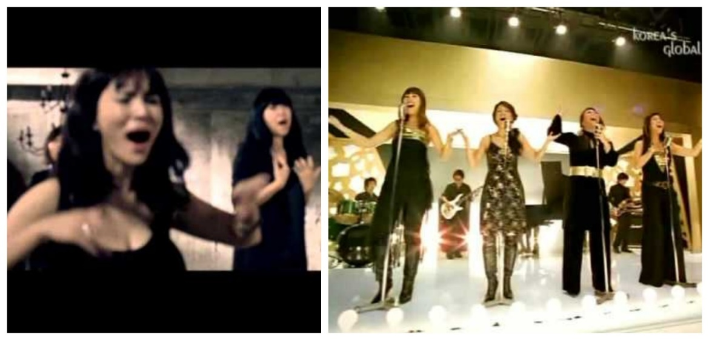
Figure 10. Big Mama vocal embellishments & gestures. Sources noted in Appendix 2.

For hip-hop, delivery is just as important as musical arrangement. Jessi’s rapping voice is deeper than her speaking voice which is reminiscent of the delivery styles of rappers Lil’ Kim and Foxy Brown. In terms of lyrical content and oratory styling, a Korean fan believed that Jessi’s sound is similar to rapper Nicki Minaj. As previously noted, artists also take an opportunity to cement their place within Korea’s hip-hop hierarchy by asserting their skill and dominance, calling out detractors, assuring that they will always keep it real and “will never be a sellout” and paying lyrical homage to American rappers to highlight their history and understanding of the genre. Jessi does so in “Spirit Animal” and “Arrived,” MFBTY includes such lyrics in “BizzyTigerYoonmirae” and “All In Together.” To illustrate, in “BizzyTigerYoonmirae” rapper Yoon Mi Rae (aka Tasha) says “I represent the ROK but my name not Hova.” This is a lyrical twist and reference to American rapper Jay-Z who also calls himself Jayhova, a portmanteau of Jay-Z and Jehovah, to imply his “god-like” lyrical mastery in hip-hop. Jay-Z also owns a production company named Rocafella records, called ROC for short. Often in his songs Jay-Z shares how he represents the Roc. For Yoon Mi Rae, she is representing the Republic of Korea (the official name of South Korea). The nuance is in the meaning of ROK and Roc.
Hip-hop instrumentation made use of primary reliance on the percussion; brass; and keyboard and harp families. As is common within hip-hop beatboxing, DJ scratching, heavy basslines, synthesizer, horns, “clapping” beats, finger snaps, and whistles; and syncopated drums were all part of the musical arrangements. There were inclusions of other genres made popular within the African Diaspora employed such as reggae in “Rebel Music” by MFBTY and Afro-Caribbean kompa, soca, and calypso in “As If It’s Your Last” by BLACKPINK.
The music is the heart of the song and the musical sound is where the appropriation of Black form is the strongest. The traditional sounds of Korean music found within minyo, chapka, kugak, pansori, kasa, and even trot music does not sound like the music used in these songs. Big Mama was the only artist that had two songs that seemed to incorporate traditional Korean sounds, a method many producers call ppong or ppongkki. Most of the songs listened to, are what ethnomusicologist Michael Fuhr categorizes as flow-oriented. They were “beat-driven, often with a continuously looped rhythm pattern throughout, heavily influenced by hip-hop production while paying more attention to horizontal organization (i.e. groove, layering of sound patterns) than harmonic progression and melodic contours.” For hip-hop songs, the “rap vocals [were] mostly dominant and [defined] the song’s flow and dynamic, whereas the instrumental groove and dynamic remain relatively static and are only interrupted (if at all) by rhythmic stops, short breaks, and the more melodic chorus part [that can be] described as ‘non-teleological’ groove.”
Though this is more highly expected when using European and Western producers, several albums (e.g. Lee Hi’s First Love) were created entirely by Korean producers and still have a heavily-American R&B and/or hip-hop sound. For many Korean producers and up-and-coming Korean idols in the 1990s, Michael Jackson was the gold standard of success and musicianship. In various interviews, Korean producers shared that they were further inspired by Black R&B artists such as Whitney Houston, James Brown, Janet Jackson, Erykah Badu, Donny Hathaway, Jazmin Sullivan, Lauryn Hill, Mariah Carey, Pharrell, Bobby Brown, and Beyoncé; and Black hip-hop artists and Black music labels such as “Blu, Kendrick Lamar and all of TDE, A$AP Rocky, Danny Brown, Childish Gambino, G.O.O.D music, and MMG.”
Due to close similarities, producers and artists have found themselves as part of plagiarism allegations, controversies, and copyright infringement court appearances around their songs. As such, this “modeling of K-Pop songs, especially after American pop songs in their adoption of Black music idioms, dance rhythms, rap vocals, and English language use, means many listeners view K-Pop as a product of mere imitation or Americanization.”
A part of musicality is also the arrangement of the songs. Music sampling is common within the worldwide music industry. All the Korean artists reviewed, sampled components of a song by an African-American artist or Black artists within the diaspora (e.g. Jamaica) in their discographies. Russell remarked that “a popular trend at the moment is to create songs that almost sound like mash-ups of three or four different songs stuck together at random...It’s a hyperactive style that has long been popular in Korean discos, where you often get just minute segments of a song before the deejay quickly moves on to something else.” It is presumed that the multiple producers on the albums all imprint the song lyrics and arrangements with their interpretations of R&B and/or hip-hop. The resulting interpretations and mash-ups were readily present in this review.
Within several songs, two or more songs by Black artists were identified as having components of those songs incorporated by the Korean artists. Songs by European and non-Black artists were also identified as being sampled, such as “Candy” by Brown Eyed Soul sampling “What You Won’t Do for Love” by Bobby Caldwell and “1234” by Lee Hi sampling “A Girl Like You” by Edwyn Collins. However, these samples were not included in the tracking count (see Figure 12). One example from each artist is noted below:

Table IV. Example of Korean Artist Song Sampling
Artist | Song | Sampled Song(s)
Jay Park | Nana | Summertime by Will Smith
Se7en | I Just Wanna Be | 1. Shut ‘Em Down by Public Enemy  2. If I Ruled the World by Nas feat. Lauryn Hill
Lee Hi | Fool for Love | 1. Dance with My Father by Luther Vandross  2. One Sweet Day by Boyz II Men
Jessi | My Walk | 1. Don’t Let Me Be Misunderstood by Nina Simone  2. A Clock with No Hands by The Roots
EXO | XOXO | Girlfriend by Bow Wow and Omarion
Brown Eyed Soul | 그대와 둘이 (Track 16) | 1. Just the Two of Us by Grover Washington Jr.  2. Never Too Much by Luther Vandross
Big Mama | Wine | 1. Sweet Love by 112  2. Bump & Grind by R. Kelly
BLACKPINK | Boombayah | DJ Got Us Fallin’ In Love by Usher feat. Pit Bull
MFBTY | Time Travel | 1. Back in the Day by Ahmad  2. Ooh La La La by The Fugees  3. Set Adrift on Memory Bliss by P.M. Dawn
Trouble Maker | Don’t You Mind | 1. Tender Love by Force M.D.  2. With You by Chris Brown

In focusing on only songs by Black artists, sixty-six (66) musical samples were identified in thirty-nine (39) songs out of two-hundred ninety-nine (299) singles. Often, I made the notation that several other songs had melodies that sounded similar to American R&B or hip-hop songs but could not be readily identified. As such, there could be more than sixty-six (66) samples across the twenty-five (25) albums reviewed.

Figure 11. By Korean artist, the number of songs that include samples.

Figure 12. Number of identified samples within songs.

This is the hardest place for one to make an argument that Korean music practitioners are being innovative and creating something new, when the groundwork for that “something new” is built on the mixing of several Black songs. If it was a merger of Korean and Black sounds, perhaps that argument would have more merit. However, mixing the melody and rhythms of songs originally sung by artists such as Aretha Franklin; Chaka Khan; and Earth, Wind, and Fire; is still only a song with Korean lyrics over the music of Aretha Franklin; Chaka Khan; and Earth, Wind, and Fire. It was also noticed in the album review that some beats and melodies were sped up or slowed down which could make identification difficult, but the sound was still recognizable.
With the rise of K-Pop during Hallyu in the 1990s, Korean composers looked abroad to find songs with beats and melodies that differed from the ballads and ballad-pop style music dominating Korean airwaves. They engaged in several methods to manufacture new music. One method was to collaborate with overseas producers, songwriters, and composers to create customized songs for artists. Another was to purchase the rights to original songs within their backlogs which had not been “previously released by someone else but were also not intentionally written for a specific K-Pop artist.” Finally, the method that seems to be the most popularly used and was present across the discographies reviewed, is to purchase licensing rights in order to create “cover songs, remixes, and adaptations of songs that were previously released by other artists.” In the beginning (e.g. early 90s) this may have been the most practical method. However, the Korean music industry has had over twenty-five (25) years to hone its sound and style. Yet, it does not seem to have progressed passed borrowing from its Western and European counterparts, especially from African-American and Black Diaspora artists. Though the processes and need for certain types of music has changed, the main priority to “find the best song available” has stayed the same for composers, and often the “best song” is performed by a Black artist.
Aside from sampling, select verses or lyrics from Black artists found their way into songs by almost all artists. Big Mama and Trouble Maker are the only groups that did not borrow, adapt, or directly copy lyrics from a Black artist. Jay Park uses the line “Started from the bottom now we’re here” in “1 Hunnit” which is also a song of the same title by rapper Drake. Se7en repeats Missy Elliot’s hook from “Work It” in the introduction to Just Listen. He also directly quotes lyrics from Mary J. Blige feat. Lauryn Hill’s song “I Used to Love Him” and “You Are Everything” by the Stylistics in Must Listen. Lee Hi borrows from The Impressions in “Fool for Love.” Jessi uses lyrics from “Feeling Myself” by Nicki Minaj feat. Beyoncé in “Arrived.” Looking to a Black female artist, EXO uses lyrics from Rihanna’s song “Diamonds” in their same named track in The War. Reinforcing their American R&B foundation, Brown Eyed Soul uses lyrics from “Can You Stand the Rain” by New Edition. BLACKPINK uses the well-known verse “Why you wanna go and do that?” by group A Tribe Called Quest in their single “Find a Way.” Like Se7en, on the album The Cure, MFBTY visits Missy Elliot’s “Work it” and they use the drum vocalization – “pa rum pa pum pum” – in their song “BizzyTigerYoonmirae.” Their multi-sampled track “Time Travel” also uses lines and lyrics from the same named songs “Back in the Day” by Ahmad and “Ooh La La La” by The Fugees. In a unique instance of multi-generational borrowing, for their song “Forever Young” BLACKPINK samples the melody from Korean artist CL’s (of girl group 2NE1) single “Lifted.” However, CL originally sampled this melody from American rapper Method Man of Wu-Tang Clan.

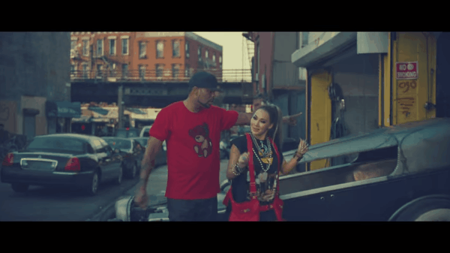
Figure 13. Method Man’s cameo in CL’s video for “Lifted”. Source noted in Appendix 2.

Name dropping of well-known American artists was employed. As previously noted Yoon Mi Rae of MFBTY mentions Jay-Z. In several songs, Jay Park mentions American singers he finds attractive such as Beyoncé, Rihanna, and Tinashe. I infer that to highlight their interest in Black music, Brown Eyed Soul decided to use Black artwork for the album covers to Soul Free and The Wind, The Sea, The Rain (see below).
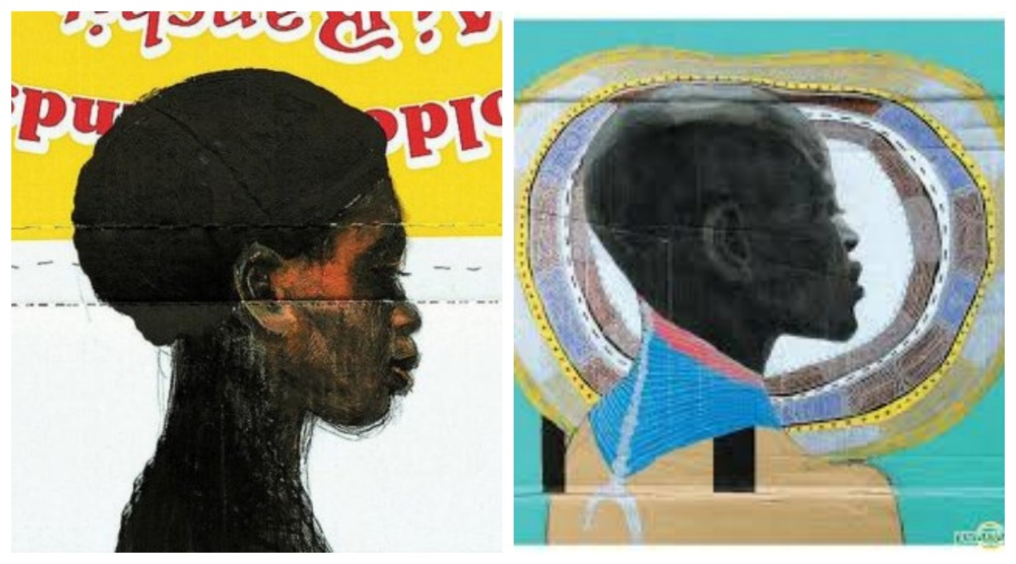
Figure 14. Album covers for Soul Free (2003) and The Wind, The Sea, The Rain (2007) by Brown Eyed Soul. Source noted in Appendix 2.

Finally, a few artists looked outside of the country for guest features. For instance, Jay Park collaborated with three non-Korean artists; Trini-American rapper Trinidad James, African-American rapper Raz Simone, and African-American singer Cha Cha Malone.
Akin to making local connections, the collaborations provided platforms to highlight the various ways in which hip-hop and R&B is approached by different artists within these genres. The work with non-Korean artists can be seen as a way of legitimizing the presence of Korean artists in this genre. Though it veers into the territories of directly copying lyrics and plagiarism, using snippets of actual lyrics from other artists or adapting them, could perhaps be seen as another way of paying homage. Similar to name dropping icons within these genres, in naming or referencing the work of current American artists dominating the charts within hip-hop and R&B, Korean artists are showing that they are aware of and following current trends but are also on par with these artists. Yet, artists should be careful because actions such as “ appropriating foreign elements [has] created the foundation for claims that remain common today, namely, that K-Pop has been ‘de-Koreanized’ and become ‘culturally odorless’, ‘too white’, and ‘trapped’ as a hybrid form between the national and the global.”
Similar observations were made in other fan reviews and professional reviews of artist albums. Most fan reviews followed my process and evaluated the album track-by-track. Reviews by more professional outlets such as Seoulbeats, Rolling Stone, and Billboard provided overall reviews while highlighting certain singles. These reviewers noted that certain Korean producers have developed a distinct sound and that “one can abstractly decipher each composer’s bread and butter by listening to each one’s interpretation of the R&B & Soul genre.” As each of the big three entertainment agencies are also known for producing a certain sound, those sounds find themselves reflected in their artists. BLACKPINKS’ debut album was noted for having the “tunes that are signature of the YG [Entertainment] family: hip-hop rhythms, addictive beats, bluesy melody, soulful vocals, and no lack of swag.”
The range of sounds and the ability of artist’s with mixed sounds (both hip-hop and R&B within their albums) to shift from being rap heavy with “hard-hitting bits” to a mellow rhythm using acoustic guitar and piano was noted. The many styles encountered in listening to one album from these artist’s range from “smooth R&B to beat heavy rap to downbeat acoustics [that] all share a common character.” The aforementioned ballads that focus moreso on artist’s singing voices were noted in one review as songs that use “a crystalline piano throughout paired with a stripped-down R&B beat. Even when it begins to add a little more, it never takes away from the members’ voices, letting listeners bask in their vocals.”
Discussion about EXO’s album The War acknowledged the ability of certain songs to be “throwbacks” to earlier sounds, such as “Touch It.” Producers felt it “already had such a non-today-ish vibe -- a classic vibe... [They] were like, ‘Yo, this sounds like an old Justin Timberlake, almost Michael Jackson type of thing.’ That old school vibe.” The addition of guest performers was hit or miss across reviews. While some reviewers felt that guests added to a song or albums’ sound, some felt that it overshadowed or detracted too much from the main star(s). Such is the case with MFBTY’s Wondaland, which has nine (9) guest rappers, in addition to the three members of the group. One reviewer felt that though the album was oversaturated in outside voices. They recognized the ability of guests to “contribute to the project and it certainly adds to the eclectic nature of the album, but MFBTY already has three strong and distinctive voices and styles…to have so many other voices clouded the project rather than enhancing it.” Finally, one reviewer cited the composition of “Bang Diggy Bang Bang” by MFBTY as a great example of how the merger of different sounds can create an amazing song. “Listeners are transported to the lands of South Asia with the track’s Desi influence. This is fusion at its best, as the lyrics celebrate the union of different cultures. Extra points for incorporating the members’ names into the chorus for branding power.” The ability of Korean artists to create authentic, respectful, seamless cultural hybridization through such fusion is a component of what this thesis is exploring.

A review of selected music videos, artist interviews, and an overall conclusion regarding the findings from this performance review is included in the next chapter.

Chapter IX
Performance Review, Part II: Selected Singles and Artist Interviews (Random Sampling)

“Music, at its essence, is what gives us memories. And the longer a song has existed in our lives, the more memories we have of it” – Stevie Wonder

As noted in Chapter 8, this review included a mixed methods approach that provided both quantitative and qualitative data relevant to the following research questions: 1) Is the presence of African-American musical stylings in Korean music an example of adoption, appropriation, integration, or something else? 2) Within South Korea, are there particular African-American artists with global appeal (e.g. Run DMC, Diana Ross) who influenced this acculturation? and 3) What is the viewpoint of South Korean practitioners (artists, producers, choreographers) and music listeners (fans, professional reviewers) about the influence of African-American music; is it acknowledged or ignored? The process to answer these questions was dependent on my own personal knowledge and general interest in music, particularly Black music, as a fan and music aficionado.
Where possible the music videos for three songs, one from each album of the ten (10) selected artists (see Table V.), were chosen and viewed. This occurred to assess the visual representation that the artist or their company envisioned for the song. In watching the videos, attention was paid to the choreography, the use of background dancers and their ethnicities, the existence of any props, the theme or concept of the video, the background scenery and filming locations, fashion, and overall aesthetic to the video. Common with African-American R&B songs are videos that tell the story inherent in the song, with the artist often playing a role. It is not surprising to see the use of wind machines, inclement weather (e.g. singing in the rain), and “live” bands or musicians. If the song is upbeat, there is judicious use of background dancers who often play the role of friends. Regardless of the lyrics, Black hip-hop videos depict “real” life with urban scenery highlighting socioeconomic disparity; the “good life” exemplified by expensive homes, several cars, exotic shooting locations and parties full of beautiful people and flowing liquor; or the “club life” where the focus is on the artist being at or going to several parties with their friends, jewelry, money, alcohol, and sometimes weapons on open display. The videos were watched to see to what extent Korean videos may have imitated or adapted this. The music videos for twenty-nine (29) singles were reviewed.

Table V. Selected Single Discography
a. An asterisk indicates the selected single was not on any of the albums listened to.
b. An italicized single means it is not affiliated with an album and was released as a free-standing single.

Artist (debut year): dominant genre | Album name: Selected Single
Jay Park (2008): Hip-Hop | 1. New Breed: Know Your Name (feat. Dok)  2. Evolution: Joah  3. Everything You Wanted: Drive (feat. Gray)
Se7en (2003): R&B | 1. 24/Seven: Be Good to You*  2. Must Listen: Passion  3. Just Listen: Come Back to Me
Lee Hi (2012): R&B | 1. First Love: 1234  2. Seoulite: My Star  3. Seoulite: Breathe
Jessi (2005): Hip-Hop | 1. Get Up: Get Up  2. Un2verse: Gucci  3. Ssenunni*
EXO (2012): Mix | 1. XOXO: Wolf  2. The War: Ko ko bop  3. Universe: Universe
Brown Eyed Soul (2003): R&B | 1. Soul Cooke: Home  2. Soul Free: I Love You  3. BROWNEYED SOUL: You*
Big Mama (2003): R&B | 1. It’s Unique: Woman  2. Like the Bible: Break Away  3. For the People: Never Mind*
BLACKPINK (2016): Mix | 1. BlackPink: Whistle  2. BlackPink: Boombayah  3. Square Up: Dddu-du Ddu-du
MFBTY (2013): Hip-Hop | 1. WondaLand: Bang Diggy Bang Bang  2. WondaLand: BuckuBucku  3. WondaLand: Angel
Trouble Maker (2011): Mix | 1. Troublemaker: Trouble Maker  2. Chemistry: Now  - only released two videos

The final component of this three-part review was to conduct searches for artist and producer interviews. Within the interviews, I paid attention to both the questions asked and how the music practitioners spoke about their work. I made notes of any references to their experience within the world of K-Pop, if they addressed where they receive their inspiration and/or influence, and how the artist talked about the album being promoted or their music in general. Over one-hundred and forty (140) interviews were read and/or watched.

Selected Singles: Music Videos

Energetic live performances and engaging choreography are key elements in Korean entertainment. Producers involved in EXO’s album The War noted the importance of songs being able to meet those criteria in the writing process and how the instrumentation impacts that. In talking about the single “What U Do?”, a producer noted that “[they] tried to create a song that would be danceable and organic sounding with emphasis on real instruments – bass, guitar, piano. The song was really based around the guitars and a simple chord progression. Sound-wise [they] had a reference from another boy band of SM Entertainment’s called NCT, which [they] originally aimed for: danceable, but not ‘synthy.’” Videos are akin to being one step removed from live performances. They are also often the first opportunity for fans to see the choreography and to see how the artist has visually interpreted the song. The videos watched for selected songs from artist’s albums ran the gamut. Some videos such as “Joah” by Jay Park, “Breakaway” and “Woman” by Big Mama, “Be Good to You” and “Come Back to Me” by Se7en, “Troublemaker” by Trouble Maker, and “Home” by Brown Eyed Soul had themes or stories that related to the song.
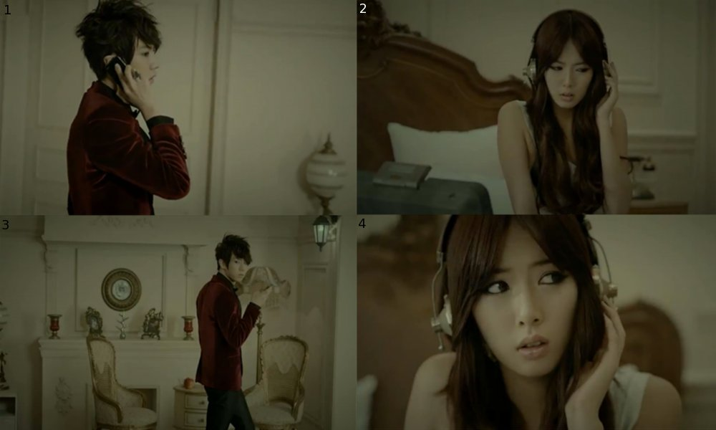
Figure 15. Spying theme of video “Troublemaker”. Source noted in Appendix 2.

Most of the mise en scène focused on a cluster of main characters whose interactions were followed by the camera. For example, Jay Park was the lead character in the video for “Joah.” Surrounded by friends, all wearing “urban gear” – baggy sweatpants, backwards baseball caps, chain necklaces and diamonds in both ears, low-hanging jeans, etc. – they are hanging out together when Jay sees a girl that he likes. The rest of the song follows his attempts to woo her throughout the city. Big Mama are background singers in two of their videos. In “Woman,” they are the singers at a club where a woman is going through a bad breakup. She is being comforted by a friend when she sees her ex-boyfriend with another woman. This apparently takes her to her limit and she attempts suicide. Being a fairly conservative country, the ground miraculously turns into water and the woman falls into the water at the end of the video. In “Breakaway,” it almost seems to be a parody of their own journey in the music industry. It shows their rehearsals and performances as small-time lounge singers with a live band, while trying to break into the mainstream Korean music industry. In both videos, Big Mama employ wide hand gestures and vocalizations exercised by singers such as Whitney Houston and groups such as Brownstone, En Vogue, SWV, and so on. Each of the videos listed above has a narrative with the artists playing either an active or inactive role in the screenplay. However, as is the norm in K-Pop, “there is much less storytelling than in Western music and more of a focus on describing a feeling or metaphor.” As such, many videos focused on having colorful visuals, not necessarily related to the lyrics, and tight choreography. The videos also skillfully showcased the local community. There was a balance between videos filmed throughout the country, particularly in Seoul, and those filmed in studios. “Joah” by Jay Park is the only reviewed video that was filmed outside of the country in Seattle, WA.
Across the board, the choreography had Black influence, from dance moves such as breakdancing, twerking, popping and locking, and in the case of MFBTY’s “Bang Diggy Bang Bang,” sub-Saharan African inspired movements performed by Yoon Mi Rae and the background dancers. Jay Park and Se7en’s dance moves were strongly reminiscent of Michael Jackson and Usher. Some videos specifically had dance breaks where the focus was only on the choreography. Even freestyle gestures, that were not necessarily part of the choreography, but the artist incorporating a movement with his or her oration, were hand and body gestures to convey swagger (or swag), a concept in Black culture that personifies a particular level of confidence and self-expression. Such movements were especially visible in “Know Your Name feat. Dok” and “Drive feat. Gray” by Jay Park, “Gucci” and “SSenunni” by Jessi, and in “Buckubucku” and “Angel” by all members of MFBTY. I noted an affectation of swag mannerisms, by Jennie and Lisa, the rappers of BLACKPINK during their segments in “Whistle,” “Booombayah,” and “Dddu-Du Dddu-Du.” Similarly, at different points in the videos, the twelve (12) members of EXO failed at attempting to personify swagger in “Ko ko bop” and “Wolf.” Though their gestures and how they carried themselves seemed to infer swag, there was something inauthentic in their presentations that felt as if they were putting on personas. For the three artists previously mentioned, conveying swag looked and seemed more natural.
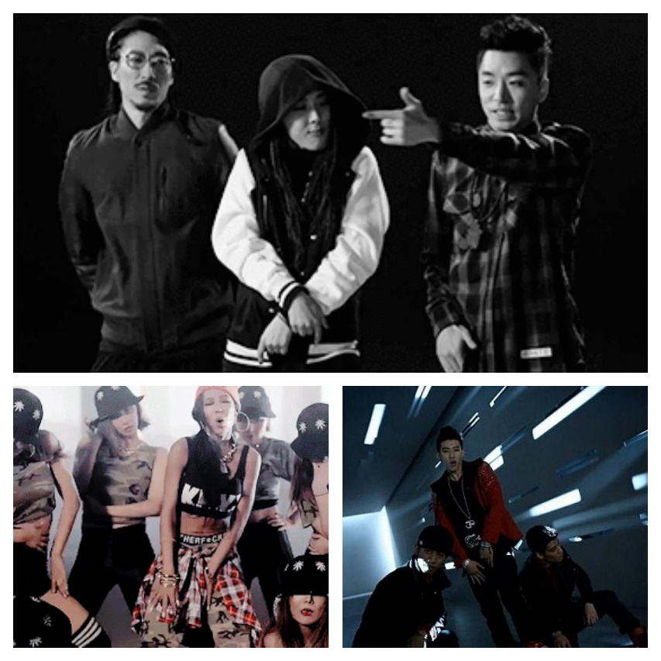
Figure 16. “Swag” collage (clockwise): MFBTY, Jay Park, and Jessi. Sources noted in Appendix 2.

Other aesthetics of the videos include the fashion, visual items and props used, and the previously mentioned idea of collective community representation. Jewelry such as gold chains, oversized initial jewelry pieces, bamboo and hoop earrings were all present for Jessi, Jay Park, MFBTY, Se7en, EXO, and BLACKPINK. Previously mentioned dress such as backwards or tilted baseball caps, low-hanging jeans, bandanas and fedoras were also elements of video wardrobes. In one sequence in “1234” Lee Hi’s background dancers are shown in so-called B-boy gear. Se7en adapted Michael Jackson’s one-glove fashion and wore it in “Passion” and “Come Back to Me.” He also wore baseball caps with do-rags underneath, fedoras cocked to the side, and baggy jeans. Similarly, Jay Park channeled Michael Jackson with the choreography and style for “Know Your Name.” Specifically, he wears a red jacket similar to one worn by Jackson for the song “Beat It” and has isolated all-male choreography as occurred in Jackson’s video. Hair styles are an important part of fashion. EXO members had braids and wore bandanas under fedoras in “Wolf.” A member sported dreadlocks in “Ko ko bop.” BLACKPINK members wore rainbow-colored braid clip-ons in “Boombayah.” In “Angel” rapper Tiger JK wears two braids, a style made famous by American rapper Snoop Dogg.

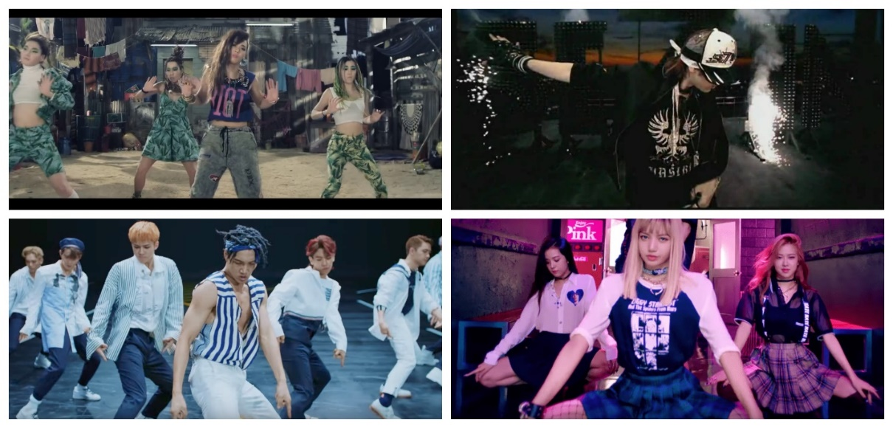
Figure 17. Video choreography and hairstyles (clockwise): MFBTY, Se7en, BLACKPINK, and EXO. Sources noted in Appendix 2.

For a rap sequence in “Boombayah,” rapper Lisa is in an enclosure that appears surrounded by trash and broken musical equipment. In scenes of “Joah,” Jay Park sings and walks through areas covered in graffiti. MFBTY perform parts of “Bang Diggy Bang Bang” in an abandoned warehouse and side alley. Lee Hi walks through an ever-changing soundstage set with one section covered in graffiti in “1234” similar to how Janet Jackson traverses a soundstage in the video for “Alright.” Ballads such as “Breathe” by Lee Hi and “Universe” by EXO incorporate the solo spotlight camerawork/videography well-known in such slow tempo videos. Lee Hi’s visuals are pared down, the camera mainly focuses on her singing in an empty auditorium. EXO members are separated and spotlighted in solo vignettes before the group comes together at the end.
The idea of collective community is encompassed in the friendships highlighted in the R&B videos and the guest features in rap videos. Jay Park hangs out with friends and fellow members of his breakdancing crew in “Joah.” Big Mama highlight the warmth and support within their own friendship in “Breakaway.” Se7en is surrounded by friends, ready to have a fun night out in “Passion.” In “Boombayah” BLACKPINK and friends enjoy themselves at the roller skating rink. In “Whistle,” the four members dance and sing in the car, having a “with my girls” moment similar to Janet Jackson’s “You Want This” video. They also ride bikes together, similar to Snoop Dogg in “Gin & Juice.” MFBTY are surrounded by friends and fellow rappers in “BuckuBucku” which has a simple video theme of everyone coming together and showcasing their skills. There is a more celebratory, block-party hang-out vibe in “Bang Diggy Bang Bang.”
The theme within certain videos as well as visuals and background images seem to support the continued evolution of a noted trend in the 1990s of Korean music. That trend is that “popular music is moving from aural to visual.” Having bright and colorful soundstages or livescapes of local geography seem aimed to catch and keep a viewer’s interest. As part of the “formula” for making hit videos, there are “two immediate attention grabbers; the visual and the hook, [and] you get them both at the same time.” That the hook is either in English or reminiscent of Black R&B and/or hip-hop is unsurprising.
According to ethnomusicologist Sarah Morelli, “Korean [artists] are not so much uncritically mimicking Black culture as they are (with the help of the record industry) appropriating it and using it as a guide to fashion similar musical products for their own use.” Choreography is a solid example. “K-Pop dance can be described as a mixture of different dance styles, especially hip-hop, often simplified to more minimalistic dance patterns, choreographed for group performance, and combined with characteristic gestural movements.” As such, the choreography already had an African-American foundation, with the influence of jazz, hip-hop, and other Black styles, yet the accompanying dress and swag movements of the dancers and artists reinforced this foundation. Michael Jackson’s moonwalk is an example of an iconic or signature dance move. Korean choreography also emphasizes dynamic formations and the creation of signature moves that are unique to a song; American equivalents are the hand rolling gesture and body spins in Tina Turner’s song “Proud Mary,” the hammertime dance in M.C. Hammer’s song “U Can’t Touch This,” and the booty shaking dance for the song “Da Butt” by Experience Unlimited (E.U.). Similar to the creation of dances like the dougie, harlem shake, and the whip and nae nae, these moves create a direct relationship for the viewer between the song and artist. Such “extramusical elements of dance music are just as important as the dance music itself in fostering image and creating meaning within this social context.”
To a degree, the fashion observed in the videos is not surprising. Since the early 1990s when hip-hop and R&B began their global treks around the world, the visuals provided by American artists were adapted by their international counterparts. As it relates to fashion, swagger is “a popular term used within contemporary youth culture that refers to the performance of style, involving knowledge of what to wear and how to wear it. Swagger is also closely associated with urban grime music and hip-hop culture. Swagger, therefore, is a performance and an aesthetic that can be seen to signify classed, gendered, and racialized positions.” As genres and in creating collective communities within their genres R&B and hip-hop “constitute a global urban subculture that has entered people’s lives and become a universal practice among youth the world over...Looking at some of the predominant visual signs of urban youth in the streets of Sofia, New York, or [Seoul], it is easy to recognize the casual fashion styles of oversized, baggy pants, sloppy T-shirts, baseball caps, and other accessories associated with hip-hop.” It is only a given that these same visuals are found within videos. “These sounds and signs bear witness that, contrary to the brief existence many predicted, rap [and R&B] music [have] not only taken root firmly in the vocabulary of contemporary popular music but defined [themselves] as specific artistic idioms in both visual and musical terms.”
The connotation of swagger is distinct within Black culture and Black performance. Merriam-Webster dictionary defines swagger as “to conduct oneself in an arrogant or superciliously pompous manner especially: to walk with an air of overbearing self-confidence; arrogant or conceitedly self-assured behavior.” Relating to Black culture, swagger adheres to this traditional definition and elevates it. “Within hip-hop speech communities, swagger basically maintains the general sense of its standard definition. However, the “walk” or “walking” has been transformed into the total projection of one’s public persona. Thus, swagger is a comprehensive, boastful, stylistically arrogant, and somewhat effortless presentation of self in the public sphere.” MFBTY, Jay Park, and Jessi, artists who – perhaps due to their experiences in the United States or sincere affinity for the music – exhibit swag naturally. Within their performance, it did not seem fake or a “front” (i.e. facade) that they were employing to create additional interest in their music videos. Their swagger movements and gestures seemed like natural extensions of their performance personas. However, swagger looked like an ill-fitting coat that was tried on by BLACKPINK and EXO. Their attempts were textbook examples of faux presentation and incorporation. None of the members seem to have an actual understanding or natural acculturation to swagger. Again, “they’re just imitating what they see. Without understanding a culture and its meanings, [it creates] an endless cycle of appropriation.”

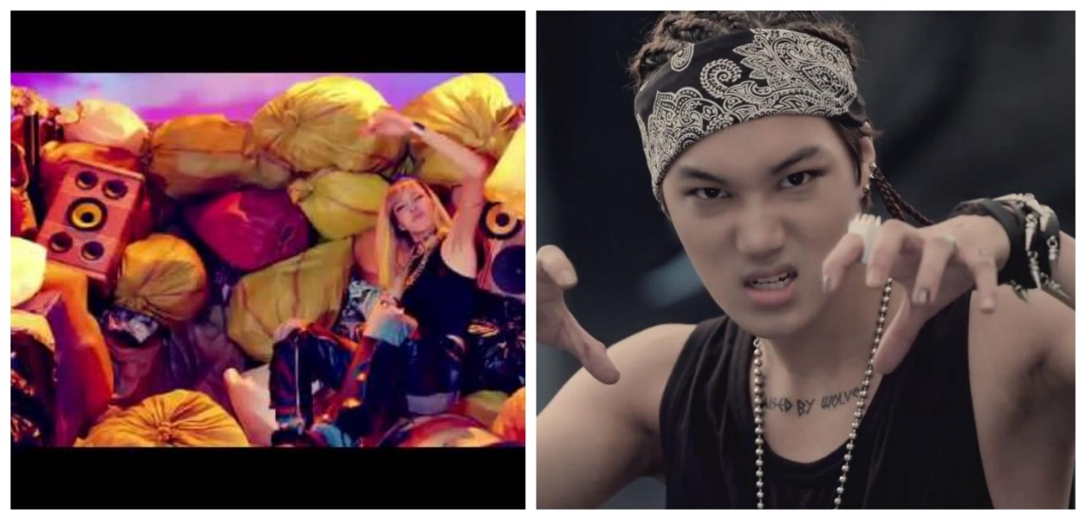
Figure 18. Imitation swagger by BLACKPINK and EXO. Sources noted in Appendix 2.

One unfortunate side-effect of borrowing from U.S. hip-hop [and R&B] is the appropriation of what is perceived to be Black American culture, as is evident in [Korean hip-hop and R&B] music videos. Despite the racial diversity that shaped hip-hop [and R&B] history, Korean hip-hop [and R&B] often look single-mindedly toward Black culture as source material for [performance]. The use of the word “side-effect” here does not suggest that such appropriation is guiltless. In fact, the argument for Korean racial naïveté is a cop out. Feigning ignorance of racial stereotypes (i.e. because of a lack of “contact” with dark-skinned foreigners — which is not historically accurate) is a mechanism for avoiding critical examinations of racism in Korea. It is understandable how, in [their] gestation phase, [Korean hip-hop and R&B] came to appropriate elements of U.S. Black culture given the aforementioned imitation of “real” American hip-hop [and R&B]. What is inexcusable is the continued, intentional appropriation of Black culture to this day.

When such actions are repeated on the albums, in the music videos and in the live performances, it also raises the question of “where is the line between cross-cultural influence and cross-cultural theft?’’ Such repetition and continued appropriation also affirms the needs for spaces to rightly call out and question performers and producers for their lack of cultural sensitivity, cultural awareness, and proper recognition of the artists’ whose original work their successes are built upon.

Artist Interviews

How the artists themselves do or do not talk about their craft is a key/telling factor in the question of blind appropriation, semi-acknowledgement, or full accreditation for the development of their crafts. Interviews conducted by media companies, magazines, fan sites, and general artist question and answer (Q&A) on social media platforms (e.g. artists answering fan questions on Instagram or Twitter) were searched for and reviewed. Both written and video interviews were considered. Aside from general interviews for the artist, searches were also conducted for interviews promoting their music, and looking for specific keywords. Online searches began with the artist’s name and a key word such as “R&B,” “hip-hop,” “inspiration,” “sound,” and “influence.” However, these searches quickly revealed that responses were outwardly facing, i.e. results showed fans or others speaking about the artist.
The search was then modified. Sample online searches then included the artist’s name and specific phrases such as “R&B influence” and “hip-hop inspiration,” or more general phrases like “music inspiration,” “artistic sound,” “music influence,” and “music idol.” In total, one hundred forty-two (142) interviews were read or watched, ranging between ten (10) to fifteen (15) interviews per artist. There were two exceptions. Over twenty (20) interviews were reviewed for information for Brown Eyed Soul and Big Mama. I tried to look at, at least ten (10) interviews per artist. Using the various search phrases, I quickly gained an idea of what types of interviews would be found and the questions asked of the artists. If it seemed that interviews continually asked variations of the same questions and musical inspiration or process was rarely mentioned by the artist, then the search would stop below the fifteen (15) mark. If it seemed that I could not find any interviews longer than one minute if they were videos, or that only asked two or three questions, then I looked at closer to fifteen (15) interviews to try and find quality interviews.
I only needed to look at ten (10) interviews to see that Jay Park and MFBTY are purposeful in sharing how Black music has influenced their craft. In one of his public facing biographies, Jay Park’s inspirations are noted as “Michael Jackson, Usher, and Chris Brown.” As a Korean-American raised in the western United States (Seattle, Washington), Jay Park often finds himself in the dual role of having to assert and define his “Koreanness” but also his right to perform in nominally African-American genres. He acknowledges that there is a duality of stereotypes based on his citizenship; in Korea and Asia Jay Park is considered a hip-hop artist/rapper. In the United States, he is considered too Korean. His response is that he is “doing me and [to] have people figure out who I am and what type of artist I am.” Being raised in the country where hip-hop was founded and developed has given him a unique understanding of the history and nuances within the genre. He was exposed to hip-hop at a young age, when a cousin allowed him to listen to rapper Warren G.’s song “Regulate”, and his interest grew from there, which included him joining a breakdancing crew in Seattle. In responding to questions about “real” hip-hop and his thoughts on hip-hop culture today, Jay shared that he and everyone around him appreciates hip-hop culture and does not take it for granted.
He emphasized the importance of those who are part of hip-hop culture to “really, truly [be] themselves and authentic.” For himself, he emphasized the need to “represent right; Asian dudes can be swagged up too. We can rap as well...just as good as the next man.” Finally in sharing some of his hip-hop knowledge, Jay Park revealed his thoughts on Jay Z’s The Black Album, Kendrick Lamar’s Good Kid, Mad City, and Tupac’s All Eyez on Me; what he considered to be three (3) classic rap albums. His reasoning on why he considers these albums “classic” reaffirmed his due diligence in continually educating himself on the nuances present in hip-hop music and hip-hop culture.
MFBTY is made of a group of friends with similar backstories to Jay Park. Individually they have been recording music since 1995 (Tiger JK), 1997 (Yoon Mi Rae [Tasha]), and 2000 (Bizzy). They came together as a collaborative in 2013. Though born in Seoul, Tiger JK was raised in Los Angeles, CA; Yoon Mi Rae (who is biracial; half Black and half Korean) was raised in Fort Hood, TX; and Bizzy was born in New Zealand and raised in Washington, D.C. Their upbringing and occurrences that they were part of, such as Tiger JK living in Los Angeles during the 1992 riots after the Rodney King verdict and Tasha’s father being a deejay exposing her to various sounds of music and creating a broad appreciation for music, definitely influenced their sound. Such immersion and exposure to lesser known names such as The Black Moon, Artifacts, and being able to see up-and-coming artists such as Tupac perform live allowed their connections to hip-hop, R&B, jazz, etc. to feel and be more organic. For them it is as simple as having “grown up on it [because what] really got [them] about hip-hop was that you could be yourself.” This relationship to and with hip-hop also makes MFBTY one of the few groups researched in this performance review to be cognizant of the content of their lyrics and to stay true to rapping about topics that are relevant to them. When describing the sound of the album Wondaland, Tiger JK shares the nuance that “it’s more pop like a Black Eyed Peas record: hip-hop and rap are still at its core, but the beats are big, the themes are universal, and the energy is fun.” He also makes clear that the content is relevant to MFBTY by asking off-handedly, “‘what would we rap about, dropping molly?’ JK continues. ‘It just don’t fit, it’s not real.’”
Their range of influence is broad, their inspirations varied, and the styles and artists from whom they have observed, practiced like and sometimes practiced with for their craft differ by individual taste of each member. This includes Slick Rick, A Tribe Called Quest, Tupac, Notorious B.I.G., Jay-Z, and Wu-Tang Clan. As with several of the above-mentioned artists, especially Tupac, there are times when their raps address societal issues. The song “Rebel Music” is unique in that MFBTY was inspired by the events surrounding the murder of unarmed Black youth Trayvon Martin in the United States by a white (ethnically self-identified) security guard, which progenerated the “Black Lives Matter” Movement in the U.S. They built on this inspiration and pivoted their message to address issues of “journalism, South Korean censorship, and politics.” In speaking broadly at work within the Korean music industry, the members continually circled back to the importance of authenticity and integrity. They shared “you have to love it, respect it, and dig deep and find your voice – your voice, not theirs.”
Conversely, I only needed to look at ten (10) and twelve (12) interviews for EXO and BLACKPINK respectively to see that such questions were rarely, if ever, asked of them and that the members did not attempt to expound on such topics themselves. With BLACKPINK, hitting such a wall was especially frustrating as this is a relatively “new” group. As is the case with K-Pop groups, the members of BLACKPINK have been in “training” with their agency for four (4) to six (6) years but only recently debuted in 2016. Yet, nothing in their interviews or the interviews examined for EXO included questions about their musical tastes, preferences, or inspirations. Instead questions revolved around their group chemistry, likes and dislikes, hair, makeup and outfits, and their extracurricular or de-stressing activities. Even interviews that focused on promotion of a particular album did not have questions that delved into their personal thoughts or feelings about a particular song. Questions were very top-level and outwardly focused; with interviewers asking what they hope fans like or get out of the album.
Twelve (12) interviews of Korean-American rapper Jessi similarly revealed that while interviewers were interested in hearing about her journey from New Jersey to Seoul, they were more interested in hearing about her favorite things and relationships with her fans.
The eleventh (and final) interview found for Lee Hi was where she shared her musical influence and thoughts on the Korean R&B scene. Similar to her response in the Red Bull mini-documentary Seoul Music: The Rise of Korean R&B, Lee Hi reiterated her belief that Korean R&B (or K-R&B) is a subcategory of the genre that “artists in Korea have changed into [its] own unique style.”
The interviewer asked two (2) key questions that I was hoping to find in some variation across all interviews. He asked: 1) What inspires your sound and how does it differ from typical K-Pop/other artists? and 2) Which musicians, or people in general, inspire you and your artistry? Lee Hi gave a general answer to the first question, sharing that she listens to different types of music and incorporates her favorites from each to create her own sound. In the follow-up question, “off the top of [her] head” she lists some of the many artists that influence her artistry. They are “Anita Baker, Michael Jackson, Erykah Badu, Beyoncé, Rihanna, D’Angelo...The Internet, [and] Daniel Caesar.”

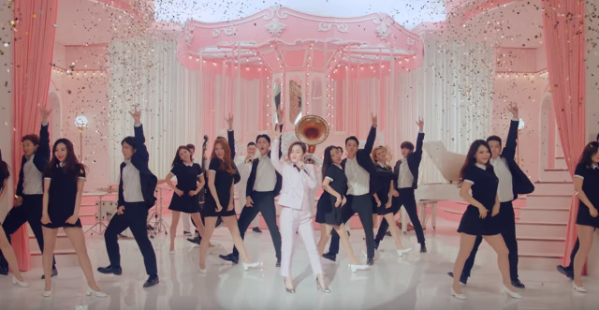
Figure 19. Lee Hi performance in video “My Star”. Source noted in Appendix 2.

I looked at thirteen (13) interviews for Trouble Maker and fourteen (14) for Se7en to similarly see if they acknowledged the musical space they occupy. Trouble Maker is a male/female duo who were previously members of other same-gender groups; respectively, Hyun-seung was a member of Beast and Hyuna was a member of Wonder Girls and 4Minute. The duo recently disbanded after being active from 2011-2018. Se7en debuted in 2003 with various breaks in his career due to the mandatory enlistment service for Korean males and a “scandal,” by Korean standards, regarding a visit to an adult massage parlor. The interviews found for both Trouble Maker and Se7en were like those of BLACKPINK and EXO; what I began to term as “fluff” interviews that had no substance or quality in relation to my research questions. This was especially troubling for Se7en, as he has been active in the music industry for approximately sixteen (16) years. Yet he seems to have never spoken explicitly or directly around his musical influence, even though I found interviews that questioned his growth and new music. His responses were always inwardly focused on how his singing or dancing had improved and how he was excited to try a new sound.
I looked at over twenty (20) interviews to try and find at least one interview for Brown Eyed Soul and Big Mama; I read twenty-two (22) and twenty-eight (28) interviews respectively. For two groups that both debuted in 2003, finding interviews was a challenge. I added individual interviews by members of the group who embarked on solo projects to the search parameters. If their solo project was in the same genre, then they possibly spoke of how their solo project was connected to work in the vocal group. Additionally, in considering one of the fastest sources about celebrities – fan sites – I also searched for fan sites or forums for Big Mama that may have had quotes or links to interviews, which ended up being the best avenue in finding relevant interviews.
I was able to find four (4) interviews with relevant content for Brown Eyed Soul. Brown Eyed Soul is a quartet whose name is a derivative of the term “blue-eyed soul” created in the 1960s for white performers of Black music. The shift to “brown eyes” connotes their Asian heritage. In one interview, member Na Eol forthrightly spoke on the origin of their musical style. He stated “basically, we pursue soul – a genre of African-American roots. But we are not confined by certain genres. Instead, we are deeply attached to the lexical meaning of soul. Soul is the privilege that is unique to humans. We’d like to create music that can have a positive impact on people’s souls.” This is strongly reinforced with their album cover work (see Figure 14), the mix of sounds in their albums, and in some cases, even their album’s name. For example, Soul Cooke was named thusly for two reasons: “Not only does it tell a narrative, Soul Cooke also offers a panoramic view of American soul music, spanning Philly soul, R&B, modern soul, funk and jazz. In fact, the ‘e’ added to ‘Cooke’, pays homage to the legendary soul singer Sam Cooke.”
Members further shared that their music is based on the sounds they grew up listening to, which was American R&B. American R&B influenced their vocal arrangements with one member openly admitting that “[he] grew up listening to American R&B singers on the radio. [He] liked it so much, [he] tried imitating them.”
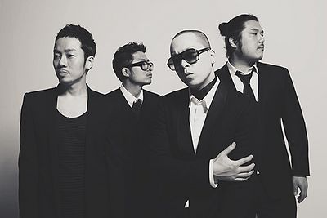
Figure 20. Brown Eyed Soul in pose similar to many American R&B vocal groups. Source noted in Appendix 2.

It also influenced their songwriting as member Yon Jun shared that the inspiration for a song on their album Soul Breeze was Peabo Bryson and Roberta Flack’s “Tonight, I Celebrate My Love.” From a performance perspective, for Brown Eyed Soul the origin seems irrelevant, the importance is the sound; as one member shared “it doesn’t matter if it’s ‘Black music.’ The race is not important.”
Big Mama was a four-member group developed at YG Entertainment and active from 2003-2012. Their musical inspiration ran the gamut of American artists such as Ella Fitzgerald, Lauryn Hill, Stevie Wonder, Whitney Houston; international performers in the genres of jazz and avant-garde pop; and local Korean performers of rock and folk. Overall, interviews of them seemed to be rare due to their focus on going “against the grain in the image conscious world of the Korean music industry by promoting themselves on the virtue of their talent, not their looks.” The members were also a bit of outliers with their older ages upon their debut which did not conform to the K-Pop model active in the 2000s (or even today). A 2003 article in Billboard magazine noted that Big Mama was a group that fell outside of the norm of “pretty boys and long-legged, long-lashed girls, slick dance moves, and flashy videos…Big Mama happen to be full-figured and thus offer a decided contrast to such lithesome stars as BoA and Lee Hyolee that usually dominate the Korean pop scene.” The article shares the decision of their label to “not use the singers’ images in press materials and videos, preferring to let the music speak for itself.”

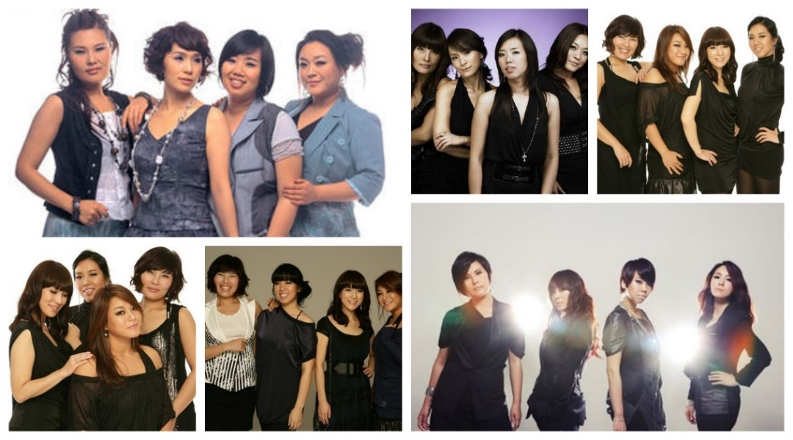
Figure 21. Big Mama’s appearance from 2003-2010. Sources noted in Appendix 2.

Of course, their perceived attractiveness being the reason for the rarity of their interviews is only speculation, supported by additional articles that address the “double-standard” regarding the appearance of male and female entertainers. As such, only a few interviews were found online, and the content was not relevant to the research questions. Questions within the interviews of Big Mama focused specifically on promotional tours and new albums, the minutiae of planning, and nothing about the group’s sound or musical influence.
In looking at the process for finding and reviewing artist interviews, there are several general observations to be made. The searches could have been endless if not capped at a certain number. Interviews I came across focused on questions around song-style choice (e.g. ballad vs. upbeat) and the creative process in creating the songs or album as related to who the artist worked with and what that process was like. Few questions in the interviews specifically or broadly asked about what inspired a song, in terms of style. It was moreso, what was happening in the artists’ life at that time that inspired such a song. Even questions around a song having a sound reminiscent of a certain period (e.g. 1950s or1970s) were answered in response to wanting to recreate that sound because it is “retro” and brings a feeling of nostalgia versus the artists responsible for that sound. I saw several spaces in interviews where an artist could have commented, I was influenced by X or grew up listening to Y, but it was not said.
Whether it is based on interviewer acumen or perceived audience interest, there was a definite gap in the lack of questions that delved into artistic inspiration; especially for artists who have debuted within the past eight (8) years or even when speaking about certain albums. “Idol singers are not necessarily required to acquire a deep understanding of genres. They are fundamentally characterized by their nature as heroes for teenagers and products for commercial success.” However, those idols and performers who have taken the time to develop thorough and critical understandings of the genres in which they perform help to move K-Pop forward to chip away at existing preconceived notions and criticisms of mimicking hip-hop and R&B for profit. That the interviews found lacked most artists sharing this depth and awareness continues to place these performances within the spectre of blind cultural appropriation.

Review Limitations

This process acknowledges several limitations as well as suggestions for where to take this research if repeated or further continued in the future. Language and use of language were highlighted as important parts of an artist’s creation of discography. Language was a major barrier to this review as there seemed to be limited materials available in English, especially in regards to the interviews. It is possible the questions I was looking for were asked; I just was not able to find that interview or it had not been translated from Korean. Having even an elementary grasp of Korean, access to translation materials, or a research support who speaks and reads fluent Korean would be invaluable in the future. Conversely, the barrier provided another layer to the review. The translated lyrics of one song were viewed from several websites. This in and of itself, was a brief foray into how language is interpreted and understood by different people, as the lyrics sometimes differed in language choice or meaning. Assumptions were made on the availability of certain information, such as interviews or posts by/from choreographers, producers, songwriters, etc. to speak about their work, their experiences working with artists in K-Pop and where they receive their inspiration and/or influence when working on particular albums. One interview provided the producer and songwriter perspective, but this seemed to be a rare find. Looking for additional interviews by practitioners – producers, choreographers, songwriters – to get a broader scope of their perspectives may help to fill in some existing gaps. Similar assumptions were made on the content interviews. I assumed it would be a “given” that among the questions asked would be some related to the music, sound, and style of the artist’s themselves. This ended up being few and far in between. Additionally, there was an issue of few available interviews or album reviews for earlier album releases and debuts in the early 2000s.
As previously acknowledged, though this did not deter from the ability to embark on performance review of Korean artists, the lack of professional or academically based musical background created some restrictions to the breadth and depth of this research. Either having this background or access to a resource – person, institution, materials – that can provide this background would strengthen the basis of any future conclusions around music sampling, copying, remixing, etc. Multiple background vocals and melodies sounded familiar, but I could not place them or find information from sampling sites or free databases that collect artist content and information. Another brief aside, is that this research was kept cost-free due to a lack of budget. There are several paid online music databases that carry artist content and information, but they were not used. If additional research entailed a budget, I suggest looking into making use of some paid resources. There was limited information available online or at local libraries. I was unable to find hard-copies of the compact discs (CD) to review liner notes or information available within CD booklets. The digital versions utilized did not include album credits or detailed production information.
K-Pop and its associated genres such as K-Hip-hop and K-R&B seem to be disregarded by professionals within the music industry and are considered a “low art” with low interest in review and appraisal throughout the industry. As such, it proved difficult to find a broad swath of interviews or input from producers, songwriters, choreographers, et al. Finally, the focus of this review on only mainstream artists, may mean that I am missing more “real” or “authentic” representations of the genres by Korean artists as a whole. Several allusions were made to the “underground” R&B and hip-hop scenes that are continually growing in the country. Additional research and consideration should be given to the indie and underground R&B and hip-hop scenes in South Korea. However, the focus of this research is on the mainstream aspect of the industry because these are the artists and the venues (e.g. television shows such as Show Me The Money and Unpretty Rapstar which are discussed in Chapter 13) that are getting widespread attention and whose delivery of these sounds feed into how the Korean community understands and identifies hip-hop and R&B.

Performance Review Conclusions

This performance review was conducted to answer the following research questions: 1) Is the presence of African-American musical stylings in Korean music an example of adoption, appropriation, integration, or something else? 2) Within South Korea, are there particular African-American artists with global appeal (e.g. Run DMC, Diana Ross) who influenced this acculturation? and 3) What is the viewpoint of South Korean practitioners (artists, producers, choreographers) and music listeners (fans, professional reviewers) about the influence of African-American music; is it acknowledged or ignored?
An article by The New Yorker stated that “K-pop is an East-West mash-up. The performers are mostly Korean, and their mesmerizing synchronized dance moves, accompanied by a complex telegraphy of winks and hand gestures, have an Asian flavor, but the music sounds Western: hip-hop verses, Euro-pop choruses, rapping, and dubstep breaks.” This is a more than apt description for the audio and visual experiences I had with this performance review.
Specific to the research questions, dependence on what I have termed Black constructs of genres – how African-American artists have cultivated and exemplified hip-hop and R&B – impacts the claims of originality, integration, and creation of a “local, traditional [music] culture” by Korean artists. By relying on the constructs, the effectiveness of showing the “Koreanness” of hip-hop and R&B performed in the country is diluted. As such, the initial response to Question One is that the presence of African-American musicianship is cultural appropriation. Based on the selected discography reviews and additional research, it is apparent that Korean hip-hop and R&B have shown growth from simple imitation of American artists and their styles to “finding authenticity in Koreanness.” Yet, overall, the artists within these genres still engage in “racial stereotyping and appropriation of Black culture,” which dampens their credibility, legitimacy, success, competitiveness, and recognition from the global hip-hop and R&B communities and the global music industries. “The issue needs to be addressed not only within the K-hip-hop [and K-R&B] subgenre[s], but also in Korea more generally. In the end, the quest for authenticity in Korean hip-hop [and R&B] is ongoing; the ‘K’ in K-hip-hop [and K-R&B] is thriving but needs to rid itself of its unseemly elements.” Though Korean practitioners may argue and hope that it is more integration or a hybridization, the process that they are using is the opposite of their aspirational mentality.
Based on my own familiarity with Black music, a key component of the reviews was “sound.” There is a distinct sound to Black music. I heard it repeatedly copied or reimagined in several of these songs. Though not all potential samples were readily identified, they were clearly heard; Black artists and their signature sounds were apparent in every album reviewed. As such, the influence of various Black artists with global appeal is readily apparent. The initial answer to Question Two is a resounding yes. Several examples were found throughout the album reviews, artist interviews, and in general research. Artists either named their influence or it was alluded to in their re-crafting of that artist’s lyrics or dance movements. The influence was truly apparent in the audio and especially came through in the videography.

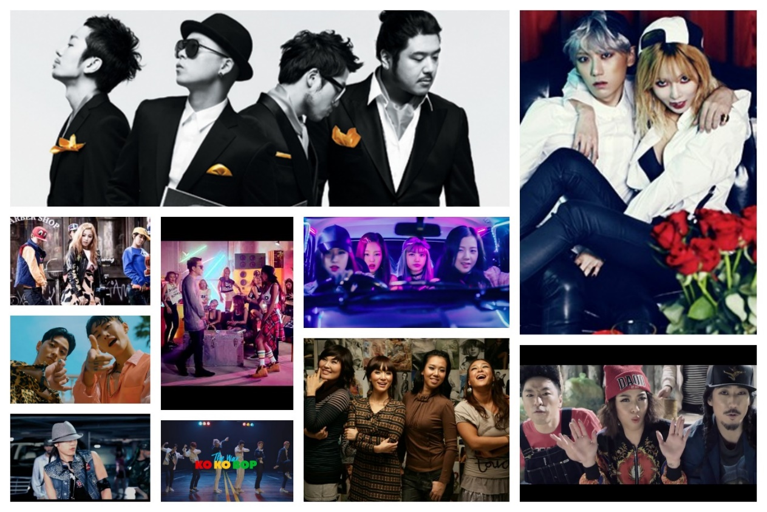
Figure 22. The ten (10) artists. Sources noted in Appendix 2.

Finally, the perspective of Korean music practitioners and music listeners on the influence of Black sound is all over the place. The initial response to Question Three is that there is a mixed response. Based on interviews found, there is a sense that it is ignored due to the lack of both quality questions and quality answers. Looking at online discussions in fan communities it seems recognized, but not explicitly acknowledged. The same spectrum applies with some practitioners. As previously stated, artists like Brown Eyed Soul, Jay Park, and MFBTY are highly cognizant of the influence of Black music and Black culture in their craft. They will readily share the artists by whom they are inspired and who they look to for inspiration. Some producers will similarly, speak about who they are listening to and who influences their sound. Others, not so much. Unfortunately, the “others” seem to make up the majority of the Korean music industry.
“Some may claim that K-pop is an archetypal example of a new cultural genre that has occurred through the hybridization process, recasting national identities. The issue is that they cannot explain the major differences between K-pop influenced by American genres and styles, and American pop music other than saying that ‘K-pop is unique and different.’” Such reasoning is shallow and insufficient. As previously stated, creatively remixing Black American scores or recrafting the original meaning of a Black artists’ lyrics does not equate to “the development of a new form of culture. The current form of structural hybridization in music mainly fails to reflect Korean mentalities.” Korean hip-hop and R&B lack agency and will continue to lack their own space, “flavor,” and style until they can wean themselves from their dependence on the African-American constructs created in these genres. The absence of any inclusion of or minimal reflection of Korean themes and Korean identity as currently understood and defined by the country in these performances, only highlights that these artists are “struggling in making an authentic local culture through the hybridization process, regardless of burgeoning attempts to make a hybrid popular culture.” The output from these performance reviews is further analyzed in the Chapter 12 subsections Applying Authenticity and Observing Authenticity in Korean music.

Chapter X
Solo Singer “Bright Spots”: BoA and Rain

“Did you know that the human voice is the only pure instrument? That it has notes no other instrument has? It’s like being between the keys of a piano. The notes are there, you can sing them, but they can’t be found on any instrument” – Nina Simone

From reviewing a sampling of artists performing within the hip-hop and R&B genres, this thesis will now focus on a handful of “bright spots.” In the next two chapters the focus narrows even further to top-selling solo and group artists in these genres. I consider these performers to be “bright spots” with influence. The ideology behind “bright spots” is based in the Appreciative Inquiry (AI) theory around organizational change developed by David Cooperrider and Suresh Srivastva. Within organizations, Appreciative Inquiry focuses on a “positive, strengths-based change approach. AI focuses on leveraging an organization’s ‘positive core’ strengths to design and redesign the systems within an organization to achieve a more sustainable and effective future.” In applying this theory to Korean artists and the music industry these solo and group “bright spots” will hopefully be looked to as the drivers for changing how R&B and hip-hop are understood and performed in South Korea. By further acknowledging and lauding artists, producers et al. who have taken the time to study the genres and American artists, who openly acknowledge these influences in their works as well as when they commit faux pas’, and who have been successful within the industry and in broadly sharing their interpretation of these arts with the Korea community and abroad, a new, more culturally competent and inclusive standard may be set for how Korean music practitioners operate.
In what can be considered a pivot in the thought process from the rest of this thesis, instead of examining and dissecting what I (and others) consider to be faults within music-making in Korea, I will highlight examples of cross-cultural, musical integration done well. These examples are what AI considers to be “bright spots” that are succeeding and participating within these genres and performing R&B and hip-hop the “right way.” I believe such a shift in ideology would be beneficial to the Korean music industry as it encourages them to not try and be like their best contemporary or peer (i.e. American music industry), but how the industry can be “like itself at its best moments.”
For this reason, in the simplest explanation, BoA, Rain, BIGBANG, and 2NE1 can be considered “bright spots” on how to respectfully and successfully merge local and foreign sounds. They also check all of the boxes relevant to this thesis. An overview of their musical profiles shares how they are successful in hybridization and translocation; why they receive industry-wide respect for their sound and artistry, both within the mainstream and underground music scenes; that because they are seen as veterans and icons and are often referred to as “icons among idols,” they have major influence; that they are viewed as the standard to aspire to by up-and-coming artists; and how they have participated in artist discovery and development. They are not without their missteps, from having to experience and learn through their own moments of called-out cultural appropriation to accusations of plagiarism and improper accreditation. The difference, is in how they responded to and learned from these public mistakes, and how they have – so far – successfully worked to not repeat them.
Kwon Boa, mononymously known as BoA, is a household name in Korea and internationally recognized across East Asia. “If one singer has defined K-pop for the past decade, it would be BoA.” BoA was discovered at 11 years old when she accompanied her brother to an audition for agency SM Entertainment. In 2000, at the age of 13, she had her debut, which peaked at No. 10 on the Korean billboards. In collaboration with Avex Entertainment, a high-power music label in Japan, SM Entertainment released BoA’s debut Japanese album Listen to My Heart, in 2002 and it was an immediate best-seller. BoA’s success in Japan translated well back home and her journey to being one of Korea’s top-selling and brand-name artists began. BoA has had a non-stop career style, continually releasing songs and albums, which has an official count of over eighty-six (86) products in her music catalogue. This includes twenty-eight (28) albums released in Korean and Japanese, under the categories of studio, special (e.g. holiday), compilation, and recorded live appearances; two (2) remixed albums, one (1) extended play; and six (6) non-album singles. She has guested or appeared on over sixty-nine (69) albums. Her hard work has been repeatedly recognized by various East Asian music industries. In Korea, BoA has been nominated for thirty-three (33) awards for different shows such as the Seoul Music Awards and MNet Asian Music Awards, and won twenty-two (22). In Japan, she has been nominated for and won all twelve (12) of the honors offered by the Japan Gold Disc Awards, Japan Records Awards, and Best Hits Song Festival. Finally, she has also received thirty-seven (37) awards from international awards shows, Korean music programs, and for topics unrelated to music, such as fashion and her persona (e.g. South Korea’s Ministry of Culture and Tourism: Annual Hallyu Award).

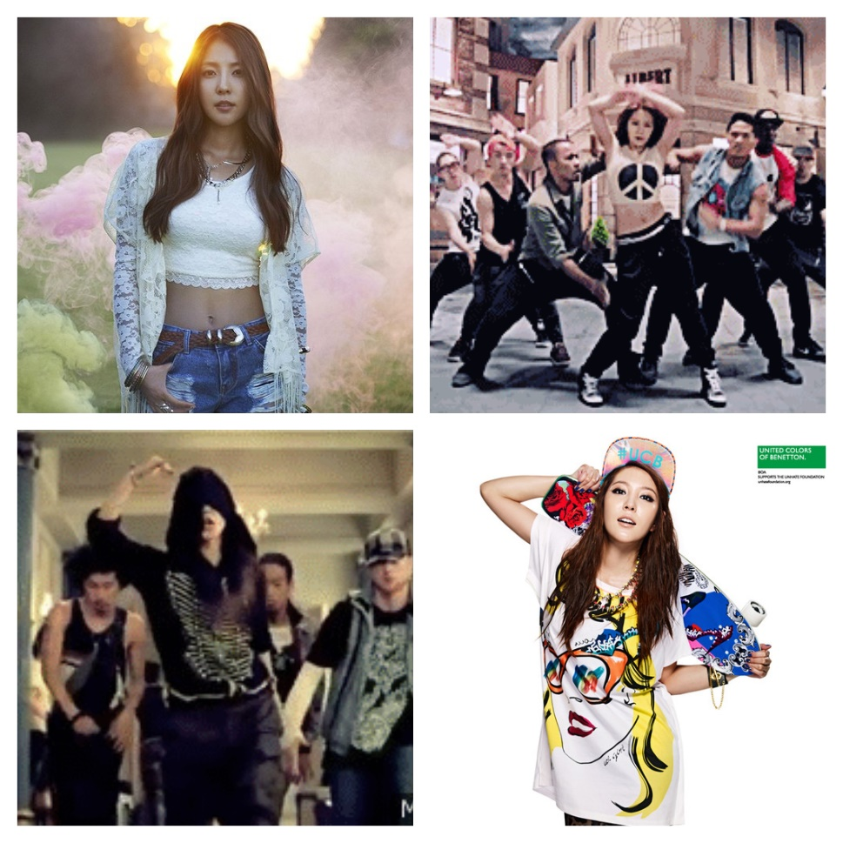
Figure 23. BoA collage. Sources noted in Appendix 2.

In Korea and Japan, she continually sets trends. For example, to date, she is the only “non-Japanese artist in Japan, to sell over a million copies of two albums.” She has also broken records with releases of certain singles in both countries, with such audience favorites as “‘No.1,’ ‘Valenti’ and ‘Listen to My Heart.’” Through her fame, “BoA has also become a cross-cultural icon, helping to bridge the historical tensions between South Korea and Japan. BoA’s songs are [also] popular in Taiwan, China and many Southeast Asian countries.”
Michael Jackson inspired BoA to want to be a singer. Specifically, in watching the video for “Billie Jean,” she was impressed by what she considered to be “the mix of fantastic choreography and amazing music.” The work of Michael’s sister Janet Jackson is also an inspiration for BoA, especially Janet’s ability as a female artist to “dominate the stage.” Her favorite artists have been noted as including Nelly, Brian McKnight, Janet Jackson, Jay-Z, and Michael Jackson. In a 2009 interview BoA shared that her (then) favorite American rap album was Paper Trail by T.I.
BoA’s brand has extended beyond music, with her also holding contracts in acting and modeling. She also stays plugged into the works of current artists both at home and abroad. Of American singer Bruno Mars’ song “Finesse,” she felt that his music was strongly reminiscent of the sounds she enjoys; “when the trend was to make futuristic music, this throwback to the ‘80s’ and ‘90s’ new-jack-swing style sounded very fresh to me. Personally, this style of music was what I used to listen to so much, and I was so happy to hear it again.” As both a mentor and brand ambassador for new talent at SM Entertainment, BoA is a judge on talent discovery show K-Pop Star, which incidentally, is the same reality show where R&B singer Lee Hi was discovered.


Figure 24. BoA, only female judge on K-Pop Star with YG (in hat) and JYP Entertainment CEOs. Source noted in Appendix 2.

Rain or Bi-Rain, born Jung Ji-hoon, began his career as a singer for JYP Entertainment, known for producing artists similar to the sound of its founder Park Jin-young. Park Jin-young is a singer known for “big hits in the late 1990s, mostly in the R&B/dance music genre, with a distinctive funk sound noticeably more soulful that most of the Korean pop scene.” Rain’s journey was a circuitous route for success as he did not have the traditional “look” that the industry was enamored of at the time. He initially debuted as part of a boy-band that was a commercial failure. He was rejected eighteen (18) times by various companies and labels due to what they considered his lack of aesthetic and appeal. Several suggested that he get cosmetic surgery. However, Park Jin-young saw his potential and at 19 years old, Rain became a trainee for JYP Entertainment. He debuted in 2002 as a solo artist with the album Bad Guy. Rain expanded his repertoire to include acting in 2003 and has balanced the two, while finding success in both mediums ever since.
Like Park Jin-young, Rain was influenced by the sounds of American pop, R&B, and hip-hop music. His style has been described as “interpretations [that] provide, at the least, an Asian face and filter. His producer, [Park] Jin-Young, describes Rain’s music as more ‘sensitive and delicate’ than American R&B and says that his choreography is crisper and more precise, influenced by classical dance and martial arts.” In capturing the hearts of an entire region – east Asia – with his sound and dance moves, Rain has become a bit of an Asian Ambassador. “‘In Rain, Asians might see the spirit of Usher or Timberlake or even Michael Jackson, but he makes the music theirs,’ said Nusrat Durrani, senior vice president and general manager of MTV World. ‘He is a huge star in the making, but, at the same time, he is a very indigenous artist and a source of local pride.’”
Since debuting, Rain has released ten (10) albums, one (1) extended play, and appeared or guested on thirteen (13) compilations. He has amassed over one-hundred forty (140) awards in the realms of music and acting from South Korean and International entities, such as the Seoul Music Awards, IFPI Hong Kong Music Sale Awards, Gold Disk Awards, Korean Film Awards, Blue Dragon Film Awards, and various music programs. He has been recognized twice by TIME Magazine’s 100 Most Influential People.
Along with all of these impressive accomplishments and awards, “Rain also began to arrange an impressive list of firsts.” He was the first Korean to simultaneously pursue acting and singing, “to embark on an East-Asia tour,” and to perform at Japan’s largest arena, the Tokyo Dome, to an audience of 30,000. He additionally held sold-out performances in Korea and China to audiences between 20,000 and 40,000. In North America, Rain was the first Asian artist invited to two of MTV’s award shows – the Video Music Awards in Miami and the Latin Video Music Awards in Mexico – in 2005. Finally, as an actor, Rain has extended his brand and recognition to American and European audiences by starring in several high profile films, such as Speed Racer and Ninja Assassin.

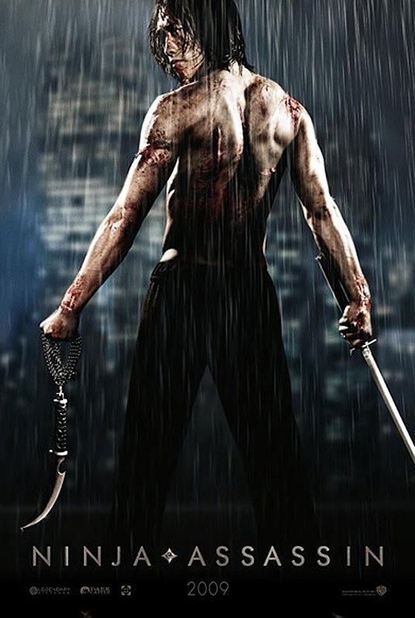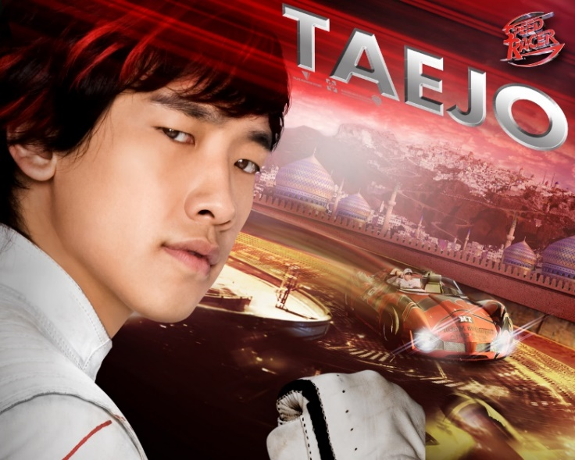
Figure 25. Promotional posters for films Speed Racer and Ninja Assassin. Sources noted in Appendix 2.

His interests are varied, from singing, to acting, to fashion as the owner of his own fashion brand SixtoFive1982 which he managed from 2008 to 2010. Like BoA, Rain continues to engage with the music industry from various facets – as a performer, a mentor in forming the boy band MBLAQ, and as an owner of his own record label – because he wants “to groom young talent, contribute to K-pop culture, and raise the quality of the system.”
“Rain, one of the most successful K-pop musicians in Asia, is unique and so different from American pop music, regardless of the fact that Rain’s style virtually clones American pop.” He acknowledges that his favorite artists and those he looks to for inspiration in song and dance include Usher and siblings Janet and Michael Jackson. However, it is how he has integrated their styles into his culture that has helped Rain to stand out. When asked what he had learned from being around American performers such as Will Smith, Lil’ Kim, and Mariah Carey, at the MTV awards shows, Rain shared “I learned that instead of relying on and imitating American music, there is a better chance for an Asian artist to succeed if he or she follows his or her own culture. For example, I incorporate Korean and Asian marshal[sic] arts into my dancing...So an important thing that I’ve learned is that instead of following the US market, we need to follow our own cultural style.” This level of awareness and authenticity has been continually apparent in his public persona and is one of the many reasons that he is adored by so many fans.
Related to the thesis research questions, Rain’s answer above highlights how he and BoA have shown an understanding of how the musical and artistic integration between American and Korean cultural facets can be integrated aurally and visually. They have successfully gained and maintained international followers because there is a level of sincerity and authenticity in their performance. They are Korean artists who grew up listening to and dancing to American hip-hop and R&B, among other music, and are open about this influencing their styles in singing and dancing. It is interesting that both note the influence of siblings Michael and Janet Jackson in their art and this is readily apparent.

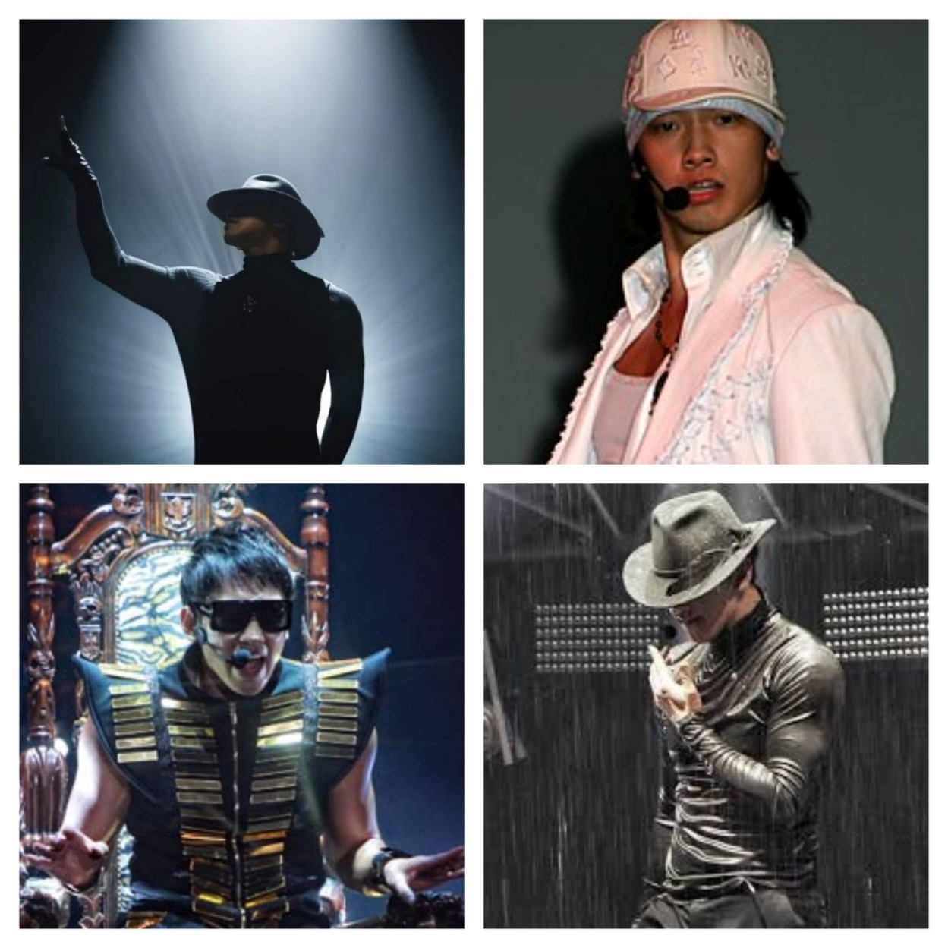
Figure 26. Rain performing. Sources noted in Appendix 2.

In reflecting on her sound and her musical journey, BoA once said “although I don’t write most of my music, it is true that I’ve been singing with the emotions that are my own. If I failed to convey those emotions, I probably have not grown enough to hold my own philosophy and life experiences into my music. But I am still growing and one day, I really believe people will be able to listen to real ‘BoA music’…You have to become the ‘first of yourself’ instead of trying to become the second of anyone.” Similarly, Rain is quoted as saying “if you are truthful, most people will like you. It is important to be able to say, honestly, if there is something that you cannot do. Just like it is important to acknowledge the things that you do do well, so that you can ask people to enjoy them with you. That’s my approach, and I think this is why my fans like me.” Both artists clearly understand the importance of being their authentic selves within their music, in creating a space where they can showcase their love of their genre and their Korean heritage, and in staying connected to their roots while also exemplifying the “rooting” of another culture within their own.

The discussion of “bright spots” for group artists continues in the next chapter.

Chapter XI
Performance Group “Bright Spots”: BIGBANG and 2NE1

“We don’t want to box ourselves within any type of genre, you know? Whatever feels good, if it moves us and we like it, we get on it and make it our own. That’s what we do” – Rozonda “Chilli” Thomas (TLC)

As musical groups, BIGBANG and 2NE1 are unique examples of “bright spots” that stand out from the other groups that are part of the strict and stringent training regimen that most Korean groups endure. Unlike in the United States and elsewhere, groups rarely come together organically in Korea. As referenced in discussing BoA and Rain, the first step for most aspiring artists is to attend one of the open auditions hosted by the major talent agencies. If accepted, they enter what is referred to variably as the trainee system, idol star system, or academy system, which entails a long-term investment of time, money, room, and board for some individuals who may never debut. While in the system, trainees (or idol hopefuls), not only work to improve their singing and dancing, but also their potential as models, actors, and brand marketers, appearing in print and television ads for various products. More recently, trainees may appear in reality television shows as the culmination of their training leads to their potential selection to a group that will shortly debut for an agency. Such was the case for BIGBANG and 2NE1. So even though they went through, what has become a prescriptive, training model for Korean performance groups, what makes their success within their genres “bright”? It is several factors, such as their agency (both are signed to YG Entertainment), the group member dynamic, and the way their groups decided to engage in these genres.
BIGBANG, who debuted in 2006, developed in real-time, as fans of YG Entertainment saw the final selection of members on a reality television series. The Big Bang Documentary followed the final weeks of the six young men slated to be selected to a five-member male group. In the end, two rappers – Kwon Ji-yong (G-Dragon), Choi Seung-hyun (T.O.P) – and three singers – Dong Young-bae (Taeyang), Kang Dae-sung (Daesung), and Lee Seung-hyun (Seungri) – were selected. As a group, in pairs (G-Dragon and T.O.P have released several rap collaborations), and as solo artists, they have each been successful on the Korean music charts and solidified themselves as consummate performers. “Since its 2007 debut, BIGBANG has made a name for itself as one of the most dynamic groups in K-Pop, throwing together an incredible variety of sounds and visual styles, often within the same song. With two rappers in the – G-Dragon and T.O.P. – who have quite different styles and are able to rap melodiously, BIGBANG is also unusually versatile.” The group debuted with a heavily R&B and hip-hop influenced sound and style. As remarked by member G-Dragon, “YG, the label itself puts out boy bands, but they don’t strictly deal with bubblegum pop music. Since its foundational core is based around hip-hop, I trusted the label’s directions.”
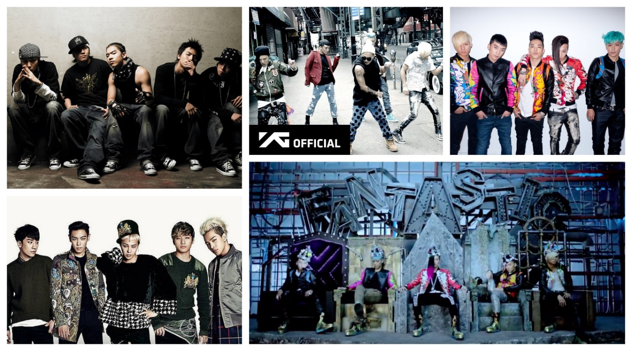

Figure 27. BIGBANG group photos. Sources noted in Appendix 2.

Their earliest songs invoked that agency core and alluded to late 90s and early 2000s African-American R&B and hip-hop releases, as reflected by their musical influences. For instance, T.O.P’s background as an underground rapper makes it seamless for him to drop memorable and flawless verses throughout their songs. This was highly notable in “We Belong Together,” BIGBANG’s debut single. “[T]he first noticeable quality about ‘We Belong Together’ is its gratuitous mid-2000s hip-hop/R&B influence. It is reminiscent of R&B star Ne-Yo whose clean and crisp drum-basslines coupled with do-wop [sic] synths create the quintessential mid-2000s R&B sound.” Their musical influences include Wu-Tang Clan, Fabolous, Kanye West, Pharrell Williams, Will.i.am, Frank Ocean, Kendrick Lamar, Miguel, Michael Jackson and Prince.
Commonly called the “Kings of K-Pop,” their style is an amalgamation of their individual interests coming together to create new sounds and set new heights within Korean music. They were one of the first groups to produce and write their own music, to segue from underground to mainstream hip-hop idols, have record-breaking sales both digital and online, to build an international fanbase crossing the globe from South Korea to the United States, to find both group & solo success, to cultivate high-energy, design-oriented performances, and to individually and collectively expand their reach within fashion, movies, television, and the arts. Group members “G-Dragon and Taeyang perform clearly notable activities based on a thorough understanding of hip-hop and R&B, receiving relatively high praise from enthusiasts and experts in the genres.” As the lead singer, Taeyang “has established himself as one of the country’s foremost R&B vocalists...While the two youngest, powerhouse singer Daesung and manic mood-maker Seungri, have built out their careers in variety shows and acting.”
As the designated rappers, and especially for G-Dragon as the leader of the group and the primary author of several of their songs, he and T.O.P have greatly contributed to the sound and direction of BIGBANG. G-Dragon acknowledges that he was “heavily influenced by American rap albums. But for songs that are more melody-driven, I get my inspiration from Korean albums. For Korean music, I mostly listen to individual songs over complete albums.” As noted above, G-Dragon is continually cognizant of the merge and integration of sounds considered Eastern and Western. T.O.P segued into the mainstream from the underground, where he performed under the name T.E.M.P.O. This experience served him well once he signed to YG Entertainment. “In BIGBANG videos prior and current, as well as in his solo videos, hip-hop is a concept he explores wildly, and his verses are always masterworks of meter and percussion.”

[Together] there is something awe-inspiring about the blend of G-Dragon’s gaudiness and T.O.P’s edge…Stimuli come in rapid fire...Though T.O.P is a rapper at heart, and G-Dragon claims that he owes his career to the Wu-Tang Clan, the marriage of these two distinctly Korean artists produced a distinctly K-Pop [sound]. It is the planetary collision of these two aesthetics that really shape a majority of BIGBANG’s sound and look today, and it is a style that makes both stars immediately recognizable. The fact that both come from distinctly hip-hop roots seems like a footnote and yet it is of the utmost importance. An authentic hip-hop background is what produced the star confidence that this duo has; one cannot understand BIGBANG without understanding GD & T.O.P.

Tionne “T-Boz” Watkins of American R&B group TLC once said, “we were always authentic when it came to our style. From when we started to the height of our fame, we’ve always been consistent in our look because how we dressed was a result of how we felt. We weren’t playing dress-up.” The same can be said for BIGBANG. Their sound, fashion, and aesthetic draw heavily from their personal experiences, musical interests, and the styles that have been able to develop during solo outings. Due to the opportunity to test a sound and look that differed from the BIGBANG image during solo promotions, when BIGBANG regroups as a unified unit, the final product is exemplary of their solo and joint journey and is “heavily influenced by their hip-hop and urban roots.” Their subsequent albums “can be viewed as unanimous success[es] because of the flawless way [they] meld the experiences of the entire group over the years. There is a new energy in their performance that is mightily close to American artists, and this can probably be attributed above all to the confidence each member must have gained from artistically striking out on their own.”
As a group and individually, their accolades are many. They were recognized among TIME Magazine’s 100 Most Influential People in 2016. “Achieving recognition in music, Taeyang won two awards – for best album and best singer in the R&B and Soul category – at the 6th Korean Music Awards in 2009.” Out of one hundred eighty-six (186) nominations, they have won one hundred thirty-one (131) awards for national and international bodies such as the Seoul Music Awards, Myx Music Awards, World Music Awards, Gold Disc Awards, and Mnet Asian Music Awards. They have additionally been awarded eighty-seven (87) honors by various music programs.
Not only in Korea, but among boy bands and male groups worldwide, BIGBANG has sustained a longevity not previously seen. They have been together consecutively for twelve (12) years, dominating across east Asia with sold out concerts to crowds of up to and over 150,000, winning, as previously noted, over two-hundred eighteen (218) music-related awards domestically and internationally, successfully crossing over into the English market, having three top number 1 hits on Billboard’s Digital Song’s record, and continually influencing their peers and up-and-coming artists. One reason for their long-standing success has been noted as the unprecedented creative freedom given to the members by YG Entertainment in both their solo and group projects. Further, is the opportunity to highlight these diverse talents in their concerts and guest appearances, which gives fans a chance to hear them both as a unit and their styles individually.
The group is on a temporary hiatus as most members (four out of five) have begun their mandatory two-year enlistments with the South Korean military. T.O.P first entered the military in February 2017. G-Dragon, Taeyang, and Daesung entered at various points in 2018. With Seungri, the youngest member, slated to enter the military in 2019, the earliest all five can be expected to perform together again is in 2021. Until then, similarly to when they were active, members may release solo efforts once their enlistments begin ending in 2019.
2NE1, pronounced “To Anyone” or “21” debuted with YG Entertainment in 2009. They were initially styled as “a female BIGBANG” with an emphasis on vibrant beats and even more vibrant attitudes among the four members, Sandara Park (Dara), Park Bom (Bom), Gong Min-ji (Minzy), and Lee Chae-rin (CL) who interchangeably sing and rap. From the release of their first single “Fire” they immediately began shifting the perception of the sound and appearance, especially the expected uber-femininity, of female groups. They “consistently pushed for a harder, bolder sound, than any other girl group in Korea.” Their sound is a mix of being young and carefree while also advocating for women’s empowerment, especially in an oft-male dominated genre. Their songs range from sharing messages on how to be independent women to also expressing uncertainty or vulnerability.
Regardless of whether “2NE1 going hard” or “2NE1 going soft” was their image, “the dominant theme throughout 2NE1’s career has always been swag.”

The thing about [many girl] groups [debuting in 2009] is that they came at a time when there weren’t many girl groups, and when the ones around were mostly stuck in the cute/sexy binary. Then, 2NE1 broke onto the scene, shattering the [aeygo] mould [sic] by embodying and projecting female independence and confidence. It wasn’t a simple matter of being different and refreshing; it was about speaking up and for women, reaching out to a very important facet of identity, that gained the hearts and admiration of fans and non-fans alike. It was okay to be gentle and demure as a woman, but now it was okay to be cool and confident, too. You could dislike their music and image, but you couldn’t deny the influence the group had in shaping the scene for the better. They were part of what made hoobaes like miss A, Mamamoo, [sic] Black Pink, and other girl groups riding on the image of female independence and sass even possible to be around.

Capturing this balance between being “fierce-yet-playful” made them game-changers in the industry. Not only do up-and-coming artists look to them for inspiration, but their peers and contemporaries (many who debuted before 2NE1) look to them for inspiration as well. Their musical influences and inspirations include TLC, Beyoncé, Rihanna, Michael Jackson, Lauryn Hill, Lil’ Kim, and Mariah Carey.

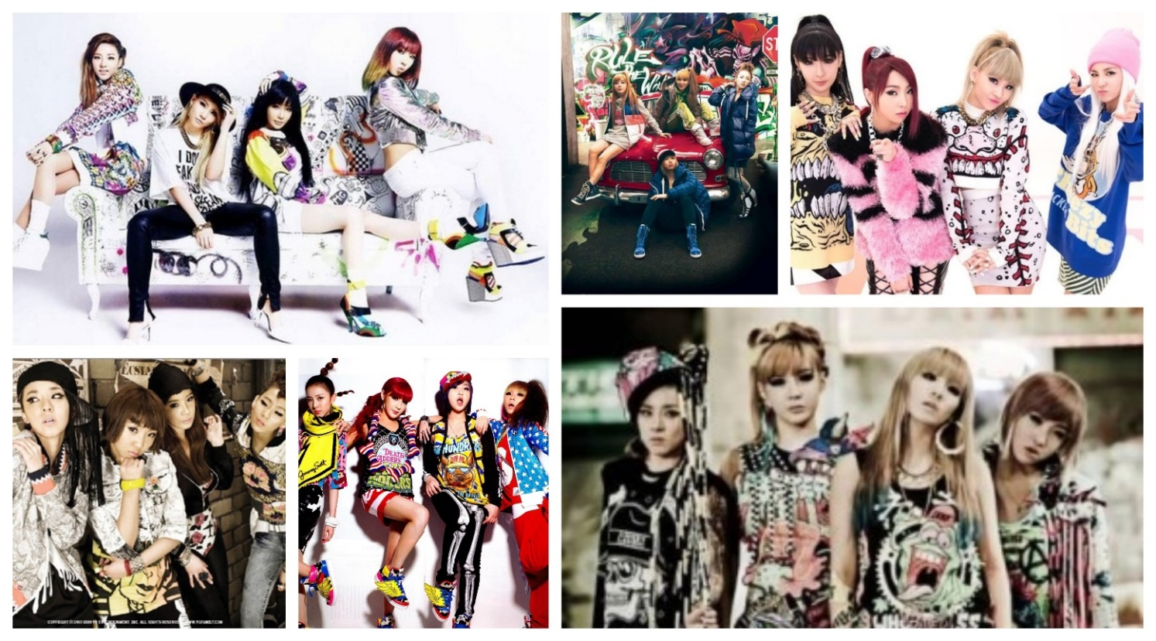
Figure 28. 2NE1 collage. Sources noted in Appendix 2.

With over 66.5 million records sold, 2NE1 consistently found itself listed among international lists of “best-selling” girl groups, among the likes of Destiny’s Child, The Spice Girls, and the Supremes. In the Korean music industry, they similarly found themselves noted as one of many girl groups that impacted K-Pop culture. Within the first three years of their debut, their popularity reached international status and their music received radio play in markets such as Japan, the United States, and Brazil. “Their single ‘Come Back Home’ made them the most-successful girl group in South Korea’s Gaon Chart. To date, 2NE1 holds the record for being the girl group with most number 1 hits in South Korea.”
2NE1 is credited with ushering in a new “look” and sound for girl groups, while also shattering present expectations around what is considered acceptable. They “are arguably the most recognisable [sic] of the female idol groups beyond K-Pop’s usual stamping grounds; they’ve held several successful American concerts, worked with Will.i.am, and starred in a U.S. Adidas campaign as well as [been] critically lauded by MTV, BBC, Forbes, CNN, Elle, and Rolling Stone” to name a few of their accolades. They were also nominated for over one hundred thirty-seven (137) awards, winning one hundred five (105) in various international music awards shows such as the China Music Awards, Singapore E-Awards, and World Music Awards; as well as awards on various music-related programs. Yet, their largest contribution to the Korean music industry continues to be their sound. Described as “bass heavy electro pop with nods to hip-hop, [it] is big, bold and brash and the accompanying visuals scorn the aegyo, the cutesy cheek puffing and big anime eyes, that so many girl groups employ. Instead, CL and her band members Minzy, Dara and Bom have adopted the styles associated with their male contemporaries (including their YG label-mates BIGBANG) of fast cars, studs, spikes and aggressive choreography.”
Individually and as a group, the members are aware of their musical roots. Leader and main rapper CL once shared “whatever music it is; we always create it with the hopes that the public will listen to it. I definitely like rock and R&B. However, I’m a rapper. The blood that runs in me is hip-hop. Because of that, whatever genre it is, I always end up mixing it with hip-hop.” Though their album repertoire is short, with only six (6) studio albums, they continually explored and pushed their sound and continued to make connections between home and abroad, old and new. Rapper Lisa “Left Eye” Lopes of TLC once said, “by tapping into the sounds of each decade and creating unique ways to tell these stories, we’re confirming our commitment to being the destination for adults who are passionate about music.” In an interview, 2NE1 shared a similar story and analogy between finding an older pair of popular jeans and making music. It was that “whether in music or clothes, [we] like things with an ‘old feeling’. [We] like to take this sense of ‘old’ and to mix that with things from the present time.”
This versatility of sound, interest in exploring sound genres, and vocal balance would serve them well in their final release. The group officially disbanded in the fall of 2016, after losing one member, Minzy, earlier in the year. As the first and only single, released by the remaining trio, “Goodbye” highlighted each of their skillful vocals:

[CL] puts her fluid rap skills aside to croon the sorrow she felt when writing this song. She said in an interview with her record label YG, she cried writing it. In regards to Dara, she’s always been a set of velvety vocals for 2NE1 enriching their songs and she doesn’t disappoint in “Goodbye.” On the contrary Bom’s soprano has always served as the powerhouse vocals for 2NE1 and she eloquently hits the high notes again in “Goodbye.”

Since then, the members have each continued with solo projects in singing and acting, yet they are never far from the minds of their fans. One year after their separation, their music and songs still found themselves trending and topping charts on online music sites, which speaks to their continued influence and popularity.
Related to the thesis research questions, both performance groups highlighted a diverse makeup of skills, personalities, and strengths; but all members had several commonalities: A love of their country and culture, an appreciation for American R&B and hip-hop that started young, and being groomed at an agency with a solid understanding of the roots of hip-hop and R&B. Of course, this last is a given, given that the founder of YG Entertainment was a member of Seo Taiji and Boys, the group who launched the interest of these two genres within South Korea. Additionally, both performance groups saw the merit and worth in the intersections of past and present sounds, mixing Korean folk with American R&B, dance, electronica, and other genres. Moreover, their sincerity and the authenticity with which they visually represented these genres was accepted and lauded within Korea and internationally. Their collaborations with artists such as Missy Elliot, Will.i.am, and Method Man – some highly influential names within different periods of post-2000 Black music – attest to their familiarity and appreciation of Black sounds.
In returning to the idea of “bright spots” for all artists highlighted in Chapters 10 and 11, these four, even with 2NE1’s recent disbandment, are examples of that “positive anomaly – the one thing that looks like all the other things but for some reason is thriving when the rest aren’t.” These artists not only highlight positive cases of cultural collaboration, but also musical successes for the broader Korean music industry. They are a few of the shining illustrations that show that one can perform in these genres, reach influential and iconic statuses, and still be respectful of the nominative culture from which one is borrowing from or influenced by. “The key to [success] is often in the anomalous success stories – the mutations or unorthodox practices that allow impossible recoveries or improbable escapes.” Bright Spot theory and the spotlighted artists show how it is possible for Korean artists to both embrace their culture as well as their favorite things about Black culture. They prove that it is unnecessary to mimic or inauthentically appropriate another culture for memorable or successful performances. For the Korean music industry, looking to “bright spots” and engaging in Appreciative Inquiry could be an ideal opportunity for them to begin breaking the “undesirable habits” of over-reliance on Western sounds, poor integration of Korean sounds, and an overall sense of the loss of “Koreanness” in popular music. Instead, the industry should look to artists such as BoA, Rain, BIGBANG, and 2NE1 as models for doing things the “right way” and engage in a paradigm shift that creates a trainee or idol system that emphasizes trainee education and sincere appreciation for the genres in which they hope to perform.

Chapter XII
Defining, Applying, and Observing Authenticity in Korean Music

“Every time I speak I want the truth to come out. Every time I speak I want a shiver. I don’t want them to be like they know what I’m gonna say because it’s polite. I’m not saying I’m gonna change the world, but I guarantee that I will spark the brain that will change the world” – Tupac Shakur

To answer the question of whether Korean hip-hop and R&B artists are legitimate performers of the genre, one should have an understanding of how terms such as “legitimate” and “authentic” are defined in relation to musical performance. R&B and hip-hop are recognized as genres with universal appeal. The music itself is not restricted to only being able to be performed by African-American or Black artists. Yet, how the music is performed has strong implications for how the artists are perceived and their legitimacy. About the music-making process, African-American jazz pianist and composer Andrew Hill once said “these magic moments when rhythms and harmonies extend themselves and jell together and the people become another instrument. These things are priceless, and they can’t be learned; they can only be felt.” If an artist takes these genres and adapts or integrates them into local and national cultural traditions, practices, and processes, then the earlier idea of cultural hybridization is realized with the music.
However, if the performance references elements that are colloquially attributed to a particular racial or ethnic group, without accreditation, then concerns arise around cultural appropriation and inauthenticity. The strong presence of Black sounds and musical stylings within Korean performance breeds apprehensions about the latter.

Defining “Authenticity” as it relates to Korean Hip-Hop and R&B

The term “authentic” within music is mercurial. As it relates to the cross-cultural adaptation of musical genres, the impacts of globalization must be recognized. “The global and the local are not polarized opposites; rather, they intersect, each defined by the other. Thus, the global becomes localized and the local globalized.” The global communities for hip-hop and R&B created musical cultures that encourage transnational flows of ideas, national and social identification, artistic expression, community organization, and political advocacy. Within these communities, audience members and practitioners are able to deconstruct and reconstruct traditional paradigms around issues of “identity, race, nation, community, aesthetics, and knowledge.” The underpinning to delving into these constructs is the use of innovation and new approaches. This usage or lack of usage is reviewed below as it relates to Korean performers.
It is interesting to briefly note that one researcher proposed that in the end, there is no set definition for authenticity within musical genres because authenticity is “not inherent in the object or event that is designated authentic but is a socially agreed-upon construct [that is] a sign, a discursive formation with multiple meanings.” As such, how authenticity is defined, observed, and applied across a genre is unequal and differs depending on the lens and perspective from which it is being spoken. I find such a presumption to be short-sighted in the application of how authenticity, credit, and originality overlap. I re-assert that regardless of how it is defined, a key meaning of authentic is “real.” The notion of authenticity as a social construct, which is defined by subjective, socially prescriptive views does not excuse portrayers of fallacious assertions of authenticity from “consequence or tangible effects.” Even if authenticity is considered a social construct it still, rightfully, raises questions around the re-use or claimed re-imagination of traditions, practices, or idioms nominally identified or seen as being related to other cultures.
Merriam-Webster dictionary defines authentic as “worthy of acceptance or belief as conforming to or based on fact; not false or imitation; [and] true to one’s own personality, spirit, or character.” The second definition “not false or imitation” is where Korean hip-hop and R&B performers seem to stumble in their craft. The often-used phrase keepin’ it real within these genres is a simple reminder of the heart of the ideology of authenticity. The phrase means that artists should only speak about what is true for their history, their existence, and their lived experiences. If you did not grow up in poverty, experience discrimination or abuse, or have conflicts with the government or authorities, then your songs should not imply that you did. The caveat, is in being a conscientious performer who speaks about these issues to raise awareness about them and to call for improvements. Hip-hop and R&B speak on real, often harsh or uncomfortable topics from drug abuse to gun violence to sexually transmitted diseases to infidelity. They provide “unabashed, raw reflection of things adults would prefer not to admit” often using frank, and sometimes profane language. From this, “the notion of authenticity, however, ‘can be understood not so much as an individualist obsession with the self [but] rather as a dialogical engagement with community.’”
As such, when considering the Korean hip-hop and R&B communities, as a collective, how they package their music and public personas feeds into the narrative that is created around the hip-hop and R&B genres developed in their country. Hip-hop and R&B in the United States has handfuls of solo artists that have found success, but the greatest innovators in America were often parts of groups. In looking at similar timeframes to when these sounds developed in Korea, during the 1980s to early 2000s in U.S. hip-hop there were groups like N.W.A, A Tribe Called Quest, Grandmaster Flash and the Furious Five, The Roots, and Public Enemy. In U.S. R&B there were groups like 112, En Vogue, New Edition, Soul for Real, TLC, and Boyz II Men. Either through collaborations or engagements in the industry, all of those artists mutually influenced each other within their craft around the vocalization, choreography, and fashion. In Korea, most of the top-selling hip-hop and R&B performers are part of groups and they too are able to influence each other. “The importance of collectivity and audience to historical authenticity cannot be overstated. While individual innovators are acknowledged and celebrated, the notion of the collective [influence is] intertwined with [these genres].”
As noted in the Seoul Rising documentary, live performances are an optimal time for an artist to both engage with their audience and to showcase their craft. Many ethnomusicologists affirm that the “the essence or truth of music [is] located in its performance by musicians in front of an audience.” In this space, the performer is able to truly show the range of their voice, the depth of their musical ability, and the control that they have over their music. With live performances, performers have the opportunity to change or mix up the arrangements of their songs; to slow them down or speed them up, and to demonstrate to their audience the ownership and novelty they have within their craft. Sociologist Sarah Thornton created the term subcultural capital from the works of Pierre Bourdieu on cultural capital theory. According to Thornton, a component of subcultural capital, is referencing past performance – images and sounds – as a way of showing (historical) authenticity to a craft. Giving this nod to history or paying homage both shows an awareness and acknowledgement of what came before and intimates a commitment to continue faithfully and accurately representing within a genre.
While the early ascendency of hip-hop was happening in Korea, questions around authenticity still abounded in the United States. In the late 1990s, journalist and researcher Kembrew McLeod attempted to answer the following questions: “What do authenticity claims mean to people within the hip-hop community, and how does the invocation of authenticity function? Does the invocation of authenticity make appeals to solidarity across racial, gender, class, or cultural identity formations? what are the contexts in which authenticity is invoked? How and why are authenticity claims – specifically, the term, keepin’ it real – contested by some members of the hip-hop community? [and] How do the community members that use these terms resolve the apparent contradiction between being both outside mainstream U.S. culture and very much inside it as well?” McLeod’s studies concluded that there should be a multi-faceted approach to understanding authenticity within musical genres and an awareness that such an understanding could sometimes be affected by subjective perceptions or bias. Aside from any concerns that may arise from the bias component of McLeod’s theory, this multifaceted having, multi-level meaning component of the term is a useful lens through which to view South Korean hip-hop & R&B artists and the level of their “authenticity” in these genres. “Authenticity is a particularly potent battle ground in hip-hop [and R&B]: fans, artists, and critics are quick to distinguish what is true or real [hip-hop and R&B] from the inauthentic.”
In thinking through some of McLeod’s questions as they relate to the hip-hop and R&B communities in Korea, I believe a solid foundation can be found for beginning to understand how these communities understand authenticity. As noted in Chapters 8 and 9, their claims of authenticity and legitimacy are in the truth behind their lyrics and verses. For many artists, it is important for them to speak about their own experiences, to highlight social conditions within South Korea – both good and bad – and raise general awareness, to speak on various societal issues and themes; from love and relationships, to travel and good times, and sometimes saying nonsense lyrics that sound good; but ensuring that it’s an interesting mix of nonsense in English and Korean. Such invocations function in the lyrics themselves and often, in the accompanying music abilities. The use of local iconography and livescapes helps to visually cement their rap and song narratives within their country. The tenets of Korean Confucianism highly exemplify the idea of collective community, therefore the appeals for resonance and solidarity within R&B and hip-hop songs often focus on class and cultural lines. The “bright spots” enumerated in Chapters 10 and 11 reaffirm that the “invocations of authenticity” lay within purposeful integration of Black and Asian elements. Also integral, is the artist’s self-awareness of their strengths, shortcomings, and performance skill sets (to be strengthened or improved).
In delving into cultural theorist’s speculations on how authenticity interacts with locality, hybridity, and transnationalism, perhaps it is important to consider the backdrop of these interactions. For hip-hop and R&B, as they have traveled the globe people have become enamored with these genres because they have found “a language, a set of resources, and knowledge with which to articulate similar but not identical struggles and concerns.” Due to the distinctions found within this articulation “the global and the local are not polarized opposites; rather, they intersect, each defined by the other. Thus, the global becomes localized and the local globalized.” In returning to the concept of translocal the music of Korean hip-hop and R&B artists clearly underline this intersection and multi-layered dialogue between Korean artistry, cultural, politics and society; as well as the “transcultural interactions” between Korean and Black musical influences, though the lines sometimes blur.

Applying Authenticity to Korean Hip-Hop and R&B

It is clear that Korean performers are heavily influenced by Black artists who perform hip-hop and R&B. It would be a lapse however, to ignore the unique contributions that Korean artists bring to these genres and the influence they have in shaping how R&B and hip-hop are perceived and understood locally and nationally throughout the country. Purposeful innovation by Korean artists through creative use of language, history, and present socio-economic conditions supported the hybridization of the genre into a “Korean-based” form. One of the most prominent ways in which this is showcased is through the uses and application of Korean language. Members of MFBTY shared that a part of the uniqueness of Korean hip-hop artists is the “incredible way [they] flow in Korean and still find intricate rhymes and tell stories” because they believe “there’s something about the cadence and the flow of the syllables that appeal to [audiences].” Additionally, language can be a touchpoint in proving the mettle and authenticity of local rappers due to the challenge of creating lyrical connections and rhyming in Korean. The artists’ conjectured that if one took the time to listen and study Korean lyrics, one can tell by the cadence and composition of “flow and patterns” or lack thereof if an artist is taking the time and intent necessary to do justice to these crafts.
Global hip-hop and R&B have developed into subgenres that provide a platform for artists to showcase their ability to innovatively and evocatively integrate “artistic expression, knowledge, production, social identification, and political mobilization. In these respects, [they] transcend and contest conventional constructions of identity, race, nation, community, aesthetics, and knowledge.” For Korean hip-hop and R&B artists, the “bicultural energy in their music” is an integral component of their sound because it intones the evolution and history of Korean music through “borrow[ing] sounds and styles from Western pop, along with their own Korean musical heritage, [to] often make eclectic, idiosyncratic music.” This duality is often felt more strongly, or harshly, by Korean-American artists within the Korean music industry. Often, they are seen as “not quite Korean enough for Korea and not quite American enough for America; [they are] from the hip-hop [and R&B] soil, but many won’t see [their] roots as deep enough, if existent at all.”
In discussions of the “Koreanness” of these genres, one artist explained this borrowing moreso as using Western and other music as a template: “[It was] Western music that we were listening to and trying to put our style into what we thought Western music should be like.” This artist continued to go on to “stress that the authenticity of their music comes from representing who they are and how they grew up, not from a specifically ‘Western’ style.” For them, and I infer for many other artists performing hip-hop and R&B, from that template comes a sound that is mixed, but still wholly Korean. Such conscious and conscientious adoptions of Black music have allowed the genres to develop a sound and style that in many ways is relatable to local audiences, fits within local contexts, and into sociocultural contexts. The “[meanings] are generated in the interactions that local actors, located in specific historical, social, and political circumstances, have with translocal and mass-marketed commodities, images, and processes.”

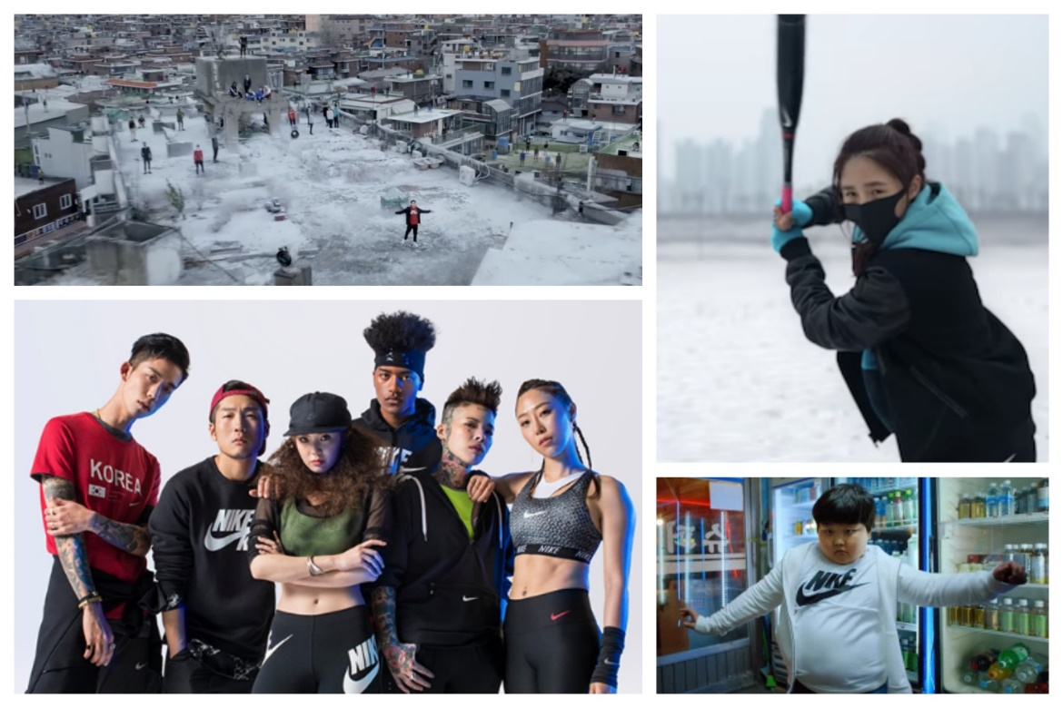
Figure 29. Nike “Run It” video stills and participants. Sources noted in Appendix 2.

A quintessential example is the 2018 music video created by American company Nike for distribution within Korea. As part of Nike’s Impossible to Ignore campaign and in advance of South Korea hosting the 2018 Winter Olympics, the video was created to highlight creative expression and individuality. The titular song “Run It” was performed by rappers Jay Park, Jessi, and Woo Won-jae. The video had cameos by various local public figures within sports, fashion, dance, and music. The lyrics spoke to continual hard work, overcoming adversity, and perseverance, exemplified in the biographies of each of the guests appearing. Many of the athletes would be competitors at the Olympics; one figure is recognized as challenging discrimination by becoming a top model in Korea with a biracial (Black and Korean) background; another is renowned for shifting gender expectations in being a well-known female tattooist (covered in tattoos as well). The visual was of them practicing, running, training, and living in cold, gritty Seoul. It was visceral, it was real, it showed Korean faces and spoke to the Korean spirit.

Observing Authenticity in Korean Hip-Hop and R&B

Citizenship in the hip-hop [and R&B] nation[s] is defined not by conventional national or racial boundaries, but by a commitment to [the genre’s] multimedia arts culture, a culture that represents the social and political lives of its members...the hip-hop [and R&B] nations serve as imagined cultural communit[ies] and, just as important, [they] function as communit[ies] of imagination.

In response to the question “Rap is known as a Black art form, and even in the United States there’s a whole controversy surrounding the issue of the authenticity of white rappers. Do people in Korea see rap as Black music?”, in a 2003 interview, rappers Jinusean answered “Yeah, they do. And it’s mainly because its history in Korea is so short – Koreans only started rapping in 1992. It’s Black music, and nobody’s denying it. I guess we’re trying to make it our own. There’s not a […] style these days. When it first started, Korean rappers were mainly trying to copy from the United States, but now they’re trying to develop their own style.” Early on, Korean rappers admitted to copying African-American artists. Looking ahead to sixteen (16) years after this interview, how much has changed?
Based on the earlier discography and videography analyses and “bright spot” studies, it is noted that in the twenty-seven (27) years since Seo Taiji and Boys ushered in these new musical sounds, foundationally, the answer is both much and not enough. The music has more local references, but the sound still has heavy foreign influence. The production skill of ppong or ppongkki is one that attempts to bridge the gap between older and younger Korean listeners by melding traditional Korean music with more modern sounds. Ppong has both melodic and voice components.
Technically, it is a “songs’ characteristic 2/4 duple meter rhythmic pattern with its accented first beat (ppong) and weak second beat (tchak).” A ppong melody is illustrated by several chord progressions occurring in the course of a song; “[a] kind of ascent/descent arch-contour in pitch and minor key-centered harmonic progression”. In this way the vocal melody moves like a wave. “This is well illustrated in the 2009 song “T.T.L.” [by T-ara feat. Supernova, in which] the vocal melody line, start[s] up-beat, ascend[s] over the first four bars and descend[s] again for the last four bars, while the ambit ranges from A3 to D5.” Vocally, ppong characteristics are reminiscent of the vocal embellishments of singers such as Aretha Franklin and Al Green, but are culturally based in Korean pansori, minyo, and kagok song practices. The embellishments are called sigimsae and are characterized by using “vocal inflections through vocal breaks, narrow and wide vibrato, switches between chest and head voice, shifting vocal attacks, and other forms of micronatal shadings.” Drawing on such cultural aspects of musical genres grounds the music in a distinctly Korean sound that is readily different from Western and African-American artists, that has traditional and historical roots, and that is readily familiar and identifiable by Korean listeners.
Conversely, where there is origination, there continues to be perceived imitation. Several Korean rappers seem to copy the tonality of other well-known rappers. There are similarities in rhythmic flow of rap artists like Epik High to B.O.B, of Keith Ape to OG Maco. Similarly, Korean R&B singers borrow the “persona” and inflection of U.S. singers such as Taeyang affecting that of Usher and Yoon Mi Rae’s vocal similarities to Lauryn Hill. These are concerning because “if artists are perceived as distancing themselves from their roots, they are considered a sell-out.”
In their interview, Jinusean continued to share that as the Korean hip-hop scene developed and came more into its own, they were confident that the sound would more accurately reflect the Korean experience. Until then, they acknowledged that any hip-hop music coming out of Korea would be measured against American artists. In the sixteen (16) years since this interview, that accuracy has yet to be realized. In returning to the idea of subcultural capital, Jinusean’s response reflects how “in music subcultures, authenticity is concerned with the organic representation of a subculture, that is, when ‘it rings true or feels real; when it has credibility and comes across as genuine.’”
A part of the Hallyu branding model within the music industry was creating musical groups that focused heavily on pop music, intricately choreographed dances, and rap. Hip-hop has African-American roots as a “cultural form and diasporic expression, especially in the contexts of subcultural, underground resistance against the dominant hegemony… [and is a] postmodern music for which the creative process is to ‘cut and mix’ different musical styles and cultural references, allowing for a continuous process of hybridization and syncretism.” Hence, the beginning of K-Pop. Much of the inspiration for K-Pop artists seems to come from Black American music and artists. For instance, Park Jin-young, founder of JYP Entertainment, has a strong “inspirational orientation” towards American music. He also has a “personal preference for American Black music as well as for European 1980s music [that has] permeated the musical style of many JYP artists. Influences from Soul, Funk, Disco, and R&B characterize the label’s hybrid sound that Park in [a 2007] interview described as ‘Black music with a K-Pop feel.’” Similarly, the growth of hip-hop in Korea can possibly be argued as a “process of appropriation, adaptation, and ‘cultural reterritorialization’”:

While borrowing from the international/American hip-hop idiom, such as sampling techniques, clothing and dance style, Korean hip-hop has also developed some distinct local characteristics by introducing elements of Korean music (both popular and traditional) and by mixing Korean and English lyrics in ways that are meaningful to its domestic audience.

The use of English slang instead of Korean slang raises questions of authenticity, versus “coolness” versus word flow. As noted in previous chapters, some rappers and ethnomusicologists may consider the use of English as a cop out as according to “cultural hybridization theory, a culture should be shaped according to the local context to demonstrate an authentic adaptation of the original culture. In hip-hop culture, this would be reflected in the usage of Korean by local rappers.” Others may consider it as a subtle nod to the genre’s beginnings.
For example, Korean rap group C.Cle believes that using English language provides a vast improvement to one’s flow because the translation of similar words or phrases in Korean is not as “smooth sounding.” Of note, is that C.Cle use a variety of languages in their raps; English, Korean, Spanish, and Japanese, which “supports the notion of cultural hybridity laced with elements of authenticity.” Their argument for the use of English language is one often repeated by other performers. English, is in a way a crutch, as artists work to weave a rhymed narrative with their lyrics. However, as they gain comfort and greater expertise in their craft they also gain greater comfort and a greater appreciation of Korean language as they learn to make it work for them. “Being a better rapper requires developing a deeper sense of the ways to sculpt the [Korean] language.” Within R&B, English words such as “girl” and “love” are similarly used in place of words that do have Korean translations, but whose sound do not complement the verse or melody. Conversations around language align with the view of cultural hybridization where the local language is adapted into the genre to highlight “authentic adaptation of the original culture.”
The evolution of hip-hop and R&B in Korea has, and perhaps always will encompass “the merging of cultures and contestations between ‘Americanness’ and ‘Koreanness.’” Within Korea the earliest understanding of keepin’ it real meant to have the music be an imitation of American R&B and hip-hop. As such, though the use of Korean language may be found throughout the majority of a song, artists are still using popular English vernacular or more derogatory language (e.g. curse words) because, “dissing and performing explicit, in-your-face machismo are essential K-hip-hop practices adopted from U.S. hip-hop culture.” Such language adaptations which are more for an effect than for content lead to concerns of needless appropriation. One must keep in mind:

Authenticity is invoked around a range of topics that include hip-hop music, racial identification, the music industry, social location, individualism, and gender and sexual roles. Profanity and slang are used in discourse often to emphasize the claims about authenticity that the speaker or writer is trying to support.

The performance reviews in Chapters 8 and 9, and the “bright spots” featured in Chapters 10 and 11, demonstrated some of the many indicators within Korean music from which authenticity and legitimacy can be gauged, assessed, and evaluated. What it seems to come down to, is what standards or internal indicators that Korean music practitioners – artists, producers, choreographers et. al – are using to distinguish their music from its foreign influencers and the overall understanding that the practitioners have of these genres. Again, in reiterating Thornton’s idea of subcultural capital, “authenticity is concerned with the organic representation of a subculture, that is, when ‘it rings true or feels real; when it has credibility and comes across as genuine.’” From the creation of the concept or theme, to the songwriting and sound production, to the accompanying music videos, the practitioners have control over the output. Being universal genres, R&B and hip-hop have subcultures across the world, yet Korean music practitioners continually, single-mindedly seem to narrow their focus on Black music constructs and Black culture as their source of inspiration. If the aim of producers continues to be find the “best song available” and then go from there to create a Korean sound, they will continue to be stymied.
Additionally, they will continue to be plagued with accusations of cultural appropriation and a faux Korean sound. As such, aside from a shift in paradigm and mindset around musical development, within Korean entertainment companies, there needs to be a shift around understanding cross-cultural adaptation and blatant cultural appropriation. When the companies care about the criticism and harsh feedback from minority groups who feel that their cultural identity has been commodified by an artist, I believe the companies will then take more care with their sound creation. This could also encourage them to look more inwardly and use more of the ppongkki production style.
There must also be greater awareness and understanding of the genres in which artists are performing and how they are perceived by the listening community within Korea and the rest of the world. When asked what set of standards they believe Korean rappers were being measured by, Jinusean noted that the sound was a key indicator. Though many listeners may not understand the lyrics to American rap (due to a language barrier), they understand the balance and flow – the lyricism – and that American rap would be the gold standard that Korean rappers are held against. If either of those two – internal standards and understanding of the genres – are lacking or missing, then the claims to authenticity lack as well.

Chapter XIII
Looking Ahead: R&B and Hip-Hop’s Future Representation in the Mainstream Media

“As musicians, and as people who sell material for people to hear and absorb, it’s important that we use that voice wisely” – Roberta Flack

Due to its history as an occupied nation before reaching autonomy, South Korea started later in the development of its musical sound and other aspects of its economy. “When it comes to South Korea, the country has been looking overseas for inspiration since it started modernizing. And K-pop, like many aspects of Korean culture that emerged in the 1960s and 70s, is inherently ‘appropriative.’” An apt metaphor is applying the origins of the first car manufactured in South Korea to how the Korean music scene has similarly developed. The car, called the Shibal, was developed from left-over parts of American military vehicles, mostly jeeps. As noted in previous chapters, K-Pop has developed from the left-over or similar parts of Western and European sounds, artists, etc. “Piecing together the best parts of finished technologies and practices perfected overseas and creating more efficient domestic versions is as old as modern, industrial Korea itself. And this is what K-Pop is. It’s a Shibal car cobbled together from elements of Western boy/girl bands (who were themselves borrowing from the Motown bands), a good helping of bubblegum pop, glued together with some rap and all smoothed out in the style of hip-hop.”
This history and these habits are acknowledged, however, the underlying argument that seems to be expressed around Korean hip-hop and R&B is that Korean artists are “engaged in a ‘new cultural politics of affiliation’, that draws inspiration from African-American struggles while generating distinctive approaches to race and protest in [Korea].” Though operating differently, issues of race, colorism, and class are still highly prevalent within the Korean community. Through their rap lyrics and through songs such as “Black Happiness” by Yoon Mi Rae, artists bring attention to “their specific location in a differently configured racial matrix. In this, they suggest the possibilities for a transnational cultural politics of race that improvises on their understandings of hip-hop [and R&B’s] core values.” Such multi-level and nuanced understanding of the ability of these types of music to create both local and translocal expression speak highly of the ability of Korean performers to fully assimilate these genres into a hybrid-balanced mix of Western (read: African-American) and Korean sound.
As the journey to this sound continues, Korean music practitioners find themselves, or should find themselves grappling with several questions: “What would it mean to know [R&B and] hip-hop, and what would be required to participate in the production of [R&B and] hip-hop, in a language other than English and for people with little (if any) historical connection to the largely African-American communities that gave birth to the style[s]? How can a [Korean] artist ‘keep it real’?” The representation of these genres within the mainstream media, the access to underground artists in these genres, and the access allowed to artists’ conception, thought, and execution processes by the Korean community may reveal the possible answers to those questions.
As it relates to this thesis, “hybridity is situated within debates about cultural identity and media specificity” as K-Pop was disbursed to and reviewed by the rest of the world in the 2000s largely through technological avenues. The advent of social media and online networking sites such as Facebook, Twitter, Instagram, and YouTube have “expedited the flow of cultural products; therefore, the nexus of culture and technology has become one of the most significant components in understanding hybridity in the digital technology era.” These platforms made it easier for individuals worldwide to see and hear K-Pop videos online; the inclusion of subtitles on YouTube helped to lessen language barriers. The platforms changed the way in which music was found, listened to, and understood. The Korean mainstream media has followed suit. New variety shows, real-time documentaries that follow the daily lives of K-Pop artists, and competitions looking for “the next big thing” in K-Pop, K-Hip-hop, and K-R&B have been developed. All of these are continually based off the format and understanding that executives and companies have around what these genres are and in what the Korean community will be interested. YG power house BIGBANG was developed in the aforementioned Big Bang Documentary. R&B singer Lee Hi was discovered on the competition series K-Pop Star, placing as first-runner-up. The variety show BLACKPINK House follows the members of BLACKPINK in their day-to-day lives. It has become a common staple of YG Entertainment to create reality shows around it’s (potentially) top artists and to give fans 24/7-like access. In 2012 and 2015, television station MNet launched two shows focused on hip-hop, Show Me the Money with a predominantly male cast and Unpretty Rapstar with an all-female cast, respectively. Contestants of each show were mentored by established artists in the industry, performed original raps each episode, and the winner was signed to a major label.
All these programs have several features in common. From a consumer perspective, they feed into the frenzy and almost obsessive behavior that fans can have around K-Pop musicians. From a business perspective, these are sound investments that provide additional brand, exposure, and revenue from their artists. As they relate to this thesis, they send out certain messages about the music and the production of the music found within Korean hip-hop and R&B. Viewers see songs from the creation process – the time spent in the studio, learning choreography, contestants as they are writing their lyrics or verses – to the first performance, and through the in-show interviews and mentoring sessions hear how these artists and top-selling Korean producers speak about their craft and how they understand these genres. These portrayals all contribute to the creation of an image, accurate or not, of what hip-hop and R&B are in Korea and what they are supposed to sound like. Their influence has already been noted in changing the way the Korean community perceives and talks about hip-hop and R&B in-person and online and they will continue to do so, so long as up-and-coming or established artists encourage or allow such access and publicity.

Reality Television and the Further Economics of K-Pop

The range of reality show concepts has adapted to allow viewers to receive more “intimate” views of their idols engaging in activities that go beyond preparation or promotion for their next single or album. K-pop idols have been seen providing childcare service, going on camping trips, responding to challenges similar to competition shows, producing their own reality show, and in survivalist themed shows where the idols have limited funds and resources.
Though such shows provide fans an opportunity to see their idols in a new light or to learn more about them, they are also subliminal marketing and promotional tools for both new viewers/potential fans and existing viewers/fans. Authenticity and sincerity are noted as keys to the success of such “bright spots” as Rain and BoA. Idols’ responses in these situations and the private confessionals create a level of intimacy where the idol’s personality, work ethic, and/or values rise to the surface and may resonate with a viewer. In turn, the viewer may be more apt to listen to, purchase, and support the idols musical endeavors. Chapter 7 discussed the financial positives of K-Pop for the Korean music industry. Here, the discussion continues with a narrower lens around how else these genres and their artists are commodified.

Table VI. 2017 Revenue and Net Profit of Highest Reporting Entertainment Agencies. Source noted in Appendix 1.
Agency | Revenue (USD equivalent) | Net Profit (USD equivalent)
SM Entertainment | ₩ 377.45 Billion ($350 Million) | ₩ -4.70 Billion ($ -4.3 Million)
YG Entertainment | ₩ 349.86 Billion ($324.3 Million) | ₩ 11.91 Billion ($11 Million)
JYP Entertainment | ₩ 102.24 Billion ($94.7 Million) | ₩ 16.36 Billion ($15.1 Million)
Big Hit Entertainment | ₩ 92.40 Billion ($85.6 Million) | ₩ 24.56 Billion ($22.7 Million)

As can be seen above, since beginning to invest in Korean popular music, the agencies who groom these potential idols recognize K-Pop for the “cash cow” that it is. Depending on the artist lineup and additional activities (e.g. reality shows or streaming stations, or direct radio investments), companies can have a diverse profile that ensures they net more than ₩20 Billion in profit and accrue at least ₩90 Billion in revenue before deductions (see Table VI.). Much of this is related to the direct activities in which their artists engage. For instance, in the first half of 2017 at JYP Entertainment, the album sales from two of their groups – TWICE and GOT7 – totaled 950,000 copies (600,000 and 350,000 respectively), which was close to their “entire sales volume for 2016 (about 1,100,000 copies)” which showed a definite increase in volume and profit. Though it is all considered “friendly competition,” the culmination of album sales, tours, fan meetings, etc. within an overlapping market (regionally and gender-wise) have indelible impacts on overall sales and which agency comes out on top fiscally at the end of the year. The data for fiscal year 2018 revenue and profit has not yet been released, but available quarterly reports show that such upward trends continue. Most recently revealed in August 2018 was that the “Big 3” entertainment agencies of SM, JYP, and YG continued to see financial growth, amid an overall trend of South Korean market uncertainty. For entertainments companies, while other entities are seeing a slow in investment, their stocks prices are rising, and overall profits are increasing which is directly attributable to the performance of their artists on the charts and in the public eye.
Technological innovations such as the previously mentioned social media platforms and the multi-operability of smartphones have allowed for the flow of information about artists to the public to increase exponentially. The internet continues to be the main hub for exposure to R&B and hip-hop in South Korea with its wide searchability and continuing online communities related to these genres such as DC Tribe, Hip-hop Player, and Rhythmer. It is a hot spot to discover and discuss new, returning (the industry is notorious for artist “comebacks”), and current artists, and creating colloquial terminology. “The famous Korean idiom ‘haters in the room corner (bangguseok hayruh)’, now a cliché in rap, was invented by [Korean rapper] Verbal Jint and refers to anonymous online trolls.”
The exposure to these genres has increased as accomplishment has been found by several artists who successfully integrate these sounds into their music. BIGBANG’s roots are in hip-hop and a love of R&B. Due to the widespread national and international exposure to their songs “the sounds of the genre[s] became familiar to the mainstream.” Yet, this exposure walks a fine line. How and what is displayed to the public can sometimes be distorted or lost on the editing room floor. Or, as has been the case with much of hip-hop and R&B’s integration into the broader K-Pop scene, the sound is diluted.
Similarly, only a select few may benefit due to their connections to larger agencies or the luck of gaining infamy via YouTube or another platform. For example, “while BIGBANG was often associated with bringing the hip-hop sound to the mainstream, the truth is that the community as whole did not benefit from the public greater acknowledgement of the genre as a whole.” BIGBANG put hip-hop and R&B on the radar of the Korean community and generated some interest, but it was not enough for independent or underground artists to fully invest in self-promotion or increase the possibility of them being signed to well-paying performance opportunities.

Underground Artists’ Movement into the Mainstream

Many argue that the vitality and originality of Korean hip-hop and R&B remain with underground artists. These are the individuals who are intimately aware of their genres origins, who still listen closely to Bone Thugs-N-Harmony or Marvin Gaye albums, who dissect the sounds they hear, compare, and analyze their own, because they are highly cognizant that they are engaging in what is primarily identified as “Black Western music” and want to ensure they have “figure[d] out what was the proper way to do things.” Underground artists were the first to write songs and lyrics that spoke about the quotidien of life in South Korea and “relatable themes as life and love, at times self-deprecatingly, at times optimistically, gaining a following.” These are the artists who have worked, to varying degrees of success, to exemplify the purest forms of integrative hip-hop and R&B.
In particular, DJ DOC is one of the earliest artists credited with creating a song that related an issue in South Korea – police brutality and systemic issues of the justice system – to an issue also facing Black Americans. His 2000 single titled “Pojori” – which is an adaption of pojol, referring to a soldier (or police officer) in the Joseon Dynasty – was modeled after “Fu*k tha Police”, an infamous song that speaks to anti-establishment and anti-police brutality, by American rap group N.W.A. “DJ DOC’s “Pojori” carries [the spirit of resistance within N.W.A’s song], but its portrayals of the police are more South Korea-specific. In the song, the South Korean police is demeaningly called jjapsae (literally, a bird that catches thieves), and is mocked as incompetent and corrupt. Hip-hop’s spirit of resistance lies essentially in the sense of identity that African-Americans had as a racial minority, in their rage against oppressive white America.” DJ DOC and other artists have analogued that oppressiveness to Korean issues such as “labor and democracy movements, criticized the government’s unconstitutional practices, [called for the resignation of government officials,] and critiqued other general social issues.”
The “underground” is increasingly finding itself above ground. More artists are finding themselves included on “artists you need to know,” “artists who are taking over,” “artists who are underrated,” or “new artists of X year” lists. There has also been an upswing in the number of “YouTube channels and playlists dedicated to new underground artists waiting to be discovered, such as Offonoff, Rheehab, Bevy Maco, MISO and Summer Soul.” Additionally, the inaugural Korean Hip-hop Awards show was held in 2017 to honor the top artists and releases in R&B and hip-hop as selected by a combination of aggregate votes by a selection committee and netizens. It was co-hosted by HipHopPlaya, a major online Korean hip-hop community, and HipHopLE, a major online Korean hip-hop and R&B magazine.
Though it is an open secret that proper attribution has been lacking within R&B and hip-hop as a whole, some African-American songwriters working in South Korea are noting that Korean artists have begun stepping up in speaking out more about their influences and inspiration. They find themselves “happy that the K-pop scene is so unapologetic about giving props to Nineties R&B for its influence – much more than American pop does, much more than American hip-hop does, much more than American country music does.” These up-and-coming or “next generation” R&B artists which includes Lee Hi, Dean, Crush, and Zion T., openly share their inspiration by groups such as N*E*R*D, Marvin Gaye, Donny Hathaway, James Ingram, Maxwell, D’Angelo, Erykah Badu, and Musiq Soulchild. They will emphasize their study of these artists and additional genres such as trapsoul, neo-soul, and jazz. They also opt to sign with smaller, independent labels that allows for more creative control in their sound and collaborations. Many independent labels, such as AOMG and H1GHR Music both started by rapper Jay Park, “focus [on giving] a voice to those underground talented rappers and R&B singers and spread multicultural open-mindedness.” This puts these artists in a unique space to not only produce their own music but to contribute to the broader, more mainstream K-Pop sound as well. “Today, South Korea’s music industry might be small, secretive and fast-paced, but it’s also hungry for hit songs, and multi-talented artists who can write, produce, and perform. Which means that this new wave of Korean R&B artists work with and write for K-Pop singers and groups, shifting them into the spotlight of the masses.”

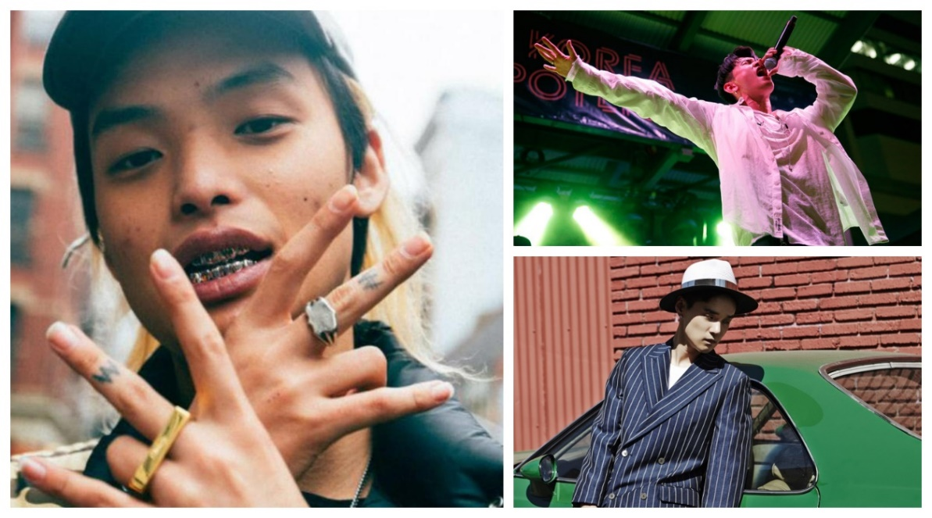
Figure 30. Keith Ape, Crush, and Dean. Sources noted in Appendix 2.

Underground and up-and-coming artists are slowly but surely changing the face of the Korean music scene. Though K-Pop continues to dominate, they are creating niches within R&B and hip-hop that lend more originality and integration to various sounds, because of their boldness and willingness to experiment and their initial efforts to learn the history and nuance of these genres. To illustrate, R&B singer Dean shares that he attempted to learn more about U.S. culture by listening to Black music. R&B singer Crush is purposeful about mixing hip-hop and R&B with “Korean style and lyrics, which [he] think[s] has made it easier for Koreans to relate to.” Rapper Keith Ape was initially exposed to local rappers, before hearing Nas’ album Illmatic in 2004. From this he was primarily enamored of East coast rap and “New York classicism. But the more he researched American hip-hop online, the more he became infatuated with its rowdier side, especially the music from the South.” As such, his 2015 breakout hit “It G Ma” was heavily influenced by and sampled the sound of southern rapper (by way of Atlanta, GA) OG Maco’s “U Guessed It.” Similar to how “U Guessed It” expressed OG Maco’s frustration with the current rap scene (and his drunken brilliance with lyricism), “It G Ma” was Keith Ape’s attempt to share his own dissatisfaction with what he considered the bubble gum pop factory of K-Pop and its tendency to only sprinkle in hip-hop as a novelty. “Keith Ape wanted to make what he considered to be true hip-hop, ‘not to be wearing makeup and dancing up and down onstage.’”
Underground R&B and hip-hop artists endeavor to uphold the concept of keepin’ it real. They recognize that by only consuming and observing Black culture at a distance, they disadvantage themselves from truly understanding the nuance and “specific social circumstances” from which the music originates. Without this understanding, one devolves into making “gestures and aesthetics, [where] exaggeration is almost a given, and the potential for offense is high.” Their scene is still a small and intimate market compared to the mainstream, though it is continually changing. The demographic – age and gender – of their audience is changing and expanding, and they are also becoming media savvy in making their music accessible on platforms such as SoundCloud and YouTube. “Korean rappers [and R&B singers] aren’t just finding success at home, but overseas, and the trickle-down effect of Korean [R&B and] rap’s new mainstream popularity to international K-Pop fans can’t be discounted. Many fans from around the world have jumped on the Korean [R&B and] rap bandwagon[s] after discovering the music and artists through its gradually decreasing degrees of separation from the K-Pop world.” Up-and-coming artists are continually making use of live performance venues as well, gaining performance blocks at clubs known for an emphasis on hip-hop and/or R&B music.
For independent artists and independent labels however, financing and promotion continue to be the greatest challenges to their solubility and longevity. Therefore, though they were initially derided by the underground hip-hop and R&B communities, more artists have begun appearing on shows such as K-Pop Star and Show Me the Money. South Korean rap legend MC Meta, of the infamous crew Garion, who has also participated as a mentor on Show Me the Money (SMTM) shared that success for underground or up-and-coming artists is dependent on three things: “First is skill, which is basic. More than that, rappers need to be smart and know what opportunities to take. Lastly, they should look at things in the long run and be willing to work their way up the ladder, step by step.” The participation of such artists in reality and competition shows is an opportunity for them to show if they have or lack any of MC Meta’s recommended informal prerequisites in very public forums.

The Narrative Competition Shows Create Around Hip-Hop and R&B

There have been a recent spate of singing competition shows, from The Unit to Produce 101 to Mix Nine to K-Pop Star, which create American Idol or The Voice-like formats for aspiring solo or group performers to share their talents and hopefully receive a contract with a well-known entertainment agency. Similar to the reality shows, they have varying concepts: some are straightforward competitions, others focus on idol trainees rejected from other companies, and some focus on supporting the “comeback” of previously well-known groups who “failed” in the industry. R&B Singer Lee-Hi was the runner-up on Season 1 of K-Pop Star though still continued on to sign with YG Entertainment. The winner of K-Pop Star Season 4 was also an R&B focused artist. Korean-American Katie Kim, who goes by the mononym KATIE, also initially signed with YG Entertainment, before moving on to start-up agency AXIS. Music is a constant in her life. As a student at Berklee College of Music, she studied to be a jazz singer but “‘fell in love so deep’ with R&B and soul that she changed her career path.” Her musical influences include the Hathaway father-daughter combination of Donny and Lalah, Frank Ocean, Lauryn Hill, Anderson Paak (whom she considers “a pure genius”), and early (90s and 2000s) R&B. Though her beginnings were on a reality show, KATIE hopes to cement herself as a serious R&B singer, unattached to K-Pop, with the June 2018 release of her debut album.

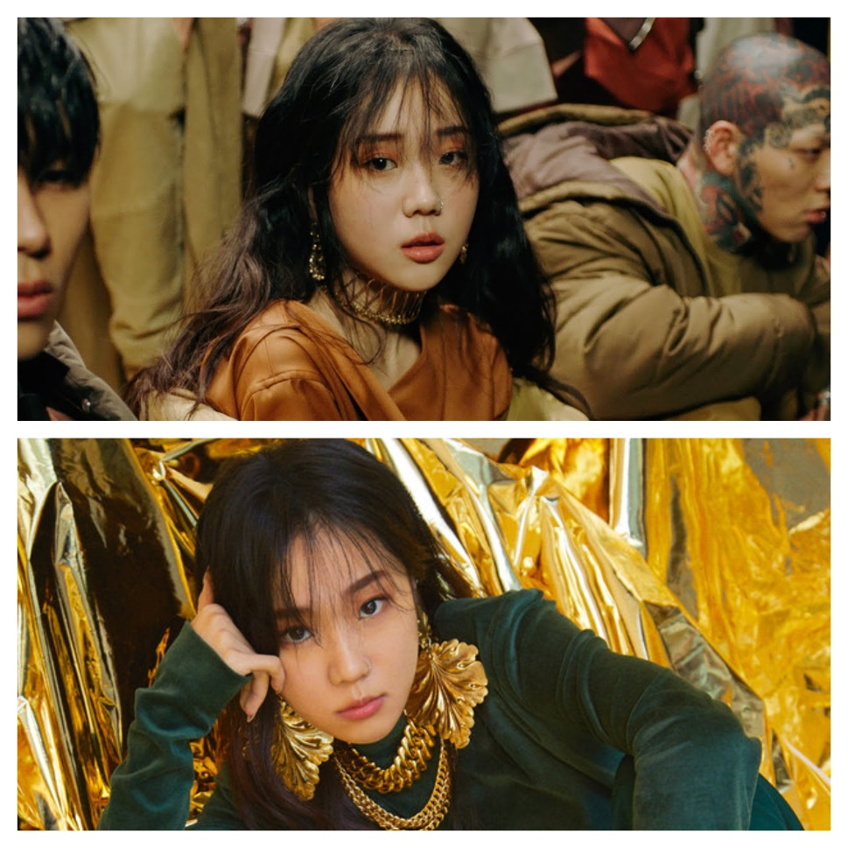
Figure 31. KATIE. Source noted in Appendix 2.

Rap competition show Show Me the Money (SMTM) had a slow rise to influence. The first season debuted in 2012 to general curiosity and tepid responses. Season 3 which aired in 2014 was the breakout season for the show. The competitor’s songs regularly found themselves “ranking on the national digital charts, [receiving radio play], and quotes becoming memes instantly. [Season 3] recorded the series’ highest ratings yet, along with the show’s first number one singles.” Though the show boasts a mixed-gender cast of male and female rappers, the females are often eliminated early in the series. As such, in 2015 the all-female Unpretty Rapstar debuted with a similar format. Its first season featured many of the eliminated female artists from Season 3 of SMTM, which automatically created buzz. Both shows have received acclaim and criticism for their influence and impact on Korea’s hip-hop scene. They have received acclaim for being a venue by which new artists and types of music can be introduced to the mainstream.
However, they have also received much criticism. The criticism lies in the quality of sound and the visuals that are produced. Since it is a show, the producers have been accused by participants – mentors and competitors – of not understanding hip-hop or how it should be showcased. Due to this lack of understanding, important segments, such as showing the competitors experimenting with sounds or merging sounds of “old school” rap and Korean melodies, often find their ways to the cutting room floor. Viewers have no idea that these creative processes happened when hearing/viewing the final product if they are not familiar with hip-hop’s history or Korean folk music. One critic claimed that SMTM does a disservice to the authenticity within the hip-hop genres because of the shows selectivity in sensationalizing certain elements of hip-hop for television ratings such as “diss and swagger” and in “importing clichés” and skewed understandings of aspects of the hip-hop journey, such as what it means to hustle. “The South Korean hustle is limited to describing moneymaking [sic] through music, without integrating specific local realities: ‘Earn money, earn money.’ ‘Imma rest after I’m dead.’ ‘Money pile gettin’ bigger, money, money, money pile!’ Lyrics like these aren’t narratively persuasive; they’re hackneyed and repetitive. It’s understandable that the public is getting tired of South Korean hip-hop, which many think sounds generic and pretentious.” Additionally, seasons have often featured rappers from idol groups, such as Mino from WINNER and Hyolin from SISTAR. However, parent company MNet made it clear that supporting the discovery and recognition of underground artists is not the goal of these shows; instead it is to “introduce the genres of hip-hop and rap to the Korean public so that they could enjoy a wider variety of music,” which negates requests to exclude idols from competing.
Hip-Hop pioneer Afrika Bambaataa is quoted as saying “somewhere down the line, the evil ones stole the legacy of hip-hop and flipped it to a corporate type of hip-hop. They decided to tell everybody, ‘Well, this is what hip-hop is’, instead of coming back to the pioneers and getting the true definition of what hip-hop is and what it was and what we been pushing for all these years.” Such reasoning as given by MNet seems to justify Afrika Bambaataa’s argument and raises additional concerns that shows like Show Me the Money (SMTM), Unpretty Rapstar, and K-Pop Star have more insidious impacts on the hip-hop and R&B genres due to the broad selection and formatting of their programs.

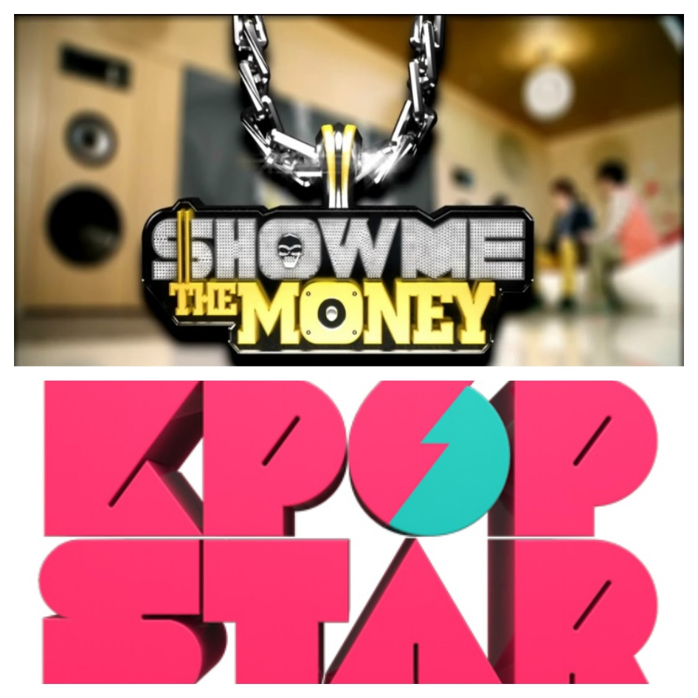
Figure 32. Show logos for SMTM and “K-Pop Star”. Sources noted in Appendix 2.

In their airing of six seasons for K-Pop Star and seven seasons of Show Me the Money, these shows have built a level of influence that many Korean journalists argue have made them the de facto “bosses” of the R&B and hip-hop genres. This means that these programs now “dictate the activities of the mainstream hip-hop [and R&B] sphere[s]” which has negatively impacted these industries by commercializing them and spreading inauthentic R&B and hip-hop culture in the pursuit of making profit and “a good show.” Through the feedback from the mentors and judges, and the final products aired by the contestants, these shows are writing new narratives about hip-hop and R&B in Korea and redefining authenticity as it applies to these genres. Their definitions of “authentic hip-hop [and R&B] culture overtly reflect [these genres] as money-making exercise[s] to generate more profit. Moreover, since [shows like K-Pop Star and] SMTM [are] so seminal in the culture, it reflects this commercialized image as authentic, in turn influencing the general public’s image[s] of [R&B and] hip-hop culture.” Emerging singers and rappers are also impacted, as they no longer have a grounded foundation in real hip-hop or R&B and instead duplicate the trends created by K-Pop Star and SMTM.
The output for many of the performers on these shows and within mainstream Korean music can be, at times, described as a caricature at the politest. It is continually noted that there is a lack of thought in how singers and rappers can “best localize the music they’re appropriating. The mission of South Korean hip-hop [and R&B] should be to create music that is both attractive and convincing, one that acknowledges the different local condition and correspondingly transforms the genre, or even transcends the limits imposed by the difference in that condition.” Until then, such ignorant mimicry returns to earlier statements about failed cultural hybridity and raises concerns about the future of hip-hop and R&B in Korea. Their ignorance is based on a “deficit of grassroots hip-hop [and R&B] subcultural knowledge.” If these competition shows are what aspiring artists look to for education, then two narratives emerge; the inauthentic one the shows promulgate and the authentic one that underground artists continue to promulgate. However, due to distribution and reach, it is easy to see which narrative will have broader reach to the masses and lead to a continued, broken cycle of cultural appropriation. A key component of the hip-hop and R&B scenes in Korea is that their claims to authenticity are not made through connections to race but in how they integrate and adapt what are considered symbols of those genres. If the instruction on how to do such integration is flawed, then the integration itself will be flawed.

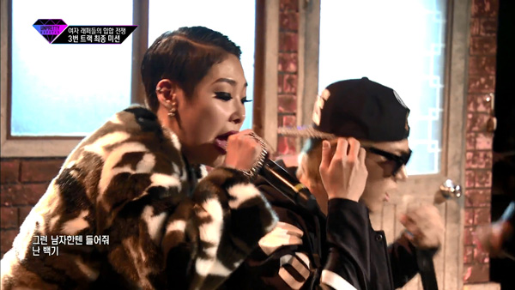
Figure 33. Contestant on “Unpretty Rapstar”. Source noted in Appendix 2.

One of the few “bright spots” or earnest rappers from SMTM is Woo Won-jae, who guested on Jay Park’s “Run It” song for Nike. His sound exemplifies successful localization of foreign genres. His lyrics are easily relatable to the Korean community as he speaks about everyday things such as being a student and hiding his tattoos from elders. He keeps himself and his listeners in the “now” of his life; “Woo Won-jae uses present continuous, to laugh at the world and simultaneously acknowledging his own vulnerability while overcoming it. He raps not in a physically violent ghetto, but in a country with a high suicide rate, intensive emotional labor and psychological violence. His honesty complements his narrative talent.” His honesty resonated with viewers. Though he finished in third place during his season, this exposure allowed him to sign with a label and for his singles, such as “We Are” to chart at number 1 on several digital music charts.
Gems such as Lee Hi, Woo Won-jae, and KATIE are a rarity on such competition shows, but their presence helps in the proliferation of authentic R&B and hip-hop genre performance into Korean households. Of SMTM, MC Meta said “it is simply an entertainment show, but if you look into it, it shows all the different sides of underground hip-hop ― not only the passion and the dreams of the artists, but also how underground hip-hop is treated. It shows that there is a limit to how far Korean hip-hop can go in Korea.” Perhaps such a perspective can be applied to all of the reality shows highlighting idols and emerging artists, which may help diminish concerns over the long-term impacts these shows may have on the hip-hop and R&B genres.

The Public Faces of Hip-Hop and R&B

How Korean performers approach their expressions of these genres is of utmost importance. They lay the foundation of understanding and interpretation to the Korean community as a whole. Above all else, hip-hop and R&B are understood in Korea as Black music moreso than American music. With that comes “racial connotations emphasized more than national origins. Over time, this Blackness has been interpreted and used in a wide variety of ways (e.g., hair styles, skin tanning, rapping, body language, ideas of self-expression, clothing, musical taste, etc.).” For entertainment agencies, it is how they have decided to stylize their artists or to specialize in Black sound and Black music through the management of their K-Pop groups.
These varying interpretations are often on a slippery slope of homage vs. appropriation. In returning to Keith Ape and his single “It G Ma,” his sampling of OG Maco was not without issue. Not only did he not request or receive permission to sample the melody, but the visuals that Keith Ape chose in his video came off as tone-deaf at the least, ignorant at best. “American artist OG Maco realized ‘It G Ma’ shared similarities with his track ‘U Guessed It’ and worse, that its low budget music video was bombarded with stereotypical Black imagery. OG Maco called this out on Twitter saying, ‘I didn’t have grills or extra jackets and lean cups (Styrofoam cups filled with “lean” or “purple drank”, i.e. cough syrup mixed with Sprite) and sh*t in the ‘U Guessed It’ video, so why did they? Black stereotypes. Lame as fu*k.’” Though the two artists eventually resolved their issues and OG Maco now receives royalties for the sample, this anecdote highlights how “the obsession with appropriating predominantly Black culture in hip-hop is still prevalent and must continue to be challenged as K-hip-hop continues to carve a place for itself into the global hip-hop world.”
This vigilance and awareness are not only needed at the artist and practitioner level, but also among the fans. Unless they know – or care – about the cultural appropriation occurring by their artists and call them out for these missteps, they will continue. K-Pop fans are known to be some of the fiercest supporters, defenders, and detractors of artists they like or dislike. The Korean community are both consumers and influencers of K-Pop, Korean Hip-Hop, and Korean R&B. “[Korean music] is consumed on a global basis now, and perpetuating negative stereotypes of Black people does little to change the current undercurrent of racism in South Korea, even Seoul, and the rest of the world.” They can and should be encouraged to use their consumer voice and consumer power to push for change and more positive instances of cross-cultural collaboration and/or idealization.
“Appropriation can be done well or in poor taste. It can be done with attribution or as part of an act of wholesale theft. And it can be done in acceptable and unacceptable ways.” Social media, reality television, and the artists themselves are still the main sources of how the Korean community learns about these genres. These mediums provide the basis for the opinions community members form and provide the overall understanding they have of what makes up these genres. “Black music is indispensable and essential in the contemporary Korean popular music scene.” Its representation should be reflective of its importance and influence.

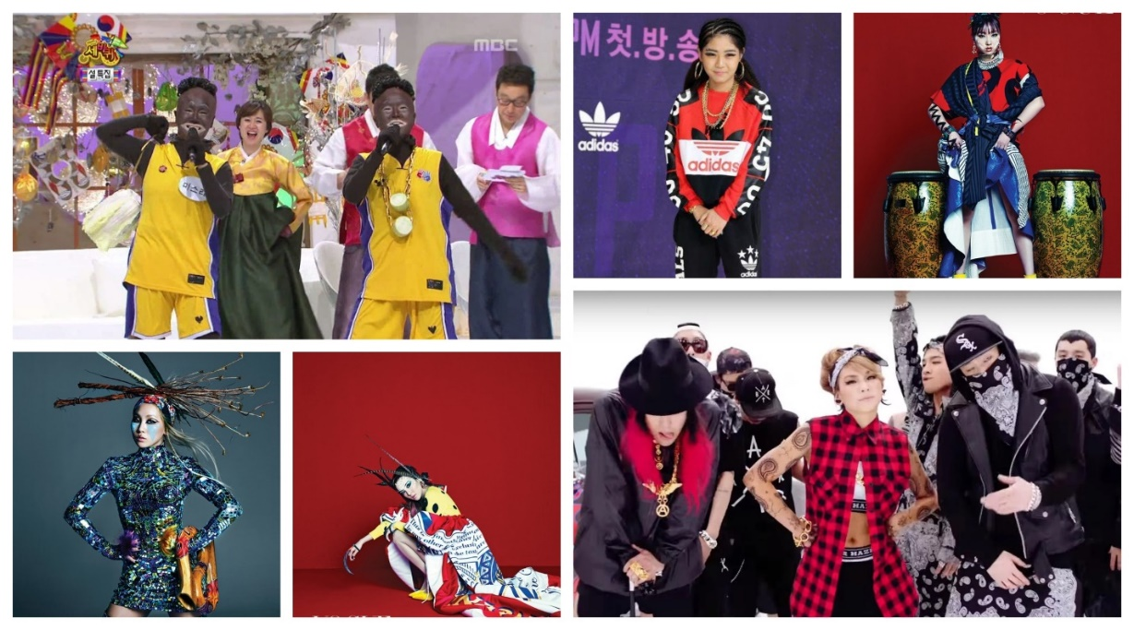
Figure 34. Performers with artistic, appropriative, and offensive interpretations of Black culture.
Sources noted in Appendix 2.

Looking ahead, the public faces of R&B and hip-hop do not only raise issues of concern. There is also optimism. African-American songwriters in Korea have taken note that in many ways Korean music is stepping up. They recognize “K-Pop’s willingness to acknowledge its debts to R&B leads to an odd phenomenon for the genre’s ace writers – a feeling more familiar to American jazz musicians, who have long been valorized overseas and overlooked in their homeland. ‘It’s almost like you get more honor outside of your own country for what you do sometimes.’” These writers are cognizant of the conflicting, often contradictory reception that Black music and songwriters of Black music have received in the U.S. As such, for their work to receive proper attribution abroad is a great boon and a positive precursor for more progressive changes in the Korean music industry.
In considering cultural globalization and cultural hybridity as they relate to music, a point that many scholars continually circle back to is the transformative process of the “transnational flows” of musical genres. For hip-hop and R&B, it is clear that though the initial integration or institutionalization of these forms into a non-American culture seems to perpetuate a homogenous “look” and “sound” that is nominally based on Black culture, that is not case. When the effort is made, these genres are able to become “distinctive domestic versions” through the localization process. This is the ultimate goal of these genres and speaks to the true universality of music.
A suggestion for the Korean music industry is that “more Korean unique stories and culture archetypes should be discovered and recreated by integrating global sense and perspective.” Until then, practitioners seem to find themselves ensnared in the initial absorption of outside influence, where reliance is on the base (original) form of the genre, so it appears that a copy-and-paste has occurred with appropriative aural and visual outputs as the result. In considering these linkages, cultural anthropologist Ian Condry posits an interesting perspective on how to focus on these issues by sharing “[his] focus is not on ‘culture of a people’ nor ‘culture of a place’ so much as ‘culture as it is performed.’ This offers a way of analyzing the complex linkages of global and local that operate in different artists work.” In looking at “culture as it is performed”, perhaps the innovation of Korean music relating to hip-hop and R&B will be discovered, moreso than the instances of caricature.

Chapter XIV
Conclusion

“I only hope that one day, America will recognize what the rest of the world already has known, that our indigenous music – gospel, blues, jazz, and R&B – is the heart and soul of all popular music; and that we cannot afford to let this legacy slip into obscurity, I’m telling you” – Quincy Jones

The Korean music industry is approaching a pivotal moment within its history. With the requirement of two (2) years of mandatory enlistment in the military for South Korean males, many of the solo and group artists and voices responsible for the continuation of Hallyu in the 2000s will be on hiatus. Similarly, several of the girl groups that debuted in the mid-2000s are either going on hiatus for members to pursue solo projects in venues other than music or completely disbanding such as SISTAR and Wonder Girls. Both occurrences are creating gaps to be filled. Whether it is through the debut of trainees who have been in the system for several years, as was the case with BLACKPINK in 2016, or further attention being paid to up-and-coming or previously underground artists through reality and competition shows, or more agency auditions; the industry is approaching a crossroads. Agencies will have the opportunity to focus on new sounds, encourage more experimentation, and the use of the ppongkki integrative method. On the other hand, the industry may continue on the same blurred path of “are they” or “aren’t they” committing cultural appropriation in their genres. The cumulative conclusion from this thesis remains the same as the preliminary conclusions shared at the end of Chapters 9 and 12, and implicitly alluded to throughout the rest of the research. Below are summative answers to the six (6) research questions and my final thoughts.
When considering how this musical integration can be defined, the answer remains contingent upon the lens with which one is looking at Korean popular music (K-Pop), Korean hip-hop, and Korean R&B. From the perspective of Korean music practitioners, it is defined as a merging of cultural sounds, with the use of European and American; especially African-American sounds, as a base or foundation. The Korean understanding seems to be that the mash-up of various melodies and the sometimes incorporation of traditional Korean musical components creates a new and innovative sound.
However, the perspective of an outsider reading, listening, and watching the outputs of this process more prominently lies in the conclusion that this integration is defined as primarily cultural appropriation with some instances of proper attribution occurring. This is due to how the R&B and hip-hop music scenes have developed and continue to be practiced in Korea. “Neither the phrase global homogenization nor the term localization accurately describes the changes in the scene over the years. Instead, we see both deepening connectedness (to the global scene) and widening diversity (both within [Korea] and worldwide).” Yet the continual reliance on Black constructs aurally and visually in these genres stunts the growth of these scenes to metamorphose into a translocal or fully culturally hybrid musical form.
As such, the overall reply to whether the presence of African-American musical stylings in Korean music are examples of adoption, appropriation, integration, or something else; is that this presence is an example of cultural appropriation. However, the “bright spots” and performance review emphasized that there is reason for optimism and visibility of the possibility of change. There are examples in Korean R&B and hip-hop where cultural integration has successfully occurred. The universal aspect of these genres and the idea of cultural globalization in relation to music lend themselves to several challenges when a focused comparative analysis or assessment occurs between the originator of a style and a culture that has begun performing in it. A key challenge is in “recognizing that the global and the local are not so much matched pairs as they are symbolic crystallizations of more fluid, ongoing processes unfolding over time.” As previously noted, due to its history, the Korean music industry is in relative infancy or young adulthood. Its sound and the understanding of musical genres by the Korean community are still developing.
The upcoming “crossroad” of artistry can (and should) be seen as an opportunity for their ongoing musical process to further advance and further hone its own unique sounds and styles in all genres – pop, R&B, hip-hop, rock, etc. Some scholars have questioned if “the spread of such popular culture forms ultimately produce cultural homogenization or increasing diversity?” The measured retort is that globally “what seems most likely is that we are witnessing both convergence and divergence, albeit in different dimensions and with contradictory effects.” Currently for Korea however, it does not seem to be a mixed issue of “convergence and divergence.” American R&B and hip-hop are not being assimilated into Korean music, so much as Korean music is assimilating American R&B and hip-hop and being dominated by Black, Western sounds. The outlier is seen, again by the “bright spots,” as well as certain artists – mainstream and independent – who have taken the time to educate themselves about hip-hop and R&B culture. These artists affirm that cross-cultural adoption can be done successfully and respectfully. Further, that such integration due to these “global crosscurrents are accompanied by a widening diversity among artists, fan groups, and media. If anything, the differences between [Korea’s] various rap [and singing] styles [have the ability to become] more, not less, pronounced.”
Such suppositions are key to comprehending how the terms “adoption,” “hybridization,” “integration,” etc. are defined and understood within a musical context. There is no ideal or perfect definition because those terms are all mercurial as they relate to music. In certain contexts and countries, music is “a weapon in battles to create a cultural basis for new nations to transform alliances and identities with already existing states, and to unmask the power imbalances that give regions, languages, and ethnic groups very different relations to the state they supposedly all share.” Korean hip-hop and R&B were used as weapons by the sinsedae generation to share their displeasure with the systems in which they were living. The genres evolved in Korea to not only deconstruct and reconstruct traditional paradigms around issues of “identity, race, nation, community, aesthetics, and knowledge” but also to create sounds and styles that are relatable to local audiences, fit within local contexts, and fit into sociocultural contexts. Drawing on such cultural aspects of musical genres grounds the music in a distinctly Korean sound that is readily different from Western and African-American artists, that has traditional and historical roots, and that is readily familiar and identifiable by Korean listeners. When such groundings successfully occur, then translocation, hybridization, integration, and adoption have effectively occurred in a musical context.
The above response is similarly applicable when considering a good working definition and understanding of cultural appropriation as it relates to a “global” phenomenon such as music. In exploring the Korean music industry broadly, and then narrowing the focus to the R&B and hip-hop genres, it is apparent that both the denotations and connotations to phrases like cultural appropriation and the cultural globalization of music should be revised. “To the extent that we conceive of transnational flows primarily in terms of multinational corporations, powerful media, communications technology, or government actors, we fail to recognize the diversity of paths that can lead to global cultural connections.”
The internet and social platforms are powerful venues for Korean popular music by expanding the consumption of the music past Korea’s borders. They also helped the music of underground and independent artists to gain visibility, followings, and interest. The above-noted, more traditional means of transnational flows are not the only outlets by which cultural connections now occur. With new ways that fresh ideas, sounds, and/or formats of music are being introduced, one must also consider that they are being processed and absorbed by people and entities differently. As such, current definitions of cultural appropriation may no longer apply as the lines begin to blur in how the origin or foundation of certain sounds may be traced.
Legendary producer and composer Quincy Jones asserts that Black indigenous music is the foundation for all popular music. As such, Black sound will always be present in some form in these genres; it is how world communities build off of that foundation that will determine how “adoptive” or “appropriative” the final product is. As such, new ways need to be thought of in how the current core components of societal interaction and societal constructs are made – people, technology, the media, the financial sector/private industry, etc. – can come together and conduct assessments of the mutual benefits in their interactions and flows of communication, information, and resources. In small ways, the Korean music industry can take steps to lessen instances of appropriation due to either ignorance, indolence, or naiveté. More investment can be made in the previously mentioned pponggki method of integrating Korean folk and other sounds. Cultural competency can be included in the intensive idol training. Cultural awareness and musical history can be included for songwriters at the various “songwriting camps in South Korea.”
In their open willingness of sharing their musical inspiration and influences, Korean artists already declare which Black artists – past and present – have global appeal and influenced this acculturation. Being anointed as the “King of Pop,” it is no surprise that Michael Jackson is a universal influence. Due to their dominance in the music charts during different periods, names such as Marvin Gaye, Whitney Houston, Prince, Anita Baker, James Brown, and Janet Jackson are unsurprising. Similarly, in hip-hop it is expected that N.W.A., Warren G, Tupac, Wu-Tang Clan, Nas, and Jay-Z are considered “founding fathers” for Korean rappers. However, there were artists referenced whose fame never reached such international levels and it was a pleasant surprise to discover their music ascribed as being influential. This includes neo-soul artists such as Musiq Soulchild, Frank Ocean, D’Angelo and Jazmine Sullivan. There were also lesser, internationally known rappers such as Fabolous, Nelly, and T.I. Hearing these names indicates that additional time and energy was taken to truly explore Black R&B and hip-hop, and to possibly gain a more well-rounded understanding of these cultures, musical communities, and genres.
When considering the viewpoint of South Korean artists and music listeners about the influence of African-American music and whether it is acknowledged or ignored, the answer remains a mixed bag. The lack of understanding of hip-hop culture and R&B culture is still prevalent within the Korean community. A similar understanding is not expected of the artists who train to become music idols. The entertainment agencies are not currently concerned with proper attribution or acknowledgement of their music. And yet, there are still “bright spots” and shifts are still occurring, as noted by African-American songwriters living and working Korea. The industry is strongly encouraged to adjust as needed to ensure that proper attribution of sound, of choreography, of fashion, and of cultural traditions happens.
Finally, I will assert that there is a small percentage of Korean music practitioners and consumers within both the mainstream and underground R&B and hip-hop music scenes who are what is colloquially termed as woke. To “stay woke” or “be woke” is to be aware of what is going in one’s community and to challenge any perceived social injustices. The word, phrase, and its connotative meaning are attributed to neo soul and R&B singer Erykah Badu and her 2008 single “Master Teacher”. To expand on this idea, to be woke means that while the Black community hopes and looks forward to the day when equality across racial, societal, and socioeconomic lines is achieved in the U.S. and beyond, one must not get caught up in (day)dreaming. One must stay present and aware of society’s current shortcomings.
Staying woke acquired recognition and influence with the increased shootings of unarmed Black men in the U.S. and transformed to also infer activism, specifically within the “Black Lives Matter” (BLM) Movement. “The word woke became entwined with the [BLM] Movement; instead of just being a word that signaled awareness of injustice or racial tension, it became a word of action. Activists were woke and called on others to stay woke.” In building off of its usage by BLM, it now has the (infamous) distinction of having also “gained traction on social media and permeated mainstream culture.” With this shift, and with allowance from the Black community, being woke is not limited to members of the Black community. It can also include People of Color (POC) allies and non-POC allies. “In the vaguest terms, woke refers to an intangible level of awareness about community issues and social justice, but the specific meaning changes depending on the speaker.”
The intent behind woke as I am applying it to a segment of both practitioners and consumers of Korean music is apt. “Stay woke became a watch word in parts of the Black community for those who were self-aware, questioning the dominant paradigm, and striving for something better.” The cultural and paradigm shifts that Korean music needs to take in order to more honestly, accurately, and effectively harness its “Koreanness,” is readily apparent to this small group.
They are highly cognizant and pushing back against the “dominant paradigm” of the industry’s tendency to rely on European and Black sounds without accreditation and without attempting to infuse Asian or Korean cultural elements. These woke individuals will be the drivers and change-makers that will make the industry’s self-actualization to cultural hybridity possible. At its heart, “cultural hybridization has a cultural focus and emphasizes cultural interplay where ‘traces of other cultures exist in every culture.’” This small percentage of the Korean community who acknowledge, properly attribute, and are pushing themselves to grow off of and to grow better from the Black constructs and Black sounds in which Korean music is firmly entrenched, can lead the industry towards true progress and innovation.
The Korean music industry will continue to stumble and be stymied until it learns how to incorporate and recreate “more [unique] Korean stories and culture archetypes [by integrating them with] global sense and perspective.” Until then, it will persist in finding itself ensnared in heavy reliance on the base forms of hip-hop and R&B genres – which is rooted in Black artistry – and it will continue to outwardly appear that a copy-and-paste process has occurred with appropriative aural and visual outputs as the result. The tools are in place for the Korean music industry to be “the best of itself” if it will only take the time to invest in itself and these new processes.
To those potential innovators, I implore them to stay woke.

Appendix 1.
Table Information

Sources of information for data within the tables.

Table | Information Source
I. Black Producers/Songwriters | 1. Leight, “American R&B Songwriters”  2. Oh, “Globalization of K-Pop,” 396  3. https://www.koreaboo.com/lists/8-famous-western-producers-writing-songs-kpop/
II. List of Potential Korean Artists | Author generated
III. Album Discography | Author generated
IV. Korean Artist Sampling Example | Author generated
V. Single Discography | Author generated
VI. Revenue & Net Profit | https://www.allkpop.com/article/2018/03/big-hit-entertainment-beats-the-big-3-agencies-and-records-the-highest-profit-for-2017

Appendix 2.
Figure Information

Sources of information for graphics within the figures.
Figure | Information Source
Figure 1. Early Korean Singers | 1. http://kore.am/before-k-pop-hit-u-s-shores-the-kim-sisters-were-an-american-musical-sensation/  2. https://nathannothinsez.blogspot.com/2013/08/south-korea.html  3. http://m.koreaherald.com/common/newsprint.php?ud=20140116000877  4. https://www.shazam.com/track/40068001/leopard-of-mtkilimanjaro
Figure 2. Seo Taiji and Boys | 1. https://aminoapps.com/c/k-pop/page/blog/boy-groups-over-the-generations-generation-one/R6Iw_uWwobELGgnbZWYKGo8qQjaxdn  2. https://kpopinfo114.wordpress.com/1st-generation-idols/s/seo-taiji-and-boys-profile/  3. https://www.youtube.com/watch?v=IRFfPZQeJuo  4. https://www.youtube.com/watch?v=_boAWQ9I25A  5. http://www.koreaherald.com/view.php?ud=20120323001104
Figure 3. Gummy, Sechskies, SOLID, and Soul Star | 1. https://8tracks.com/explore/korean+sechskies  2. https://notednames.com/Music/Singer/Gummy-Birthday-Real-Name-Age-Weight-Height/  3. http://www.koogle.tv/media/news/soulstar-releases-happy-ending-teaser/  4. http://www.asianjunkie.com/2018/03/08/um-i-think-90s-korean-rb-kings-solid-might-be-making-a-comeback/
Figure 4. K-Pop videos with Asian elements | https://www.soompi.com/article/1008003wpp/6-vivid-k-pop-music-videos-incorporate-asian-cultural-elements-folklore
Figure 5. Hip-Hop inspired fashion | http://seoulsync.com/lifestyle/fashion/korean-fashion-picks-of-the-week-dynamic-duos
Figure 6. Cultural appropriation in situ | https://feministelizabethan.com/2015/08/07/k-pop-has-a-cultural-appropriation-problem/
Figure 7. English use in songs | Author generated
Figure 8. English use by artist | Author generated
Figure 9. English profanity | Author generated
Figure 10. Big Mama gestures | 1. https://www.youtube.com/watch?v=yid--NTF6og  2. https://www.youtube.com/watch?v=2SymmvQREnQ
Figure 11. Black song samples | Author generated
Figure 12. Identified song samples | Author generated
Figure 13. Method Man & CL | https://genius.com/a/k-pop-superstar-cl-s-new-single-lifted-was-inspired-by-method-man
Figure 14. Brown Eyed Soul album covers | https://itunes.apple.com/us/artist/brown-eyed-soul/148045514
Figure 15. Troublemaker video theme | https://ddramatards.wordpress.com/2011/12/30/part-1-trouble-maker-mv/
Figure 16. Swag collage | 1. https://aminoapps.com/c/k-pop/page/blog/mfbty-buckubucku-buggeubuggeu-feat-ee-rap-monster-of-bangtansonyeondan-dino-j-wondaland-preview-video/mlIk_ux3vBdM2a6gm80Pnp54DjBLKK  2. http://dayanboo.blog51.fc2.com/blog-entry-841.html  3. https://aminoapps.com/c/k-pop/page/blog/top-5-favorite-rappers/XrIg_ugBo3X1LPr3Md7Rd6ZaMQdQDR
Figure 17. Choreography & hair styles | 1. https://www.youtube.com/watch?v=8mfCRjtYdL4  2. https://www.youtube.com/watch?v=PZV-UX6a6bQ  3. https://www.soompi.com/article/1152225wpp/blackpinks-boombayah-becomes-1st-music-video-reach-300-million-views  4. https://www.collegefashion.net/inspiration/exo-ko-ko-bop-fashion-kpop/
Figure 18. Imitation swagger | 1. https://www.youtube.com/watch?v=QyUTAJWH_EU  2. https://playlistology.wordpress.com/2013/05/30/exo-wolf/
Figure 19. Lee Hi video performance | https://yellowslugreviews.wordpress.com/2016/04/19/review-lee-hi-my-star-is-a-perfectly-alright-lee-hi-effort/
Figure 20. Brown Eyed Soul group photo | https://www.generasia.com/wiki/Brown_Eyed_Soul
Figure 21. Big Mama group photos | 1. https://www.generasia.com/wiki/Big_Mama  2. http://asianmusicover.blogspot.com/search/label/Big%20Mama  3. https://www.allkpop.com/forum/threads/the-evolution-of-yg-groups.18967/
Figure 22. 10 analyzed artists | 1. https://thebiaslist.com/2016/10/20/song-review-jay-park-drive-ft-gray/  2. https://www.youtube.com/watch?v=GsU2oznbDn8  3. https://www.pinterest.com/mandalyn2014/lee-hi/  4. https://www.letras.mus.br/jessi-k-pop/ssenunni/  5. https://www.whatthekpop.com/2017/07/17/watch-exo-drops-fierce-teaser-video-for-ko-ko-bop/  6. https://www.billboard.com/articles/columns/k-town/5777993/brown-eyed-soul-expresses-gratitude-to-fans-in-always-be-there  7. https://csaphd.com/2014/10/08/eonnisister-big-mama/  8. https://www.soompi.com/article/1151005wpp/blackpinks-whistle-becomes-4th-mv-hit-200-million-views  9. https://www.soompi.com/article/709965wpp/get-ready-to-party-with-mfbtys-bang-diggy-bang-bang-mv-teaser  10. https://www.jpopasia.com/troublemaker/
Figure 23. BoA photo collage | 1. https://kpopconcerts.com/k-pop-news/boa-selected-as-model-for-benetton-korea/  2. https://makeagif.com/gif/boa-eat-you-up-official-music-video-hd-with-download-link-mp3-hd-video-lyrics—awzVQ  3. https://www.soompi.com/article/891587wpp/16-difficult-k-pop-choreographies; and https://www.jpopasia.com/boa/
Figure 24. Judge BoA on “K-Pop Star” | http://seoulbeats.com/2011/11/the-complications-of-boa-representing-sm-entertainment/
Figure 25. Rain film posters | 1. https://thefangirladventurelog.com/2013/09/08/k-shot-postscript-rain-%EB%B9%84-speed-racer/  2. https://greenteamovie.blogspot.com/2009/11/movie-review-ninja-assassin.html
Figure 26. Rain performing | 1. https://www.allkpop.com/article/2017/01/rain-snaps-to-his-comeback-in-the-best-present-mv  2. https://www.facebook.com/rainkingofkpop/  3. https://en.wikipedia.org/wiki/Rain_(entertainer)  4. http://koreajoongangdaily.joins.com/news/article/article.aspx?aid=2941912
Figure 27. BIGBANG group photos | 1. https://www.sbs.com.au/popasia/blog/2015/10/22/baby-bigbang-are-just-cute-grown-version  2. http://www.fanpop.com/clubs/big-bang/images/34510167/title/terry-richardson-photoshoot-2012-photo  3. https://www.youtube.com/watch?v=1qnV55LUFVM  4. http://www.bigbang.vinlune.com/  5. http://www.bigbangmusic.info/bigbang-archive/bigbang-articles?start=2170
Figure 28. 2NE1 group photo | 1. Seoul Beats “Roundtable”  2. https://www.soompi.com/article/365480wpp/2ne1s-lonely-most-watched-video-on-youtube-in-first-half-of-2011-1  3. http://www.4usky.com/download/163974938.html  4. https://www.billboard.com/articles/columns/k-town/6214538/microsoft-commercial-2ne1-i-am-the-best-k-pop-ad-apple  5. http://www.asiastarz.com/articles/1429/20160119/psy-2ne1-to-perform-at-korea-night-during-world-economic-forum-in-davos.htm  6. https://www.amazon.co.uk/2NE1-Korean-Group-Decoration-Poster/dp/B00CUY596Y
Figure 29. Nike “Run It” video | 1. https://www.nautiljon.com/clips/jay+park/run+it+(feat.+wu+won+jae+-+jessi)+(prod.+by+gray).html  2. https://www.highsnobiety.com/p/nike-korea-jay-park-run-it-video/  3. http://www.thestable.com.au/tag/nike-korea-jay-park-run-it/  4. https://the5thelementmag.com/2018/02/01/peep-this-nike-korea-and-jay-park-run-it/
Figure 30. Keith Ape, Crush, and Dean | 1. https://www.billboard.com/articles/columns/k-town/8299803/crush-singer-interview-sxsw  2. https://www.factmag.com/2016/01/16/rnb-artists-to-watch-2016/5/  3. https://www.newshub.co.nz/home/entertainment/2016/11/korean-rapper-keith-ape-sells-out-nz-show-without-releasing-album.html
Figure 31. KATIE | Herman, “Korean-American R&B Singer.”
Figure 32. SMTM & “K-Pop Star” logos | 1. https://www.koreaexpose.com/removed-from-context-unbearable-lightness-korean-hip-hop/  2. https://1boon.kakao.com/melon/2017kpopstar
Figure 33. “Unpretty Rapstar” contestant | http://koreajoongangdaily.joins.com/news/article/article.aspx?aid=3001941
Figure 34. Artistry, Offense, & Appropriation | 1. https://www.soompi.com/article/602017wpp/2ne1-makes-a-drastic-transformation-in-a-unique-photoshoot-for-vogue  2. https://twitter.com/girlgroupzone/status/641080725979033601  3. Tucci, “K-Pop Culturally Appropriates”

References

Alina. “OG Maco Interview: “U Guessed It was the Dumbest Sh*t I Ever Made.”” The Hundreds, February 19, 2015. https://thehundreds.com/blogs/content/ogmaco.

Anderson, Crystal. “Hybrid Hallyu: The African American Tradition in K-Pop.” In Global Asian American Popular Cultures, edited by Davé Shilpa, Nishime Leilani, and Oren Tasha, 290-303. New York: New York University Press, 2016.

Angela. “Black Pink - ‘Square One’ Album Review.” funcurve, August 17, 2016. http://www.funcurve.com/music/black-pink-square-one-album-review/.

Angela. “Fetishizing Black Culture: Taeyang on Being Black.”seoulbeats. December 20, 2016. http://seoulbeats.com/2016/12/fetishizing-black-culture-taeyang-on-being-black/.

Apple. “About Jay Park.” Apple Music. Accessed November 6, 2018. https://itunes.apple.com/us/album/joah-single/632541786.

Arab News. “South Korean Singer BoA: Six Songs that Inspired Me.” Arab News, April 4, 2018. http://www.arabnews.com/node/1278891/art-culture.

ARB. “The Underground South Korean R&B is Globally Taking Over.” Just Musically Speaking, February 7, 2018. https://justmusicallyspeaking.com/en/the-underground-south-korean-rb-is-globally-taking-over/.

Ashiva. “10Asia Interviews SME’s Hit Song Producer Yoo Young-Jin.” Omona, June 13, 2010. https://omonatheydidnt.livejournal.com/3586995.html?page=2.

Atwood, Kevin. “Today’s Song: K-Pop’s 2NE1 Bid a Solemn Farewell on “Goodbye.”” Atwood Magazine, February 6, 2017. http://atwoodmagazine.com/goodbye-2ne1/.

Beard, Sonya. “Gospel Choir Gives Expat Christians a Taste of Home.” The Korea Herald, December 14, 2010. http://www.koreaherald.com/view.php?ud=20101214000863.

Blancada, Almira. “In Focus: Why the Boys of BIGBANG are still the Kings of K-Pop.” ABS-CBN, September 11, 2018. https://lifestyle.abs-cbn.com/articles/6972/chalk/in-focus-why-the-boys-of-bigbang-are-still-the-kings-of-k-pop/.

BrookeNicole. “11 Underrated Korean R&B Artists That’ll Have You Eargasming All Day.” soompi, March 25, 2016. https://www.soompi.com/article/834329wpp/11-underrated-korean-rb-artists-thatll-have-you-eargasming-all-day.

Bui, Hoai-Tran. “BIGBANG: The Biggest Boy Band in the World You Probably Haven’t Heard of.” USA Today, April 21, 2016. https://www.usatoday.com/story/life/entertainthis/2016/04/21/bigbang-biggest-boy-band-world-you-probably-havent-heard/83197506/.

Caramanica, Jon. “Getting Rowdy: Keith Ape and Real Rap in Korea.” New York Times, August 13, 2015. https://www.nytimes.com/2015/08/16/arts/music/getting-rowdy-keith-ape-and-real-rap-in-korea.html.

Chang, Yujeong. “A Study on the Traditionalism of “Trot” – Focused on Yi Nanyǒngs’ “Tears of Mokp’o.” Journal of Marine and Island Cultures 5, no. 1 (June 2016): 60-67.

Cheung, HP. “Crush’s Experimental Journey Beyond K-Pop & Rap.” HypeBeast, May 18, 2016. https://hypebeast.com/2016/5/crush-interview.

Cho, Jae-hyon. “YG Hits Sony over Plagiarism Allegations.” The Korea Times, September 25, 2009. http://www.koreatimes.co.kr/www/news/special/2009/09/178_52518.html.

Cho, Jaeki. “G-Dragon’s 15 Favorite Albums.” Complex, September 13, 2013. https://www.complex.com/music/2013/09/g-dragon-favorite-albums-of-all-time/.

Chun, Allen. “The Americanization of Pop Culture in Asia?” Inter-Asia Cultural Studies 13, no. 4 (2012): 495-506.

Cjontai. “MFBTY Takes Us Through Their Wondaland.”seoulbeats, March 31, 2015. http://seoulbeats.com/2015/03/mfbty-takes-us-wondaland/.

Color Coded Lyrics. “Lee Hi - Special (feat. Jennie Kim).” colorcodedlyrics.com, March 10, 2013. https://colorcodedlyrics.com/2013/03/lee-hi-ihai-special-feat-jennie-kim.

Condry, Ian. Hip-hop Japan: Rap and the Paths of Cultural Globalisation. Durham: Duke University Press, 2006.

Cooperrider, David and Associates. “What is Appreciative Inquiry?” davidcooperrider.com. Accessed December 8, 2018. http://www.davidcooperrider.com/ai-process/.

Dahanizzle. “Big Mama.” soompi, July 28, 2006. https://forums.soompi.com/en/topic/30524-big-mama/.

DatJoeDoe. “BoA’s the Only non-Japanese Artist (in Japan) to Sell over a Million Copies of Two Albums.” sbs.com, February 8, 2018. https://www.sbs.com.au/popasia/blog/2018/02/08/boas-only-non-japanese-artist-japan-sell-over-million-copies-two-albums.

Discogs. “2NE1.” Discogs. Accessed December 10, 2018. https://www.discogs.com/artist/1794474-2NE1.

Discogs. “BoA, Discography and Songs.” Discogs. Accessed December 7, 2018. https://www.discogs.com/artist/112795-BoA.

Discogs. “Rain.” Discogs. Accessed December 7, 2018. https://www.discogs.com/artist/821712-Rain-11.

Djvlad. “Jay Park on Moving from the US to South Korea to Join Boy Band “2PM” (Part 1).” Filmed June 2018. Video, 8:37. https://www.youtube.com/watch?v=9tiK_onp54s.

Dutta, Soma. “16 Best Selling Girl Groups of All Time.” Insider Monkey, October 15, 2015. https://www.insidermonkey.com/blog/16-best-selling-girl-groups-of-all-time-377221/?singlepage=1.

Erudite Risk Business Intelligence. “Content Industry Statistics 2015.” EruditeRisk.com, March 15, 2017. http://www.eruditerisk.com/index.php/the-erudite-blog/90-content-industry-statistics-in-2015.

FaceKP. “MFBTY Bang Diggy Bang Bang Lyrics.” facelyrics.com, March 19, 2015. https://facelyrics.com/mfbty-bang-diggy-bang-bang/.

Fangorn. “Brown Eyed Soul Interview.” reika no rakuen, December 20, 2007. https://reikanorakuen.wordpress.com/2007/12/20/brown-eyed-soul-interview/.

Foley, Greg. “V’s Consulting Creative Greg Foley Caught Up with the Korean Sensation at SXSW, Who Gave Us Her Top K-pop Tracks.” V Magazine, March 21, 2018. https://vmagazine.com/article/lee-hi-is-a-k-rb-sensation/

Friedman, Megan. “Korean Pop Star Rain Wins TIME 100 Poll — Again.” TIME, April 15, 2011. http://newsfeed.time.com/2011/04/15/korean-pop-star-rain-wins-time-100-poll-again/.

Fuhr, Michael. Globalization and Popular Music in South Korea. New York: Routledge, 2016.

Garibaldi, Christina. “2NE1 Bringing K-Pop ‘Girl Power’ Stateside with Will.i.am-assisted Debut.” MTV.com, October 17, 2012. http://www.mtv.com/news/1695757/2ne1-korean-pop/.

Garofalo, Alex. “What Does ‘Stay Woke’ Mean? BET to air Documentary on Black Lives Matter Movement.” International Business Times, May 26, 2016. https://www.ibtimes.com/what-does-stay-woke-mean-bet-air-documentary-black-lives-matter-movement-2374703.

GD.BB. “2017 Korean Hip-hop Awards Nominations.” OneHallyu, January 27, 2017. https://onehallyu.com/topic/461843-2017-korean-hip-hop-awards-nominations/.

Generasia. “BoA.” generasia. Accessed December 7, 2018. https://www.generasia.com/wiki/BoA.

Generasia. “Rain (singer).” generasia. Accessed December 7, 2018. http://www.generasia.com/wiki/Rain_(singer).

Genius. “New Breed (Intro) Lyrics.” genius.com, August 8, 2017. https://genius.com/Jay-park-new-breed-intro-lyrics.

Glasby, Taylor and Dazed Digital. “K-Pop’s Baddest Female.” Dazed Digital, March 27, 2013. http://www.dazeddigital.com/music/article/15932/1/k-pops-baddest-female.

Glasby, Taylor. “Korean Rap is Your New Favourite Thing: How Three Korean Rap OGs Bizzy, Tasha, and Tiger JK Cemented Their Hold on K-raps’s Future - and Aim their Fire at Hollywood.” Dazed Digital, April 21, 2015. http://www.dazeddigital.com/music/article/24437/1/mfbty-bizzy-tasha-tiger-jk.

Glasby, Taylor. “Meet Dean, the Rising Star Bringing Korean R&B to the World.” Hero, March 6, 2017. http://hero-magazine.com/article/90012/meet-dean-the-multi-skilled-star-bringing-korean-rb-to-the-world/.

Godbole, Divya. “How K-Pop Perpetuates Double Standards for Men and Women.” Feminism India, November 5, 2018. https://feminisminindia.com/2018/11/05/k-pop-double-standards/.

Goh, Teresa. “Die-hard Fans Drive K-pops Multi-million Dollar Industry.” CNBC, November 26, 2013. https://www.cnbc.com/2013/11/26/die-hard-fans-drive-k-pops-multi-million-dollar-industry.html.

Greenwood, Douglas. “10 Emerging Korean Rappers You Need to Know.” HighSnobiety, September 25, 2017. https://www.highsnobiety.com/2017/09/25/10-korean-rappers-to-know/.

Growling_Wolf. “Why is there English in K-Pop Songs?”. allkpop.com, February 11, 2017. https://www.allkpop.com/forum/threads/why-is-there-english-in-kpop-songs.54740/.

Hahn, Lorraine. “Rain Talkasia Transcript.” CNN.com, December 14, 2005. http://www.cnn.com/2005/WORLD/asiapcf/12/14/talkasia.rain.script/index.html.

Hare, Sarah and Andrea Baker. “Keepin’ It Real: Authenticity, Commercialization, and the Media in Korean Hip-hop.” SAGE Open 7, no. 2 (June 2017): 1-12.

Hellokpop Community. “Gumship Interviews Producer and Songwriter Choice37.” HelloKpop, September 11, 2012. https://hellokpop.com/news/gumship-interviews-producer-and-songwriter-choice37/.

Herman, Tamar. “K-Pop Singer Lee Hi Talks Seoulite & 3-Year Hiatus.” Billboard, April 22, 2016. https://www.billboard.com/articles/columns/k-town/7341730/lee-hi-interview-k-pop.

Herman, Tamar. “10 Best K-Pop Girl Groups of the Past Decade: Critic’s Picks.” Billboard, July 12, 2017. https://www.billboard.com/articles/columns/k-town/7865168/best-k-pop-girl-groups-decade.

Herman, Tamar. “Taeyang Talks ‘White Night’ Album & Tour, BIGBANG, Mandatory Military Service.” Billboard, September 6, 2017. https://www.billboard.com/articles/columns/k-town/7950297/taeyang-white-night-bigbang-military-service-interview.

Herman, Tamar. “K-Pop Audition Shows Produce Big Results, But Cause Concerns Over Industry’s Future.” Billboard, November 12, 2017. https://www.billboard.com/articles/columns/k-town/8031250/k-pop-audition-shows-produce-big-results-south-korea-music-industry.

Herman, Tamar. “Korean-American R&B Singer Katie is Ready to Prove there are ‘No Boundaries to Music.’” Billboard, August 10, 2018. https://www.billboard.com/articles/columns/k-town/8469653/katie-kim-interview-remember.

Herman, Tamar. “‘Big 3’ K-Pop Agencies, See Gains, Raise Q3 Expectations Amid South Korean Market Uncertainty.” Forbes, August 20, 2018. https://www.forbes.com/sites/tamarherman/2018/08/20/big-3-k-pop-agencies-see-gains-raise-q3-expectations-amid-south-korean-market-uncertainty/#7af922bd505a.

Hess, Amanda. “Earning the ‘Woke’ Badge.” The New York Times Magazine, April 19, 2016. https://www.nytimes.com/2016/04/24/magazine/earning-the-woke-badge.html.

HipHopDC. “Jay Park Details Career Pressures & Receiving Beyoncé’s Praise | Soulful Sundays.” Filmed September 2018. Video, 15:31. https://www.youtube.com/watch?v=vMwjFhUYWrs.

Hong, C. “JYP Records Highest Profits Among Entertainment Companies in 2nd Quarter.” soompi, August 14, 2017. https://www.soompi.com/article/1027503wpp/jyp-records-highest-profits-among-entertainment-companies-2nd-quarter.

Hong, Damy-young. “Star Producer Teddy’s Plagiarism Controversies Drag On.” The Korea Herald, January 19, 2018. http://www.koreaherald.com/view.php?ud=20180119000830.

Hong, Euny. The Birth of Korean Cool: How One Nation is Conquering the World Through Pop Culture. New York: Picador, 2014.

Howard, Keith. “Mapping the K-Pop Past and Present: Shifting the Modes of Exchange.” Korea Observer 45, no. 3 (Autumn 2014): 389-414.

Huq, Rupa. Beyond Subculture: Pop, Youth and Identity in a Postcolonial World. Oxon, UK: Routledge, 2006.

Hurt, Michael. “How K-pop Gets Away with Cultural Appropriation – of R&B, Hip-hop and Bubblegum Pop.” South China Morning Post, October 16, 2018. https://www.scmp.com/culture/music/article/2168815/k-pop-ultimate-cultural-appropriation-or-south-korea-improving.

Inomata, Takashi. “Brown Eyed Soul: Soul Breeze.” Tower Records Japan, November 19, 2013. Translated by Google. https://tower.jp/article/interview/2013/10/16/b1288.

Interrante, Scott. “Music is Colorblind: An Interview with MFBTY.” popMatters, October 26, 2015. https://www.popmatters.com/196933-music-is-colorblind-an-interview-with-mfbty-2495490759.html.

Jin, Dal Yong. New Korean Wave: Transnational Cultural Power in the Age of Social Media. Champaign: University of Illinois Press, 2016.

J.K. “Woo Won Jae of “Show Me the Money 6” Achieves Certified All-Kill With “We Are.”” soompi, September 6, 2017. https://www.soompi.com/article/1039509wpp/woo-won-jae-show-money-6-achieves-certified-kill.

J. Kim. “Why Did Papa YG Give Park Ji Min a Score of 100 but Lee Hi an 80?” soompi, May 14, 2013. https://www.soompi.com/article/499098wpp/why-did-papa-yg-give-park-ji-min-a-score-of-100-but-lee-hi-an-80.

J. Lee. “G-Dragon Opens Up About Plagiarism Scandal in Interview with “XXL.”” soompi, December 11, 2012. https://www.soompi.com/article/454225wpp/g-dragon-opens-about-plagiarism-scandal-in-his-interview-with-xxl.

Johnelle. “Big Mama Soul, Angelic.” seoulbeats, June 15, 2011. http://seoulbeats.com/2011/06/big-mama-soul-angelic/.

Johnson, Jennie Alice. “Exploring Korea’s Pop Culture: An Interview with the Reigning Korean Hip-Hop Group, Jinusean.” Harvard Asia Pacific Review 7, no. 1 (Summer 2003): 83-87.

Jung, Eun-young. “Seo Taiji Syndrome: Ride of Korean Youth and Cultural Transformation through Global Pop Music Styles in the Early 1990s.” In Made in Korea: Studies in Popular Music, edited by Hyunjoon Shin and Seung-Ah Lee, 143-154. New York: Routledge, 2017.

Jung, Sun. Korean Masculinities and Transcultural Consumption: Yonsama, Rain, Oldboy, K-pop Idols. Hong Kong: Hong Kong University Press, 2011.

Kelsey. “Misrepresentation Continues with Rain’s LA Song.” seoulbeats. January 6, 2014. http://seoulbeats.com/2014/01/misrepresentation-continues-rains-la-song/.

Kim, Jung-kyoon. “Korean Hip-hop Comes Out from the Underground: The Explosion of the Genre Comes with its Share of Growing Pains.” Korea JoongAng Daily, February 23, 2017. http://koreajoongangdaily.joins.com/news/article/article.aspx?aid=3030202.

Kim, Sohee. “The $4.7 Billion K-Pop Industry Chases its ‘Michael Jackson Moment.’” The Jakarta Post, August 23, 2017. https://www.thejakartapost.com/life/2017/08/23/the-47-billion-k-pop-industry-chases-its-michael-jackson-moment.html.

Korea Herald. “Court Rules Park Chung-hee’s 1970s Emergency Decrees Unconstitutional.” The Korea Herald, March 21, 2013. http://www.koreaherald.com/view.php?ud=20130321000846.

Korea Herald. “Keeping it Fresh.” The Korea Herald, August 18, 2013. http://www.koreaherald.com/view.php?ud=20130818000161.

Korea Herald. “Making Korean Hip-hop a Culture.” The Korea Herald, September 30, 2013. http://www.koreaherald.com/view.php?ud=20130929000169.

Korea Times, KF and CJ E&M. “2NE1 Out to Conquer the World.” ABS-CBN, July 14, 2012. https://news.abs-cbn.com/entertainment/07/14/12/2ne1-out-conquer-world.

Kpop Jjang. “[INFO] BoA’s Interview in Complex Magazine.” Kpop Jjang, May 30, 2009. https://minsarang.wordpress.com/2009/05/30/info-boas-interview-in-complex-magazine/.

Kpopmap. “Age and Gender Demographics of K-Pop Girl Group Listeners in South Korea 2018.” Kpopmap, August 9, 2018. https://www.kpopmap.com/age-and-gender-demographics-of-kpop-girl-group-listeners-in-south-korea-2018/.

KProfiles. “2NE1 Member Profiles.” KProfiles. Accessed December 9, 2018. https://kprofiles.com/2ne1-members-profile/.

Ladyandsansa. “Album Review: Jessi - Un2verse.” Oh!Press, July 22, 2017. https://blog.onehallyu.com/album-review-jessi-un2verse/.

L.A. Live. “Jay-Z’s Nicknames and their Meanings.” L.A. Live. Accessed February 16, 2019. https://www.lalive.com/news/detail/jay-zs-many-nicknames-and-their-meanings.

Laverne. “Spotlight: BoA, Queen of K-pop.” seoulbeats, September 20, 2013. http://seoulbeats.com/2013/09/spotlight-boa-queen-k-pop/.

Lee, Jamie Shinhee. “Glocalizing Keepin’ It Real: South Korean Hip-Hop Playas.” In Languages of Global Hip-hop, edited by Marina Terkourafi, 139-161. New York: Continuum International Publishing Group, 2010.

Lee, Ceejay. “Venturing into the Enemy’s Territory?: K-Pop and Feminism.” FEM Magazine, November 28, 2014. https://femmagazine.com/venturing-into-enemys-territory-k-pop-and-feminism/.

Lee, Madeleine. “2015 was Korean Rap’s Breakthrough Year.” noisey, December 1, 2015. https://noisey.vice.com/en_us/article/r7pdnx/2015-the-year-korean-rap-broke.

Lee Min-a. “Singer’s Art Looks at ‘Sweet Things.’” Korea JoongAng Daily, February 2, 2006. http://koreajoongangdaily.joins.com/news/article/article.aspx?aid=2680282.

Lee, Woo-young. “‘Show Me the Money’ Exposes Good and Bad of the Industry.” The Korea Herald, August 25, 2013. http://www.koreaherald.com/view.php?ud=20130825000166.

Leight, Elias. “How American R&B Songwriters Found A New Home in K-Pop.” Rolling Stone, May 2, 2018. https://www.rollingstone.com/music/music-news/how-american-rb-songwriters-found-a-new-home-in-k-pop-627643/.

Lent, Jesse. “G-Dragon Claims He Owes His Career To ‘Enter the Wu-Tang’: ‘I Started Rapping Because Of That Album’ Big Bang Frontman Says [AUDIO].” Kpopstarz, September 9, 2013. https://www.kpopstarz.com/articles/40902/20130909/gdragon-wu-tang-clan-big-bang.htm.

Leslie. “Exo’s ‘XOXO’: Worth the Wait.” seoulbeats, June 4, 2013. http://seoulbeats.com/2013/06/exos-xoxo-worth-the-wait/.

Leslie. “‘Wondaland’, Hip-Hop and Korea: An Interview with MFBTY.” seoulbeats, April 26, 2015. http://seoulbeats.com/2015/04/wondaland-hip-hop-and-korea-an-interview-with-mfbty/.

Levy, Claire. “Rap in Bulgaria: Between Fashion and Reality.” In Global Noise: Rap and Hip-Hop Outside the USA, edited by Tony Mitchell, 134-148. Middletown: Wesleyan University Press, 2001.

Lie, John. K-Pop: Popular Music, Cultural Amnesia, and Economic Innovation in South Korea. Berkeley: University of California Press, 2015.

Lipsitz, George. Dangerous Crossroads: Popular Music, Postmodernism, and the Poetics of Place. New York: Verso Press, 1994.

Liz K-Popped. “Big Mama (빅마마).” K-popped, September 25, 2007. http://k-popped.com/2007/09/big-mama/.

Macfadyen, Alex. “Bright Spot Theory and the Science of the Heart.” The Cultural Gutter, May 1, 2014. http://theculturalgutter.com/screen/bright-spot-theory-and-the-science-of-the-heart.html.

Mason, Will. “‘Swagger’: Urban Youth Culture, Consumption and Social Positioning.” Sociology (April 2017): 1-17. doi: 10.1177/0038038517698638.

Maurer, Roy and Dan Heath. “Find the ‘Bright Spots’ to Generate Change.” Society for Human Resource Management, November 10, 2011. https://www.shrm.org/resourcesandtools/hr-topics/benefits/pages/danheath.aspx

McClure, Steve, Mark Russell, Scott Murphy, and Christie Leo. “Despite Challenges, Asia Biz Thrives: Territory Spawns Rich Cache of New Acts.” Billboard Magazine (Vol. 115, No. 52), December 27, 2003, YE-16. https://books.google.com/books?id=bA8EAAAAMBAJ&pg=PA62&lpg=PA62&dq=korea+big+mama+R%26B+interview&source=bl&ots=rtnhcpY6AE&sig=QoG8Qy9i__nYyQvzv4c5L00AYkY&hl=en&sa=X&ved=2ahUKEwj28q-TqefeAhVqiFQKHVyICXIQ6AEwEnoECAQQAQ#v=onepage&q=korea%20big%20mama%20R%26B%20interview&f=false.

McLeod, Kembrew. “Authenticity within Hip-hop and Other Cultures Threatened with Assimilation.” Journal of Communication 49, no. 4 (December 1999): 134-150.

Melendez, Monique. “How EXO’s ‘The War’ Came Together: A Song-By-Song Breakdown With the Band, Its Producers & More.” Billboard, August 24, 2017. https://www.billboard.com/articles/columns/k-town/7941809/exos-the-war-song-by-song-breakdown-band-producers.

Merriam-Webster. “Words We’re Watching: Stay Woke.” Merriam-Webster Online Dictionary. Updated September 2017. https://www.merriam-webster.com/words-at-play/woke-meaning-origin.

Merriam-Webster. “Authentic.” Merriam-Webster Online Dictionary. Accessed October 19, 2018. https://www.merriam-webster.com/dictionary/authentic.

Merriam-Webster. “Swagger.” Merriam-Webster Online Dictionary. Accessed November 12, 2018. https://www.merriam-webster.com/dictionary/swagger.

Morelli, Sarah. “Who is a Dancing Hero? Rap, Hip-Hop, and Dance in Korean Popular Culture.” In Global Noise: Rap and Hip-Hop Outside the USA, edited by Tony Mitchell, 248-258. Middletown: Wesleyan University Press, 2001.

Morgan, Marcyliena and Dionne Bennett. “Hip-Hop & the Global Imprint of a Black Cultural Form.” Daedalus 140, no. 2 (Spring 2011): 176-196.

Myers, Owen. “Inside CL’s Four-year Struggle to Make it Big(ger) in America.” Fader, February 26, 2018. https://www.thefader.com/2018/02/26/cl-english-album-2ne1-kpop-yg-scooter-braun.

Nam, Kim Chang. K-Pop: Roots and Blossoming of Korean Popular Music. Seoul: Hollym, 2012.

Naxos. “Orchestra Instruments.” Naxos Records. Accessed November 5, 2018. https://www.naxos.com/education/enjoy2_instruments.asp.

Ng, Gwendolyn. “Korean Singer-actor Rain Embarks on Behind-the-Scenes Career in Showbiz.” The Straits Times, December 5, 2016. https://www.straitstimes.com/lifestyle/entertainment/rain-sets-sights-on-stars.

Ng, Josiah. “[Group Feature] Big Bang: Greater Parts.” A Musical Stew, March 4, 2015. https://musicalstew.wordpress.com/tag/big-bang/.

Nguyen, Huy. “How is Hip-hop Culture in Korea?” Quora, August 23, 2016. https://www.quora.com/How-is-hip-hop-culture-in-Korea.

Nike. “The Who’s Who of Nike’s “Run It.”” Nike, January 26, 2018. https://news.nike.com/news/korean-athletes-in-nikes-run-it-film.

NOVAsiaMag. “K-Hip-hop: Searching for Authentic Koreanness.” NOVAsia, June 20, 2016. http://novasiagsis.com/k-hip-hop-searching-for-authentic-koreanness/.

Oh, Ingyu. “The Globalization of K-pop: Korea’s Place in the Global Music Industry.” Korea Observer 44, no. 3 (Autumn 2013): 389-409.

Onwuachi-Willig, Angela. “Race and Racial Identity are Social Constructs.” The New York Times, September 6, 2016. https://www.nytimes.com/roomfordebate/2015/06/16/how-fluid-is-racial-identity/race-and-racial-identity-are-social-constructs.

Parky1. “10 Chilling Instances of Anti-fans’ Attacks.” allkpop, July 7, 2015. https://www.allkpop.com/article/2015/07/10-chilling-instances-of-anti-fans-attacks.

Park, Sara. “The 10 Best Hip-hop Clubs in Seoul.” 10mag, April 20, 2018. https://10mag.com/the-10-best-hip-hop-clubs-in-seoul/.

Park, Young-woong. ““Park Bom is Beyoncé?” ... What is 2NE1’s Role Model?” Star News, October 13, 2010. http://star.mt.co.kr/stview.php?no=2010101315062267092&type=3.

Peterson, James Braxton. “The Revenge of Emmett Till: Impudent Aesthetics and the Swagger Narratives of Hip-Hop Culture.” African American Review 45, no. 4 (Winter 2012): 617-631.

Pondewaywayway. “MFBTY: The Cure - Album Review.” pondewaywayway, June 5, 2015. https://pondewaywayway.wordpress.com/2015/06/05/mfbty-the-cure-album-review/.

PopGasa. “Jay Park (feat. B-FREE, Take One) – WHO THE F*CK IS U.” popgasa.com, September 1, 2014. https://popgasa.com/2014/09/01/jay-park-feat-b-free-take-one-who-the-fck-is-u/.

PopGasa. “Jay Park (ft. Woo Won Jae & Jessi) - Run It.” popgasa.com, January 22, 2018. https://popgasa.com/2018/01/22/jay-park-ft-woo-won-jae-jessi-run-it/.

PopGasa. “MFBTY – BizzyTigerYoonmirae.” popgasa.com, September 23, 2013. https://popgasa.com/2013/09/23/drunken-tiger-yoon-mi-rae-bizzy-bizzytigeryoonmirae/.

Public01. “Rap is Black America’s TV Station.” Quote Investigator, February 11, 2014. https://quoteinvestigator.com/2014/02/11/cnn-black/.

Quinto, Kendra. “How 2NE1’s Popularity Affects K-pop Acts Today?” kenethquinto, May 17, 2015. https://kenethquinto.wordpress.com/2017/05/17/2ne1-8th-anniversary/.

Quora. “Why are Rap Songs so Popular?” Quora. Last modified October 26, 2017. https://www.quora.com/Why-are-rap-songs-so-popular.

Quora. “Why do K-Pop Groups Speak so much English in their Songs?” Quora. Last modified August 26, 2016. https://www.quora.com/Why-do-K-Pop-groups-speak-so-much-English-in-their-songs.

Rachel. “Interview with MFBTY.” koreanindie.com, May 15, 2015. https://www.koreanindie.com/2015/05/15/interview-with-mfbty/.

Random.org. “List Randomizer.” Random.org. Accessed October 15, 2018. https://www.random.org/lists/.

Reddit. “Discussion - K Hip-hop and American Hip-hop.” Reddit. Last modified February 19, 2017. https://www.reddit.com/r/kpop/comments/5uwho3/discussion_k_hip_hop_and_american_hip_hop/.

Reddit. “From Kpop to Korean R&B and Hip-hop.” Reddit. Last modified August 6, 2017. https://www.reddit.com/r/kpop/comments/6rz0oc/from_kpop_to_korean_rb_and_hip_hop/.

Reddit. “Let’s have a Real Discussion for the Korean Hip-hop Scene!” Reddit. Last modified May 22, 2013. https://www.reddit.com/r/hiphopheads/comments/1eslws/lets_have_a_real_discussion_for_the_korean_hip/.

Red Bull Music & Culture. “Seoul Music: The Rise of Korean R&B (Feat. Gallant & Lee Hi).” Filmed November 2017 in South Korea. Video, 6:47. https://www.youtube.com/watch?v=SC0xRFph-qU.

Richardson, Elaine and Gwendolyn Pough. “Hip-hop Literacies and the Globalisation of Black Popular Culture.” Social Identities 22, no. 2 (2016): 129-132.
Romano, Aja. “How K-pop Became a Global Phenomenon.” Vox, February 26, 2018. https://www.vox.com/culture/2018/2/16/16915672/what-is-kpop-history-explained.

Russell, Mark James. K-Pop Now! The Korean Music Revolution. North Clarendon: Tuttle Publishing, 2014.

Russell, Mark James. Pop Goes Korea: Behind the Revolution in Movies, Music, and Internet Culture. Berkeley: Stone Bridge Press, 2008.

Ryoo, Woongjae. “Globalisation, or the Logic of Cultural Hybridisation: The Case of the Korean Wave.” Asian Journal of Communication 19, no. 2 (June 2009): 137-151.

Sang, Elliot. “The Ballad of Jay Park, Who is Fighting to be Hip-Hop’s First Asian Star.” DJBooth.net, August 20, 2018. https://djbooth.net/features/2018-08-20-jay-park-hip-hop-first-asian-star.

SBS PopAsia HQ. “2NE1 Started Trending in Korea Again (And No one Knows Why).” SBS.com, September 18, 2017. https://www.sbs.com.au/popasia/blog/2017/09/18/2ne1-started-trending-korea-again-and-no-one-knows-why.

SBS PopAsia HQ. “9 Intense Stories of Over-obsessive Sasaeng Fans.” SBS.com, February 1, 2018. https://www.sbs.com.au/popasia/blog/2018/02/13/9-intense-stories-over-obsessive-sasaeng-fans.

SBS PopAsia HQ. “8 Must-watch K-pop Idol Travel Reality Shows.” SBS.com, May 28, 2018. https://www.sbs.com.au/popasia/blog/2018/05/28/8-must-watch-k-pop-idol-travel-reality-shows.

SBS PopAsia HQ. “9 Co-ed K-pop Groups You Need to Listen to.” SBS.com. Updated July 3, 2018. https://www.sbs.com.au/popasia/blog/2017/07/19/9-co-ed-k-pop-groups-you-need-listen.

SBS PopAsia HQ. “11 Must-watch K-pop Idol Reality Shows.” SBS.com, August 15, 2018. https://www.sbs.com.au/popasia/blog/2018/04/16/11-must-watch-k-pop-idol-reality-shows.

Seabrook, John. “Factory Girls: Cultural Technology and the Making of K-pop.” The New Yorker, October 8, 2012. https://www.newyorker.com/magazine/2012/10/08/factory-girls-2.

Seo, Min-soo, Tae-soo Jung, Young-min Joo, and Hae-wook Lee. “Six Strategies for Sustainable Growth of New Korean Wave.” Korean Economic Trends 18, no. 24 (June 2013): 9-14.

Seoul Beats. “Roundtable: 2NE1, Taehyun, and YG.” seoulbeats, December 2, 2016. http://seoulbeats.com/2016/12/roundtable-spring-cleaning-yg-style/.

Shermarie. “8 Korean R&B and Hip-Hop Songs You Need to Add to Your Playlist.” Affinity Magazine, January 13, 2018. http://culture.affinitymagazine.us/8-korean-hip-hop-songs-you-need-to-add-to-your-playlist/.

Shim, Sun-ah and Eun-jung Lee. “(Yonhap Interview) After ‘Successful’ 20 years, YG Entertainment to Keep Pursuing Refined Music: CEO.” Yonhap News Agency, January 20, 2017. https://en.yna.co.kr/view/AEN20170120008600315.

Shin, Hyunjoon. “Have You Ever Seen the Rain? And Who’ll Stop the Rain? The Globalising Project of Korean Pop (K-pop).” InterAsia Cultural Studies 10, no. 4 (2009): 507-523.

Shin, Hyunjoon and Seung-ah Lee (eds). Made in Korea: Studies in Popular Music. New York: Routledge, 2017.

Shin, Hyunjoon and Seung-Ah Lee. “The Road to Popular Music: Regulation, Resistance, and Negotiations.” In Made in Korea: Studies in Popular Music, edited by Hyunjoon Shin and Seung-Ah Lee, 1-10. New York: Routledge, 2017.

Shin, Hyunjoon. “The Stage Show and the Dance Floor: A History of “Live Music” in Korea.” In Made in Korea: Studies in Popular Music, edited by Hyunjoon Shin and Seung-Ah Lee, 15-22. New York: Routledge, 2017.

Singh, Lavanya. “These Five Artists are Leading the Korean R&B Takeover.” Dazed Digital, January 26, 2018. http://www.dazeddigital.com/music/article/38803/1/these-five-artists-are-leading-the-korean-rb-takeover.

Sivasubramanian, Shami. “Why Aren’t there Many Mixed Gender K-pop Groups?” SBS.com. Updated July 17, 2017. https://www.sbs.com.au/popasia/blog/2016/08/25/why-arent-there-many-mixed-gender-k-pop-groups.

Sontag, Deborah. “The Ambassador.” New York Times, January 29, 2006. https://www.nytimes.com/2006/01/29/arts/music/the-ambassador.html.

Soyogi. “Korean Hip-hop Awards 2017.” Omona, March 5, 2017. https://omonatheydidnt.livejournal.com/19876727.html.

Suejinners. “Boa - “Star Shines Brighter, Loneliness Deepens” + “I Don’t Fear Decline.”” forum.soompi.com, January 27, 2007. https://forums.soompi.com/en/topic/57682-boa-star-shines-brighter-loneliness-deepens-i-dont-fear-decline/.

Sunny Lady. “[20130807] Sunwoo Jung Ah – Interview for Rhythmer.” thesunnytown, March 14, 2015. https://thesunnytown.wordpress.com/2015/03/14/20130807-sunwoo-jung-ah-interview-for-rhythmer/.

Sun, Rebecca. “Big Bang’s Global Influence: How to Build a Boy Band that Lasts.” The Hollywood Reporter, November 1, 2015. https://www.hollywoodreporter.com/news/big-bangs-global-influence-how-835839.

Talk of the Nation. “Digital Music Sampling: Creativity or Criminality?” NPR, January 28, 2011. https://www.npr.org/2011/01/28/133306353/Digital-Music-Sampling-Creativity-Or-Criminality.

Terri. “His Biography: The Reimagining of Rain.” Cloud USA. Accessed December 8, 2018. https://cloudusa.blog/bio-jung-ji-hoon/.

Tidalkpop. “Album Review - Lee Hi First Love.” tidalkpop.blogspot.com, April 13, 2013. http://tidalkpop.blogspot.com/2013/04/review-lee-hi-first-love-full-album.html.

TOZ [that one zombie]. “MFBTY - WondaLand Review.” Selective Hearing, March 19, 2015. https://selective-hearing.com/mfbty-wondaland-review/.

Tsuruoka, Doug. “K-pop Boy Band Big Bang Hits TIME’s Most Influential List.” Asia Times, April 14, 2016. http://www.atimes.com/k-pop-boy-band-big-bang-hits-times-most-influential-list/.

Tucci, Sherry. “When K-pop Culturally Appropriates.” The Daily Dot, February 27, 2017. https://www.dailydot.com/upstream/kpop-hip-hop-culture-appropriation/.

Ukbaddestfemale. “Trans: CL’s Interview with Vogue Korea July Issue (July 9, 2013).” ukbaddestfemale, August 5, 2013. https://ukbaddestfemale.wordpress.com/2013/08/05/trans-cls-interview-with-vogue-korea-july-issue-july-9-2013/.

Um, Hae-kyung. “The Poetics of Resistance and the Politics of Crossing Borders: Korean Hip-hop and ‘Cultural Reterritorialisation.’” Popular Music 32, no. 1 (2013): 51-64.

Um, Hae-kyung. “The Voice of Popular Korea: Styles, Genres, and Contexts.” In Made in Korea: Studies in Popular Music, edited by Hyunjoon Shin and Seung-Ah Lee, 191-200. New York: Routledge, 2017.

Urla, Jacqueline. “We Are All Malcolm X!: Negu Gorriak, Hip-Hop, and the Basque Political Imaginary.” In Global Noise: Rap and Hip-Hop Outside the USA, edited by Tony Mitchell, 171-193. Middletown: Wesleyan University Press, 2001.

Volodzko, David. “K-pop’s Gross Double Standard for Women.” PRI, April 25, 2016. https://www.pri.org/stories/2016-04-25/k-pop-s-gross-double-standard-women.

Wermuth, Mir. “Rap in the Low Countries: Global Dichotomies on a National Scale.” In Global Noise: Rap and Hip-Hop Outside the USA, edited by Tony Mitchell, 149-170. Middletown: Wesleyan University Press, 2001.

Wikipedia. “List of Awards and Nominations Received by 2NE1.” Wikipedia. Accessed. December 10, 2018. https://en.wikipedia.org/wiki/List_of_awards_and_nominations_received_by_2NE1.

Wikipedia. “List of Awards and Nominations Received by BoA.” Wikipedia. Accessed December 7, 2018. https://en.wikipedia.org/wiki/List_of_awards_and_nominations_received_by_BoA.

Wikipedia. “List of Awards and Nominations Received by Big Bang.” Wikipedia. Accessed December 9, 2018. https://en.wikipedia.org/wiki/List_of_awards_and_nominations_received_by_Big_Bang.

Wikipedia. “List of Awards and Nominations Received by Rain.” Wikipedia. Accessed December 7, 2018. https://en.wikipedia.org/wiki/List_of_awards_and_nominations_received_by_Rain.

Williams, Justin. “Historicising the Breakbeat: Hip-hop’s Origins and Authenticity.” Song and Popular Culture 56. Jahrg (2011): 133-167.

Won, Ho-jung. “‘Unpretty Rapstar’ Presents Vol. 2 with 11 Rappers.” The Korea Herald, September 8, 2015. http://www.koreaherald.com/view.php?ud=20150908001143.

Yang, Jaeyoung. “Korean Black Music and its Culture: Soul, Funk, and Hip-hop.” In Made in Korea: Studies in Popular Music, edited by Hyunjoon Shin and Seung-Ah Lee, 95-106. New York: Routledge, 2017.

YG Life. ““Three Reasons” Why BIGBANG Fascinated 770,000 Japanese Fans.” YG Life, January 14, 2014. http://www.yg-life.com/archives/26592?lang=en.

YG Life. “[Oh!SEN Focus] BIGBANG·WINNER Followed Up By ‘BLACKPINK TV’..The BLACKPINK Reality Show We’ve Been Waiting For.” YG Life, November 4, 2017. http://www.yg-life.com/archives/95013?lang=en.

Yi, David. “Lydia Paek on Her Career, Body Image and Making It as an Asian American Entertainer.” Hyperbae, March 28, 2018. https://hypebae.com/2018/3/lydia-paek-interview-yg-entertainment-asian-american.

Yonhap. “Brown Eyed Soul Wants to Tell Story with ‘Soul Cooke.’” The Korea Bizwire, December 8, 2015. http://koreabizwire.com/brown-eyed-soul-wants-to-tell-story-with-soul-cooke/46294.

Youn, Kwang-eun. “Removed from Context: The Unbearable Lightness of Korean Hip-hop.” Korea Expose, October 27, 2017. https://www.koreaexpose.com/removed-from-context-unbearable-lightness-korean-hip-hop/.

Michael Fuhr, Globalization and Popular Music in South Korea (New York: Routledge, 2016), 7.
Fuhr, Globalization and Popular Music, 7.
Jaeyoung Yang, “Korean Black Music and its Culture: Soul, Funk, and Hip-hop,” in Made in Korea: Studies in Popular Music, ed. Hyunjoon Shin and Seung-Ah Lee (New York: Routledge, 2017), 104.
Hae-Kyung Um, “The Poetics of Resistance and the Politics of Crossing Borders: Korean Hip-hop and ‘Cultural Reterritorialisation’,” Popular Music 32, no. 1 (2013): 52.
Crystal Anderson, “Hybrid Hallyu: The African American Tradition in K-Pop,” in Global Asian American Popular Cultures, ed. Davé Shilpa, Nishime Leilani, and Oren Tasha (New York: New York University Press, 2016), 291.
Anderson, “Hybrid Hallyu,” 298-299.
John Lie, K-Pop: Popular Music, Cultural Amnesia, and Economic Innovation in South Korea (Berkeley: University of California Press, 2015), 188.
Anderson, “Hybrid Hallyu,” 291.
Lie, K-Pop: Popular Music and Allen Chun, “The Americanization of Pop Culture in Asia?” Inter-Asia Cultural Studies 13, no. 4 (2012): 495-506.
Yang, “Korean Black Music”; Anderson “Hybrid Hallyu”; Um, “The Poetics of Resistance.”
Fuhr, Globalization and Popular Music, 26.
Hyunjoon Shin and Seung-Ah Lee, “The Road to Popular Music: Regulation, Resistance, and Negotiations,” in Made in Korea: Studies in Popular Music (New York: Routledge, 2017), 2.
Lie, K-Pop: Popular Music, 188.
Lie, K-Pop: Popular Music, 44.
Hyunjoon Shin, “The Stage Show and the Dance Floor: A History of “Live Music” in Korea,” in Made in Korea: Studies in Popular Music, ed. Hyunjoon Shin and Seung-Ah Lee (New York: Routledge, 2017), 17.
Shin, “The Stage Show,” 17.
Yang, “Korean Black Music,” 96.
Um, “The Poetics of Resistance,” 53-54.
Yang, “Korean Black Music,” 96.
Lie, K-Pop: Popular Music, 27.
Eun-Young Jung, “Seo Taiji Syndrome: Ride of Korean Youth and Cultural Transformation through Global Pop Music Styles in the Early 1990s,” in Made in Korea: Studies in Popular Music, ed. Hyunjoon Shin and Seung-Ah Lee (New York: Routledge, 2017), 144.
Keith Howard, “Mapping the K-Pop Past and Present: Shifting the Modes of Exchange,” Korea Observer 45, no. 3 (Autumn 2014): 402.
Shin and Lee, “The Road to Popular Music,” 2.
Howard, “Mapping K-Pop,” 402.
Um, “The Poetics of Resistance,” 60-61.
Um, “The Poetics of Resistance,” 60-61.
Woongjae Ryoo, “Globalisation, or the Logic of Cultural Hybridisation: The Case of the Korean Wave,” Asian Journal of Communication 19, no. 2 (June 2009): 139.
Euny Hong, The Birth of Korean Cool: How One Nation Is Conquering the World through Pop Culture (New York: Picador, 2014), 92-95.
Ryoo, “Globalisation,” 140.
Hong, Birth of Korean Cool, 93.
Dal Yong Jin, New Korean Wave: Transnational Cultural Power in the Age of Social Media (Champaign: University of Illinois Press, 2016), 115.
Hong, Birth of Korean Cool, 7.
Yang, “Korean Black Music,” 105-106.
Yang, “Korean Black Music,” 105-106.
Um, “The Poetics of Resistance,” 53-54.
Yang, “Korean Black Music,” 95.
Yang, “Korean Black Music,” 95.
Yang, “Korean Black Music,” 96.
Jung, “Seo Taiji Syndrome,” 144.
Jennie Alice Johnson, “Exploring Korea’s Pop Culture: An Interview with the Reigning Korean Hip-Hop Group, Jinusean,” Harvard Asia Pacific Review 7, no. 1 (Summer 2003): 84.
Um, “The Poetics of Resistance,” 53-54.
Yang, “Korean Black Music,” 104.
Marcyliena Morgan and Dionne Bennett, “Hip-Hop & the Global Imprint of a Black Cultural Form,” Daedalus 140, no. 2 (Spring 2011): 177.
Morgan and Bennett, “Hip-Hop,” 176.
Sarah Hare and Andrea Baker, “Keepin’ It Real: Authenticity, Commercialization, and the Media in Korean Hip-Hop,” SAGE Open 7, no. 2 (June 2017): 3.
Yang, “Korean Black Music,” 100.
Fuhr, Globalization and Popular Music, 53.
Jung, “Seo Taiji Syndrome,” 152.
Elaine Richardson and Gwendolyn Pough, “Hip-Hop Literacies and the Globalisation of Black Popular Culture,” Social Identities 22, no. 2 (2016): 130.
Morgan and Bennett, “Hip-Hop,” 184.
Yang, “Korean Black Music,” 98.
Korea Herald, “Court Rules Park Chung-hee’s 1970s Emergency Decrees Unconstitutional,” The Korea Herald, March 21, 2013, http://www.koreaherald.com/view.php?ud=20130321000846.
Korea Herald, “Court Rules.”
Korea Herald, “Court Rules.”
Korea Herald, “Court Rules.”
Yang, “Korean Black Music,” 98.
Yang, “Korean Black Music,” 98.
Yujeong Chang, “A Study on the Traditionalism of “Trot” – Focused on Yi Nanyǒngs’ “Tears of Mokp’o,” Journal of Marine and Island Cultures 5, no. 1 (June 2016): 61-62.
Yang, “Korean Black Music,” 99.
Yang, “Korean Black Music,” 99.
Yang, “Korean Black Music,” 99.
Red Bull Music & Culture, “Seoul Music: The Rise of Korean R&B (Feat. Gallant & Lee Hi),” filmed November 2017 in South Korea, video, 6:47, https://www.youtube.com/watch?v=SC0xRFph-qU.
Red Bull, “Seoul Music.”
Red Bull, “Seoul Music.”
Red Bull, “Seoul Music.”
Red Bull, “Seoul Music.”
Red Bull, “Seoul Music.”
Red Bull, “Seoul Music.”
Rupa Huq, Beyond Subculture: Pop, Youth and Identity in a Postcolonial World (Oxon, UK: Routledge, 2006), 117-118.
Hare and Baker, “Keepin’ It Real,” 3.
Yang, “Korean Black Music,” 100-102.
Hare and Baker, “Keepin’ It Real,” 3.
Shin and Lee, “The Road to Popular Music,” 1.
Yang, “Korean Black Music,” 95.
Hyunjoon Shin, “Have You Ever Seen the Rain? And Who’ll Stop the Rain? The Globalising Project of Korean Pop (K-Pop),” InterAsia Cultural Studies 10, no. 4 (2009): 515-516.
Hong, Birth of Korean Cool, 108.
Jin, New Korean Wave, 113.
Richardson and Pough, “Hip-Hop Literacies,” 129.
Ingyu Oh, “The Globalization of K-Pop: Korea’s Place in the Global Music Industry,” Korea Observer 44, no. 3 (Autumn 2013): 389-390.
Oh, “Globalization of K-pop,” 389-390.
Hare and Baker, “Keepin’ It Real,” 2-3.
Hare and Baker, “Keepin’ It Real,” 2-3.
Ryoo, “Globalisation,” 142.
Ryoo, “Globalisation,” 143.
Ryoo, “Globalisation,” 143.
Ryoo, “Globalisation,” 143.
Yang, “Korean Black Music,” 104.
Yang, “Korean Black Music,” 104.
Richardson and Pough, “Hip-Hop Literacies,” 129.
Justin Williams, “Historicising the Breakbeat: Hip-Hop’s Origins and Authenticity,” Song and Popular Culture 56, Jahrg (2011): 134.
Ian Condry, Hip-Hop Japan: Rap and the Paths of Cultural Globalisation (Durham: Duke University Press, 2006), 30-31.
Condry, Hip-hop Japan, 30-31.
Condry, Hip-hop Japan, 17.
Condry, Hip-hop Japan, 16.
Condry, Hip-hop Japan, 16.
Yang, “Korean Black Music,” 102-103.
Yang, “Korean Black Music,” 105-106.
Quora, “Why are Rap Songs so Popular?”, Quora, last modified October 26, 2017, https://www.quora.com/Why-are-rap-songs-so-popular; Reddit, “Discussion - K Hip-hop and American Hip-hop,” Reddit, last modified February 19, 2017, https://www.reddit.com/r/kpop/comments/5uwho3/discussion_k_hip_hop_and_american_hip_hop/; Reddit, “From Kpop to Korean R&B and Hip-hop,” Reddit, last modified August 6, 2017, https://www.reddit.com/r/kpop/comments/6rz0oc/from_kpop_to_korean_rb_and_hip_hop/; Reddit, “Let’s have a Real Discussion for the Korean Hip-hop Scene!”, Reddit, last modified May 22, 2013, https://www.reddit.com/r/hiphopheads/comments/1eslws/lets_have_a_real_discussion_for_the_korean_hip/
Quora, “Rap Songs”; Reddit, “Discussion”; Reddit, “KPop to Korean R&B”; Reddit, “Korean Hip-Hop Scene”.
Quora, “Rap Songs”; Reddit, “Discussion”; Reddit, “KPop to Korean R&B”; Reddit, “Korean Hip-Hop Scene”.
Quora, “Rap Songs.”
Hare and Baker, “Keepin’ It Real,” 8.
Condry, Hip-hop Japan, 207.
Quora, “Rap Songs”; Reddit, “Discussion”; Reddit, “KPop to Korean R&B”; Reddit, “Korean Hip-Hop Scene”.
Condry, Hip-hop Japan, 180.
Kpopmap, “Age and Gender Demographics of K-Pop Girl Group Listeners in South Korea 2018,” Kpopmap.com, August 9, 2018, https://www.kpopmap.com/age-and-gender-demographics-of-kpop-girl-group-listeners-in-south-korea-2018/.
Fuhr, Globalization and Popular Music, 70.
Fuhr, Globalization and Popular Music, 71.
Aja Romano, “How K-Pop Became a Global Phenomenon,” Vox, February 26, 2018, https://www.vox.com/culture/2018/2/16/16915672/what-is-kpop-history-explained.
Hare and Baker, “Keepin’ It Real,” 7.
Hare and Baker, “Keepin’ It Real,” 7.
Hare and Baker, “Keepin’ It Real,” 7.
Williams, “Historicising the Breakbeat,” 156.
Hare and Baker, “Keepin’ It Real,” 7.
Sherry Tucci, “When K-Pop Culturally Appropriates,” The Daily Dot, February 27, 2017, https://www.dailydot.com/upstream/kpop-hip-hop-culture-appropriation/.
Tucci, “K-pop Culturally Appropriates.”
Tucci, “K-pop Culturally Appropriates.”
Condry, Hip-hop Japan, 33.
Condry, Hip-hop Japan, 33.
Condry, Hip-hop Japan, 18.
Morgan and Bennet, “Hip-Hop,” 180.
Morgan and Bennet, “Hip-Hop,” 180.
Condry, Hip-hop Japan, 18.
Condry, Hip-hop Japan, 113.
Hare and Baker, “Keepin’ It Real,” 2.
Public01, “Rap is Black America’s TV Station,” Quote Investigator, February 11, 2014, https://quoteinvestigator.com/2014/02/11/cnn-black/.
Howard, “Mapping K-Pop,” 404.
Tamar Herman, “‘Big 3’ K-Pop Agencies, See Gains, Raise Q3 Expectations Amid South Korean Market Uncertainty,” Forbes, August 20, 2018, https://www.forbes.com/sites/tamarherman/2018/08/20/big-3-k-pop-agencies-see-gains-raise-q3-expectations-amid-south-korean-market-uncertainty/#7af922bd505a.
Herman, “‘Big 3’ K-Pop Agencies See Gains.”
Condry, Hip-hop Japan, 123.
Jin, New Korean Wave, 119-122.
Condry, Hip-hop Japan, 113.
Condry, Hip-hop Japan, 113.
Condry, Hip-hop Japan, 113.
Howard, “Mapping K-Pop,” 391.
Jin, New Korean Wave, 118-119.
Howard, “Mapping K-Pop,” 391.
Jin, New Korean Wave, 33.
Jin, New Korean Wave, 33.
Jin, New Korean Wave, 32.
Tucci, “K-pop Culturally Appropriates.”
Tucci, “K-pop Culturally Appropriates.”
Tucci, “K-pop Culturally Appropriates.”
Condry, Hip-hop Japan, 207.
Talk of the Nation, “Digital Music Sampling: Creativity or Criminality?” NPR, January 28, 2011, https://www.npr.org/2011/01/28/133306353/Digital-Music-Sampling-Creativity-Or-Criminality.
Shami Sivasubramanian, “Why Aren’t there Many Mixed Gender K-pop Groups?”, SBS.com, updated July 17, 2017, https://www.sbs.com.au/popasia/blog/2016/08/25/why-arent-there-many-mixed-gender-k-pop-groups.
SBS PopAsia HQ, “9 Co-ed K-pop Groups You Need to Listen to,” SBS.com, updated July 3, 2018, https://www.sbs.com.au/popasia/blog/2017/07/19/9-co-ed-k-pop-groups-you-need-listen.
BrookeNicole, “11 Underrated Korean R&B Artists That’ll Have You Eargasming All Day,” Soompi, March 25, 2016, https://www.soompi.com/article/834329wpp/11-underrated-korean-rb-artists-thatll-have-you-eargasming-all-day; Shermarie, “8 Korean R&B and Hip-Hop Songs You Need to Add to Your Playlist,” Affinity Magazine, January 13, 2018, http://culture.affinitymagazine.us/8-korean-hip-hop-songs-you-need-to-add-to-your-playlist/; Lavanya, Singh, “These five artists are leading the Korean R&B takeover,” Dazed Digital, January 26, 2018, http://www.dazeddigital.com/music/article/38803/1/these-five-artists-are-leading-the-korean-rb-takeover.
Random.org, “List Randomizer,” Random.org, accessed October 15, 2018, https://www.random.org/lists/.
Hare and Baker, “Keepin’ It Real”; Jin, New Korean Wave; Tucci, “K-pop Culturally Appropriates”; Um, “The Poetics of Resistance”; Williams, “Historicising the Breakbeat”; Yang, “Korean Black Music”.
Jamie Shinhee Lee, “Glocalizing Keepin’ It Real: South Korean Hip-Hop Playas,” in Languages of Global Hip-hop, ed. Marina Terkourafi (New York: Continuum International Publishing Group, 2010), 141.
Mark James Russell, K-Pop Now! The Korean Music Revolution (North Clarendon: Tuttle Publishing, 2014), 23.
Jin, New Korean Wave, 125.
Jin, New Korean Wave, 125.
Color Coded Lyrics, “Lee Hi - Special (feat. Jennie Kim),” colorcodedlyrics.com, March 10, 2013, https://colorcodedlyrics.com/2013/03/lee-hi-ihai-special-feat-jennie-kim.
FaceKP, “MFBTY Bang Diggy Bang Bang Lyrics,” facelyrics.com, March 19, 2015, https://facelyrics.com/mfbty-bang-diggy-bang-bang/.
Jin, New Korean Wave, 126.
Genius, “New Breed (Intro) Lyrics,” genius.com, August 8, 2017, https://genius.com/Jay-park-new-breed-intro-lyrics.
Genius, “New Breed (Intro) Lyrics.”
PopGasa, “Jay Park (feat. B-FREE, Take One) – WHO THE F*CK IS U,” popgasa.com, September 1, 2014, https://popgasa.com/2014/09/01/jay-park-feat-b-free-take-one-who-the-fck-is-u/.
Russell, K-Pop Now!, 23.
Mir Wermuth, “Rap in the Low Countries: Global Dichotomies on a National Scale,” in Global Noise: Rap and Hip-Hop Outside the USA, ed. Tony Mitchell (Middletown: Wesleyan University Press, 2001), 153.
Growling_Wolf, “Why is there English in Kpop songs?”, allkpop.com, February 11, 2017, https://www.allkpop.com/forum/threads/why-is-there-english-in-kpop-songs.54740/.
Quora, “Why do K-Pop Groups Speak so much English in their Songs?”, Quora, last modified August 26, 2016, https://www.quora.com/Why-do-K-Pop-groups-speak-so-much-English-in-their-songs.
Growling_Wolf, “English in K-pop”.
Wermouth, “Rap in the Low Countries,” 154.
Wermuth, “Rap in the Low Countries,” 153.
Naxos, “Orchestra Instruments,” Naxos Records, accessed November 5, 2018, https://www.naxos.com/education/enjoy2_instruments.asp.
Kim Chang Nam, K-Pop: Roots and Blossoming of Korean Popular Music (Seoul: Hollym, 2012), 126.
Sonya Beard, “Gospel Choir Gives Expat Christians a Taste of Home,” The Korea Herald, December 14, 2010, http://www.koreaherald.com/view.php?ud=20101214000863.
Ladyandsansa, “Album Review: Jessi - Un2verse,” Oh!Press, July 22, 2017, https://blog.onehallyu.com/album-review-jessi-un2verse/.
PopGasa, “MFBTY – BizzyTigerYoonmirae,” popgasa.com, September 23, 2013, https://popgasa.com/2013/09/23/drunken-tiger-yoon-mi-rae-bizzy-bizzytigeryoonmirae/.
PopGasa, “MFBTY - BizzyTigerYoonmirae”; emphasis mine.
L.A. Live, “Jay-Z’s Nicknames and their Meanings,” L.A. Live, accessed February 16, 2019, https://www.lalive.com/news/detail/jay-zs-many-nicknames-and-their-meanings.
Fuhr, Globalization and Popular Music, 102.
Fuhr, Globalization and Popular Music, 91.
Fuhr, Globalization and Popular Music, 91.
Fuhr, Globalization and Popular Music, 83.
Fuhr, Globalization and Popular Music, 83.
David Yi, “Lydia Paek on Her Career, Body Image and Making It as an Asian American Entertainer,” Hyperbae, March 28, 2018, https://hypebae.com/2018/3/lydia-paek-interview-yg-entertainment-asian-american; Ashiva, “10Asia Interviews SME’s Hit Song Producer Yoo Young-Jin,” Omona, June 13, 2010, https://omonatheydidnt.livejournal.com/3586995.html?page=2; Sunny Lady, “[20130807] Sunwoo Jung Ah – Interview for Rhythmer,” thesunnytown, March 14, 2015, https://thesunnytown.wordpress.com/2015/03/14/20130807-sunwoo-jung-ah-interview-for-rhythmer/.
Hellokpop Community, “Gumship Interviews Producer and Songwriter Choice37,” HelloKpop, September 11, 2012, https://hellokpop.com/news/gumship-interviews-producer-and-songwriter-choice37/.
Damy-young Hong, “Star Producer Teddy’s Plagiarism Controversies Drag on,” The Korea Herald, January 19, 2018, http://www.koreaherald.com/view.php?ud=20180119000830 and Jae-hyon Cho, “YG Hits Sony over Plagiarism Allegations,” The Korea Times, September 25, 2009, http://www.koreatimes.co.kr/www/news/special/2009/09/178_52518.html.
Fuhr, Globalization and Popular Music, 81.
Russell, K-Pop Now!, 23.
Tidalkpop, “Album Review - Lee Hi First Love,” tidalkpop.blogspot.com, April 13, 2013, http://tidalkpop.blogspot.com/2013/04/review-lee-hi-first-love-full-album.html.
Fuhr, Globalization and Popular Music, 86.
Fuhr, Globalization and Popular Music, 85.
Fuhr, Globalization and Popular Music, 84.
Fuhr, Globalization and Popular Music, 83.
Williams, “Historicising the Breakbeat,” 156.
Howard, “Mapping K-Pop,” 402.
Tidalkpop, “Album Review - Lee Hi First Love.”
Angela, “Black Pink - ‘Square One’ Album Review,” funcurve, August 17, 2016, http://www.funcurve.com/music/black-pink-square-one-album-review/.
Ladyandsansa, “Album Review: Jessi.”
Ladyandsansa, “Album Review: Jessi.”
Pondewaywayway, “MFBTY: The Cure - Album Review,” pondewaywayway, June 5, 2015, https://pondewaywayway.wordpress.com/2015/06/05/mfbty-the-cure-album-review/.
Leslie, “Exo’s ‘XOXO’: Worth the Wait,” seoulbeats, June 4, 2013, http://seoulbeats.com/2013/06/exos-xoxo-worth-the-wait/.
Monique Melendez, “How EXO’s ‘The War’ Came Together: A Song-By-Song Breakdown With the Band, Its Producers & More,” Billboard, August 24, 2017, https://www.billboard.com/articles/columns/k-town/7941809/exos-the-war-song-by-song-breakdown-band-producers.
TOZ [that one zombie], “MFBTY - WondaLand Review,” Selective Hearing, March 19, 2015, https://selective-hearing.com/mfbty-wondaland-review/.
Cjontai, “MFBTY Takes Us Through Their Wondaland,” seoulbeats, March 31, 2015, http://seoulbeats.com/2015/03/mfbty-takes-us-wondaland/.
Red Bull, “Seoul Music.”
Melendez, “EXO’s ‘The War.’”
Russell, K-Pop Now!, 23.
Sarah Morelli, “Who is a Dancing Hero? Rap, Hip-Hop, and Dance in Korean Popular Culture,” in Global Noise: Rap and Hip-Hop Outside the USA, ed. Tony Mitchell (Middletown: Wesleyan University Press, 2001), 253.
Hong, Birth of Korean Cool, 130.
Morelli, “Dancing Hero,” 253.
Fuhr, Globalization and Popular Music, 110.
Fuhr, Globalization and Popular Music, 112.
Morelli, “Dancing Hero,” 254.
Will Mason, “‘Swagger’: Urban Youth Culture, Consumption and Social Positioning,” Sociology, (April 2017): 2.
Claire Levy, “Rap in Bulgaria: Between Fashion and Reality,” in Global Noise: Rap and Hip-Hop Outside the USA, ed. Tony Mitchell (Middletown: Wesleyan University Press, 2001), 134.
Levy, “Rap in Bulgaria,” 134.
Merriam-Webster, “Swagger,” Merriam-Webster Online Dictionary, accessed November 12, 2018, https://www.merriam-webster.com/dictionary/swagger.
James Braxton Peterson, “The Revenge of Emmett Till: Impudent Aesthetics and the Swagger Narratives of Hip-Hop Culture,” African American Review 45, no. 4 (Winter 2012): 618.
Tucci, “K-pop Culturally Appropriates.”
NOVAsiaMag, “K-Hip-hop: Searching for authentic Koreanness,” NOVAsia, June 20, 2016, http://novasiagsis.com/k-hip-hop-searching-for-authentic-koreanness/.
Condry, Hip-hop Japan, 33.
Apple, “About Jay Park,” Apple Music, accessed November 6, 2018, https://itunes.apple.com/us/album/joah-single/632541786.
HipHopDC, “Jay Park Details Career Pressures & Receiving Beyoncé’s Praise | Soulful Sundays,” filmed September 2018, video, 15:31, https://www.youtube.com/watch?v=vMwjFhUYWrs.
HipHopDC, “Jay Park Career Pressures.”
HipHopDC, “Jay Park Career Pressures.”
HipHopDC, “Jay Park Career Pressures.”
Djvlad, “Jay Park on Moving from the US to South Korea to Join Boy Band “2PM” (Part 1),” filmed June 2018, video, 8:37, https://www.youtube.com/watch?v=9tiK_onp54s.
HipHopDC, “Jay Park Career Pressures.”
HipHopDC, “Jay Park Career Pressures.”
HipHopDC, “Jay Park Career Pressures.”
Scott Interrante, “Music is Colorblind: An Interview with MFBTY,” popMatters, October 26, 2015, https://www.popmatters.com/196933-music-is-colorblind-an-interview-with-mfbty-2495490759.html.
Interrante, “Music is Colorblind.”
Interrante, “Music is Colorblind.”
Interrante, “Music is Colorblind.”
Interrante, “Music is Colorblind.”
Interrante, “Music is Colorblind.”
Interrante, “Music is Colorblind.”
Interrante, “Music is Colorblind.”
Leslie, “‘Wondaland’, Hip-Hop and Korea: An Interview with MFBTY,” seoulbeats, April 26, 2015, http://seoulbeats.com/2015/04/wondaland-hip-hop-and-korea-an-interview-with-mfbty/.
Rachel, “Interview with MFBTY,” koreanindie.com, May 15, 2015, https://www.koreanindie.com/2015/05/15/interview-with-mfbty/.
Taylor Glasby, “Korean Rap is Your New Favourite Thing: How Three Korean Rap OGs Bizzy, Tasha, and Tiger JK Cemented their Hold on K-raps’s Future - and aim their fire at Hollywood,” Dazed Digital, April 21, 2015, http://www.dazeddigital.com/music/article/24437/1/mfbty-bizzy-tasha-tiger-jk.
Rachel, “MFBTY Interview.”
Greg Foley, “V’s Consulting Creative Greg Foley Caught Up with the Korean Sensation at SXSW, Who Gave Us Her Top K-pop Tracks,” V Magazine, March 21, 2018, https://vmagazine.com/article/lee-hi-is-a-k-rb-sensation/.
Foley, “V’s Greg Foley.”
Foley, “V’s Greg Foley.”
Foley, “V’s Greg Foley.”
Foley, “V’s Greg Foley.”
Foley, “V’s Greg Foley.”
Dahanizzle, “Big Mama,” soompi.com, July 28, 2006, https://forums.soompi.com/en/topic/30524-big-mama/.
Fangorn, “Brown Eyed Soul Interview,” reika no rakuen, December 20, 2007, https://reikanorakuen.wordpress.com/2007/12/20/brown-eyed-soul-interview/.
Yonhap, “Brown Eyed Soul Wants to Tell Story with ‘Soul Cooke’,” The Korea Bizwire, December 8, 2015, http://koreabizwire.com/brown-eyed-soul-wants-to-tell-story-with-soul-cooke/46294.
Yonhap, “Brown Eyed Soul.”
Lee Min-a, “Singer’s Art Looks at ‘Sweet Things’,” Korea JoongAng Daily, February 2, 2006, http://koreajoongangdaily.joins.com/news/article/article.aspx?aid=2680282.
Takashi Inomata, “Brown Eyed Soul: Soul Breeze,” Tower Records Japan, November 19, 2013, translated by Google, https://tower.jp/article/interview/2013/10/16/b1288.
Yonhap, “Brown Eyed Soul.”
Liz K-Popped, “Big Mama (빅마마),” K-popped, September 25, 2007, http://k-popped.com/2007/09/big-mama/.
Johnelle, “Big Mama Soul, Angelic,” seoulbeats, June 15, 2011, http://seoulbeats.com/2011/06/big-mama-soul-angelic/.
Steve McClure, Mark Russell, Scott Murphy, and Christie Leo, “Despite Challenges, Asia Biz Thrives: Territory Spawns Rich Cache of New Acts,” Billboard Magazine (Vol. 115, No. 52), December 27, 2003, YE-16; https://books.google.com/books?id=bA8EAAAAMBAJ&pg=PA62&lpg=PA62&dq=korea+big+mama+R%26B+interview&source=bl&ots=rtnhcpY6AE&sig=QoG8Qy9i__nYyQvzv4c5L00AYkY&hl=en&sa=X&ved=2ahUKEwj28q-TqefeAhVqiFQKHVyICXIQ6AEwEnoECAQQAQ#v=onepage&q=korea%20big%20mama%20R%26B%20interview&f=false.
McClure, Russell, Murphy, and Leo, “Despite Challenges.”
David Volodzko, “K-pop’s Gross Double Standard for Women,” PRI, April 25, 2016, https://www.pri.org/stories/2016-04-25/k-pop-s-gross-double-standard-women; Ceejay Lee, “Venturing into the Enemy’s Territory?: K-Pop and Feminism,” FEM Magazine, November 28, 2014, https://femmagazine.com/venturing-into-enemys-territory-k-pop-and-feminism/; Dlvya Godbole, “How K-Pop Perpetuates Double Standards for Men and Women,” Feminism in India, November 5, 2018, https://feminisminindia.com/2018/11/05/k-pop-double-standards/.
Tamar Herman, “K-Pop Singer Lee Hi Talks Seoulite & 3-Year Hiatus,” Billboard, April 22, 2016, https://www.billboard.com/articles/columns/k-town/7341730/lee-hi-interview-k-pop.
Nam, K-Pop Roots and Blossoming, 128.
Nam, K-Pop Roots and Blossoming, 128.
https://popgasa.com/; https://colorcodedlyrics.com/; https://genius.com/.
Melendez, “EXO’s ‘The War.’”
https://www.whosampled.com/.
https://www.discogs.com/ and https://musicbrainz.org/.
https://www.acrcloud.com/; https://www.allmusic.com/; https://github.com/musescore/MuseScore.
Russell, K-Pop Now!,7.
John Seabrook, “Factory Girls: Cultural Technology and the Making of K-pop,” The New Yorker, October 8, 2012, https://www.newyorker.com/magazine/2012/10/08/factory-girls-2.
Jin, New Korean Wave, 130.
NOVAsiaMag, “K-Hip-hop.”
NOVAsiaMag, “K-Hip-hop.”
NOVAsiaMag, “K-Hip-hop.”
NOVAsiaMag, “K-Hip-hop.”
Jin, New Korean Wave, 128.
Jin, New Korean Wave, 127-128.
Jin, New Korean Wave, 128.
Jin, New Korean Wave, 128.
David Cooperrider and Associates, “What is Appreciative Inquiry?”, davidcooperrider.com, accessed December 8, 2018, http://www.davidcooperrider.com/ai-process/.
Roy Maurer and Dan Heath, “Find the ‘Bright Spots’ to Generate Change,” Society for Human Resource Management, November 10, 2011, https://www.shrm.org/resourcesandtools/hr-topics/benefits/pages/danheath.aspx.
Angela, “Fetishizing Black Culture: Taeyang on Being Black,” seoulbeats, December 20, 2016, http://seoulbeats.com/2016/12/fetishizing-black-culture-taeyang-on-being-black/ and Kelsey, “Misrepresentation Continues with Rain’s LA Song,” seoulbeats, January 6, 2014, http://seoulbeats.com/2014/01/misrepresentation-continues-rains-la-song/.
Cho, “YG Hit Sony” and Hong “Star Producer.”
Russell, K-Pop Now!, 110.
Mark James Russell, Pop Goes Korea: Behind the Revolution in Movies, Music, and Internet Culture (Berkeley: Stone Bridge Press, 2008), 156.
Russell, Pop Goes Korea, 156.
Russell, Pop Goes Korea, 156-157.
Discogs, “BoA, Discography and Songs,” Discogs, accessed December 7, 2018, https://www.discogs.com/artist/112795-BoA.
Discogs, “BoA Discography.”
Wikipedia, “List of Awards and Nominations Received by BoA,” Wikipedia, accessed December 7, 2018, https://en.wikipedia.org/wiki/List_of_awards_and_nominations_received_by_BoA.
Wikipedia, “List of BoA’s awards and nominations.”
Wikipedia, “List of BoA’s awards and nominations.”
DatJoeDoe, “BoA’s the Only non-Japanese Artist (in Japan) to Sell over a Million Copies of Two Albums,” sbs.com, February 8, 2018, https://www.sbs.com.au/popasia/blog/2018/02/08/boas-only-non-japanese-artist-japan-sell-over-million-copies-two-albums.
Ryoo, “Globalisation,” 140.
Ryoo, “Globalisation,” 140.
Arab News, “South Korean Singer BoA: Six Songs that Inspired Me,” Arab News, April 4, 2018, http://www.arabnews.com/node/1278891/art-culture.
Arab News “BoA: Six Songs.”
Arab News, “BoA: Six Songs.”
Generasia, “BoA”, generasia, accessed December 7, 2018, https://www.generasia.com/wiki/BoA.
Kpop Jjang, “[INFO] BoA’s Interview in Complex Magazine,” Kpop Jjang, May 30, 2009, https://minsarang.wordpress.com/2009/05/30/info-boas-interview-in-complex-magazine/.
Laverne, “Spotlight: BoA, Queen of K-pop,” seoulbeats, September 20, 2013, http://seoulbeats.com/2013/09/spotlight-boa-queen-k-pop/.
Arab News, “BoA: Six Songs.”
Laverne, “Spotlight: BoA.”
Russell, Pop goes Korea, 146.
Russell, Pop goes Korea,146.
Deborah Sontag, “The Ambassador,” New York Times, January 29, 2006, https://www.nytimes.com/2006/01/29/arts/music/the-ambassador.html.
Sontag, “The Ambassador.”
Sontag, “The Ambassador.”
Discogs, “Rain,” Discogs, accessed December 7, 2018, https://www.discogs.com/artist/821712-Rain-11.
Wikipedia, “List of Awards and Nominations Received by Rain,” Wikipedia, accessed December 7, 2018, https://en.wikipedia.org/wiki/List_of_awards_and_nominations_received_by_Rain.
Megan Friedman, “Korean Pop Star Rain Wins TIME 100 Poll — Again,” TIME, April 15, 2011, http://newsfeed.time.com/2011/04/15/korean-pop-star-rain-wins-time-100-poll-again/.
Terri, “His Biography: The Reimagining of Rain,” Cloud USA, accessed December 8, 2018, https://cloudusa.blog/bio-jung-ji-hoon/.
Terri, “His Biography.”
Terri, “His Biography.”
Sontag, “The Ambassador.”
Terri, “His Biography.”
Russell, K-Pop Now!, 118.
Terri, “His Biography.”
Gwendolyn Ng, “Korean Singer-Actor Rain Embarks on Behind-the-Scenes Career in Showbiz,” The Straits Times, December 5, 2016, https://www.straitstimes.com/lifestyle/entertainment/rain-sets-sights-on-stars.
Sun Jung, Korean Masculinities and Transcultural Consumption: Yonsama, Rain, Oldboy, K-pop Idols, (Hong Kong: Hong Kong University Press, 2011), 107.
Generasia, “Rain (singer),” generasia, accessed December 7, 2018, http://www.generasia.com/wiki/Rain_(singer).
Lorraine Hahn, “Rain Talkasia Transcript,” CNN.com, December 14, 2005, http://www.cnn.com/2005/WORLD/asiapcf/12/14/talkasia.rain.script/index.html.
Suejinners, “Boa - “Star Shines Brighter, Loneliness Deepens” + “I Don’t Fear Decline”,” forum.soompi.com, January 27, 2007, https://forums.soompi.com/en/topic/57682-boa-star-shines-brighter-loneliness-deepens-i-dont-fear-decline/.
Terri, “His Biography.”
Fuhr, Globalization and Popular Music, 70.
Fuhr, Globalization and Popular Music, 71.
Russell, K-Pop Now!, 35.
J. Lee, “G-Dragon Opens Up About Plagiarism Scandal in Interview with “XXL”,” soompi, December 11, 2012, https://www.soompi.com/article/454225wpp/g-dragon-opens-about-plagiarism-scandal-in-his-interview-with-xxl.
Josiah Ng, “[Group Feature] Big Bang: Greater Parts,” A Musical Stew, March 4, 2015, https://musicalstew.wordpress.com/tag/big-bang/.
Ng, “[Group Feature].”
Jesse Lent, “G-Dragon Claims He Owes His Career To ‘Enter the Wu-Tang’: ‘I Started Rapping Because Of That Album’ Big Bang Frontman Says [AUDIO],” Kpopstarz, September 9, 2013, https://www.kpopstarz.com/articles/40902/20130909/gdragon-wu-tang-clan-big-bang.htm.
Jaeki Cho, “G-Dragon’s 15 Favorite Albums,” Complex, September 13, 2013, https://www.complex.com/music/2013/09/g-dragon-favorite-albums-of-all-time/.
Tamar Herman, “Taeyang Talks ‘White Night’ Album & Tour, BIGBANG, Mandatory Military Service,” Billboard, September 6, 2017, https://www.billboard.com/articles/columns/k-town/7950297/taeyang-white-night-bigbang-military-service-interview.
Almira Blancada, “In Focus: Why the Boys of BIGBANG are Still the Kings of K-Pop,” ABS-CBN, September 11, 2018, https://lifestyle.abs-cbn.com/articles/6972/chalk/in-focus-why-the-boys-of-bigbang-are-still-the-kings-of-k-pop/.
Blancada, “In Focus.”
Nam, K-Pop Roots and Blossoming, 127.
Hoai-Tran Bui, “BIGBANG: The Biggest Boy Band in the World You Probably Haven’t Heard of,” USA Today, April 21, 2016, https://www.usatoday.com/story/life/entertainthis/2016/04/21/bigbang-biggest-boy-band-world-you-probably-havent-heard/83197506/.
Cho, “G-Dragon’s 15 Favorite Albums.”
Ng, “[Group Feature].”
Ng, “[Group Feature].”
Ng, “[Group Feature].”
Ng, “[Group Feature].”
Doug Tsuruoka, “K-pop Boy Band Big Bang Hits TIME’s Most Influential List,” Asia Times, April 14, 2016, http://www.atimes.com/k-pop-boy-band-big-bang-hits-times-most-influential-list/.
Nam, K-Pop Roots and Blossoming, 127-128.
Wikipedia, “List of Awards and Nominations Received by Big Bang,” Wikipedia, accessed December 9, 2018, https://en.wikipedia.org/wiki/List_of_awards_and_nominations_received_by_Big_Bang.
Wikipedia, “Big Bang’s Awards and Nominations.”
YG Life, ““Three Reasons” Why BIGBANG Fascinated 770,000 Japanese Fans,” YG Life, January 14, 2014, http://www.yg-life.com/archives/26592?lang=en.
Wikipedia, “Big Bang’s Awards and Nominations.”
Rebecca Sun, “Big Bang's Global Influence: How to Build a Boy Band That Lasts,” The Hollywood Reporter, November 1, 2015, https://www.hollywoodreporter.com/news/big-bangs-global-influence-how-835839.
Sun, “Big Bang’s Global Influence.”
Russell, K-Pop Now!, 76.
Russell, K-Pop Now!, 76.
Kendra Quinto, “How 2NE1’s Popularity Affects K-Pop Acts Today?”, kenethquinto, May 17, 2015, https://kenethquinto.wordpress.com/2017/05/17/2ne1-8th-anniversary/.
Russell, K-Pop Now!, 76.
Seoul Beats, “Roundtable: 2NE1, Taehyun, and YG,” seoulbeats, December 2, 2016, http://seoulbeats.com/2016/12/roundtable-spring-cleaning-yg-style/.
Quinto, “2NE1’s Popularity.”
Quinto, “2NE1’s Popularity.”
Christina Garibaldi, “2NE1 Bringing K-POP ‘Girl Power’ Stateside with Will.i.am-assisted Debut,” MTV.com, October 17, 2012, http://www.mtv.com/news/1695757/2ne1-korean-pop/.
Young-woong Park, ““Park Bom is Beyoncé?”...What is 2NE1’s Role Model?”, Star News, October 13, 2010, http://star.mt.co.kr/stview.php?no=2010101315062267092&type=3.
KProfiles, “2NE1 Member Profiles,” KProfiles, accessed December 9, 2018, https://kprofiles.com/2ne1-members-profile/.
Soma Dutta, “16 Best Selling Girl Groups of All Time,” Insider Monkey, October 15, 2015, https://www.insidermonkey.com/blog/16-best-selling-girl-groups-of-all-time-377221/?singlepage=1.
Tamar Herman, “10 Best K-Pop Girl Groups of the Past Decade: Critic’s Picks,” Billboard, July 12, 2017, https://www.billboard.com/articles/columns/k-town/7865168/best-k-pop-girl-groups-decade.
Korea Times, KF and CJ E&M, “2NE1 Out to Conquer the World,” ABS-CBN, July 14, 2012, https://news.abs-cbn.com/entertainment/07/14/12/2ne1-out-conquer-world.
Quinto, “2NE1’s Popularity.”
Taylor Glasby and Dazed Digital, “K-Pop’s Baddest Female,” Dazed Digital, March 27, 2013, http://www.dazeddigital.com/music/article/15932/1/k-pops-baddest-female.
Wikipedia, “List of Awards and Nominations Received by 2NE1,” Wikipedia, accessed December 10, 2018, https://en.wikipedia.org/wiki/List_of_awards_and_nominations_received_by_2NE1.
Glasby and Dazed Digital, “K-Pop’s Baddest Female.”
Ukbaddestfemale, “Trans: CL’s Interview with Vogue Korea July Issue (July 9, 2013),” ukbaddestfemale, August 5, 2013, https://ukbaddestfemale.wordpress.com/2013/08/05/trans-cls-interview-with-vogue-korea-july-issue-july-9-2013/.
Discogs, “2NE1,” Discogs, accessed December 10, 2018, https://www.discogs.com/artist/1794474-2NE1.
Ukbaddestfemale, “CL’s Vogue Korea Interview.”
Kevin Atwood, “Today’s Song: K-Pop’s 2NE1 Bid a Solemn Farewell on “Goodbye”,” Atwood Magazine, February 6, 2017, http://atwoodmagazine.com/goodbye-2ne1/.
SBS PopAsia HQ, “2NE1 Started Trending in Korea Again (And No One Knows Why),” SBS.com, September 18, 2017, https://www.sbs.com.au/popasia/blog/2017/09/18/2ne1-started-trending-korea-again-and-no-one-knows-why.
Alex Macfadyen, “Bright Spot Theory and the Science of the Heart,” The Cultural Gutter, May 1, 2014, http://theculturalgutter.com/screen/bright-spot-theory-and-the-science-of-the-heart.html.
Macfadyen, “Bright Spot Theory.”
Owen Myers, “Inside CL’s Four-year Struggle to Make it Big(ger) in America,” Fader, February 26, 2018, https://www.thefader.com/2018/02/26/cl-english-album-2ne1-kpop-yg-scooter-braun.
Macfadyen, “Bright Spot Theory.”
Lee, “Glocalizing Keepin’ It Real,” 140.
Morgan and Bennet, “Hip-Hop,” 177.
Morgan and Bennet, “Hip-Hop,” 177.
Kembrew McLeod, “Authenticity within Hip-hop and other Cultures Threatened with Assimilation,” Journal of Communication 49, no. 4 (December 1999): 135.
Angela Onwuachi-Willig, “Race and Racial Identity are Social Constructs,” New York Times, September 6, 2016, https://www.nytimes.com/roomfordebate/2015/06/16/how-fluid-is-racial-identity/race-and-racial-identity-are-social-constructs.
Merriam-Webster, “Authentic,” Merriam-Webster Online Dictionary, accessed October 19, 2018, https://www.merriam-webster.com/dictionary/authentic.
Lee, “Glocalizing Keepin’ It Real,” 141.
Lee, “Glocalizing Keepin’ It Real,” 141.
Lee, “Glocalizing Keepin’ It Real,” 141.
Williams, “Historicising the Breakbeat,” 141.
Williams, “Historicising the Breakbeat,” 144.
Williams, “Historicising the Breakbeat,” 147.
Williams, “Historicising the Breakbeat,” 147.
McLeod, “Authenticity within Hip-hop,” 136.
Williams, “Historicising the Breakbeat,” 166.
McLeod, “Authenticity within Hip-hop,” 136.
Jacqueline Urla, “We Are All Malcolm X!: Negu Gorriak, Hip-Hop, and the Basque Political Imaginary,” in Global Noise: Rap and Hip-Hop Outside the USA, ed. Tony Mitchell (Middletown: Wesleyan University Press, 2001), 173.
Lee, “Glocalizing Keepin’ It Real,” 140.
Morgan and Bennet, “Hip-Hop,” 180.
Morgan and Bennet, “Hip-Hop,” 180.
NOVAsiaMag, “K-Hip-hop.”
NOVAsiaMag, “K-Hip-hop.”
Leslie, “Wondaland, Hip-Hop.”
Leslie, “Wondaland, Hip-Hop.”
Rachel, “MFBTY Interview.”
Rachel, “MFBTY Interview.”
Morgan and Bennet, “Hip-Hop,” 177.
Elliot Sang, “The Ballad of Jay Park, Who is Fighting to Be Hip-Hop’s First Asian Star,” DJBooth.net, August 20, 2018, https://djbooth.net/features/2018-08-20-jay-park-hip-hop-first-asian-star.
Interrante, “Music is Colorblind.”
Sang, “Ballad of Jay Park.”
Interrante, “Music is Colorblind.”
Interrante, “Music is Colorblind.”
NOVAsiaMag,“K-Hip-hop.”
Urla, “All Malcolm X!”, 173.
Nike, “The Who’s Who of Nike’s “Run It”,” Nike, January 26, 2018, https://news.nike.com/news/korean-athletes-in-nikes-run-it-film.
Popgasa, “Jay Park (ft. Woo Won Jae & Jessi) - Run It,” popgasa, January 22, 2018, https://popgasa.com/2018/01/22/jay-park-ft-woo-won-jae-jessi-run-it/.
Morgan and Bennet, “Hip-Hop,” 177.
Johnson, “Exploring Korea’s Pop Culture,” 85.
Johnson, “Exploring Korea’s Pop Culture,” 85.
Fuhr, Globalization and Popular Music, 102.
Fuhr, Globalization and Popular Music, 103.
Fuhr, Globalization and Popular Music, 103.
Fuhr, Globalization and Popular Music, 107.
Fuhr, Globalization and Popular Music, 107.
McLeod, “Authenticity within Hip-hop,” 143.
Johnson, “Exploring Korea’s Pop Culture,” 87.
Hare and Baker, “Keepin’ It Real,” 2.
Um, “The Poetics of Resistance,” 52.
Fuhr, Globalization and Popular Music, 69.
Um, “The Poetics of Resistance,” 51.
Um, “The Poetics of Resistance,” 55.
Hare and Baker, “Keepin’ It Real,” 5.
Hare and Baker, “Keepin’ It Real,” 5.
Hare and Baker, “Keepin’ It Real,” 5.
Condry, Hip-hop Japan, 162.
Condry, Hip-hop Japan, 162.
Hare and Baker, “Keepin’ It Real,” 5.
NOVAsiaMag, “K-Hip-hop.”
NOVAsiaMag, “K-Hip-hop.”
McLeod, “Authenticity within Hip-hop,” 138.
Hare and Baker, “Keepin’ It Real,” 2.
NOVAsiaMag, “K-Hip-hop.”
Fuhr, Globalization and Popular Music, 83.
Tucci, “K-pop Culturally Appropriates.”
Johnson, “Exploring Korea’s Pop Culture,” 87.
Michael Hurt, “How K-Pop Gets Away with Cultural Appropriation - of R&B, Hip-hop and Bubblegum Pop,” South China Morning Post, October 16, 2018, https://www.scmp.com/culture/music/article/2168815/k-pop-ultimate-cultural-appropriation-or-south-korea-improving.
Hurt, “K-pop and Cultural Appropriation.”
Hurt, “K-pop and Cultural Appropriation.”
Hurt, “K-pop and Cultural Appropriation.”
Condry, Hip-Hop Japan, 20.
Condry, Hip-Hop Japan, 20.
Condry, Hip-hop Japan, 26.
Jin, New Korean Wave, 152.
Jin, New Korean Wave,152.
Jin, New Korean Wave, 121.
J. Kim, “Why Did Papa YG Give Park Ji Min a Score of 100 but Lee Hi an 80?”, soompi.com, May 14, 2013, https://www.soompi.com/article/499098wpp/why-did-papa-yg-give-park-ji-min-a-score-of-100-but-lee-hi-an-80.
YG Life, “[Oh!SEN Focus] BIGBANG·WINNER Followed Up By ‘BLACKPINK TV’..The BLACKPINK Reality Show We’ve Been Waiting For,” YG Life, November 4, 2017, http://www.yg-life.com/archives/95013?lang=en.
Woo-young Lee, “‘Show Me the Money’ Exposes Good and Bad of the Industry,” The Korea Herald, August 25, 2013, http://www.koreaherald.com/view.php?ud=20130825000166 and Huy Nguyen, “How is Hip-hop Culture in Korea?”, Quora, August 23, 2016, https://www.quora.com/How-is-hip-hop-culture-in-Korea.
SBS PopAsia HQ, “11 Must-watch K-pop Idol Reality Shows,” SBS.com, August 15, 2018, https://www.sbs.com.au/popasia/blog/2018/04/16/11-must-watch-k-pop-idol-reality-shows and SBS PopAsia HQ, “8 Must-watch K-pop Idol Travel Reality Shows,” SBS.com, May 28, 2018, https://www.sbs.com.au/popasia/blog/2018/05/28/8-must-watch-k-pop-idol-travel-reality-shows.
C. Hong, “JYP Records Highest Profits among Entertainment Companies in 2nd Quarter,” soompi, August 14, 2017, https://www.soompi.com/article/1027503wpp/jyp-records-highest-profits-among-entertainment-companies-2nd-quarter.
Hong, “JYP Records Highest Profits.”
Herman, “‘Big 3’ K-Pop Agencies See Gains.”
Herman, “‘Big 3’ K-Pop Agencies See Gains.”
Kwang-eun Youn, “Removed from Context: The Unbearable Lightness of Korean Hip-hop,” Korea Expose, October 27, 2017, https://www.koreaexpose.com/removed-from-context-unbearable-lightness-korean-hip-hop/.
Youn, “Removed Context.”
Jung-kyoon Kim, “Korean Hip-hop Comes out From the Underground: The Explosion of the Genre Comes with its Share of Growing Pains,” Korea JoongAng Daily, February 23, 2017, http://koreajoongangdaily.joins.com/news/article/article.aspx?aid=3030202.
Kim, “Korean Hip-hop Comes Out.”
Korea Herald, “Making Korean Hip-hop a Culture”, The Korea Herald, September 30, 2013, http://www.koreaherald.com/view.php?ud=20130929000169.
Youn, “Removed Context.”
Youn, “Removed Context.”
Youn, “Removed Context.”
Youn, “Removed Context.”
Youn, “Removed Context.”
BrookeNicole, “11 Underrated Korean R&B Artists”; Lavanya Singh, “5 Artists Leading R&B Takeover”; Madeleine Lee, “2015 was Korean Rap’s Breakthrough Year,” noisey, December 1, 2015, https://noisey.vice.com/en_us/article/r7pdnx/2015-the-year-korean-rap-broke; Douglas Greenwood, “10 Emerging Korean Rappers You Need to Know,” HighSnobiety, September 25, 2017, https://www.highsnobiety.com/2017/09/25/10-korean-rappers-to-know/.
ARB, “The Underground South Korean R&B is Globally Taking Over,” Just Musically Speaking, February 7, 2018, https://justmusicallyspeaking.com/en/the-underground-south-korean-rb-is-globally-taking-over/.
GD.BB, “2017 Korean Hip-hop Awards Nominations,” OneHallyu, January 27, 2017, https://onehallyu.com/topic/461843-2017-korean-hip-hop-awards-nominations/.
Soyogi, “Korean Hip-hop Awards 2017,” Omona, March 5, 2017, https://omonatheydidnt.livejournal.com/19876727.html.
Elias Leight, “How American R&B Songwriters Found A New Home in K-Pop,” Rolling Stone, May 2, 2018, https://www.rollingstone.com/music/music-news/how-american-rb-songwriters-found-a-new-home-in-k-pop-627643/.
Taylor Glasby, “Meet Dean, the Rising Star Bringing Korean R&B to the World,” Hero, March 6, 2017, http://hero-magazine.com/article/90012/meet-dean-the-multi-skilled-star-bringing-korean-rb-to-the-world/.
HP Cheung, “Crush’s Experimental Journey Beyond K-Pop & Rap,” HypeBeast, May 18, 2016, https://hypebeast.com/2016/5/crush-interview.
Glasby, “Meet Dean.”
Cheung, “Crush’s Experimental Journey.”
Glasby, “Meet Dean.”
ARB, “The Underground South Korean R&B.”
Glasby, “Meet Dean.”
Glasby, “Meet Dean.”
Cheung, “Crush’s Experimental Journey.”
Jon Caramanica, “Getting Rowdy: Keith Ape and Real Rap in Korea,” New York Times, August 13, 2015, https://www.nytimes.com/2015/08/16/arts/music/getting-rowdy-keith-ape-and-real-rap-in-korea.html.
Caramanica, “Getting Rowdy.”
Alina, “OG Maco Interview: “U Guessed It was the Dumbest Sh*t I Ever Made”,” The Hundreds, February 19, 2015, https://thehundreds.com/blogs/content/ogmaco.
Caramanica, “Getting Rowdy.”
Caramanica, “Getting Rowdy.”
Caramanica, “Getting Rowdy.”
Caramanica, “Getting Rowdy.”
Lee, “Show Me the Money.”
Lee, “Show Me the Money.”
Lee, “Raps Breakthrough Year.”
Sara Park, “The 10 Best Hip-hop Clubs in Seoul,” 10mag, April 20, 2018, https://10mag.com/the-10-best-hip-hop-clubs-in-seoul/.
Korea Herald, “Keeping it Fresh,” The Korea Herald, August 18, 2013, http://www.koreaherald.com/view.php?ud=20130818000161.
Lee, “Show Me the Money.”
Tamar Herman, “K-Pop Audition Shows Produce Big Results, But Cause Concerns Over Industry’s Future,” Billboard, November 12, 2017, https://www.billboard.com/articles/columns/k-town/8031250/k-pop-audition-shows-produce-big-results-south-korea-music-industry.
Tamar Herman, “Korean-American R&B Singer Katie is Ready to Prove there are ‘No Boundaries to Music’,” Billboard, August 10, 2018, https://www.billboard.com/articles/columns/k-town/8469653/katie-kim-interview-remember.
Herman, “Korean-American R&B Singer.”
Herman, “Korean-American R&B Singer.”
Herman, “Korean-American R&B Singer.”
Herman, “Korean-American R&B Singer.”
Lee, “Raps Breakthrough Year.”
Kim, “Korean Hip-hop Comes Out.”
Lee, “Show Me the Money.”
Lee, “Show Me the Money.”
Lee, “Show Me the Money.”
Youn, “Removed Context.”
Youn, “Removed Context.”
Youn, “Removed Context.”
Ho-jung Won, “‘Unpretty Rapstar’ Presents Vol. 2 with 11 rappers,” The Korea Herald, September 8, 2015, http://www.koreaherald.com/view.php?ud=20150908001143.
Hare and Baker, “Keepin’ It Real,” 9.
Hare and Baker, “Keepin’ It Real,” 9.
Hare and Baker, “Keepin’ It Real,” 9.
Hare and Baker, “Keepin’ It Real,” 9.
Hare and Baker, “Keepin’ It Real,” 9.
Youn, “Removed Context.”
Hare and Baker, “Keepin’ It Real,” 10.
Hare and Baker, “Keepin’ It Real,” 10.
Hare and Baker, “Keepin’ It Real,” 7.
Youn, “Removed Context.”
Youn, “Removed Context.”
Youn, “Removed Context.”
J.K. “Woo Won Jae Of “Show Me The Money 6” Achieves Certified All-Kill With “We Are”,” soompi, September 6, 2017, https://www.soompi.com/article/1039509wpp/woo-won-jae-show-money-6-achieves-certified-kill.
Lee, “Show Me the Money.”
Condry, Hip-hop Japan, 25.
Condry, Hip-hop Japan, 25.
Sun-ah Shim and Eun-jung Lee, “(Yonhap Interview) After ‘Successful’ 20 years, YG Entertainment to Keep Pursuing Refined Music: CEO,” Yonhap News Agency, January 20, 2017, https://en.yna.co.kr/view/AEN20170120008600315.
NOVAsiaMag, “K-Hip-hop.”
Caramanica, “Getting Rowdy.”
NOVAsiaMag, “K-Hip-hop.”
Teresa Goh, “Die-hard Fans Drive K-pops Multi-million Dollar Industry,” CNBC, November 26, 2013, https://www.cnbc.com/2013/11/26/die-hard-fans-drive-k-pops-multi-million-dollar-industry.html; SBS PopAsia HQ, “9 Intense Stories of Over-obsessive Sasaeng Fans,” SBS, February 1, 2018, https://www.sbs.com.au/popasia/blog/2018/02/13/9-intense-stories-over-obsessive-sasaeng-fans; parky1, “10 Chilling Instances of Ant-fans’ Attacks,” allkpop, July 7, 2015, https://www.allkpop.com/article/2015/07/10-chilling-instances-of-anti-fans-attacks.
Tucci, “K-pop Culturally Appropriates.”
Hurt, “K-pop and Cultural Appropriation.”
Haekyung Um, “The Voice of Popular Korea: Styles, Genres, and Contexts,” in Made in Korea: Studies in Popular Music, ed. Hyunjoon Shin and Seung-Ah Lee (New York: Routledge, 2017), 198.
Leight, “American R&B Songwriters.”
Condry, Hip-hop Japan, 18-19.
Condry, Hip-hop Japan, 18-19.
Min-soo Seo, Tae-soo Jung, Young-min Joo, and Hae-wook Lee, “Six Strategies for Sustainable Growth of New Korean Wave,” Korean Economic Trends 18, no. 24 (June 2013): 12.
Condry, Hip-hop Japan, 18.
Condry, Hip-hop Japan, 18.
Condry, Hip-hop Japan, 208.
Condry, Hip-hop Japan, 86.
Condry, Hip-hop Japan, 86.
Condry, Hip-hop Japan, 86.
Condry, Hip-hop Japan, 86.
Condry, Hip-hop Japan, 209.
George Lipsitz, Dangerous Crossroads: Popular Music, Postmodernism, and the Poetics of Place (New York: Verso Press, 1994), 151.
Morgan and Bennet, “Hip-Hop,” 177.
NOVAsiaMag, “K-Hip Hop.”
Condry, Hip-hop Japan, 207.
Condry, Hip-hop Japan, 207.
Condry, Hip-hop Japan, 18.
Leight, “American R&B Songwriters.”
Alex Garofalo, “What Does ‘Stay Woke’ Mean? BET to Air Documentary on Black Lives Matter Movement,” International Business Times, May 26, 2016, https://www.ibtimes.com/what-does-stay-woke-mean-bet-air-documentary-black-lives-matter-movement-2374703.
Amanda Hess, “Earning the ‘Woke’ Badge,” The New York Times Magazine, April 19, 2016, https://www.nytimes.com/2016/04/24/magazine/earning-the-woke-badge.html.
Garofalo, “What Does ‘Stay Woke’ Mean?”.
Merriam-Webster, “Words We’re Watching: Stay Woke,” Merriam-Webster Online Dictionary, updated September 2017, https://www.merriam-webster.com/words-at-play/woke-meaning-origin.
Garofalo, “What Does ‘Stay Woke’ Mean?”.
Garofalo, “What Does ‘Stay Woke’ Mean?”.
Merriam-Webster, “Words We’re Watching.”
Merriam-Webster, “Words We’re Watching.”
Hare and Baker, “Keepin’ It Real,” 2-3.
Seo et al., “Six Strategies,”12.
Maurer and Heath, “Find the ‘Bright Spots.’”

